Engine Analyzer v3.4B for Windows

User’s Manual
Performance Trends, Inc.
Box 530164 Livonia, MI 48152
248-473-9230 Fax 248-442-7750
www.performancetrends.com Email: feedback@performancetrends.com

Performance Trends, Inc. Box 530164 Livonia, MI 48152

Sales & Tech Help for Registered Owners (248) 473-9230 Email: sales@performancetrends.com
Website (tips, movies, FAQs, download demos, update info, etc.) www.performancetrends.com
Copyright (C) 2024 Performance Trends, Inc. All Rights Reserved

These software programs and user's manual are reserved by Performance Trends, Inc. and are intended for the use of the original owner only. Copying or duplicating these products except for the personal use of the original owner is a violation of U. S. Copyright Law and is hereby expressly forbidden.

Portions Copyright (C) Microsoft Corp. 1993-2024 All Rights Reserved

IBM PC, XT, and AT are registered trademarks of International Business Machines Corp. MS-DOS is a registered trademark of Microsoft Corp.

International Business Machines Corp. makes no warranties, either expressed or implied, regarding the enclosed computer package, its merchantability or its fitness for any particular purpose.

DISCLAIMER OF WARRANTIES:

THE SOFTWARE PROVIDED HEREUNDER IS LICENSED "AS IS" WITHOUT ANY WARRANTIES, EXPRESS OR IMPLIED, INCLUDING BUT NOT LIMITED TO, ANY WARRANTIES FOR MERCHANTABILITY OR FITNESS FOR A PARTICULAR PURPOSE. NO ORAL OR WRITTEN STATEMENTS, REPRESENTATIONS OR OTHER AFFIRMATION OF FACT, INCLUDING BUT NOT LIMITED TO STATEMENTS REGARDING CAPABILITY, CAPACITY, SUITABILITY FOR USE OR PERFORMANCE OF SOFTWARE SHALL BE RELIED UPON BY USER OR BE DEEMED TO BE A WARRANTY OR REPRESENTATION BY PERFORMANCE TRENDS, INC. FOR ANY PURPOSE, OR GIVE RISE TO ANY LIABILITY OF OBLIGATION OF PERFORMANCE TRENDS, INC. WHATSOEVER. USER ACCEPTS ALL RESPONSIBILITY FOR SELECTING THE SOFTWARE TO MEET USER NEEDS OR SPECIFIC PURPOSES. PERFORMANCE TRENDS INC. IS UNDER NO OBLIGATION TO FURNISH USER UPDATES OR ENHANCEMENTS EVEN IF FURNISHED TO OTHER USERS.
Continued on next page.
LIMITATION Of LIABILITY:

If at the time of delivery to the original User only there are any defects in the media on which the Software is provided, User's sole and exclusive remedy shall be the replacement of any media returned to Performance Trends, Inc. within 90 days of the receipt of the Software by User, or at Performance Trends Inc.'s sole option, a refund of the License fees paid to Performance Trends, Inc. by User.

IN NO EVENT SHALL PERFORMANCE TRENDS, INC. OR THIRD PARTIES WHO HAVE RIGHTS IN THE SOFTWARE BE LIABLE TO USER FOR LOSS OF PROFITS, INDIRECT, SPECIAL, INCIDENTAL OR CONSEQUENTIAL DAMAGES EVEN IF PERFORMANCE TRENDS, INC. IS AWARE OF THE POSSIBILITY OF SUCH DAMAGES.

IN THE EVENT ANY REMEDY HEREUNDER FAILS OF ITS ESSENTIAL PURPOSE, OR IN ANY OTHER EVENT, PERFORMANCE TRENDS INC.'S LIABILITY HEREUNDER SHALL NOT EXCEED ANY AMOUNTS PAID BY USER TO PERFORMANCE TRENDS, INC. UNDER THIS AGREEMENT.

Some states do not allow the limitation or exclusion of liability for incidental or consequential damages and some states do not allow the exclusion of implied warranties, so the above limitations or exclusions may not apply to you.

No action, regardless of form, arising out of any claimed breach of this agreement or performance under this agreement may be brought by either party more than one year after the affected party learns of the cause of action.

Refer to diskette envelope for full license agreement.

********************************** W A R N I N G ***********************************
The Engine Analyzer makes calculations based on equations and data found in various published and heretofore reliable documents. The program is designed for use by skilled professionals experienced with engines and Engines. The following processes are hazardous, particularly if done by an unskilled or inexperienced user:

- Obtaining data to input to the program
- Interpreting the program's results

Before making measurements of or modifications to any vehicle, engine or driving situation, DO NOT FAIL TO:

- Regard the safety consequences
- Consult with a skilled and cautious professional
- Read the entire user's manual
- Obey all federal, state & local laws
- Respect the rights and safety of others
Table of Contents
Chapter 1 Introduction 7
  - Overview of Features 7
  - Before You Start 8
  - A Word of Caution 9
  - Getting Started (Installation) 10
  - Example to Get You Going 11
Chapter 2 Definitions 15
  - Basic Program Operation 15
  - Preferences 17
  - Short Block 19
  - Cylinder Head(s) 21
  - Intake System 27
  - Exhaust System 33
  - Cam/Valve Train 37
  - Supercharger 43
  - Calculated Performance 53
    - Running Conditions 53
    - Calculate Performance Test Results 59
  - Calculation Menus 73
  - Examples 89
Chapter 3 Output 93
  - Overview 93
  - Analysis Report 95
  - ASCII Files 97
  - Graphs 99
  - Engine Library 107
  - Printer Output 111
  - History Log 113
  - Send to Vehicle Program 115

Chapter 4 Examples | 117
Example 4.1 “I Don’t Know My Engine’s Specs” | 119
Example 4.2 Installing Hydraulic and Solid Lifter | Camshafts 129
Example 4.3 Supercharging, Turbocharging and  Nitrous Oxide | 141
Example 4.4 Using Flow Bench Data | 149
Example 4.5 Optimizing Tuning | 153
Appendix 1: Accuracy and Assumptions | 161
Appendix 2: Summary of 4 Cycle, Internal Combustion Engine Theory | 164
Appendix 3: Intake and Exhaust Tuning | 171
Appendix 4: “Fine Tuning” Torque and HP Curves | 175
Appendix 5: New Features for Version 3.2 | 179
Appendix 6: New Features for Version 3.4 | 187
Appendix 7: New Features for Version 3.4 B | 203
EA Plus Supplement | 217
Index | 239

Chapter 1 Introduction
  - Overview of Features
The Engine Analyzer program by Performance Trends, Inc. is a software system to let engine builders, racers, performance enthusiasts, and even the average driver understand and predict many aspects of full power Engine acceleration. The Engine Analyzer, Version 3 has been designed to be easier and more accurate. Several new features have been added and other features enhanced. The major changes in Engine Analyzer Version 3 are listed below:

New Features:
    - Mouse driven user interface compatible with Windows and Window 95 for easier operation and better print capability.
    - Lots more example intakes, cams, heads, etc. preloaded for you to pick from.
    - Can save your own example component specs.
    - Can load cam specs based on events at .050”, .040” (1mm) or seat timing.
    - Can describe ramp of cam profile, from mild hydraulic to inverted flank solid roller.
    - Can print most menus and calculation menus separately.
    - Keeps log of last 25 tests run, for comparison or recall. You can also select to save up to 10 of these tests for as long as you wish. You can also select to graph up to 5 of these tests with the current results.
    - Advanced file Open and Save commands let you access any drive or directory with standard Windows File Dialog menu.
    - The name of the example components is saved and displayed so you know what the specs represents (like Dart II heads, Victor Jr manifold, etc.)
    - Better printing of reports.
    - Many more options for the graphs, like zoom, shift, line styles, etc.
    - Improved accuracy.
    - On screen help by simply clicking on any input spec.

If you require more detailed analysis or more features, you may need our Engine Analyzer "Pro".

  - Before You Start
What you will need:

    - Computer capable of running Windows 98, Me, XP, 2000, NT, Vista, 7 or newer
    - Printer (optional).

Many terms used by the Engine Analyzer and this user's manual are similar to terms used by other publications, like Flow Efficiency, Mach #, etc. However, these terms may have different definitions. Therefore, read Chapter 2 to see what these terms mean to the Engine Analyzer.

Occasionally it will be necessary to identify "typos" in the manual, known "bugs" and their "fixes", etc. which were not known at the time of publication. These will be identified in a file called README.DOC in the Engine Analyzer directory or folder.

To read this file in Windows 3.1, double click on Notepad in the Accessories program group. Then click on File, then Open and select All Files for the file type. Find the Engine Analyzer directory, usually EA30 under PERFTRNS.PTI, and click on README.DOC. Notepad will display the contents.

To read this file in Windows 95, use Windows Explorer to find the Engine Analyzer directory, usually EA30 under PERFTRNS.PTI. Then double click on README.DOC. Wordpad will display the contents.

A new feature also allows you to view the README.DOC file in the Engine Analyzer by clicking on Help at the main screen, then View Readme File. User Manuals and Supplements describing new features can also be viewed this way..

Every effort has been made by Performance Trends, Inc to provide you with an accurate, cost saving, high quality tool at a very reasonable price. We do not copy protect our software, to allow our customers full freedom to make back-up copies for their own personal use. Please respect the programmer's copyright and do NOT give out copies to your friends.

Important: The body of this manual covers v3.0’s features. Check Appendix 5 and 6 for new features added in v3.2 and v3.4.
  - A Word of Caution
The Engine Analyzer is a comprehensive software package which estimates a Engine's performance based on limited user input. These estimates can be used for analysis of dynamometer, race track or normal street performance. An engine is a very complex system, which makes exact calculations of all details impossible. Therefore, several simplifying assumptions are made to reduce the calculations to a manageable level. See the Assumptions in Appendix 1. The user must recognize:

The software can not predict the safety of an engine modification or running situation. Done correctly, with the proper quality parts and safety precautions, extreme engine conditions can be safe. Done by inexperienced builders with standard or low quality parts, an engine can be a "disaster waiting to happen". Please read and follow the "Safety Notes" as highlighted in this manual.

The software, like any computer model, can NOT make exact predictions because:
    - Much of the input data to the software is estimated.
    - Even if the input data were exactly correct, the simplifying assumptions within the program will limit the accuracy.
    - Environmental conditions, temperatures (which greatly influence intake and exhaust tuning), the combustion process, fuel mixing, etc. are rarely constant and repeatable.

The software should be used as a guide to:
    - Help you understand how an engine works; what parameters are important, how parameters interact, what are the tradeoffs, etc.
    - Point you in the correct, general direction for making modifications. This direction should be verified by other sources like known authorities, time slips, books, etc. Never trust one "single source" if it does not make sense to you.
    - Make you think, not think for you. If unexpected results are obtained, take a minute to:
      - Double check all your data input.
      - Refer back to this manual.
      - Ask someone else skilled and experienced in the particular area.
      - Give the retailer or Performance Trends Inc's. Tech Help Line a call for an explanation. (Computer programs are written by normal people who can make mistakes. It's always possible there may be an error in the calculations. Your phone call may help us correct it.)

Please also read the Warranty and Warning at the beginning of this manual and on the diskette envelope.
  - Getting Started (Installation)
You must install the Engine Analyzer from the website, or distribution CD to a hard drive before it will run. To do this from a CD, simply install the CD in your CDRom drive and the Performance Trends Installation Wizard should automatically start, allowing you to install the Engine Analyzer and demos of any of our other products.

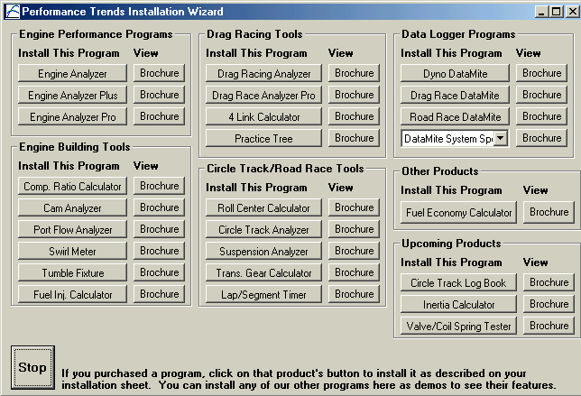
If the CD does not auto-then Run, then Browse Then look for
Figure 1.0 Installation Wizard
Click here to install
and run it to run the you want to bypass the
Programs folder and run
34.exe file.

Follow the instructions For most users, just question asked to accept suggested by the Setup installed the Engine
an Engine Analyzer You can also click on
desktop), then All Programs,
run, then click on Start, and find your CD drive. SETUP.EXE on the CD Installation Wizard. If wizard, go into the
the Engine Analyzer-

of the SETUP program. click on OK for each the default answers
program. Once you have Analyzer, there should be icon on your desktop.
Start (lower left corner of
then find the Perf. Trends program group, then Engine Analyzer v3.4.

Entering Registered Owner's Name: During your first setup, the Engine Analyzer will ask you to enter your name as the Registered Owner. During this first session, you can modify it until you are satisfied. Once you accept the name, the computer will generate a code # based on the name. To be eligible for Tech Help, you will need both your registered name and code #, and to have sent in your registration card. The name you enter should be very similar to the name you enter on the registration card. Click on About in the Main Menu to review your name and code # .

Then you must unlock the program (take it out of demo mode) by entering the correct working code given to you by Performance Trends. This code is based on the Registered Name and Registered Code number, and could have come on paperwork or in an email sent to you from Performance Trends. If you do not have this working code, email feedback@performancetrends.com the Exact Registered Name and Registered Code and we will email your working code.

You will enter the working code by clicking on File (upper left corner of the program), then Unlock Program. Depending on the version of program you purchased (std or Plus) you will get a different working code. This code works on ALL computers as long as you use the same Reg Name.

  - Example to Get You Going
To start the Engine Analyzer, click on the Desktop icon or, click on Start, then Programs, then Perf. Trends, and then Engine Analyzer. After some brief introduction screens, you will be left at the Main Screen shown below.
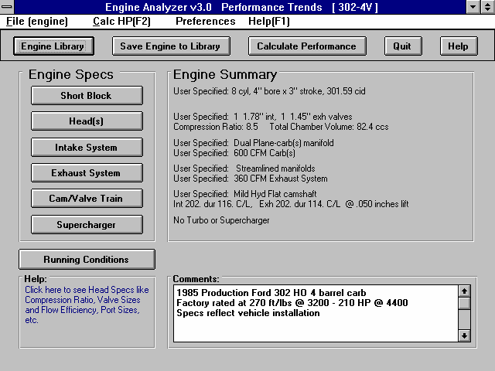
Figure 1.1 Main Screen
302-4V is
name of Engine Specs currently being worked with

Click here to display all engine saved in Engine Library

Click here to display the menu shown in Figure 1.2

From this main menu, you can:

    - Choose to review or modify any of the categories of Engine specifications displayed.
    - Open or Save a file of complete Engine specifications by clicking on the Open or Save buttons (first 2 buttons on the left) or the File menu item, then either Open or Save.
    - Add, edit or review Engine comments to describe the Engine currently held in the program.
    - Calculate Engine performance from the options listed under Calculate Performance. From here you can specify calculation options (barometric pressure, humidity, RPMs to run, etc.).
    - Change the Preferences options to somewhat customize the program for you.
    - Get HELP to explain these options by clicking on Help or pressing <F1>.
    - Quit the program by clicking on File, then Exit, or click on the Quit button.

All these options are explained in detail in Chapters 2 and 3.
In the Main Screen’s blue title bar you will notice the current Engine is [302-4V]. The program has descriptions of Engines saved in the Library right from Performance Trends. The current file from the Engine Library is called 302-4V.

To get started, let's examine (but not change) the various categories of specs. Click on a button for one of the categories like Engine, Transmission, etc. A new menu will appear displaying the various specs and the current values for the 302-4V Engine. You can click on the name of any spec and a brief description appears in the Help frame, along with a page # from this manual for more help. You can return to the Main Screen by clicking on OK or clicking on an area outside this menu.

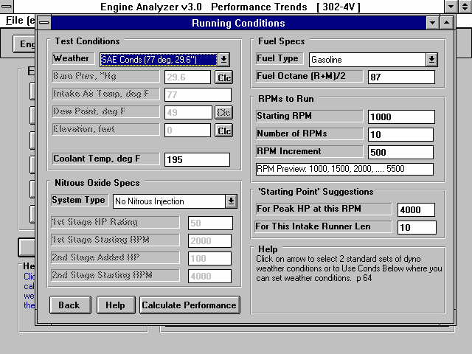
Now click on the Calculate Performance button in the Main Screen to calculate performance for this 302-4V Engine. The next menu will show you the Running Conditions menu as shown in Figure 1.2.
Figure 1.2, Running Conditions Menu
Click here to calculate dyno performance shown in Figure 1.3

For now, leave all the Running Conditions as they are and click on the Calculate Performance button. This will start the program calculating performance for the specifications of the 302-4V stored in the Engine Library with the Running Conditions currently displayed. A progress bar graph shows how the calculations are progressing. The calculations may require several seconds on slower computers.

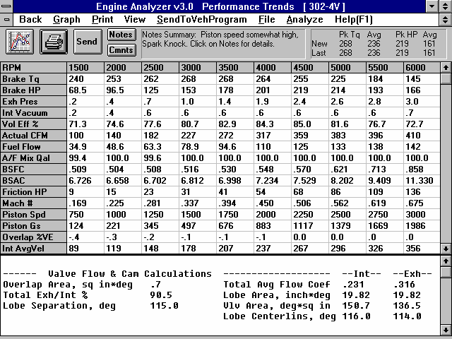
Figure 1.3 Calculated Results
Results Summary

Summary of important Notes of Interest. Click on Notes button for more info.

Tabular results which change with RPM, like dyno results.
Special Calc-ulation results which do not change with RPM, like idle vacuum, dis-placement, etc.

The final results will appear in a table as in Figure 1.3. The rows are for various types of readings (Brk Tq, Brake HP, etc) which occurred at the RPMs you requested in the Running Conditions menu.

The results contain much information, some which may not be familiar to you. However, the first three rows do look familiar:
- RPM
- Brk Tq
- Brake HP

If you look at these rows, you see a maximum or peak Brk Tq of 268 ft lbs at 3000 and 3500 RPM, and a maximum or peak HP of 219 HP at 4500 RPM. If you look in the upper right corner you see a Summary of the Current and Last performance, including the Avg Tq and Avg HP for these runs. Boy it sure is easier and cheaper than dyno testing!

The menu bar and the command buttons at the top of the screen shows some of the options for various formats for data output:

- Analyze will produce a report of performance and safety tips on the test results
- Graph will produce various types of graphs. You can also compare the current results to results of the previous run, or some other Baseline you have saved.
- Print lets you print these results on your printer.

If you have a printer hooked up to your computer, try the Print command by clicking on Print in the menu bar or on the Printer button. A small menu of printout options are presented. These options allow you to enter a report comment, include Engine specs and comments in the printout, etc. These options are explained in Section 3.5. For this first time, accept the default settings and print the report by clicking on Print Results.

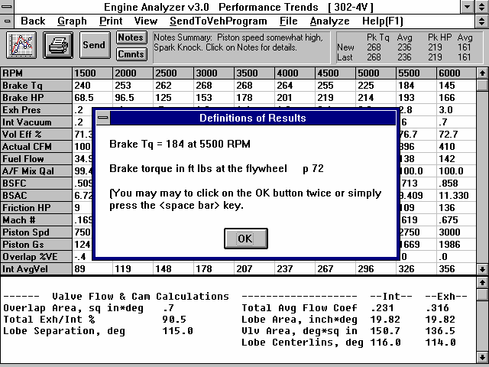
Figure 1.4, Calculated Results with Help Definition

Click here or press the F1 key for general help on what your options are at this point in the program.
By clicking on a number in the results, an explanation and definition is given, including a page number in this manual for more information.
Help is also available by clicking on output in Special Calcu-lations section.

To help explain the other columns of output, simply click on those results. A definition of that particular data will be presented in a Message box as in Figure 1.4. Then click on OK when you have read the definition.

For a detailed explanation of all the results, Running Conditions, and output options, go to Section 2.8 and Chapter 3.

Clicking on Back or pressing the <ESC> key will return you to the Main Screen. From the Main Screen you can modify the 302-4V to see the effect on performance. For example you could go into any of the component menus and:

- Change to a different cam.
- Install a turbo or supercharger.
- Change weather conditions.

The beauty of the program is that it repeats exactly each time. This lets you find differences which would be “clouded” by changes in weather conditions or test-to-test variability.

Many of the input specifications you see in the various menus may not be familiar to you. For a brief definition of the inputs, simply click on the specification name. The definition will appear in the Help frame with a page # in this manual for more information.

Some of the Engine specifications have “Clc” buttons. One example is Dew Point in the Running Conditions menu. “Clc” stands for "calculate". For example, if you want to calculate the Dew Point from wet and dry bulb readings, simply click on the Clc button. The program will display a new menu listing the inputs and the Calc Dew Point from these inputs. For further explanation, click on the Help buttons in these menus. To use the Calc Dew Point calculated from these inputs, click on the Use Calc Value button. Otherwise click on Cancel to return to the Running Conditions menu with no change to Dew Point. Section 2.9, Calculation Menus explains all these calculations.

Once you feel comfortable changing specifications in the various menus and making various performance calculations, read Section
3.4 of this manual called Engine Library to learn how to save a set of Engine specifications or recall information which has been previously saved. Then you will know all the basic commands to operate the program. For a more in-depth knowledge of using these commands and an explanation of the results, read this entire manual.

Chapter 2 Definitions
  - Basic Program Operation:
Figure 2.1 shows the Engine Analyzer’s Main Screen with explanations of your options here. Figure 2.2 shows the Head(s) Specs menu with explanations of options for most component menus.

See Appendix 5, 6 and 7 for new features on the Main Screen, including adding a picture file image.

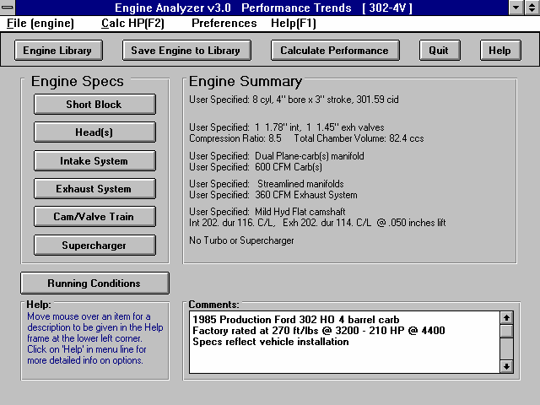
Figure 2.1 Main Screen Options
Buttons to display individual menus containing engine specs.
Menu bar. Click here for “drop down” menus of program options, some being the same as the Command Buttons.
Name of current engine file

Command buttons to Save or Open an engine file, calculate performance, etc.
This area gives a general description or summary of each of the 6 menus of specs which make up an engine.

Enter comments to describe engine
Click here to display Running Conditions (weather, fuel, nitrous, etc), and then calculate performance.
Move mouse over an area and a description of the item is given here

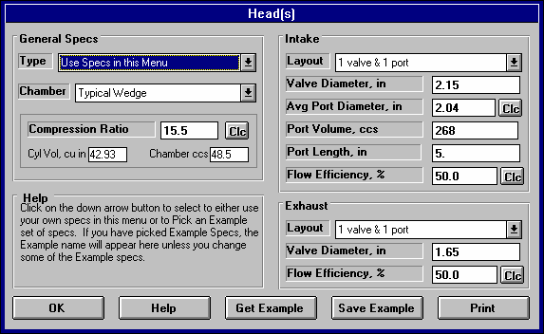
Figure 2.2 Explanation of Sections of Typical Menu
Name of specs. Click on them for a description in the menu’s help frame.
Help frame giving definition of spec and page # in manual for more info.
Drop down combo box. Click on down arrow button on the right side to pick from a list of possible choices for this spec.
Standard text entry box where you can type in the value of the spec (which will be checked against acceptable limits).
Calculation button which opens up another menu where you can calculate the value of a spec from other inputs

Click here to close menu.
Click here to obtain 1 to several screens of help to explain this menu.
Click here to display lists of examples of specs for this menu
Click here to save the appropriate current specs in this menu as an example in the list of example specs.
Click here to print this menu.
Is the name of the example specs (if an example was used) or else called something like “Use Specs Below” where specs are not from an example or are modified from an example. Other options include “Let program estimate specs”.
  - Preferences
See Appendix 5, 6, and 7 for many new Preferences which have been added.

Click on the Preferences item in the menu bar at the top of the Main Screen screen to drop down the Preferences shown in Figure 2.3. Here you can adjust some program items to personalize the program for your needs.
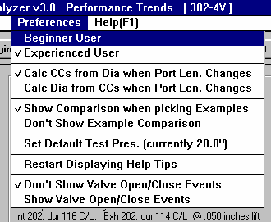
Figure 2.3 Preferences Menu
Available from Main Screen
Beginner/Experienced User
If you select Beginner, the program will lock out or hide the more complicated features, make more checks on specs assuming you could be making mistakes, and gives more explanation before an action is performed (assuming you may not be familiar with it). We strongly recommend this choice to anyone new to computers or this program.

Calc CCs from Dia when Port Len Changes Calc Dia from CCs when Port Len Changes
In the Head Specs menu, inputs are available for Average Port Diameter, Port Volume in CCs and Port Length which are all mathematically related. If you change Port Length, either the Volume must change if the Diameter does not change, or the Diameter must change if the Volume does not change. This option determines which assumption is made and which input (Diameter or Volume) is changed when you change the Port Length.

Show Comparison when Picking Examples Don’t Show Example Comparison
When you pick examples specs, the program can show a side by side comparison of the new Example specs versus the current specs before the new Example specs are loaded. Selecting “Don’t Show Example Comparison” omits this step and saves time.

Set Default Test Pressure (currently xx.x”)
For several calculation menus, flow bench test pressure is an input. The program automatically loads in the Default Test Pressure, usually 28” water. If you consistently use a flow bench test pressure different than this Default Test Pressure, you can change it here to most anything between 5-60” water. Click on this menu item and the program will ask you for a new Default Test Pressure.

Restart Displaying Help Tips
You will notice several tips displayed during running the program, many with a Check Box which says “Don’t Show This Again”. Once you are aware of a tip, you do not want to be shown it again, so click on this check box to “X” it, then click on OK.

If you ever want to review a tip, click on this menu item, and all tips will be displayed again at the appropriate time in the program, just as when the program was new, before you checked “Don’t Show This Again”.

Don’t Show Valve Open/Close Events Show Valve Open/Close Events
Asking to Show Valve Open/Close Events tells the program to show and update valve opening and closing events in the Cam/Valve Train menu. You can also then enter Opening and Closing events and have the Duration and Centerline determined from these inputs.

Asking to Don’t Show Valve Open/Close Events simplifies the Cam/Valve Train menu for many users.
  - Short Block
The Short Block specs describe the engine's size, pistons, rings, bearings and front end accessories. It also displays important engine volumes calculated from the current Short Block menu and Compression Ratio from the Cylinder Head(s) menu. By changing Bore, Stroke and # of Cylinders, you can immediately see the effect on cylinder displacement, total engine displacement, and clearance volume (assuming Compression Ratio stays fixed).
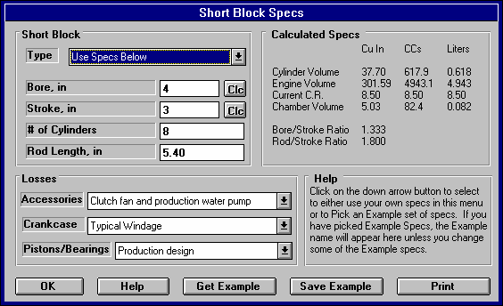
Figure 2.4 Short Block Menu
Engine Size Specs
Click here (or on the Pick Example button below) to pick an example, or choose Use Specs Below and type in you own Short Block specs.
Calculated Engine Volumes and Ratios
Specs describin g power loss items
Help section describ-ing item currently being high-lighted.

Type

This combo lets you describe the source of the specs used in this menu:
- You can select the Use Specs Below and enter in most any combination of Short Block Specs.
- You can pick the Pick an Example to be presented with a list of Example Short Block Specs, much the same as clicking on the Get Example button. It will then display the name of the Example Short Block specs you have picked.

The Type you choose has a large effect on how this menu looks. If you choose Use Specs Below, all specs will be printed in black, and you can change them to most any number you want. If you have chosen an example, the specs which relate directly to the example will be displayed in blue (or hidden if you are in Beginner User mode).

Should you choose to change any of these blue specs, a notice is given that changing any spec related to the example will change the Type from the example name to the general name of Use Specs Below. The example name is a handy reminder of what the specs in this menu represent, so you may not want to change any of these blue spec settings.
Bore, inches
The diameter of the cylinder measured in inches. Click on the Clc button to calculate a Bore to produce a certain Cubic Inches for a given Stroke and # of Cylinders. See Section 2.9.1.

Stroke, inches
The distance the piston travels from TDC (top dead center) to BDC (bottom dead center) measured in inches. Click on the Clc button to calculate a Stroke to produce a certain Cubic Inches for a given Bore and # of Cylinders. See Section 2.9.2.

# Of Cylinders
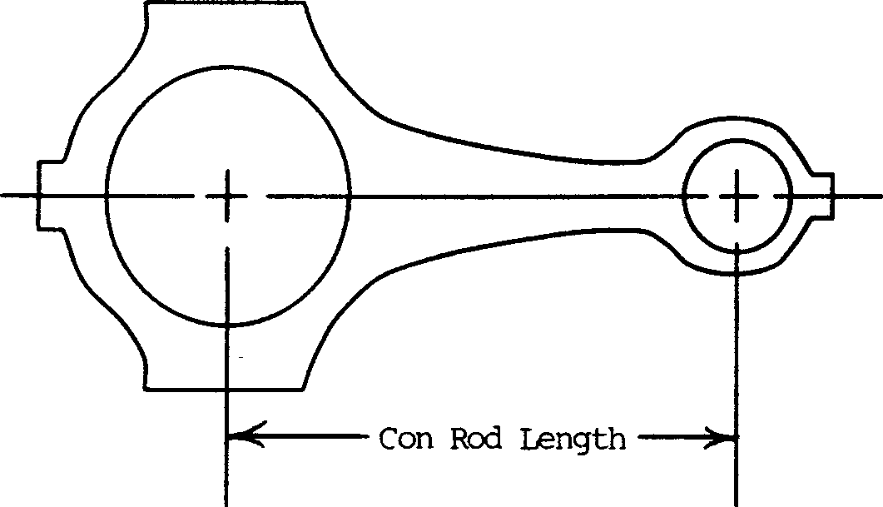
The number of cylinders for the engine. For example, for a V-8 this number is 8, for a single cylinder engine this number would be 1.
Figure 2.5 Illustration of Rod Length, in

Rod Length, in
The distance from the center of the wrist pin bore to the center of the crank journal bore measured in inches. This spec is not used in Beginner User mode as it has a small effect on performance.
Accessories
Front end accessories "rob" the engine of significant power which could otherwise be used to power the vehicle. Click on the down arrow button of this combo box to pick the
description of the accessories on your engine. Generally, the further down the list you go, the more or larger accessories that are assumed and the more power “robbed” from the final brake torque and HP numbers.

Crankcase
This combo box lets you pick a general design of the crankshaft as far as windage drag is concerned. Windage can rob significant amounts or power from the engine, especially at high speed. Pick from the following designs.

- High Oil Drag is where there is higher than normal drag, like oil overfill or excessive foaming where the crank actually hits the oil level.
- Typical windage would be a typical production design without provisions to minimize windage (like scrapers, windage tray, deep sump, etc.)
- Low windage would be where provisions have been made to minimize windage (like scrapers, windage tray, deep sump, etc.)
- Low Case Pressure is where a small air pump is used to reduce crankcase pressure significantly to over 10” mercury vacuum.
- Dry sump systems where the crankcase is evacuated to a low crankcase pressure (over 10” mercury vacuum).

Pistons/Bearings
Piston and bearing size and design have a large impact on internal engine friction. Engine friction also robs power from appearing at the flywheel, especially at high RPM. Generally, the smaller the bearings in width and diameter, the smaller the piston skirt, and the smaller and lower tension the piston rings, the lower the friction. However, small skirts and bearings will likely have reduced durability and reliability.

The program makes no assessment of the safety or reliability of a particular combination. This must be decided by an experienced engine builder and the part’s manufacturers.
  - Cylinder Head(s)
The cylinder head specs affect intake and exhaust flow potential, compression ratio and the combustion chamber.

See Appendix 5, 6, and 7 for new features, including new Plus version features.
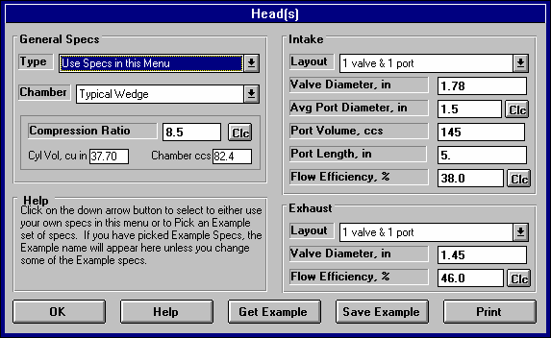
Figure 2.7 Cylinder Head(s) Menu
General Specs:
Type
This combo lets you describe the source of the specs used in this menu:
- You can select the Use Specs Below and enter in most any combination of Head Specs.
- You can pick the Pick an Example to be presented with a list of Example Head Specs, much the same as clicking on the Get Example button. It will then display the name of the Example Head specs you have picked

The Type you choose has a large effect on how this menu looks. If you choose Use Specs Below, all specs will be printed in black, and you can change them to most any number you want. If you have chosen an example, the specs which relate directly to the example will be displayed in blue (or hidden if you are in Beginner User mode).

Should you choose to change any of these blue specs, a notice is given that changing any spec related to the example will change the Type from the example name to the general name of Use Specs Below. The example name is a handy reminder of what the specs in this menu represent, so you may not want to change any of these blue spec settings.
Chamber
This combo box lets you pick a general chamber design. This spec affects:
- How well the chamber burns the air/fuel mixture for various compression ratios.
- Spark plug location and number of spark plugs which affects burn rate.

This spec does NOT affect flow as that is described by the Flow Efficiency data described later.

Table 2.1 Descriptions of Chamber Designs
Type | Description
Typical Wedge | Wedge chamber with spark plug significantly offset from the center, high compression requires significant piston popup, squish/quench area does NOT have extremely tight clearance and is a low percent of the total chamber
Compact Wedge | Wedge chamber with spark plug more centrally located, high compression does not requires significant piston popup, squish/quench area does have extremely tight clearance (.040-  .060” depending on RPM range) and is a high percent of the total chamber, valve angles generally have to be reduced for this type of chamber.
Hemi | Hemispherical chamber with centrally located spark plug, large domed pistons, squish/quench area does NOT have extremely tight clearance (.040-.060”, depending on RPM range) and is not a high percent of the total chamber.
Flat Head | Large chamber with valves and spark plug off to the side of the bore.
Pent Roof | Similar to hemi, but for most typical 4 valve engines.
Dual Plug option for all designs listed above | Select the dual plug version of one of the chamber designs above if it has 2 spark plugs which fire at approximately the same time but at different locations in the chamber

Compression Ratio
The engine's compression ratio based on cylinder clearance volume and total cylinder swept volume (sometimes called static
compression ratio). Do not use compression ratios which are corrected for cam timing, weather or supercharger boost.

Compression Ratio = Clearance Volume + Swept Volume
Clearance Volume
Clearance Volume and Swept Volume must be in the same units, both either CCs or cubic inches. Multiply CCs by .061 to obtain cubic inches, multiply cubic inches by 16.39 to obtain CCs.

Since Compression Ratio has a Clc button, see Section 2.9.3 for calculating Compression Ratio from clearance volume, piston dome volume, deck height and gasket thickness.

Cyl Vol, cu in
This is the cylinder volume in cubic inches calculated from the current Short Block Specs. This value is displayed for your information to see how Compression Ratio is calculated and can not be changed here directly, but only by changing the Short Block specs.

Chamber ccs
This is the volume of the total combustion chamber (head chamber, piston dish or dome, gasket thickness volume, etc. This value is displayed for your information and is calculated from the current cylinder volume and Compression Ratio, and can be changed here directly.

Intake Port Specs:
Layout
Identifies if there are 1 or 2 intake valves per cylinder and how many ports there are for this number of intake valves. If 2 valves are specified, both valves are assumed to be equal size and opened exactly the same. If 2 ports are specified, the program also assumes the intake manifold has the same number of runners. Therefore, if you have 2 valves per cylinder, and the ports from these valves siamese (run into each other) in the head or right after the head, specify the number of ports as 1.
Valve Diameter, in
Is the outside (largest) diameter of the head of the intake valve(s) in inches. This is not throat area.

Avg Port Diameter, in
Identifies the average inside diameter of the intake port(s) over their entire length in the cylinder head. Usually this can be measured at the end of the port which mates to the intake manifold. A more precise way is to calculate the diameter by measuring the port volume and port length. If you know port CCs, enter it in the spec below, first making sure the Port Length is accurate.

If the ports are oval or rectangular, or you know the port volume in CCs and length, click on the Clc button described in section 2.9.3, to calculate the effective diameter. If you set the number of ports to 2, this is the diameter of only 1 of these ports. These ports are assumed to be the same length and diameter.

Port Volume, CCs
Is the volume of the intake port in CCs (cubic centimeters). This value can be input directly (then the Avg Port Diameter changes to match this volume and the Port Length spec). Also, if you enter or change the Avg Port Diameter, this value will be calculated based on that diameter and the current Port Length spec.

If you set the number of ports to 2, this is the Volume of only 1 of these ports. These ports are assumed to be the same length and Volume.

Port Length, in
Is the length of the intake port (down the center of the port) from the intake valve to the end of the head port (the start of the intake manifold runner). For many common heads, 4.5"-6" is a typical length. This spec, combined with the Intake Manifold Runner Length, has a significant impact on intake tuning and therefore performance. Try to be reasonably accurate inputting this value.

Flow Efficiency, %
The flow capacity of the heads can be described by a combination of the valve area (diameter) and the Flow Efficiency. The total flow capacity of the intake port and valve has a substantial impact on performance. Precise information for a particular head design is only available from flow tests on a flow bench. A flow bench is a device which will maintain a constant pressure drop across the port and measure the amount of air flow the pressure drop produces. CFM (Cubic Feet per Minute) flow measurements are usually made with the valve at various lifts. From this data and knowing the valve diameter, flow efficiencies can be calculated.

As valve lift increases, the valve opening area (curtain area) increases, flow increases and the flow efficiency changes somewhat. See Figures 2.8. This continues until valve lift is approximately equal to 1/4 the valve's diameter. This lift is also called an L/D (ratio of valve lift to valve diameter) of .25 . At this point the valve area stops increasing with lift. The minimum flow area is now the valve throat, not the "curtain area" around the circumference of the valve. Additional valve lift gives no increase in valve area, although flow may still increase somewhat.

The flow efficiency at a valve lift of L/D=1/4 (ratio of valve lift to valve diameter) is the one which the Engine Analyzer uses to estimate the valve's entire flow curve. Flow efficiencies at L/D=1/4 can vary from 20% for a restrictive port/valve up to 75-80% for the best, latest racing technology.

It is best to have flow bench data for the cylinder heads being used to calculate the Flow Efficiency as shown in Section 2.9.5. The next best estimate of Flow Efficiency is by picking an Example Head.

If you can not find your head or a similar head in these Examples, use Table 2.2 for a general idea for estimating Flow Efficiency. You can also obtain estimates in the program similar to Table 2.2 by clicking on the Clc button, then answering No that you do not have flow bench data. You will be presented with a list of simple descriptions of ports with typical Flow Efficiencies for you to pick from.

Table 2.2: Estimate Intake Flow Efficiency
Description (years engine was designed) | Flow Effcy
1930s and 1940s Production, domestic Flatheads | 20-25%
1930s and 1940s ported production Flatheads | 25-30%
1930s and 1940s racing Flatheads | 30-40%
1950s production, domestic OHV | 25-35%
1950s ported production OHV | 35-45%
1950s racing OHV | 40-45%
1960s and 1970s production, domestic OHV | 35-40%
1960s and 1970s ported production OHV | 40-45%
1960s and 1970s racing OHV | 45-60%
1960s and 1970s production, domestic OHC | 40-45%
1960s and 1970s ported production OHC | 45-50%
1960s and 1970s racing OHC | 50-65%
1980s production, domestic OHV | 42-47%
1980s ported production OHV | 47-52%
1980s racing OHV | 52-70%
1980s production, domestic OHC | 45-50%
1980s ported production OHC | 50-55%
1980s racing OHC | 55-72%
1990s production, domestic OHV | 45-50%
1990s ported production OHV | 50-55%
1990s racing OHV | 55-72%
1990s production, domestic OHC | 47-52%
1990s ported production OHC | 52-57%
1990s racing OHC | 57-75%

Table 2.3: Examples of Valve Flow Efficiency
Description & Source | Int |  | Exh
 | Flow | Valve | Flow | Valve
Effcy% Dia Effcy% Dia
Stock "461" SB Chevy, Hot Rod 3/88 | 43.9 | 2.02 | 41.0 | 1.60
Stock "993" SB Chevy Open Chmbr, Vizard * | 44.9 | 1.94 | 38.9 | 1.60
Stock "186" SB Chevy Clsd Chmbr, Vizard * 42.3 | 1.94 | 46.6 | 1.50
Bow Tie SB, CNC Portd 24502482, Cir Trk 9/93 | 60.5 | 2.15 | 72.2 | 1.62
Dart II SB Chev, C.I., Hot Rod 3/88 | 53.8 | 2.02 | 54.6 | 1.60
Lt Pt BB Chev, C.I. Oval Port, Perf Trnds | 49.5 | 2.19 | 40.0 | 1.88
Portd BB Chev, C.I. Rect Port, SS&DI 6/81 | 50. | 2.30 | 46. | 1.90
Lt Pt BB Chev Merlin Iron. Oval Port, PrfTrns | 47.9 | 2.19 | 44.5 | 1.88
Portd Dart Alum 360 BB Chev, Sonny's Racing | 57.4 | 2.30 | 56.1 | 1.90
Stock AR SB Ford Alum, Super Ford 8/89 | 46.4 | 1.94 | 43.9 | 1.60
Portd AR SB Ford Alum, Super Ford 8/89 | 54.1 | 1.94 | 61.4 | 1.60
Stock TFS SB Ford Alum, Super Ford 8/89 49.8 | 1.94 | 40.0 | 1.60
Portd TFS SB Ford Alum, Super Ford 8/89 56.1 | 1.94 | 63.7 | 1.60
Stock 1970 351W SB Ford, C.I., SprFrd 8/89 44.2 | 1.84 | 39.7 | 1.54
Portd 70 Boss 302 Trans Am, Perf Trends | 51.0 | 2.19 | 44.0 | 1.71
Briggs & Stratton, 5 HP, Perf Trends | 24.5 | 1.12 | 29.4 | .99
Pont RamAir III Stock, HP Pont 4/91 (adj) ** | 40.9 | 2.11 | 39.5 | 1.77
Stock Mopar 360A, P4529589, Hot Rod 11/91 | 41.8 | 2.02 | 48.2 | 1.60
Stock Mopar 440B, 452, Perf Trends | 42.9 | 2.08 | 41.3 | 1.74
Light Portd Mopar 440B, 452, Perf Trends | 46.5 | 2.14 | 51.7 | 1.74
Stock Mopar 440B, 240618, Perf Trends | 53.7 | 2.08 | 47.1 | 1.88
426 Hemi Ported, SS&DI 6/81 | 60. | 2.25 | 56. | 1.94
1600 cc VW Stock Dual Port, Novak & Ass. 48.2 | 1.40 | 38.5 | 1.26
1600 cc VW Stock Dual Port 041, Novak & Ass. | 42.8 | 1.54 | 46.4 | 1.26
1600 cc VW (aftermarket) AC910, Novak & Ass. | 45.5 | 1.97 | 50.7 | 1.50

* How to Build & Modify Chevrolet Small Block V-8 cylinder Heads, David Vizard, Motorbooks International, 1991.
** Adjusted down to match other sources of stock Pontiac flow data

Many additional heads are loaded in the cylinder Head(s) Examples. If you have flow bench data at approximately L/D=.25 , click on the Clc button to calculate Flow Efficiency as described in Section 2.9.5.

Note:

The total flow potential of a port depends not only on the flow efficiency, but also on the number of valves per cylinder and the valve diameter. A very good Flow Efficiency (at L/D=.25) of say 60 to 75% does not mean the port/valve is not restrictive and limiting power. What it means is to flow more air, you probably must increase the valve size. See Figure 2.7.

Large Valve, 2” Dia | Larve Valve, 2” Dia | Small Valve, 1” Dia
Large Flow Effcy, 60% | Small Flow Effcy, 30% | Large Flow Effcy, 60%
Bench Flow = 280 CFM | Bench Flow = 140 CFM | Bench Flow = 70 CFM
HP Potential = 600 | HP Potential = 380 | HP Potential = 270

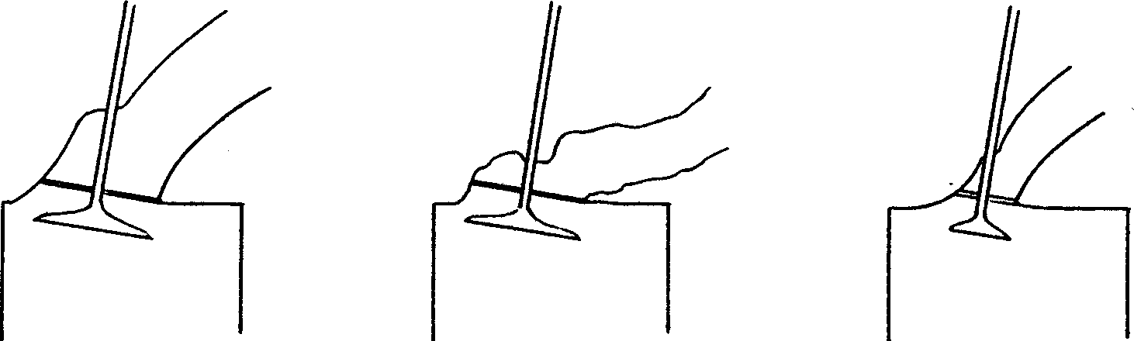
Important: Plus version adds the ability to include a full flow curve.
Figure 2.7Illustration of Valve Size (Diameter), Flow Efficiency, and Effect
of Flow Bench Air Flow and Engine HP Potential

Exhaust Port Specs:
Layout
See Layout in Intake Port Specs earlier in this chapter.

Valve Diameter, in
See Valve Diameter in Intake Port Specs earlier in this chapter.

Flow Efficiency, %
See Flow Efficiency in Intake Port Specs earlier in this chapter.

Note: Generally, exhaust valves have better Flow Efficiencies, by about 5%. This does not mean the exhaust flows more air, because the exhaust valve is generally smaller. It means the exhaust flows better for the size valve it is. This may be because the exhaust flows out of the cylinder or because the smaller valve is less shrouded by the bore.

Important: Plus version adds the ability to include a full flow curve.
  - Intake System
The intake system specs affect intake tuning, restrictions, manifold heating, fuel metering and fuel mixture quality.

See Appendixes 5 and 6 for new features added in v3.2 and v3.4.

Manifold Specs (x runner/cyl)
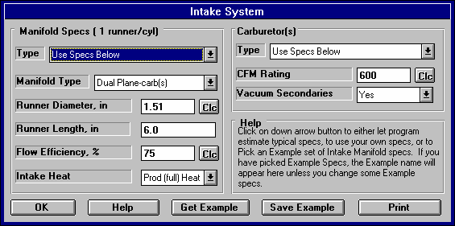
Figure 2.8 Intake System Menu

The "x runner/cyl" depends on the current value of Layout choice under Intake Port specs in the Head(s) menu. If x=2, then the Manifold Spec of Runner Diameter describe only 1 of the 2 intake manifold runners for each cylinder.

Type

This combo lets you describe the source of the specs used in this menu:
- You can select a general type of manifold and the program will estimate the specs. This is useful when you can not find an Example close to your engine and you do not know your manifold’s specs.
- You can select the Use Specs Below and enter in most any combination of Manifold Specs.
- You can select the Pick an Example to be presented with a list of Example Manifold Specs, much the same as clicking on the Get Example button. It will then display the name of the Example Manifold specs you have selected.

The Type you choose has a large effect on how the Manifold section of this menu looks. If you choose one of the Typical manifolds, all Manifold specs will be disabled (printed in gray) and you can not change them. If you choose Use Specs Below, all specs will be printed in black, and you can change them to most any number you want. If you have chosen an example, the specs which relate directly to the example will be displayed in blue. In Beginner User mode, disabled specs or specs printed in blue are hidden.

Should you choose to change any of these blue specs, a notice is given that changing any spec related to the example will change the Type from the example name to the general name of Use Specs Below. The example name is a handy reminder of what the specs in this menu represent, so you may not want to change any of these blue spec settings.

Manifold Type
This combo box lets you pick the type of intake manifold design and the type of fuel delivery system. This will determine what percent of the carburetor or throttle body is available to each individual cylinder and the type and strength of the intake tuning effects.
Table 2.4 Descriptions of Manifold Types
Manifold Type | Description
Dual Plane - carb(s) | This manifold type is where half of the engine's cylinders "see" only half of the carburetor and are isolated from the other half of the cylinders.  This type of manifold gives a stronger fuel metering signal at low speed, because each induction pulse goes to a carburetor only half as big as the entire carburetor. Most production carburetor systems are of this type for engines larger than 4 cylinders. Dual plane intakes on engines with 6-10 cylinders also exhibit some "secondary" or low speed tuning effects. See Appendix 3 and Example 4.2. A carburetor is the fuel metering device.
Single Plane - carb(s) | A single plane manifold is where all cylinders can draw from all carburetor barrels. For this reason, this manifold offers lower flow restriction at higher air flows (high RPM). These types of intakes on V- 8s tend to have shorter runners than either dual plane or tunnel ram manifolds. A "Street" single plane is one where tuning has been compromised to also provide hood clearance, good part throttle fuel distribution, good throttle response and cold weather operation, etc. Also see Tunnel Ram - carb(s) below. Single plane intakes on engines with 2-4 cylinders also exhibit "secondary" or low speed tuning effects. See Appendix 3 and Example 4.2. A carburetor is the fuel metering device.
Tunnel Ram - carb(s) | This type of single plane manifold has been designed for optimum intake tuning and low flow restriction. Single plane intakes on engines with 2-4 cylinders also exhibit "secondary" or low speed tuning effects. See Appendix 3 and Example 4.2. A carburetor is the fuel metering device.
Single Plenum - EFI | This type of production intake system is characterized by one injector dedicated to each cylinder and one large plenum which supplies air to all cylinders. Generally these intakes have been optimized for tuning effects, since fuel distribution and carb "pump shot" lag are no longer a concern. These systems generally have runner lengths in the 8 to 20 inch range. Injected intakes on engines with from 2-4 cylinders also exhibit "secondary" or low speed tuning effects. See Appendix 3 and Example 4.2. Fuel injection is the fuel metering device and a throttle body meters air.
Split Plenum - EFI | This type of manifold is very similar to the Single Plenum-EFI above except it has a split plenum, each side supplying air to only half of the cylinders. This type of fuel injected intake is usually used on engines with 6 or more cylinders to produce “secondary” tuning effects for improved low speed torque.
Ind Runner - carb(s) | This manifold type has all cylinders completely isolated from one another. This type of system generally offers the best potential for intake tuning.  However, these systems can be restrictive, even with a large Total CFM Ratings. For example, each cylinder can draw from a 600 CFM carb on a single plane, V-8 manifold. However, each cylinder could only draw from a 75 CFM carburetor (one eighth of 600 CFM) with an individual runner system with a Total CFM Rating of 600. Individual runner manifolds will exhibit no "secondary" or low speed tuning effects. If you specify # Of Cylinders as 1 in the Short Block specs, the program assumes an individual runner system, no matter what type is selected here. This system uses carburetors as the fuel metering device.
Ind Runner - fuel inj | This type is like Ind Runner - carb(s) except fuel injection is the fuel metering device and individual port throttles meter air.

Runner Diameter, in
Identifies the effective, average inside diameter of the intake manifold runner(s). If the runners are oval or rectangular or you know the runner volume and length, click on the Clc button as described in section 2.9.4, to calculate the effective average diameter.

The program assumes the same number of intake manifold runners per cylinder as you specify in the Layout in the cylinder Head(s) menu. The Runner Diameter is the diameter of only 1 of the runners. All runners are assumed to be the same length and diameter.

Runner Length, in
Is the length of the intake runner from the cylinder head port to the first "abrupt enlargement" of the runner upstream of the cylinder head. The "abrupt enlargement" can be several different things:

- The intake manifold plenum. The plenum is the open area where all the runners merge, directly under the carburetor(s) or after the throttle body on fuel injected manifolds. The best example of a plenum is the very evident "box" on "tunnel ram" type manifolds.
- The end which is open to atmosphere (or air cleaner) on individual runner fuel injection or carburetion. For "individual runner" carb systems, the runner length actually extends through the carb and through any velocity stack or air horn.
- Any point where a runner from one cylinder merges with a runner from another cylinder.

Most production, carbureted manifolds have runners from 3 to 12 inches in length. Manifolds for modern, production fuel injected engines generally have longer runners (8-20 inches) to take advantage of intake tuning effects at mid-range RPMs. Most manifolds have runners which vary in length from cylinder to cylinder. Use the average length of all the runners, or the average of the longest and shortest runner for this spec.

Flow Efficiency
Is similar to the Flow Efficiency number for the valve in the Head(s) menu, but describes the design of the runner within the intake manifold. This does not describe the size or length of the runners, as they have been described by other specifications. This specification says "for its particular size, how well is the intake runner designed". Obviously, sharp bends to clear a distributor or provide for hood clearance, rough irregular surfaces, or abrupt changes in runner size where the intake manifold mates to the head, are undesirable from a restriction and tuning point of view. See Figure 2.10.

A general rule for a good manifold (and port) design is one where you can see the entire intake valve for all cylinders from the carburetor or throttle body. This type of design would likely have a Flow Efficiency of 100%, indicating virtually no restriction due
Fig 2.9 Illustration of Restriction Level vs Runner Flow Efficiency High
Level of Restriction
Or Power Loss
Low
0
60708090100
Flow Efficiency

to the manifold estimate the Runner
design. Use Table 2.5 to Flow Effcy.

Table 2.5 Estimates of Runner Flow Efficiency
Manifold Description | Est Flow Efficiency, %
Production, carbureted manifolds | 60 to 75%
Production manifolds for individual cylinder fuel injection | 65 to 85%
Aftermarket, dual plane intake manifolds | 70 to 95%
Aftermarket, single plane, “X” type or “tunnel ram” manifolds | 85 to 100
Race single plane (sheet metal, custom design) | 100%
Runner Flow Efficiency is different from Valve Flow Efficiency in that Runner Flow Efficiency has a very "non-linear" relationship to restriction. This means that the difference in restriction between flow efficiencies of 60% to 70% is much greater than the difference between 90% to 100%. Figure 2.9 shows that most change in restriction level occurs between Runner Flow Efficiencies of 60 to 80%, and that a Flow Efficiency less than 60% is very unusual.

Runner Flow Efficiency not only affects flow restriction, but has a strong influence on intake tuning. See Appendix 3 and Example 4.6.

See Section 2.9.6 for how to calculate Runner Flow Efficiency from flow bench data by clicking on the Clc button. Even if you do not have flow bench data, review Section 2.9.6 for an understanding of how the flow capacity of the head’s ports relate to the intake manifold’s Runner Flow Efficiency.

You can also click on the Clc button to pick typical examples of Flow Efficiency from a list.

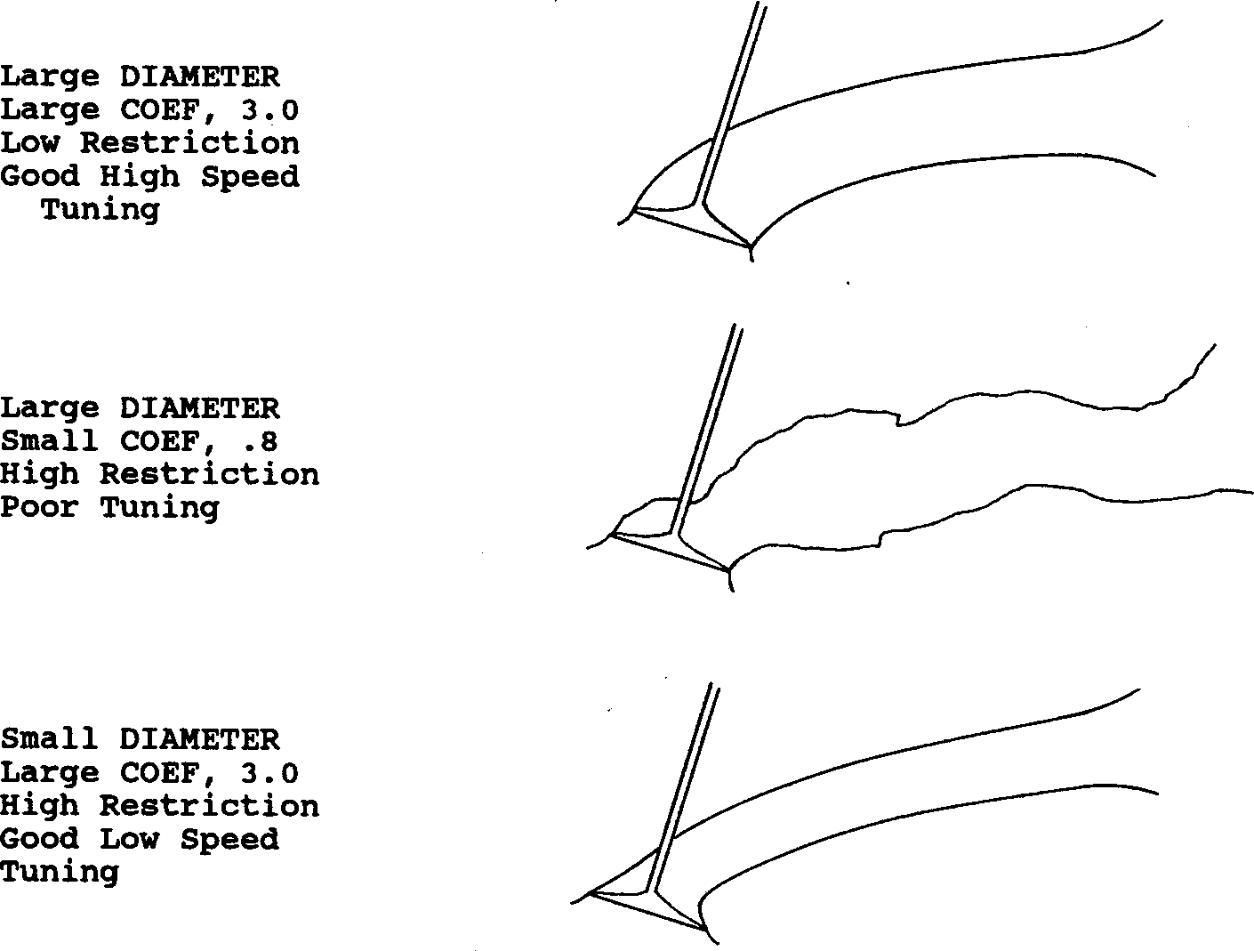
Figure 2.10 Illustration of Runner Diameter, Runner Flow Efficiency, and Qualitative Comments

Intake Heat
This combo box lets you pick the method of heating the intake manifold for improved fuel atomization, fuel distribution and cold weather operation. Use the Table 2.9 to estimate Intake Heat.
Table 2.6 Descriptions of Intake Heat Ratings
Description | Type of Intake Heat
Production carbureted manifolds heated by exhaust gas and/or engine coolant. | Prod (full heat)
Production individual cylinder fuel injection manifolds or carbureted manifolds with blocked exhaust crossover. | Reduced Heat
Manifolds with no source of engine heat; fuel injection or carbs with individual stacks; manifolds which have no coolant passages, exhaust crossover, and are insulated or isolated from the lifter valley. | No Heat
Carburetor(s) Throttle Body(s)
The title of this section of the Intake System Specs menu is determined by the choice of Manifold Type.

Type
This combo lets you describe the source of the specs used in this menu:
- You can select the Use Specs Below and enter in most any combination of Carburetor or Throttle Body Specs.
- You can pick the Pick an Example to be presented with a list of Example Carburetor or Throttle Body Specs, much the same as clicking on the Get Example button. It will then display the name of the Example Carburetor or Throttle Body specs you have picked

The Type you choose has a large effect on how the Carburetor or Throttle Body section of this menu looks. If you choose Use Specs Below, all specs will be printed in black, and you can change them to most any number you want. If you have chosen an example, the specs which relate directly to the example will be displayed in blue (or hidden if you are in Beginner User mode).

Should you choose to change any of these blue specs, a notice is given that changing any spec related to the example will change the Type from the example name to the general name of Use Specs Below. The example name is a handy reminder of what the specs in this menu represent, so you may not want to change any of these blue spec settings.

Total CFM Rating
Is the air flow rating of the carburetor(s), or throttle body(s) if the engine is fuel injected. The flow rating is measured in CFM (Cubic Feet per Minute) maintaining a 1.5" Hg (inches of mercury) pressure drop across the carburetor or throttle body. Standard CFM at
1.5" Hg pressure drop (20.4" water is the standard method of rating 4 BBL carburetors. Standard CFM ratings for 2 BBL and 1 BBL carburetors are measured with a 3" Hg pressure drop and must be converted to the 4 BBL rating before they will be accurate in the Engine Analyzer program. Use the .71 conversion as shown below:
2 BBL CFM Rating x .71 = 4 BBL CFM Rating

This spec has a Clc button, which means you can calculate it from either:

- Throttle bore sizes, # throttle bores, restrictor plate specs.
- Flow bench data.

See Section 2.9.7 on these options.

Secondary Throttles
This Yes or No combo box identifies if the carburetor has additional air flow capability at high air flow demands. Select Yes or No as follows:

No If there are no secondary throttles, pick No.
No If there are secondary throttle plates, check to see if they are mechanical secondaries. With the engine not running, see if all throttle plates are completely open with the throttle linkage in the WOT (Wide Open Throttle) position. If so, pick No.
Yes If there are throttle openings which are not completely open, but which open "on demand" when engine air flow requirements increase, pick Yes.

This spec can affect power due to increased carburetor restriction until the secondaries open, but improve power at lower RPM due to improved A/F Mixture Quality. This spec is disabled if you have specified a Fuel Injected Manifold Type.
  - Exhaust System Specs
The Exhaust System specs affect exhaust system tuning and flow losses due to restrictions in the exhaust manifold or header and exhaust/muffler system.
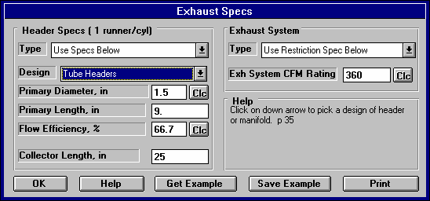
Figure 2.11, Exhaust System Menu
Header Specs (x runner/cyl):
The "x runner/cyl" depends on the current value of # Ports specified by Exhaust Port Layout in the Head(s) menu. If x=2, then the Header Specs of Inside Diameter and Total Length describe only 1 of the 2 exhaust header or manifold runners for each cylinder.

Type

This combo lets you describe the source of the specs used in this menu:
- You can select the Use Specs Below and enter in most any combination of Header Specs.
- You can pick the Pick an Example to be presented with a list of Example Header Specs, much the same as clicking on the Get Example button. The program will then display the name of the Example Header specs you have picked

The Type you choose has a large effect on how the Header section of this menu looks. If you choose Use Specs Below, all specs will be printed in black, and you can change them to most any number you want. If you have chosen an example, the specs which relate directly to the example will be displayed in blue (or hidden if you are in Beginner User mode).

Should you choose to change any of these blue specs, a notice is given that changing any spec related to the example will change the Type from the example name to the general name of Use Specs Below. The example name is a handy reminder of what the specs in this menu represent, so you may not want to change any of these blue spec settings.
Design
This combo box lets you pick the general design of the exhaust header:

- Tube headers, where each cylinder’s exhaust port connect to fairly smooth tube headers, which smoothly merge with other cylinders in a collector.
- Log Manifold, where each exhaust port dumps into a common manifold with very short runners, usually less than 1” long.
- Streamlined Manifold, where each exhaust port dumps into a common manifold, but the runners are designed to smoothly route the exhaust away, and try to prevent exhaust from 1 cylinder traveling up the port to another cylinder.
- Zoomies are just like tube headers, except there is no collector, each cylinder empties into an individual pipe which does not connect to another cylinder.
Primary Diameter, in
Is the average inside diameter of the header primary. If you know your header tubing outer diameter, simply subtract .1 inches to obtain the approximate inside diameter For example:
1 7/8" Headers: Tubing O.D. = 1.875 Inside Diameter = 1.875 - .1 = 1.775
Note: The exhaust runner dimensions are not as critical as the intake runner dimensions. It is generally “overkill” to “cc" the primary
header pipes. Simply estimating the inside diameter by subtracting .1 from the tubing OD is adequate.

Primary Length, in
Is the length of the exhaust runner from the exhaust port in the head (not including the exhaust port) to the first "abrupt enlargement" of the runner downstream of the exhaust port. The "abrupt enlargement" can be several different things:

- The header collector where individual tubes merge together.
- The end which is open to atmosphere on individual runner exhaust headers.

Production headers for performance engines generally have runners in the 12-24 inch range. Aftermarket headers generally have a length of 20-40 inches.

Flow Efficiency
Is similar to the Runner Flow Efficiency discussed in the Intake System section. Runner Flow Efficiency affects flow restriction and exhaust tuning.

See Section 2.9.6 for how to calculate Runner Flow Efficiency. Even if you do not have flow bench data, review Section 2.9.6 for an understanding of how the Valve and Runner Flow Efficiencies relate to each other. If you do not have flow data, use Table 2.7 to estimate the Runner Flow Efficiency for typical exhaust manifolds and headers.
Table 2.7, Estimate Exhaust Runner Flow Efficiency
Description | Flow Efficiency %
Aftermarket, “street” headers (typically more bends to clear frame, provide for easy installation, etc.) | 65 - 90%
Aftermarket, “race” headers (designed primarily for low restriction, good tuning characteristics) | 75 - 95%

Collector Length
Is the length of the collector on the Tube Headers from the end of the primary pipes at the beginning of the collector to the end of the collector where it opens to atmosphere or dumps into a muffler. If you have selected a Design other than Tube Headers, this spec is disabled and not used in the calculations.

Exhaust System Type
This combo lets you describe the source of the specs used in this menu:
- You can specify Open Headers or No Exhaust System
- You can select the Use Restriction Spec Below and enter in most any Exhaust System CFM Rating.
- You can pick the Pick an Example to be presented with a list of Example Exhaust System Specs, much the same as clicking on the Get Example button. It will then display the name of the Example Exhaust System specs you have picked

The Type you choose has a large effect on how the Exhaust System section of this menu looks. If you choose Use Specs Below, all specs will be printed in black, and you can change them to most any number you want. If you have chosen an example, the specs which relate directly to the example will be displayed in blue (or hidden if you are in Beginner User mode).

Should you choose to change any of these blue specs, a notice is given that changing any spec related to the example will change the Type from the example name to the general name of Use Specs Below. The example name is a handy reminder of what the specs in this menu represent, so you may not want to change any of these blue spec settings.

CFM Rating
Is the "vehicle exhaust system and muffler restriction rating" and describes the design of the exhaust system. It is very similar to a carb or throttle body Total CFM Rating in the Intake System Specs menu.

The CFM Rating is measured in CFM (Cubic Feet per Minute) maintaining a 1.5" Hg (inches of mercury, or 20.4 inches of water) pressure drop across the entire exhaust system. Exhaust system flow data is becoming more common in magazine articles and performance "how to" books. However, the pressure drop used for doing the flow tests may not be 20.4". If not,
use the following formula to obtain CFM flows corrected to 20.4":

Also, if they flow each side of the exhaust system separately, simply add the two CFM values obtained.

CFM @ 20.4” = CFM @ XX” × 20.4
XX
Where XX is the actual test pressure in inches of water
For example, a magazine article says the right side of a particular exhaust system flows 270 CFM at 28" water.

First, convert 270 CFM @ 28" to CFM at 20.4"

CFM @ 20.4" = 270 * 20.4 = 270 * .854 = 230 CFM
28
Second, add left and right side flows together to obtain total exhaust system flow (assuming the left flows equal to the right)

Total flow = Lt flow + Rt flow = 230 + 230 = 460 CFM

If you do not have flow data, use Table 2.8 to estimate the CFM Rating or click on the Clc button to calculate CFM as explained in Section 2.9.8.

As a double check, this is the range of Exhaust Back Pressures (Exh Pres) you should obtain when calculating performance for the various CFM Ratings described in Table 2.8:

Quiet = 7 to 12 PSI at the RPM for peak HP
Sporty = 2 to 8 PSI at the RPM for peak HP
Race = .5 to 3 PSI at the RPM for peak HP
Open Headers = 0 PSI

If you have the exhaust system mounted on the engine you are simulating with the Engine Analyzer, you can verify the CFM Rating by actually measuring the exhaust pressure in PSI. Weld a hose fitting to the exhaust pipe as close as practical to the header or manifold. Attach a hose from the fitting to a TEMPORARY pressure gauge OUTSIDE the vehicle. For example, tie it to a windshield wiper so it can be read inside the car. The gauge should be for reading low pressures, like 5 PSI full scale for accurate measurements. Make a full power acceleration in the vehicle and see if the measured pressure matches the Pro's Exh Pres.

SAFETY NOTE: Do not run an exhaust pressure line into the car. This is to prevent carbon monoxide poisoning.

Table 2.8, Estimate CFM Rating

Designed Engine Power in Horsepower | CFM Rating
Designed Engine Power in Horsepower | Quiet | Sporty | Race
0 - 50  51 - 100  101 - 150  151 - 200  201 - 250  251 - 300  301 - 400  401 - 600  601 - 1000  1000- 2000 | 20  60  100  140  180  220  280  400  640  1200 | 40  120  200  280  360  440  560  800  1280  2400 | 120  360  600  840  1080  1320  1680  2400  3840  7200
Definitions for Table 2.8:

- Quiet is a production exhaust system for a family sedan or luxury sedan where a "throaty" engine roar is undesirable.
- Sporty is a production exhaust system for performance/sports cars.
- Race is an exhaust system with extremely low back pressure, designed for classes of racing where rules require mufflers.
- For open headers/no exhaust system, enter a very large value of CFM, for example 100000 CFM.
  - Cam/Valve Train
The Cam/Valve Train specs describe the opening and closing of the valves, cam profile shape and valve train design.

See Appendixes 5 and 6 for MANY new features added in v3.2 and v3.4, and which can be added with Plus version.
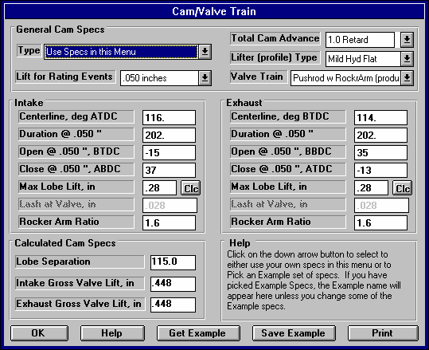
Figure 2.12, Cam/Valve Train Menu
This screen shows the full Cam/Valve Train menu with the Preference “Show Valve Open/Close Events” checked. Checking the Preference “Don’t Show Valve Open/Close Events” greatly simplifies this menu. See page 14.

Cam and valve train specifications are critical to engine performance; therefore reliable information is necessary. It is recommended that you use specifications given by the cam grinder or engine manufacturer. Actual measurements of cam specifications can be done, however this can be tricky and therefore is recommended to have someone experienced perform them. Guides for making these measurements are also available from cam grinders and manufacturers of valve train components and are beyond the scope of this
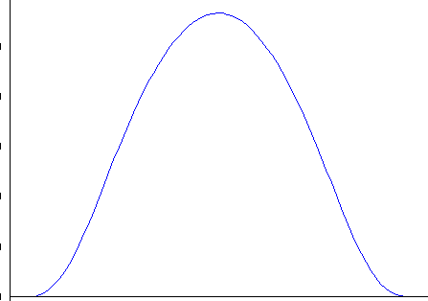
User's Manual.
Figure 2.13 Engine Analyzer Cam Profile Definitions

Typical Exhaust Lobe
Max Lobe Lift
Base Circle
Lobe Centerline
* Lash at Tappet
Opening Events
Closing Events
.050” Tappet Lift
.040” Tappet Lift
Dur. at .040”
Dur. at .050”
Adv. Dur.

* Lash at Tappet is Lash at Valve divided by Rocker Arm Ratio. Lash at Tappet is shown only to illustrate lash in general. Lash at Tappet is not used in program or engine builders because it is difficult to measure.
Lobe Separation is Cam Degrees from this Lobe Centerline to Intake Centerline

Important: The Cam/Valve Train menu updates all specs as you change other specs.
For example, if you change a centerline, the Total Cam Advance number changes to reflect the new centerline.

General Cam Specs Type
This combo lets you describe the source of the specs used in this menu:
- You can select the Use Specs in this Menu and enter in most any combination of Cam or Valve Train specs.
- You can pick the Pick an Example to be presented with a list of Example Cam Specs, much the same as clicking on the Get Example button. It will then display the name of the Example Cam specs you have picked

The Type you choose has a large effect on how this menu looks. If you choose Use Specs Below, all specs will be printed in black, and you can change them to most any number you want. If you have chosen an example, the specs which relate directly to the example will be displayed in blue (or hidden if you are in Beginner User mode).

Should you choose to change any of these blue specs, a notice is given that changing any spec related to the example will change the Type from the example name to the general name of Use Specs Below. The example name is a handy reminder of what the specs in this menu represent, so you may not want to change any of these blue spec settings.

Lift for Rating Events
You can pick the lift from base circle at which cam events are rated from the following:
- .050" which was the method used by all our previous Engine Analyzers, and is the way used by most cam grinders for American aftermarket and racing cams.
- .040" or 1mm which is a common metric method used for motorcycles and foreign cams.
- Seat Timing which is commonly used for Advertised Duration by American cam grinders.

Be sure you are using the correct one, as this will create large errors in the results if you are not.

Total Cam Advance
This combo box lets you either pick an advance, retard or “straight up” cam timing by clicking on the arrow key, or you can type in an advance or retard in degrees directly. If you just enter a number, a number with a + sign (ex. +4) or a number followed by the letters “adv”, the program assumes it is number of degrees of cam advance. If you just enter a number with a - sign (ex. -4) or a number followed by the letters “ret”, the program assumes it is number of degrees of cam retard.

Total cam advance is based on the current Intake and Exhaust Centerlines. If the centerlines are equal, Total Advance is set to 0 or straight up by the program. This is a major change from DOS versions of Engine Analyzer where the spec Additional Cam Advance was used. In those versions you could specify opening and closing events which would produce a Total Cam Advance of say 4 degrees, but the Additional Cam Advance could be set to 0. This was confusing to users. This new method of using Total Cam Advance should match cam specs used by most cam grinders.

To change cam timing from how it was ground by the cam grinder you will need special set of timing gears or an offset timing pin, key or bushing. In general, advancing the cam will give more lower end torque while giving up some top end HP; and retarding will give up low end torque to gain top end HP.

Lifter (profile) Type
This combo box lets you pick the type of lifter and the “steepness” or “aggressiveness” of the cam’s profiles. The combinations consist of:

Hyd vs Solid Hydraulic vs Solid lash adjustment
Flat vs Roller Aggressiveness or steepness of the profile (Roller being more aggressive) Mild vs Agr Aggressiveness or steepness of the profile (Agr being more aggressive)
Invrtd The most aggressive or steep profile (being more aggressive than Mild or Agr)

The choice of Hydraulic vs Solid is the most important as this dictates the use of a lash setting and whether hydraulic lifter pump up is possible. The other choices simply determine differences in the steepness of the profile for the same Max Lobe Lift.. Most truly aggressive cams or roller cams have more Max Lobe Lift for a given duration, and milder or hydraulic cams have less Max Lobe Lift.

Valve Train
This combo box lets you pick a general description of the Valve Train. This gives the program some idea of the spring loads and design which can effect engine friction, and the weights, stiffness and spring rates which effect when the valve train will go into Valve Toss for mechanical lifters or Lifter Pump Up for hydraulic lifters.

These problems also depends strongly on the steepness of the cam profile, the amount of valve lift (Lobe Lift x Rocker Arm Ratio) for the amount of duration.. High lift with low duration indicates a very steep or aggressive profile. The outputs of Valve Toss and Lifter Pump Up are displayed in the output to let you see when problems occur.

Intake
Centerline, deg ATDC
Is the location of the maximum lift point on the cam profile. If you are using the program’s standard cam profiles, this is also exactly half way between the open and closing point because the program assumes the same opening and closing profile.

Duration @ xxx
Is the number of crank degrees where the tappet is lifted to the tappet lift specified as the Lift for Rating Events in the General Cam Specs section above base circle.

Opening @ xxx
Identifies crankshaft degrees before top dead center where the tappet has been lifted to the Rated Tappet Lift above base circle Base Circle on the opening ramp. (Rated Tappet Lift is specified in the General Cam Specs section.) This value is generally available on your "cam card" or in cam catalogs. If this event occurs after top dead center, enter a negative value. For example, if it is reported as 4 degrees after top dead center, enter -4.

This spec is not displayed if you have checked the Preference “Don’t Show Valve Open/Close Events”. See Pages 13-14.

Closing @ xxx
Identifies crankshaft degrees before top dead center where the tappet has been lowered to the Rated Tappet Lift above base circle Base Circle on the closing ramp. (Rated Tappet Lift is specified in the General Cam Specs section.) This value is generally available on your "cam card" or in cam catalogs.
It is highly unlikely, but if this event occurs before bottom dead center, enter a negative value. For example, if it is reported as 4 degrees before bottom dead center, enter -4.

This spec is not displayed if you have checked the Preference “Don’t Show Valve Open/Close Events”. See Pages 13-14.

Max Lobe Lift, in

Identifies how high the cam lobe lifts the tappet above Base Circle in inches. If you are given "gross valve lift" by the cam grinder, divide by the rocker arm ratio assumed by the cam grinder to obtain gross or maximum tappet lift. This can also be done by clicking on the Clc button to open up a Calculation Menu. See Section 2.9.9.

Lash @ Valve, in
Identifies the lash or clearance in inches between the valve tip and its actuator, generally the rocker arm. If you have specified a hydraulic Lifter (profile) Type, this spec is disabled.

Notes: The Engine Analyzer assumes the lash you enter here is the lash the cam was designed for. You need the Pro version to set a lash different than what the cam was designed for.
Rocker Arm Ratio
Identifies the ratio between tappet lift and valve lift. Generally rocker arm ratios vary between 1.3 to 2.0. For valve trains with no rocker arms, for example overhead cam systems with directing acting tappets, enter 1. See Figure 2.14. The Pro assumes the ratio is constant although actual rocker arm ratios vary slightly with valve lift.

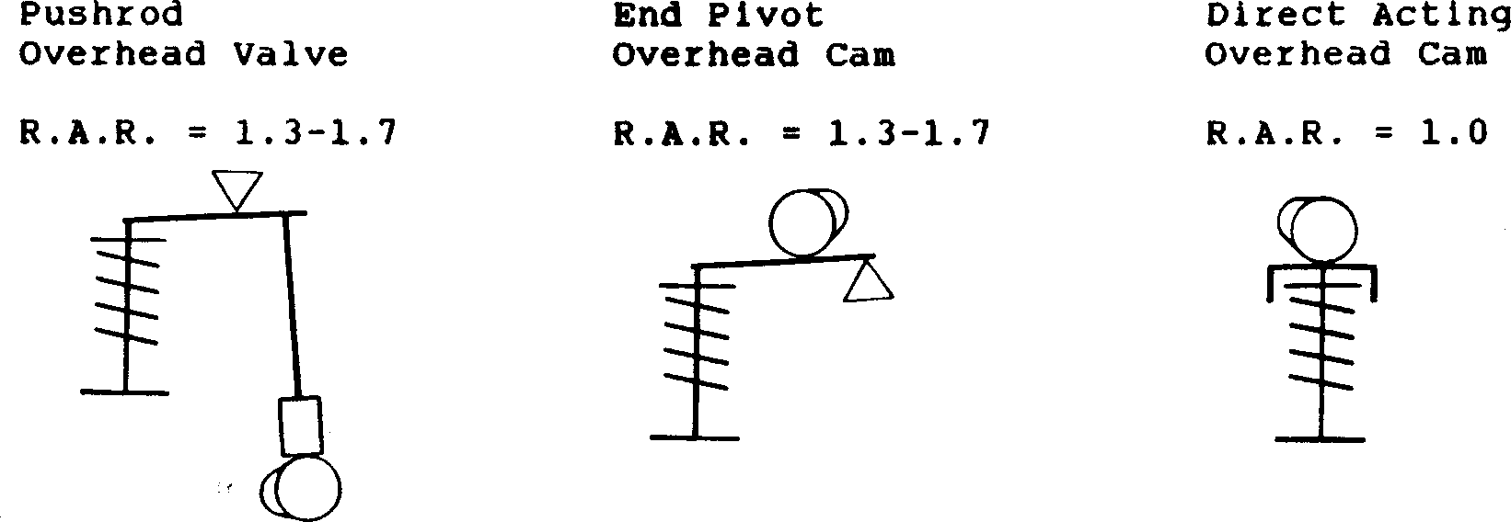
deg ATDC Duration @ .050” Max Lobe Lift, in
Figure 2.14, Various Valve Train Designs & Estimated Rocker Arm Ratios
Actual Lash @ Valve, in Rocker Arm Ratio
Definitions for these specs are the same as for the Intake cam described previously.

Calculated Cam Specs Lobe Separation, cam deg
Exhaust Centerline,

Is the separation between the intake and exhaust centerlines in cam (not crankshaft) degrees, and is the standard method used by most cam grinders. This number is calculated from other specs in this menu and can not be entered directly.
Gross Intake Valve Lift, in
Is the maximum lift of the valve with NO valve lash (even if it is a mechanical cam with valve lash). Mathematically it is Max Lobe Lift multiplied by rocker arm ratio. This is the standard way most cam grinders rate their cams for valve lift, sometimes called Advertised Lift. This number is calculated from other specs in this menu and can not be entered directly.
Note: If you are not using (specifying in the program) the same Rocker Arm Ratios as what the cam grinder is assuming, this number will not match the cam grinder’s catalog or advertised lift.

Gross Exhaust Valve Lift, in
See Gross Intake Valve Lift above.

  - Supercharger
See Appendixes 5, 6, and 7 for new features added in v3.2, v3.4 A, and 3.4 B.

The Supercharger specs describe the turbocharger or supercharger installed, if any.
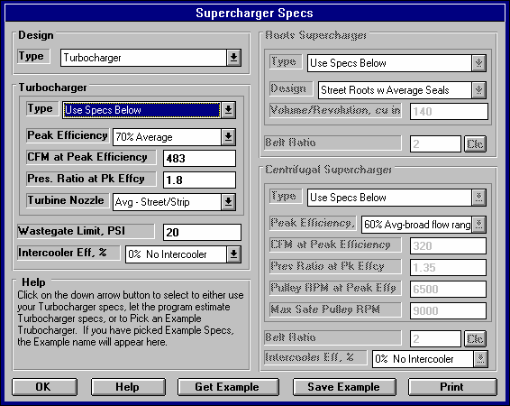
Figure 2.15, Supercharger/Turbocharger Menu

Design Type
This combo tells the program if any supercharger is installed, and if so, what type.
- No Supercharger
- Turbocharger
- Roots Supercharger
- Centrifugal Supercharger

Depending on your choice, various sections of this menu will be enabled or disabled (hidden or shown in Beginner User mode).

Turbocharger
Select Turbocharger from the Design Type combo box in the upper left corner if the engine is equipped with a turbocharger which most engine builders are familiar with. A turbocharger is basically a centrifugal compressor tied to a turbine which is driven by engine exhaust gases. This will enable or display the Turbocharger Specs section of this menu.

Turbocharger Specs
These specs describe the size and efficiency of the turbocharger's compressor and exhaust driven turbine.

The size and performance of the turbocharger's compressor can be obtained from a compressor "map", which are available from the manufacturer. A typical compressor map is shown in Figure 2.28. The "island" is the area which gives the maximum efficiency, and is where you want your turbo compressor to operate. The Engine Analyzer will need information about the point where the peak efficiency occurs.

The turbocharger compressor and turbine sizes determine how soon or at what RPM the turbo will start developing boost. Compressor and turbine sizes are primarily dictated by Island CFM and Turbine Nozzle size respectively. A small turbo system will develop boost at a lower RPM, but will become restrictive at higher RPM and higher air flows. Therefore, small turbos are better choices for street use. Larger turbos are better suited to race engines where RPM is continually high, and flow restrictions must be kept to a minimum.
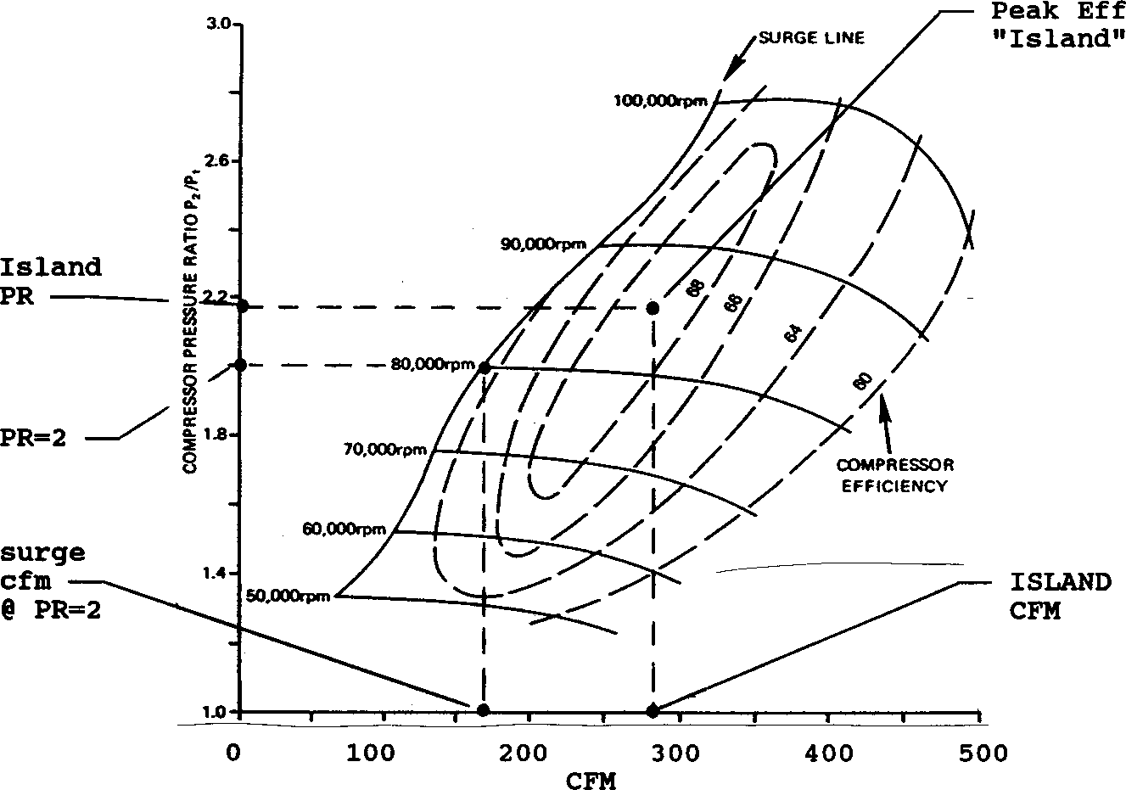
Figure 2.16, Definitions of Turbocharger Specs from Typical Compressor Performance Map
Type

This combo lets you describe the source of the specs used in this section:
- You can select a general type of turbocharger and the program will estimate the specs. This is useful when you can not find an Example close to your turbo and you do not know your turbo’s specs.
- You can select the Use Specs Below and enter in most any combination of Turbo Specs.
- You can pick the Pick an Example to be presented with a list of Example Turbo Specs, much the same as clicking on the Get Example button. It will then display the name of the Example Turbo specs you have picked

The Type you choose has a large effect on how the Turbo section of this menu looks. If you choose one of the Typical turbos, all Turbo specs will be disabled (printed in gray) and you can not change them. If you choose Use Specs Below, all specs will be printed in black, and you can change them to most any number you want. If you have chosen an example, the specs which relate directly to the example will be displayed in blue. In Beginner User mode, disabled specs or specs printed in blue are hidden.

Should you choose to change any of these blue specs, a notice is given that changing any spec related to the example will change the Type from the example name to the general name of Use Specs Below. The example name is a handy reminder of what the specs in this menu represent, so you may not want to change any of these blue spec settings.

Peak Efficiency, %
Is the highest thermal efficiency on the compressor map in percent. The highest efficiency will occur in the center of the island. Typical values range from 65 to 80%. This combo box lets you pick a general rating. If you do not have a compressor map, pick 70% or pick an Example Turbocharger.

CFM at Peak Efficiency
Is the CFM where peak efficiency occurs. CFM is usually the horizontal "X" scale of a compressor map.

If you do not have a compressor map, estimate Island CFM from your engine's displacement and application as in Table 2.9 or pick one from the Turbocharger Library.
Table 2.9 Estimate Peak Efficiency CFM
Engine CID | Application | CFM at Peak Efficiency | Number of Turbos
less than 50 | Street | 60 | 1
less than 50 | Race | 100 | 1
50 - 100 | Street | 150 | 1
50 - 100 | Race | 225 | 1
100 - 150 | Street | 200 | 1
100 - 150 | Race | 300 | 1
150 - 250 | Street | 250 | 1
150 - 250 | Race | 400 | 1
250 - 400 | Street | 450 | 1
250 - 400 | Race | 350 | 2
400 - 600 | Street | 350 | 2
400 - 600 | Race | 500 | 2

Pres Ratio at Pk Effcy
Is the pressure ratio (PR) where peak efficiency occurs. PR is usually the vertical "Y" scale of a compressor map and is usually in the range from 1.5 to 2.5. If you do not have a compressor map, use a PR of 1.8 or pick one from the Turbocharger Examples.
Turbine Nozzle
This combo box lets you pick a general description of the exhaust turbine's minimum flow area or nozzle. This spec determines when the compressor will start to produce boost, the smaller the nozzle, and the earlier (lower the RPM) the boost comes on.

Safety Note: Although the Engine Analyzer can do a very realistic job of estimating turbocharger performance, DO NOT rely on it alone to safely choose the optimum turbocharger size for a specific engine. Turbochargers can overspeed (potentially explode from overrevving) or create excessive exhaust temperatures and pressures if sized incorrectly. Use the Engine Analyzer only for estimating potential performance gains with various approximate turbocharger sizes. You must follow the turbo manufacturer's recommendations for safe turbo combinations for your application.

Wastegate Limit, PSI
If turbocharger conditions are such that it delivers boost greater than this specified level, the Engine Analyzer assumes an exhaust bypass valve or wastegate is activated to limit boost. Wastegates divert exhaust gasses around the turbocharger’s turbine. This is a very common way to control boost, especially for street applications. Therefore, set Wastegate Limit to the pressure the wastegate is designed to control boost to.

Intercooler Eff, %
This combo box lets you pick the effectiveness of the intercooler to cool the intake charge. An intercooler looks much like a radiator, but instead of cooling engine coolant, it cools the intake air charge. A turbocharger heats up the intake air considerably through the process of compression. Cool air is more dense than warm air. More cool air can be packed into a given cylinder volume, producing more power. The intercooler allows ambient air (non-compressed, surrounding air) to cool the charge. If the intercooler is 100% effective, the intake charge would be brought down to its original (ambient) temperature as specified by Air Temp in the Weather Conditions in the Running Conditions menu with no change in boost pressure. See Table 2.10 for definitions of the various ratings.

Note: If the compressed air’s temperature has increaded more than 300 degrees above ambient, the intercooler’s effectiveness drops. This is to more realistically simulate real intercoolers.

Table 2.10 Descriptions of Intercooler Effectiveness
Intercooler System | Description
0% No Intercooler | No cooling of the intake charge takes place, that no intercooler is installed.
25% Steady Runng Air-to-Air | The intake charge is brought back 25 % to its original temperature. This level simulates a typical air-to-air intercooler which has been running continually at full boost for over 30 seconds or more. An intercooler's effectiveness tends to drop under sustained full boost operation as the intercooler tends to heat up.
50% Quick Accel Air-to-Air | The intake charge is brought back 50 % to its original temperature. This level simulates a typical air-to-air intercooler for a short “burst” to full boost from a light load condition. The intercooler will not be as hot and can cool the incoming air better until the intercooler heats up.
75% Air-to-Water | The intake charge is brought back 75 % to its original temperature. This level simulates a special intercooler which has a volume of water around the fins. This intercooler is more effective because the water probably starts cooler than an air-to-air intercooler and the water takes longer to heat up (has more “thermal inertia”) than just an air cooled intercooler by itself.
100% Air-to-Cold Water | The intake charge is brought back completely (100%) to its original temperature. This level simulates a special intercooler which has a volume of cool water around the fins. This intercooler is more effective because the water starts much cooler than an air-to-air intercooler and the water takes longer to heat up than just an air cooled intercooler by itself.
125% Air-to-Ice Water | The intake charge is cooled to even colder than its original temperature. This level simulates a special intercooler which has a volume of cold water and ice around the fins. This intercooler is more effective because the water probably starts much colder than the surrounding air and takes very long to heat up.
Other | Other types of intercoolers are possible which use freon, or water or alcohol sprays, or cooling fans to keep the intercooler very cold.  You will have to estimate how well these work and select from one of the 5 choices available.

Roots Supercharger Specs
Select Roots Supercharger from the Design Type combo box in the upper left corner if the engine is equipped with a belt driven, positive displacement "Roots" supercharger, like those produced by B&M (tm), Weiand (tm) or the "original" GMC 6-71. A "Roots" compressor looks more like a typical engine oil pump, where a volume of gas is trapped and then forced into the intake manifold. The advantage of an ideal "Roots" supercharger is that a relatively constant boost level can be maintained from low RPM to high RPM.

However, the disadvantages of the "Roots" supercharger include:
- Higher internal friction due to large seals rubbing on surfaces
- Internal leakage reduces boost at lower RPM
- Lower thermal efficiency than a centrifugal supercharger

Type

This combo lets you describe the source of the specs used in this menu:
- You can select the Use Specs in this Menu and enter in most any combination of Roots Supercharger specs.
- You can pick the Pick an Example to be presented with a list of Example Roots Supercharger, much the same as clicking on the Get Example button. It will then display the name of the Example Roots Supercharger specs you have picked

The Type you choose has a large effect on how this menu looks. If you choose Use Specs Below, all specs will be printed in black, and you can change them to most any number you want. If you have chosen an example, the specs which relate directly to the example will be displayed in blue (or hidden if you are in Beginner User mode).

Should you choose to change any of these blue specs, a notice is given that changing any spec related to the example will change the Type from the example name to the general name of Use Specs Below. The example name is a handy reminder of what the specs in this menu represent, so you may not want to change any of these blue spec settings.
Design
This combo box lets you pick a general description of the Roots supercharger. This description determines the amount of leakage around the seals. More leakage spins easier (has less rubbing friction) but does not build as much boost, especially at low RPM. If you pick one of the “screw” types, the program also assumes a higher thermal efficiency. Whipple (tm) and PSI (tm) are brand names of screw type Roots superchargers.

Volume/Revolution, cu in
A "Roots" blower develops boost when the mass of air it pumps to the engine is greater than the mass of air the engine could accept at zero boost. In order for the engine to accept this mass of air it must be compressed, so a given mass of air occupies less volume.
Therefore, a "Roots" supercharger boost level is directly related to the mass of air it can pump. This mass of air depends on supercharger RPM (engine RPM and belt ratio) and supercharger swept volume per revolution. The Volume/Revolution spec is critical and is generally available from the supercharger manufacturer. The Volume/Revolution for GMC blowers can be calculated from the following equations:
For Small Diameter (5.5") Rotors
Volume/Revolution, cu in = rotor length, inches x 22.64
For Large Diameter (5.8") Rotors
Volume/Revolution, cu in = rotor length, inches x 27.45
For example, for a 6-71 with 5.8" diameter by 15" long rotors:
Volume/Revolution, cu in = 15" x 27.45 = 412

Belt Ratio
Is the ratio between the drive pulley mounted on the engine crankshaft and the driven pulley on the Roots supercharger. This ratio identifies the amount of difference between engine RPM and supercharger RPM. Belt Ratio can be calculated by the equation below or by clicking on the Clc button as shown in Section 2.9.10.
Belt Ratio = Crank Pulley Diameter, inches
S/C Pulley Diameter, inches

Many people talk about the % overdrive or underdrive of a supercharger. The equation to convert Belt Ratio to % overdrive is:

% Overdrive = (Belt Ratio - 1) x 100%

For example, if the Belt Ratio is 1.5, the % Overdrive would be (1.5-1) x 100% or 50% Overdrive. If the Belt Ratio is .8 the % Overdrive would be (.8-1) x 100% or -20% Overdrive or 20% Underdrive.
Safety Note: You must follow the supercharger manufacturer's recommendations for maximum belt ratios, maximum engine RPM and maximum supercharger RPM.

Check Appendix 7 for new Modern Supercharger designs you can pick from.

Centrifugal Supercharger
Select Centrifugal Supercharger from the Design Type combo box in the upper left corner if the engine is equipped with a belt driven, centrifugal supercharger like a Paxton (tm) or Vortech (tm). A centrifugal blower or compressor looks much like a typical engine water pump. The impeller must be driven at very high speeds to create significant boost. Usually, there is a "speed increasing drive system" internal to the centrifugal compressor so the impeller is spinning much faster than its external drive pulley.

In general terms, the boost of a centrifugal superchargers is directly related to the square of the RPM. This means that if it will produce 3 PSI boost at 3000 RPM, it will produce 4 times that boost at twice that RPM (12 PSI at 6000 RPM). Therefore, centrifugal supercharges can be quite "peaky", producing high boost over a narrow RPM range. In addition, since high boost conditions at low speeds are unlikely, engines with centrifugal compressors are less prone to detonation (spark knock).

Centrifugal Specs
Centrifugal superchargers are basically "belt driven" turbochargers. A centrifugal compressor looks like, performs like, and is tested much like a turbocharger compressor. The performance of a centrifugal compressor is also documented in a "map" like that shown in Figure 2.28. Therefore we will characterize the centrifugal supercharger with specs much like the ones we use for a turbocharger.

Centrifugal supercharger specs like those in this section are difficult for the average person to obtain. The supercharger manufacturer may supply maps on request. However, if you do not have specs, we recommend you use the specs which come preloaded in the Centrifugal Supercharger Library for common superchargers.

This section refers to many items discussed in detail in the previous Turbocharger section. You may want to glance at it first before you read this section.

Type

This combo lets you describe the source of the specs used in this section:
- You can select the Use Specs Below and enter in most any combination of Supercharger Specs.
- You can pick the Pick an Example to be presented with a list of Example Supercharger Specs, much the same as clicking on the Get Example button. It will then display the name of the Example Supercharger specs you have picked

The Type you choose has a large effect on how the Centrifugal Supercharger section of this menu looks. If you choose Use Specs Below, all specs will be printed in black, and you can change them to most any number you want. If you have chosen an example, the specs which relate directly to the example will be displayed in blue. In Beginner User mode, disabled specs or specs printed in blue are hidden.

Should you choose to change any of these blue specs, a notice is given that changing any spec related to the example will change the Type from the example name to the general name of Use Specs Below. The example name is a handy reminder of what the specs in this menu represent, so you may not want to change any of these blue spec settings.

Peak Efficiency, %
Is the highest thermal efficiency on the compressor map in percent. The highest efficiency will occur in the center of the island. Typical values range from 55 to 75%. This combo box lets you pick a general rating. If you do not have a compressor map, pick 60% or pick an Example Centrifugal Supercharger.

CFM at Peak Efficiency
Is the CFM where peak efficiency occurs. CFM is usually the horizontal "X" scale of a compressor map. The older, original Paxton had a CFM at Peak Effy of only 320 CFM. Newer Paxtons, Vortechs and PowerDynes have CFM ratings in the 500 to 1000 CFM range. If you do not have a compressor map, we strongly recommend you pick one of the Examples Centrifugal Superchargers.

Pres Ratio at Pk Effy
Is the pressure ratio (PR) where peak efficiency occurs just like for turbochargers. PR is usually the vertical "Y" scale and in the range from 1.25 to 2.0 with the old, original Paxton (tm) being approximately 1.35 and newer Paxtons and Vortechs being from 1.5 to
1.8. If you do not have a compressor map, we strongly recommend you pick one of the Examples Centrifugal Superchargers.

Pulley RPM at Pk Effy
Is the pulley RPM (not internal impeller RPM) where peak efficiency occurs.

Max Safe Pulley RPM
This is the manufacturer’s safety limit on pulley RPM. The program checks to ensure the belt ratio and engine RPM combination stays below this RPM, or you are given a warning in the Notes section of the Test results. Also, boost and power are purposely reduced significantly to flag out this overspeed problem.

Safety Note: You must follow the supercharger manufacturer's recommendations for maximum belt ratios, maximum engine RPM and maximum supercharger RPM.

Belt Ratio
Is the ratio between the drive pulley mounted on the engine crankshaft and the driven pulley on the Centrifugal supercharger. This ratio identifies the amount of speed increase between engine RPM and supercharger RPM. Belt Ratio can be calculated by the equation below or by clicking on the Clc button as shown in Section 2.9.20.
Belt Ratio = Crank Pulley Diameter, inches
S/C Pulley Diameter, inches

Many people talk about the % overdrive or underdrive of a supercharger. The equation to convert Ratio to % overdrive is:

% Overdrive = (Belt Ratio - 1) x 100%

For example, if the Belt Ratio is 1.5, the % Overdrive would be (1.5-1) x 100% or 50% Overdrive. If the Belt Ratio is .8 the % Overdrive would be (.8-1) x 100% or -20% Overdrive or 20% Underdrive.

Safety Note: You must follow the supercharger manufacturer's recommendations for maximum belt ratios, maximum engine RPM and maximum supercharger RPM.

Intercooler Eff, %
This combo box lets you pick the effectiveness of the intercooler to cool the intake charge. An intercooler looks much like a radiator, but instead of cooling engine coolant, it cools the intake air charge. A turbocharger heats up the intake air considerably through the process of compression. Cool air is more dense than warm air. More cool air can be packed into a given cylinder volume, producing more power. The intercooler allows ambient air (non-compressed, surrounding air) to cool the charge. If the intercooler is 100% effective, the intake charge would be brought down to its original (ambient) temperature as specified by Air Temp in the Weather Conditions in the Running Conditions menu with no change in boost pressure. See Table 2.10 in the Turbocharger section for definitions of the various ratings.

  - Calculate Performance
    - Running Conditions
You can run a test (calculate performance) by:
- Clicking on the Calc HP button at the top of the Main Screen
- Clicking on Calc HP(F2) menu item or press the <F2> key at the Main Screen
- Clicking on Running Conditions to open up the Running Conditions menu, then click on the Calculate Performance button in this menu. The Running Conditions menu will present a menu of conditions and options which describe how you will run or test this engine. These conditions include:
  - Weather conditions
  - Level of nitrous oxide and type of fuel
  - RPMs to run and options for the calculations

Check Appendix 6 for new features for this menu available in v3.4, standard and Plus versions.

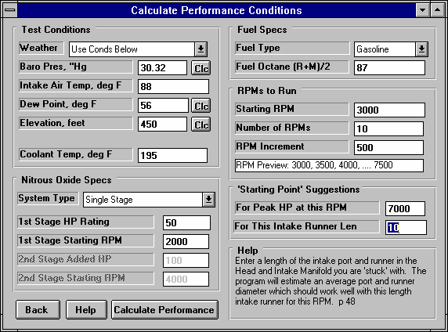
Figure 2.17, Running Conditions Menu
Test Conditions
Weather
This combo box lets you pick whether you want the test results corrected to standard dyno conditions, or to the weather conditions listed in this section. Standard conditions consist of:
- Standard Dyno 29.92” Barometer, 60 degrees F, dry air (0 deg dew point) used for most racing dynos and quoted by most racing magazines.
- SAE conditions 29.6” Barometer, 77 degrees F, normal humidity (49 deg dew point) used for rating new car engines by automakers since about 1985. This rating gives about 2% less power than the Standard Dyno conditions

If you choose standard conditions, the weather conditions in this menu are disabled, as they have no effect on the calculated performance.

Baro. Pres., “Hg
Is the barometric pressure in inches of mercury of the nearest weather station; or at the track or dynamometer room if a barometer instrument is available at these locations.

If this pressure is in: | Multiply by:
PSI | 2.036
Bar | 29.52
mm Hg | .03937
To obtain '' Hg. For example: 14 PSI is 14 x 2.036 or 28.5” Hg.

Click on the Clc button to review notes concerning the relationship of Barometric Pressure and Elevation. Also see Elevation, ft and Section 2.9.11.

Intake Air Temp, deg F
Is the temperature of the intake air as it enters the carburetor or throttle body measured in degrees Fahrenheit. To match dynamometer performance, enter dynamometer room air temperature. To simulate vehicle performance, enter the temperature of the air entering the air cleaner. Underhood temperatures can be HOT on warm days (150 degrees or more). If a hood scoop or some other type of cool air induction is provided, outside (ambient) air temperature is closer to the actual intake air temperature.

If this temperature is in: | First Multiply by: | Then Add:
Degrees R | 1 | - 460
Degrees C | 1.8 | 32
Degrees K | 1.8 | - 460
To obtain degrees F. For example 30 deg C = 30 x 1.8 + 32 = 86 degrees F.

Dew Point, Deg F
The dew point in degrees F of the air at the track or dyno room, which describes the air's humidity level. The Dew Point must be less than Intake Air Temp, deg F. Dew Point can be calculated from either wet and dry bulb temperatures, or from relative humidity and air temperature readings by clicking on the Clc button. See Section 2.9.12.

Dew Point is a less confusing way of describing the air's moisture level than relative humidity. Relative humidity readings are only meaningful if you also know the air temperature when the reading was made. However, the air's dew point remains constant even when the air temperature changes. For example, 40 degree air with a 80 % relative humidity has only a 10% relative humidity when the air is heated to 100 degrees. However, the dew point remains at 36 degrees for both air temperatures.
Elevation, ft
Is the elevation of the race track or dynamometer room above sea level measured in feet. This value should be available from the local weather station and is used to correct the Barometric Pressure, “Hg specification. Barometric pressure drops as you go up in elevation. There are two different ways of entering this specification, depending on how the Barometric Pressure measurement was made:

Barometric Pressure obtained from radio station, TV station or weather service: “Official sources” usually correct their barometric pressure readings to sea level, meaning their reading is the barometric pressure you would get if you (or your engine) could be at sea level or 0 elevation. If you have a Barometric Pressure corrected to sea level, you must enter the engine's actual elevation above sea level in feet.

Barometric Pressure obtained directly from a barometer instrument at the track or dynamometer room. This reading will usually not be corrected to sea level, but will be the "observed" or actual barometric pressure reading at the same elevation as the engine. For observed or uncorrected Barometric Pressure, enter an elevation of 0.

Click on the Clc button to review notes concerning the relationship of Barometric Pressure and Elevation. Also see Barometric Pressure in this section and Section 2.9.11.

Coolant Temp, deg F
Is the temperature of the coolant as it leaves the engine in degrees Fahrenheit. This value can be estimated as the "start to open" temperature rating of the thermostat. If the engine is air cooled, enter a value of 190 degrees.

Nitrous Oxide System Type
Click on the System Type combo box to pick the type of nitrous system, either None, Single Stage or Dual Stage.

The Nitrous Oxide specs in this section describe the amount of nitrous oxide a system can deliver. Most nitrous systems are rated for the HP increase they can deliver in a properly tuned engine. The Engine Analyzer makes 3 major simplifying assumptions concerning nitrous oxide injection:
- Jet sizes are proper for correct A/F, and good nitrous and fuel distribution
- Nitrous is injected as a liquid and only a portion vaporizes on the way to the cylinder. There is little displacement of the air which would normally enter the engine under "non-nitrous" conditions.
- Nitrous increases the burn rate, reducing the required spark advance.

You can not use the Engine Analyzer to design nitrous systems, but only to estimate performance improvements. Select the type which describes the system you are using. Various portions of the Nitrous Oxide Specs menu become enabled and disabled depending on your choice here. If you select None, all Nitrous Oxide specs are disabled (set to gray and you are not able to change them) because they have no effect on the calculations.

1st Stage HP Rating
Manufacturer's HP rating of the 1st stage of the nitrous oxide system. If you are using a 1 stage system, this is the full HP rating of this type of system.

1st Stage Starting RPM
RPM where injection from the 1st stage starts.

2nd Stage Added HP
Manufacturer's HP rating of the nitrous oxide added by the 2nd stage. Total nitrous HP is then 1st Stage HP + 2nd Stage HP.

2nd Stage Starting RPM
RPM where injection from the 2nd stage starts.

Fuel Specs:
Fuel Type
Specifies the type of fuel being burned, either street gasoline, alcohol (methanol) or “Very Rich Alcohol. The Engine Analyzer makes the following assumptions about the difference between these fuels.
- Alcohol is run at 5.0 A/F versus 12.5 for gas.
- Alcohol is 13% more dense than gas.
- Alcohol almost always produces 8-12% more power than gas
- Alcohol at 5.0 has the same burn rate as gas at 12.5 and therefore requires the same spark advance. (In actual practice, there is conflicting data concerning alcohol's burn rate or required spark advance. It appears very dependent of A/F mixture quality, A/F distribution, and other factors difficult to simulate. Therefore, this assumption is made.)

The differences between Alcohol and Very Rich Alcohol include:
- Very Rich Alcohol produces less power
- Very Rich Alcohol runs 67% richer or A/F of 3:1
- Very Rich Alcohol nearly completely eliminates any detonation.

Obviously many more considerations must be made when building an alcohol engine than what are considered in the Engine Analyzer. Generally, alcohol has a fuel octane (R+M)/2 of 100 but its cooling effects shows less detonation potential than 100 octane gasoline.

Fuel Octane (R+M)/2
Is the octane # rating of the gasoline as reported on a service station gas pump. There are two methods fuel suppliers use to rate the octane number, one is the Research method, the other is the Motor method. Generally, the Motor method will give an octane rating approximately 4-12 octane #s lower than the Research method. The octane rating given at the gas pump is the average of the Research and the Motor ratings. In fact, gas pumps will often display the formula "(R+M)/2" to say their octane rating is the Research octane # plus the Motor octane # divided by 2.

To estimate Fuel Octane from the Research octane #, simply subtract 4. To estimate Fuel Octane from the Motor octane #, simply add
4. For example, if you know the Motor octane is 94, enter a Fuel Octane (R+M)/2 of 94 + 4 = 98 into the Engine Analyzer .

The Engine Analyzer assumes that as octane increases, vapor pressure decreases. Vapor pressure is a measure of how easily the gas evaporates or can be atomized. What this means is that the higher the octane, the more likely you are to have poor A/F Mix Qal in the results, resulting in possibly significant power loss. This means that for best performance, only use as much octane as you need to eliminate detonation by keeping Knock Index low.

This spec is disabled if you choose one of the Alcohol fuesl and the program picks the octane.

RPMs to Run Starting RPM
See RPM Step Size below.

Number of RPMs
See RPM Increment below.

RPM Increment
These three RPM specifications tell the Engine Analyzer for how many and for which RPMs to calculate the results. The effect of these specs are displayed in the RPM Preview box shown directly under these specs. For example:
Starting RPM
Number of RPM Steps RPM Increment
1000
8
400
This combination will have results calculated for the following RPMs: 1000 1400 1800 2200 2600 3000 3400 3800
Due to space limitations, all RPMs can not be shown on the menu. The RPM Preview will show this as:
RPM Preview: 1000, 1400, 1800,3800

“Starting Point” Suggestions
The Engine Analyzer can give suggestions for intake and exhaust runner dimensions and cam profiles based on several very simple tuning principles or rules of thumb. See Appendix 3 and Example 4.5. These are good starting points, but you should fine tune these specs based on trial and error with the program’s calculations.

For Peak HP at This RPM
Enter the RPM where you want optimum intake and exhaust tuning, or RPM where you want HP to peak. The Engine Analyzer will list potentially good runner lengths and diameters, and cam durations and lifts at the end of the calculated results. This value has no affect on the torque and HP test results.

For This Intake Runner Len
Enter the length of the intake tract (port in the head and runner in the manifold) that you are “stuck with”. The program will give an average diameter for the port in the head and manifold runner to produce good intake tuning at the RPM entered above.

You can determine the Port Volume for this diameter by going to the Head(s) Specs menu and typing it in for Intake Port Avg Diameter and seeing what Port Volume is calculated. For this Port Volume to be accurate, you must also have entered the correct Port Length in the Head(s) Specs menu first.
Starting Point suggestions given in the Special Calculations section of the Test Results based on the specs above may NOT give best performance and MUST be refined through 'cut and try' running the program. Runner Dimensions are for Port PLUS Intake Manifold Runner or Exhaust Header Primary Pipe.

    - Test Results from Calculated Performance
The Engine Analyzer’s calculated output consists primarily of 3 types:
- RPM Data. This is data which changes for each RPM tested, like torque, HP, fuel flow, etc.
- Special Calculations. This is data which does not change with RPM, like cubic inch displacement, dynamic compression ratio, etc.
- Cycle Data. This is data which changes within one RPM, for each different crank angle of the engine. In this version of Engine Analyzer, the only cycle data available is Valve Lift.
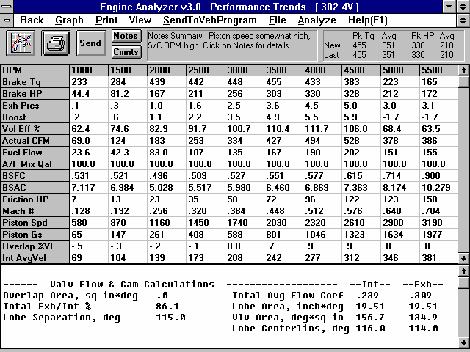
Figure 2.18 Major Features of Output Screen Showing Test Results
Menu bar with output options: Back to Main Menu, Make Graphs, Print Results, Display Help, View Special Calculations or the History Log, Analyze results (program gives advice based on current results), File to write an ASCII file
Command buttons: Make Graphs, Print Results, Display/Edit Engine, Display Notes (safety issues, possible problems, etc. about current test results)
Summary of Notes (safety issues, possible problems, etc.)
Name of current Engine File Performance Summary
RPM Data. Click on any cell in the grid for a Help definition of that particular piece of data.
Slide bar. Click and drag button to display all RPM test results.

Special Calculations. Results which do not change with RPM. Click on any result for a Help definition of that particular
Slide bar. Click and drag button to dis-play all Special Cal-culation test results.

RPM Data and Special Calculations are shown in Figure 2.35. Cycle data of Valve Lift is only available for graphing. Several other features are available from this screen (Figure 2.35) which are also discussed in this section.

RPM Data
RPM Data looks much like a dynamometer data sheet which gives projected engine test results for each RPM tested.

Engine RPM
Is the engine crankshaft’s rotational speed in revolutions per minute.

Brk Tq, ft-lbs
Is the brake torque produced by the engine measured in ft. lbs. Brake torque is the usable net torque at the engine's flywheel. See Appendix 2. This is the same as the torque numbers you see in advertisements and in dynamometer torque and HP curves.

Brake HP
Is the Brake HP produced by the engine measured in horsepower. Brake HP is the usable net HP at the engine's flywheel. See Appendix 2. This is the same as the HP numbers you see in advertisements and in dynamometer torque and HP curves. To calculate torque from HP or HP from torque, use the following formulas:
Torque = HP x 5252 HP = Torque x RPM RPM 5252

Exh Pres, PSI
Is the average exhaust pressure after the exhaust port and exhaust manifold/header, but before the exhaust system (if any), measured in PSI. (In earlier versions this was given in inches of mercury.)

Int Vac, “Hg Boost, PSI
Is the average intake vacuum or supercharger boost after the carburetor or throttle body (and supercharger/turbocharger if any) but before the intake manifold runners measured in "Hg during the intake stroke. If the engine is supercharged or turbocharged, the units are given in PSI boost.

Vol Eff%
Is the volumetric efficiency of the engine measured in %. The volumetric efficiency is the percent of air which actually enters and remains in the cylinder during each intake stroke, compared to the amount which could under perfect, unsupercharged conditions. The amount of air which can enter the cylinder under perfect conditions is the swept volume of the cylinder with air at the actual barometric pressure (Barometric Pressure and Elevation effects combined) and Intake Air Temp, deg F.
For example, if the swept volume is 50 cu in, the air density at the specific barometer and intake air temperature is .000044 lb/cu in,
.0022 lbs (50 cu in x .000044 lb/cu in) is the amount of air which can enter the cylinder under perfect conditions. If only .0018 lbs actually enters the cylinder during the intake stroke, the volumetric efficiency is:
Vol Eff% = .0018 x 100% = 82 %
.0022
During supercharging, if the engine ingests .0030 lbs each intake stroke, the volumetric efficiency is calculated as:

Vol Eff% = .0030 x 100% = 136 %
.0022
If .0030 lbs enters the cylinder, but .0003 lbs goes straight through and ends up out the exhaust (called "short circuiting"), the Vol Eff% is:
Vol Eff% = (.0030 - .0003) x 100% = 123 %
.0022
Actual CFM
Is the flow rate of fresh air into the engine measured in cubic feet per minute (CFM). This is measured at the entrance of the air cleaner or if no air cleaner is present, the carburetor(s) or throttle body(s). Since this is called "actual", it is not corrected to standard conditions as in earlier Engine Analyzer programs. Actual CFM should correlate more closely to actual dynamometer air flow measurements.

Fuel Flow, lb/hr
Is the fuel flow delivered by the carburetor(s) or fuel injectors in lbs/hr for either gas or alcohol. If you are running Nitrous Oxide, this does include the fuel for the nitrous oxide system, even though this may come from a separate fuel delivery system.

For Gasoline, the fuel is assumed to be similar to octane (an expensive type of gasoline with an octane # of 100) in density (5.86 lb/gal), heating value (19,000 BTU/lb), and stoichiometric A/F (14.7). Gasoline fuel flows are calculated based on an optimum power A/F (air/fuel ratio) of 12.5:1.

If your particular engine runs at 11.5:1 A/F, your engine burns 12.5/11.5, or 1.09 times as much fuel per unit of air as the Engine Analyzer calculates. Multiply the Engine Analyzer’s fuel flow by 1.09 to get fuel flows for an engine running at 11.5:1. To calculate fuel flows in gallons per hour (GPH), multiply lbs/hr by .171 (.171=1/5.86).

For example, the Engine Analyzer calculates 145 lbs/hr fuel flow at peak HP, assuming 12.5:1 A/F. Your engine runs at 12:1, instead of 12.5:1 A/F:
145 lbs/hr x 12.5 = 151 lbs/hr
12

You need the flow in GPH to size a fuel pump:

151 lbs/hr x .171 = 25.8 GPH

For Alcohol, the fuel is assumed to be methanol with a density of 6.6 lb/gal and heating value of 8,600 BTU/lb. (For “Very Rich Alcohol” fuel type, the A/F is assumed to be 3:1.) Fuel flows are calculated based on an A/F of 5.0:1. To calculate fuel flows in gallons per hour (GPH), multiply lbs/hr of alcohol by .152 .

A/F Mix Qal, %
Is the A/F Mixture Quality rated in %, where 100 % means there is no power loss from poor A/F Mixture Quality. A/F Mixture Quality is the combined result of these separate effects:
- A/F maldistribution where all cylinders do not get the same air and fuel. Some cylinders run leaner than optimum and some run richer.
- Fuel Metering where the fuel metering signal strength to the carb is less than required to atomize the fuel, or worse, not even pull fuel through the jets at all.
- Atomization of fuel in the chamber, which depends on many design variables and fuel properties. The Pro assumes that the higher the Octane rating of the fuel, the lower the Reid Vapor pressure and the less likely the fuel is to atomize. Obviously not all fuels have the same vapor pressure for a certain octane, so this trend is not necessarily true for all fuels. Alcohol is also assumed to be slightly more difficult to produce good A/F Mixture Quality, because of its large cooling effect.
The lower the A/F Mixture Quality, the lower the power output the program will project. Therefore, pay special attention to this number. This is a change from all other pervious Engine Analyzer programs, which always assumed perfect A/F distribution and atomization.

BSFC, lb/HP-hr
Is the brake specific fuel consumption of the engine in lbs/HP-hr, or pounds of fuel per hour per horsepower. BSFC is a measure of how efficiently the fuel is being used to produce power at the crankshaft. A good BSFC is in the range of .40-.45 for gas and .95-1.10 for alcohol, near the torque peak RPM. The lower the BSFC, the more efficient the engine is at converting fuel into HP.

BSFC is based on total engine fuel flow, including any additional fuel required for the Nitrous Oxide if any is injected.

BSAC, lb/HP-hr
Is the brake specific air consumption of the engine in lbs/HP-hr, or pounds of air per hour per horsepower. BSAC is a measure of how efficiently the air is being used to produce power at the crankshaft. A good BSAC is in the range of 5.0 to 5.5 near the torque peak RPM.

Friction HP
Is the engine's friction horsepower. This is the HP required to overcome all the rubbing, mechanical friction of the internal moving parts (bearings, rings, etc), oil pump, water pump and to drive any accessories, including the HP to drive a belt driven supercharger (if any).

Note: The friction calculated here is not the same as the friction measured during a dynamometer test where the engine is motored over by the dynamometer. Motoring HP from a dynamometer will be higher since it includes the pumping work, the power required to ingest and expel air through the engine.

Mach #
The 1979 SAE (Society of Automotive Engineers) paper "An Analysis of the Volumetric Efficiency Characteristics of 4-Stroke Cycle Engines Using the Mean Inlet Mach Number, Mim", 790484, by Fukutani and Watanabe is the basis of this calculation. It was an extension of the Mach Index characteristic first identified in the 1940s by C.F. Taylor and co-workers from MIT, "The Internal Combustion Engine In Theory and Practice", C.F. Taylor, 1985, MIT Press.
These papers state that an engine's air flow potential per cycle (volumetric efficiency) depends on its average intake flow coefficient, intake valve flow area, cylinder size, speed of sound in air and RPM. These five terms are combined into one value called the Mach Index, called Mach # by the Engine Analyzer. In simple terms Mach # relates the average velocity of the intake charge past the valve to the speed of sound. The speed of sound is theoretically the maximum velocity possible past the valve, which would give a Mach # of 1.0. A Mach # of .4 states the average velocity is only 40% of the maximum possible velocity.

Taylor's work showed good correlation between volumetric efficiency and Mach # for several engines with conservative cam timing. The correlation showed that volumetric efficiency (and therefore power) would start to drop sharply when Mach # increased above approximately .55. However, more recent studies show poor correlation if intake cam duration increases significantly. The 1979 paper includes a correction for intake duration; the higher the intake duration, the lower the Mach #, and the higher the RPM for peak volumetric efficiency.

General "rules of thumb" concerning the Mach # include:
- Peak volumetric efficiency should occur in the range of .3 to .5 Mach # with no tuning effects
- Volumetric efficiency drops rapidly in the range of .6 - .8 Mach #

Piston Spd, ft/min
Is the average speed of the piston in feet per minute. Piston speed is a useful way to rate the RPM induced stress level of the reciprocating components of engines of very different sizes. For example, engines with typical production parts can usually rev up to a piston speed on 2750 ft/min without overly stressing pistons, connecting rods, etc.

The equation for piston speed is:

Piston Speed = 2 x Stroke (inches) x RPM
12

You can see that Piston Speed only depends on RPM and Stroke. An engine with a 4” stroke will reach 2750 ft/min at 4125 RPM, but an engine with only a 3 inch stroke can rev to 5500 before it reaches 2750 ft/min. Both of these engines will be putting approximately the same stress on the rods and pistons at these quite different RPMs. This is the reason 100 cc racing motorcycle engines can rev to 25000 RPM but 500 CID Pro Stock motors can only rev to 9000 RPM. See also Piston Gs @ TDC.

Piston Gs
Is the piston acceleration in Gs where the piston changes direction at TDC. TDC is generally where the highest piston Gs occur. Internal stresses of many reciprocating components are directly related to piston Gs. For example, if piston Gs increase 25%, you need parts which are 25% stronger. Consult the manufacturer of your rotating and reciprocating components to determine their maximum G load ratings for various applications.

Overlap %VE
Is the amount volumetric efficiency increases due to scavenging during overlap. This scavenging can aid overall volumetric efficiency if Overlap %VE is positive, but detracts from volumetric efficiency if it is negative. Overlap %VE is reported primarily to show scavenging effects due to tuning, or turbo/supercharging. For example, if intake and exhaust tuning pressures should provide for good scavenging, but Overlap Area is small, Overlap %VE will be small also. With good scavenging, Overlap %VE should be in the range of 5 to 10%.

Int AvgVel
Is the calculated average flow velocity of the intake charge in the intake runner. A performance trade off exists between high and low runner velocity. Low flow velocities give little restriction to flow but posses little inertia. High flow velocities show higher flow restriction, but also posses higher inertia to continue filling the cylinder after the piston has crossed BDC.
Sources vary greatly when recommending average intake flow velocities which give maximum volumetric efficiency (torque peak). One source recommends only 80 to 180 ft/sec, another as high as 270-330 ft/sec. Most recommendations fall between 150 to 250 ft/second. However, highly successful race designs have run as high as 400 ft/sec and higher. Obviously there is no one optimum runner velocity.

The Engine Analyzer bases optimum runner velocity on runner length. Long runners give best volumetric efficiency at low runner velocities, since high velocities in long runners can be a restriction. Short runners can tolerate higher velocities. For typical runner lengths, the Engine Analyzer will use velocities ranging from 180 to 280 ft/sec.

In InertiaPrs
Is the estimated increase in pressure (over Intake Vacuum or supercharger Boost levels) caused by inertia tuning, in PSI. High values of In InertiaPrs to 5 PSI) show good inertia tuning at that particular RPM. In general, In InertiaPrs and intake tuning increases with improved Intake Manifold Flow Efficiency, Intake Manifold Type, Intake Valve Flow Efficiency and changes in intake cam timing.

In ResTunPrs
Is the estimated increase in pressure (over Intake Vacuum or supercharger Boost levels) during valve overlap caused by resonance tuning, in PSI. High values of In ResTunPrs (1 to 5 PSI) show favorable resonance tuning at that particular RPM. Negative values of In ResTunPrs show resonance pulses limiting performance.

Ex AvgVel
Is the calculated average flow velocity of the exhaust gases in the exhaust runner. Like with In AvgVel, a trade off exists between high and low runner velocity. High velocities are more restrictive, low velocities contribute little to exhaust inertia tuning.

There is better agreement for "rules of thumb" concerning calculated exhaust velocity. Most sources agree that header pipes should be sized to give average calculated flow velocities of 300 ft/sec. Also see Example 4.5 and Appendix 5 for further explanation.

The word "calculated" is stressed here because the actual exhaust gas velocities are much higher, in the range of 1000 ft/sec when the calculated velocity is 300 ft/sec. This is primarily due to exhaust being approximately 3 times hotter and less dense than the intake charge.

ExTun Prs
Is the estimated increase in pressure over ExTun Prs (exhaust back pressure) during valve overlap, in PSI. Since both inertia tuning and resonance tuning are only effective during overlap (immediately before exhaust closing), the two effects are added together.
Good exhaust scavenging will occur with large negative values of ExTun Prs (-1 to -5 PSI).

Valve Toss Lifter Pump Up
Indicates that the RPM has gone past the valve train’s safe operating range. If you are simulating mechanical lifters (with Valve Lash), Valve Toss is shown here. If you are simulating hydraulic lifters (without Valve Lash), Lifter Pump Up is shown here. Either condition will produce a drop in power.

Valve Toss and Lifter Pump Up depend strongly on the cam profile. Aggressive ramps with high rocker arm ratios, aggressive roller profiles, high lobe lifts for a given duration do increase power, but also increase the likelihood of valve toss and pump up.

Valve toss and Lifter Pump Up also depend strongly on the choice of Valve Train type you’ve chosen.

Spark Adv
Is the estimated spark advance in degrees before TDC for for optimum performance at this RPM under these conditions. The Engine Analyzer automatically reduces (retards) Spark Adv if detonation (spark knock or ping) is likely. You will see an "*" following the Spark Adv value if it has been retarded. You will also notice a HP and torque loss at RPMs where Spark Adv is retarded.
Safety Note: You can not set your engine's spark advance curve based on the Engine Analyzer's Spark Adv calculations. Details in combustion chamber design, A/F distribution, cooling system design, etc. make predicting your engine's spark requirements impossible to predict accurately.

Special Calculations
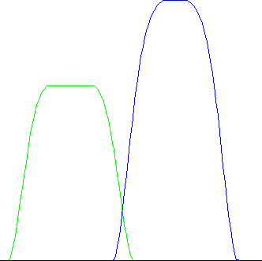
Valve Flow & Cam Calculations Overlap Area, deg*sq-in
Figure 2.19 Overlap Area

Overlap Area
This is the overlap flow area in units of degree-square inches. These units can be illustrated using the example below.

Example: If the Overlap Area was 4, it could mean that:

- A valve area of four square inches was open for one degree of crank rotation.
- A valve area of one square inch was open for four degrees of crank rotation.
- A valve area of .4 square inches was open for 10 degrees of crank rotation.
- Or any other combination which when multiplied together gives 4.

The phrase "valve area of X square inches was open" means that a perfectly flowing hole measuring X square inches was present between the exhaust and intake port for 1 crank degree. ("Perfectly flowing" means a flow coefficient of 1.0.)

At idle conditions on a street engine, this is when intake vacuum can pull residual exhaust into the intake manifold. The higher the Overlap Area, the higher the idle speed and the lower the idle vacuum.

Note: A larger cylinder can tolerate more Overlap Area. A 500 CID V-8 may idle at 1000 RPM with a given overlap area, but a 250 CID V-8 with the same overlap area could idle at 2200.

For race engines, overlap is generally needed for two reasons. First, it provides lower cam acceleration rates to attain the high lifts required for high RPM HP. Second, overlap can also improve performance by allowing for efficient purging of residual exhaust out of the clearance volume during overlap with proper intake and exhaust tuning. However, at "untuned" RPMs, overlap can increase the potential for intake reversion (reverse air flow up the intake runner from the cylinder) and poor scavenging. High overlap area
can also lead to poor fuel economy through "short circuiting" (where intake charge passes through the combustion chamber out the exhaust system without being used).

Since turbocharged engines operate with high pressure and high temperature exhaust, Overlap Area is best kept to a minimum for turbocharged engines. This is both to reduce reversion (when high pressure exhaust flows backward into the intake) and exhaust temperatures (when "short circuited" fresh charge burns in the exhaust).

The Overlap Area is given here to compare overlap areas between different cam profiles, lash settings, and cylinder head flow potential. Check Idle Vacuum, “Hg in this section also to see how Overlap Area effects an important aspect of street engine performance.
Total Avg Flow Coef
This is the average flow coefficient for the port, valve and runner for the time the valve is open. It shows how well the port flows compared to a "perfectly" designed port with a "perfect" cam profile. A perfect profile is defined as one where the valve opens immediately to a lift which gives maximum valve flow, stays open the entire duration, and immediately snaps shut at closing. Figure
2.20 compares the actual flow curve with the theoretically "perfect" flow curves to illustrate Avg Flow Coef.

Coefficient is an engineering term similar to efficiency, where a Flow Coefficient of 1.0 is the same as a Flow Efficiency of 100% (Flow Efficiency = Flow Coefficient x 100%). The Total Avg Flow Coef will compare head and camshaft combinations. An engine with a Total Avg Flow Coef of 1.0 is physically impossible to build but would run “real strong”. In reality, the Total Avg Flow Coef will be approximately .25 for production engines, .30 to .40 for race 2 valve engines, and up to .50 or more for high RPM, 4 valve race engines with very agressive roller cams.

Note:

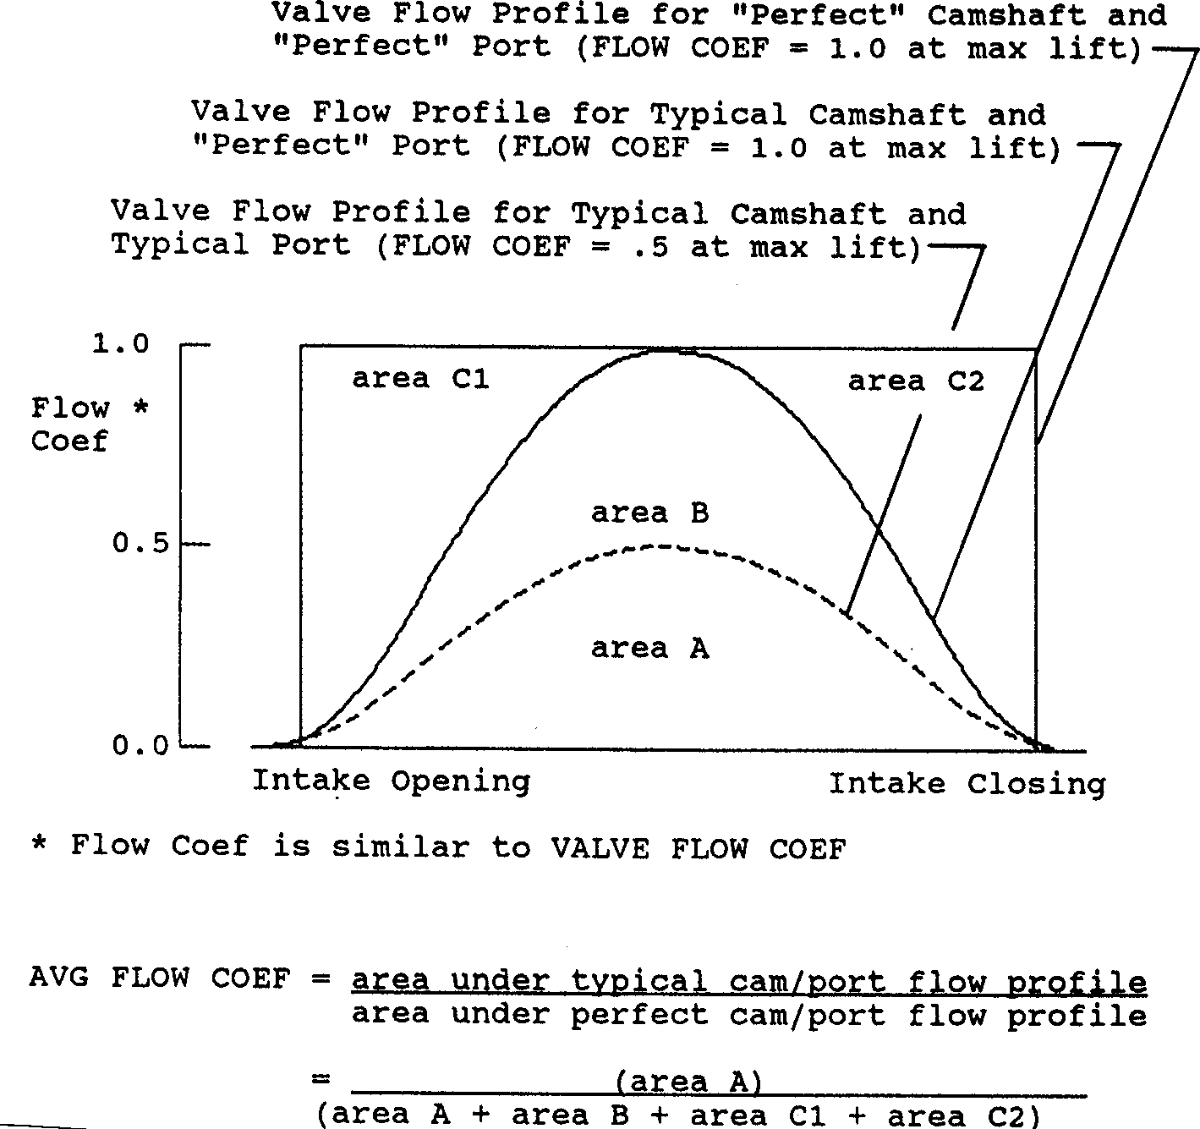
The average flow coefficient should not be confused with Intake or Exhaust Flow Efficiencies in the cylinder Head(s) input specs. Intake or Exhaust Flow Efficiency applies only to one particular valve lift (L/D=.25) and the flow at that lift. The average flow coefficient applies to all valve lifts encountered for a particular cam profile, the portion of time at each lift, and the flow potential at each lift for the entire head.
Figure 2.20, Illustration of Total Avg Flow Coef

Technically, the calculation of flow coefficient can vary significantly with the choice of valve opening and closing points. The lower the lift points chosen, the lower the flow coefficient. The Engine Analyzer uses a relatively low lift of .003" at the valve to calculate average flow coefficient. Therefore, average flow coefficients calculated by the Pro are likely to be less than average flow coefficients from other sources.
Total Exh/Int %
This is the percentage ratio of total exhaust flow area to intake flow area. It is calculated as:
Total Exh/Int % = Exhaust Vlv Area, deg*sq-in x 100%

Intake Vlv Area, deg*sq-in

"Rules of thumb" state that the exhaust port does not produce significant power losses until the exhaust flow potential falls below 75% of the intake flow potential. For supercharged or nitrous oxide engines this percent should increase to approximately 85%.

Lobe Area, inch*deg
Is the estimated area of the cam lift profile measured in tappet lift x cam degrees. See Figure 2.21.

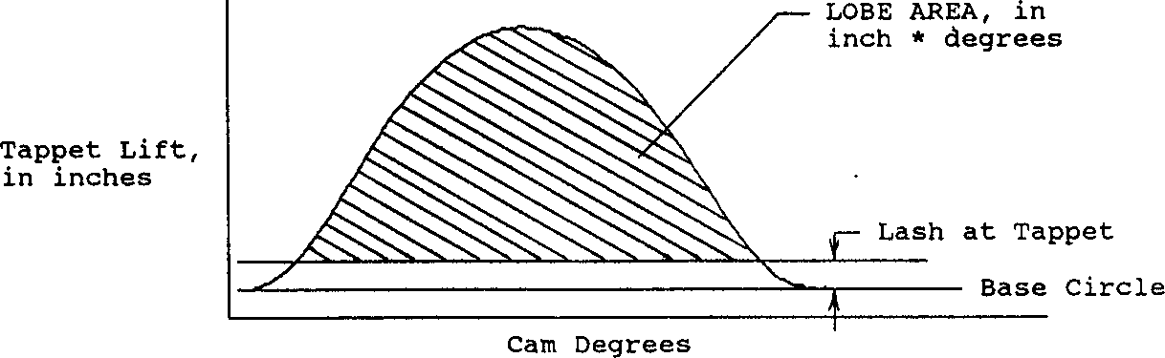
Lobe Separation, deg
Figure 2.21, Definition of Lobe Area

Is the separation lobe centerlines in Analyzer assumes
between the intake and exhaust camshaft degrees. The Engine the centerline half way between

the opening and closing events, or that the cam is
symmetrical. You would have to double this value to obtain lobe separation in crankshaft degrees.

Vlv Area, deg*sq-in
Is the valve opening flow area in units of degree-square inches, similar units to Overlap Area, deg*sq-in. This value represents the total effective flow area available for the intake or exhaust valves while they are open, not just when both are open. It is calculated from the valve lift curve and the valve flow curve. See Figure 2.22. Unlike the Avg Flow Coef. number, this value does increase directly as valve duration and valve size increases. It is these areas upon which Total Exh/Int, % is based.

The Vlv Area is given here to compare valve opening areas between different cam profiles, lash settings, valve sizes and port Flow Efficiencies. Also like Overlap Area, deg*sq-in, larger cylinders will require larger valve areas for similar volumetric efficiency.

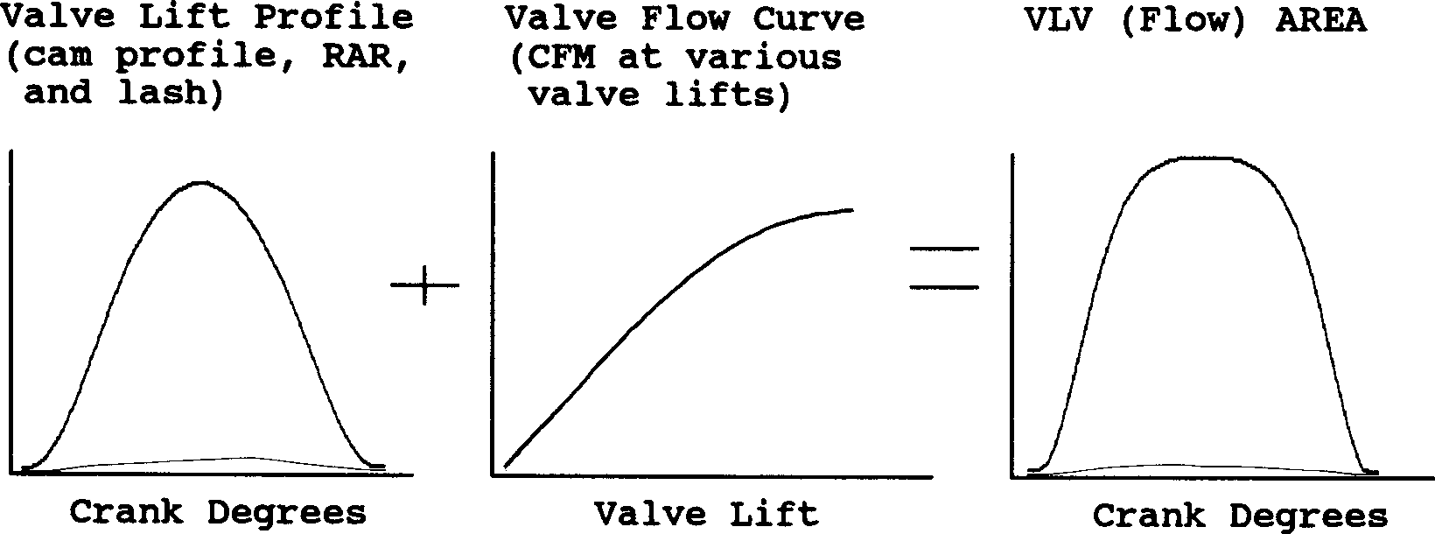
Figure 2.22, Illustration of Vlv Area Calculation

Lobe Centerlns, deg
Intake and Exhaust lobe center is simply calculated from the appropriate opening and closing events and assumes a symmetric cam lobe. The intake lobe center is given in crank degrees after TDC, the exhaust lobe center is given in crank degrees before TDC.

General Engine Calculations

Displacement, CCs
Is the total engine displacement volume (swept volume) in cubic centimeters. This is based on the standard equation including bore, stroke and # cylinders. Divide this value by 1000 to obtain engine displacement in liters. For example, 4900 CCs is 4900 / 1000 =
4.9 liters.

Displacement, cu in
Is the total engine displacement volume (swept volume) in cubic inches. This is based on the standard equation including bore, stroke and # cylinders.
Dynamic Comp. Ratio
Dynamic Comp Ratio is calculated like the Compression Ratio in the Head Specs menu except, the "swept" volume used is the cylinder volume at intake valve closing. Some people believe this is a more realistic compression ratio because the piston cannot compress the air until the intake valve has closed.
Dynamic Comp. Ratio = Clearance Volume + Cyl Vol @ Intake Valve Closing
Clearance Volume
The Dynamic Comp. Ratio is always less than the standard Compression Ratio, and ranges from 6 to 9 for most engines. You've probably heard that long duration cams need higher compression ratios. You will notice that when you specify long duration cams, with late intake valve closing, you must also specify a higher Compression Ratio to maintain a Dynamic Comp. Ratio in the range from 6 to 9.

Compression Ratio
Simply restates the specified Compression Ratio in the Head Specs menu for comparison to Dynamic Comp. Ratio.

Theo. Crank Comprssn,PSI
Is the estimated cranking compression pressure in pounds per square inch based on compression ratio, estimated intake cam profile and lash. The calculation assumes some heat losses and leakage (uses ratio of specific heats of 1.3 rather than 1.4). Your actual cranking compression (100-200 RPM) will likely be less due primarily to leakage and heat losses. Actual compression pressures can be higher with hydraulic lifters, especially high leakdown lifters. High RPM compression (1000 RPM or higher) would more closely match this value. Theo. Crank Comprssn is reported simply to show trends.

Clearance Volume, CCs
Is the calculated total clearance volume in cubic centimeters (piston dish/dome, chamber volume, deck and gasket volume) based on the given Bore, Stroke, Compression Ratio.

Est Idle Vac, ''Hg
Is the estimated idle vacuum at 1500 RPM, with no load on the engine (no torque converter). The Engine Analyzer assumes a constant Barometric Pressure of 29.92 and typical dynamometer testing accessories (water pump, but no fan, power steering, alternator, air conditioning, etc.

Starting Point Suggestions: Pk HP Peak @ xxxx RPM
These 'Starting Point' suggestions are for users who want help choosing "ball park" cam specs and/or runner sizes for good performance at a particular RPM. These recommendations are very general, being based on very simplified "rules of thumb". They are based on the current cam specs, bore, stroke, etc. Therefore, you will get somewhat different recommendations as engine specs change.

Notes:

- The RPM for these recommendations is entered in the Running Conditions menu under the heading ‘Starting Point’ Recommendations as “For Peak HP at This RPM”. See page 67.
- Veteran engine builders can likely pick better 'Starting Point' Specs than the program simply from their experience. The "fine tuning" of these specs through detailed, "cut and try" analysis on the computer is the Engine Analyzer’s real strength.
Starting Point suggestions given here are based on current engine specs and may NOT give best performance and MUST be refined through 'cut and try' running the program. Runner Dimensions are for Port PLUS Intake Manifold Runner or Exhaust Header Primary Pipe.
What this means is that these specs might be a good first try. But then you should start making small changes in runner lengths, diameters, cam advance and retard, duration, centerlines, etc. Constantly compare what these changes do compared to the performance these “Starting Point Suggestion” produced. Keep the best combination, which could be quite different than these suggestions.

Intake Dimensions (for x Runner/cylinder ):
The following sets of lengths and areas/diameters are combinations which are tuned to the RPM specified. The notation in parentheses identifies if the areas and diameters assume 1 or 2 runners per cylinder based on your inputs for Port Layout in the Heads specs menu. For example, the area given for 2 runners per cylinder will be approximately half the area recommended for 1 runner per cylinder.

These lengths and areas are based on simplistic "rules of thumb" concerning inertia tuning described in Appendix 3. The actual tuning simulated by the Engine Analyzer is more detailed and may not completely agree with these recommendations. Therefore, use the recommendations in this section as a guide, or starting point for choosing runner sizes.
These lengths and diameters are also based on the current cam specs. If you change cam specs (for example to those recommended later in this section), these runner suggestions will change also.

Rec Inertia Len, in and Rec area sq in/in
Is the recommended total length of the intake runner from the valve seat to the first abrupt opening for good inertia tuning and runner velocity. This is the sum of Port Length plus Runner Length in the cylinder Head(s) and Intake System menus. This abrupt opening could be a plenum, branching together with another intake runner, or an opening to atmosphere. See Runner Length under Intake System.

Given to the right of the recommended length is recommended runner inside cross sectional area in square inches and inside diameter in inches. This area will give adequate runner velocity for this length runner at this RPM. If you have a rectangular runner, calculate the recommended width and height from the following formulas:
Rec Width = Rec Area Rec Height = Rec Area .
Current Runner Height Current Runner Width
For example, if the recommended area was 2.08 sq in, and your current runner was 1.8 x 1.0:
Rec Width = 2.08 = 1.16"
1.8
Rec Height = 2.08 = 2.08”
1.0

You could either enlarge the width from 1.0" to 1.16" or enlarge the height from 1.8" to 2.08" to obtain the recommended area, but not both. If you want to increase both width and height, the final dimensions multiplied together should equal the recommended area.

Spec Inertia Len, in and Rec Area sq in/in
Is the length specified in the Running Conditions menu as For This Int Runner Length. The area and diameter given will give optimum inertia tuning for this engine and this specified runner length. However, runner velocity may not be optimum. Also see Rec Inertia Len, in and Rec Area, sq in/in.

Rec Len, 2nd Pulse, in and Rec Area sq in/in
Is the intake runner length to produce strong resonance tuning for this engine. This will appear in the Test Results as a strong In ResTunPrs pressure at this RPM. This resonance pulse is from the second reflection and is usually the strongest pulse available for
resonance tuning. The area and diameter given will also give optimum inertia tuning for this engine and this runner length. Also see Rec Inertia Len, in and Rec Area, sq in/in.
Rec Len, 3rd Pulse, in and Rec Area sq in/in
Is the intake runner length to produce strong resonance tuning for this engine. This will appear in the Test Results as a strong In ResTunPrs pressure at this RPM. This resonance pulse is from the third reflection and is usually not as strong as the second pulse. The area and diameter given will also give optimum inertia tuning for this engine and this runner length. Also see Rec Inertia Len, in and Rec Area, sq in/in.

You can determine the Port Volume for any diameter given in this section by going to the Head(s) Specs menu and typing it in for Intake Port Avg Diameter and seeing what Port Volume is calculated. For this Port Volume to be accurate, you must also have entered the correct Port Length in the Head(s) Specs menu first.

Exhaust Dimensions ( for x Runner/cylinder):
Similar to the intake recommendations, the assumed number of exhaust runners per cylinder is also stated in parentheses. This assumption is based on the Layout in the Exhaust section of the Head(s) menu. For example, the area given for 2 runners per cylinder will be approximately half the area recommended for 1 runner per cylinder.

Rec Len, 1st Pulse and Rec Area,300ft/sec
Is the exhaust runner length (from the valve to the collector) to produce strong resonance tuning for this engine. This resonance pulse is from the first reflection and is usually the strongest pulse available for exhaust resonance tuning.

The area and diameter given will produce an average "calculated" exhaust runner velocity of 300 ft/sec. Several sources state this velocity gives good exhaust inertia tuning. The Pro’s detailed calculations do not use this simple “rule of thumb” but it is a good starting point for many engines.

Rec Len, 2nd Pulse and Primary Tube O.D.
Is the exhaust runner length (from the valve to the collector) to produce strong resonance tuning for this engine. This resonance pulse is from the second reflection and is usually not as strong as the first pulse.

The diameter given is for the outside diameter of 18 gauge tubing which will give a "calculated" exhaust runner velocity of approximately 300 ft/sec. Also see Rec Len, 1st Pulse and Rec Area, 300 ft/sec.

Approx Cam Specs for HP Peak @ xxxx ( based on current cam ):
The following cam specs are estimated to produce a HP peak at the RPM specified above as @ xxxx. These recommendations are based on these assumptions:

- HP peak will appear at certain Mach #s. Mach # is based only on intake valve flow potential, intake cam profile and engine size. See Mach # definition on page 76.
- Tuning effects are not included, which have a large impact on the particular cam profile and cam timing (lobe centerline) to use.
- Changes in cam duration and lift will produce predictable changes in intake valve flow potential. The more different the current cam's specs are from the recommended cam's specs, the more error in this assumption.
Therefore, it is obvious that these recommendations can not accurately predict what camshaft to use for a particular application, but are only a starting point. These recommendations must be optimized by calculating performance with the Engine Analyzer, making small changes to these cam specs and then recalculating performance.

Notes:

The reliability of these recommendations depends on how close the current cam's specs are to the recommended specs. If they are significantly different (i.e. current duration is 200 degrees and recommended duration is 300 degrees), the recommendations will not be as reliable. In these cases, enter the recommended cam specs in the Cam/Valve Train menu and recalculate performance. The new cam recommendations will be more reliable.

The duration recommendations are limited to 320 degrees maximum and .550" tappet lift maximum.

HP Pk Int Dur @ .050 and HP Pk, Int Tappet Lift
Is the recommended intake duration at .050" tappet lift to produce a HP peak at the specified RPM. The Tappet Lift is a typical lift for a cam lobe with this duration @ .050" designed for a typical American, pushrod V-8.

HP Pk, Exh Dur @ .050 and HP Pk, Exh Tappet Lift
Is the recommended exhaust duration at .050" tappet lift to produce approximately 75% exhaust flow area compared to intake flow area of the intake cam profile recommended. If the engine is currently supercharged or nitrous injected, this percent is raised to 85%. The Tappet Lift is a typical lift for a cam lobe with this duration @ .050" designed for a typical American, pushrod V-8.
.
  - Calculation Menus:
Check Appendix 5 and 6 for new Calculation Menus added for versions 3.2 and 3.4, std and Plus.

The following section explains the user input for engine specs listed with Clc buttons. These specs are ones where you can simply enter a value, or click on the Clc button and the program will present a menu of inputs which will calculate that particular parameter, or a list of typical examples. These menus are like computer “scratch pads” for calculating specs like compression ratio, runner diameters from other inputs.
Figure 2.23 Typical Calculation Menu
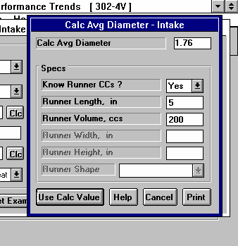

Notes:

The starting values in each calculation menu are usually blanked out. If there is other information in the program to estimate what one of you inputs will be, it may be loaded. For example, Runner Length would be set to whatever value was currently in the Intake Manifold specs menu. However, you are free to change this number to whatever you want.

Once enough specs have been entered, the calculated value(s) at the top of the menu will be displayed. This calculated value(s) will now be updated each time you change a spec. If you want to use this calculated value, click on Use Calc Value. If the calculated value is within expected limits, it will be loaded into the original menu. If you click on Cancel, you will be returned to the original menu with the original value unchanged. If you click on Help, you will be given a general explanation of calculation menus, and a page # in this section for more information about the particular menu you are using. If you click on Print, you can print this menu on your printer with some comment you can enter.
The input values or calculated values in any calculation menu have NO affect on calculated performance unless you load the Calculated value into the original menu. If you already know a spec in the form required by the program, then you have no need to use the calculation menu.
For example, if you know the Compression Ratio is 10.3, you have no
need to use a calculation menu to calculate Compression Ratio based on Gasket Thickness, Piston Dome CCs, etc.

Example:
You are working with a particular engine. Assume you want to calculate the Avg Port Diameter for the intake manifold runner menu for a new manifold. You click on the Clc button for Runner Diameter and are shown the Calculation Menu shown in Figure 2.40.
Note that all inputs are blank except Runner Length which is copied from the current Runner Length in the Intake Manifold specs. Also note that only the Know Port CCs? spec is enabled (not dimmed to gray).

Click on the combo box arrow for Know Port CCs? spec to answer the question Yes or No. Lets say you select Yes, because you do know the runner CCs. This is usually the more accurate way to measure average runner diameter. The specs of Port Length and Port Volume are now enabled (printed in black, not gray). You enter in the values for the new manifold of Length of 5 inches and a Port Volume of 200 CCs and obtain a Calc Avg Diameter of 1.76. If you click on Cancel, you will return to the cylinder Head(s) menu with Avg Port Diameter at its original value.

If you had clicked on Use Calc Value, you would have returned to the cylinder Head(s) menu with Avg Port Diameter set to the new calculated value of 1.76. If you now calculate performance, it will be based on the new Avg Port Diameter of 1.76".

If you change one of the preloaded specs (in the example above you changed the preloaded Runner Length of 6” to 5”), the program will ask if you want to use that new value also. If you say Yes, the preloaded value will be changed as well. In the example above, answer Yes and the new Runner Length you entered into the Calculation Menu of 5” will also be loaded into the Intake Manifold Specs menu for Runner Length.
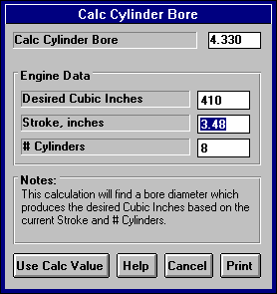
    - Calc Bore
Figure 2.24 Calc Bore
This calculation is available at the Short Block menu and lets you calculate what Bore is required to produce a certain Cubic Inch displacement for a given Stroke and # Cylinders. See introduction to Calculation Menus on page 91 for understanding how Calculation Menus work.

Desired Cubic Inches
Is the cubic inch displacement you want for this engine combination.

Stroke, inches
Is the Stroke for this engine. Stroke is the distance the piston travels from TDC to BDC.

# Cylinders
Is the number of cylinders in this engine. For example, for a V-8 this would be 8.

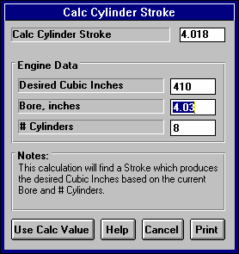
    - Calc Stroke
Figure 2.25 Calc Stroke
This calculation is available at the Short Block menu and lets you calculate what Stroke is required to produce a certain Cubic Inch displacement for a given Stroke and # Cylinders. See introduction to Calculation Menus on page 91 for understanding how Calculation Menus work.

Desired Cubic Inches
Is the cubic inch displacement you want for this engine combination.

Bore, inches
Is the Bore for this engine. Bore is the diameter of one cylinder.

# Cylinders
Is the number of cylinders in this engine. For example, for a V-8 this would be 8.

    - Calc Compression Ratio
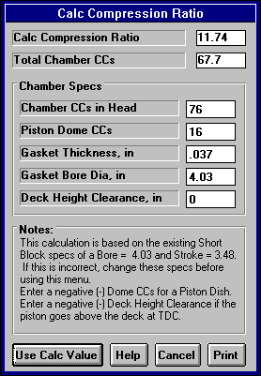
Is the Compression Ratio calculated from the following specs and the current cylinder volume (based on the current Bore and Stroke in the Short Block menu). Compression Ratio is defined on page 21 under
Figure 2.26 Calc Compression Ratio
cylinder Head(s) specs. See page 91 for general notes on Calculation Menus and for an example of their use.

The equation for Compression Ratio depends on the cylinder displacement. This displacement is based on the current Bore and Stroke in the Short Block menu and is displayed in the Notes section at the bottom of this menu. Make sure these specs match the engine for which you are calculating Compression Ratio before using this menu.
Performance Trends offers a very detailed Compression Ratio Calculator program on its website: www.performancetrends.com.
Chamber Specs Chamber CCs in Head
Is the combustion chamber volume in the cylinder head, measured in cubic centimeters. This is the value obtained if the heads are "cc'd".

If you know the entire clearance volume of the cylinder, but do not know Piston Dome CCs, Gasket Thickness or Deck Height Clearance, enter that volume here as Chamber CCs in Head. Then enter 0 for Piston Dome CCs,
Gasket Thickness and Deck Height Clearance. The program will calculate
compression ratio based on the equation below where Clearance Volume is the Chamber CCs in Head.

Compression Ratio = Clearance Volume + Swept Volume
Clearance Volume

Piston Dome CCs
Is the volume of the "pop up" in the piston measured in cubic centimeters. The "pop up" is the volume of piston material added to the top of a flat top piston. If the piston has a "dish" (depression), enter the dish volume as a negative (-) number.

Gasket Thickness, in
Is the thickness of the head gasket in inches after it has been "crushed". "Crushed" thickness is after the head bolts have been torqued to spec.

Gasket Bore Diameter, in
Is the diameter of the bore in the head gasket. A good approximation is to use the same as the Bore in the Short Block Specs menu, and this value is loaded in when you first open up this menu. You can change it to most any value you want. (In actual use, gasket bores are usually .030-.100” larger than the cylinder bore.)
Deck Height Clearance, in
Deck Height Clearance is the distance in inches from the top of the piston to the top of the cylinder block when the piston is at TDC.
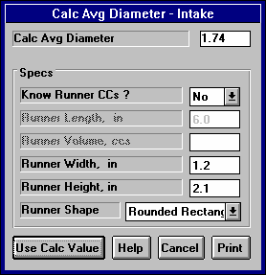
The top of the cylinder is the deck, or surface to which the head bolts. If the outer edge of the piston travels above the deck, this is called negative deck height and you must enter a negative (-) number.
Figure 2.27 Calc Avg Port Diameter

    - Calc Avg Port Diameter
Is the Port Diameter or Runner Diameter calculated from following specs. Port Diameter is defined on page 22 under cylinder Head(s) specs. Runner Diameter is defined on page 32 under Intake System specs and on page 38 under Exhaust System specs. See page 91 for general notes on Calculation Menus and for an example of their use.

Know Port CCs?
Click on this combo box to select Yes or No. Your choice here will enable (turn to black print from gray and allow for inputs) different specs in this menu. You must select this choice first before any other specs in this menu can be entered.

Calculating Avg Diameter from volume is generally the more accurate method. However, for the Intake Port, this is automatically done for you in the main Heads Specs menu. Port Diameter is calculated and displayed based on the current Port Length as you enter in Port Volume in CCs.
For exhaust headers, it is usually best to simply subtract .1" from the tubing OD to obtain the inside runner diameter, and not use this Calculation Menu.

Port Length, in
The length of the port or runner along its centerline in inches. For a port, this would start at the valve stem (center) location at the valve seat or valve throat. It would continue down the middle of the port to the manifold or header mating surface. For many intake ports, 5" is a typical length.

For an intake runner, this is the length from the cylinder head to the first "abrupt enlargement" upstream of the cylinder head. The "abrupt enlargement" can be several different things:
- The intake manifold plenum. The plenum is the open area where all the runners merge, directly under the carburetor(s) or after the throttle body on fuel injected manifolds. The best example of a plenum is the very evident “box” on “tunnel ram” type manifolds.
- The end which is open to atmosphere (or air cleaner) on individual runner fuel injection or carburetion. For individual runner carb systems, the runner length actually extends through the carb and through any velocity stack or air horn.
- Any point where a runner from one cylinder merges with a runner from another cylinder.

Again, for the Exhaust Runner Diameter, it is usually best to simply subtract .1" from exhaust header tubing OD to estimate their inside runner diameters, rather than use this calculation menu.

Port/Runner Volume. CCs
Is the volume of liquid required to fill the port or runner in cubic centimeters. For a cylinder head, this is a common spec head manufacturers quote.

For an intake, you will likely have to measure this yourself. This measurement does not require the precision of "CC’ing" combustion chambers. That's because for most intake or exhaust manifolds there is no clear distinction where the runner ends. Cover the "manifold to head" mounting surface with a plate or heavy tape. Tip the manifold so you can pour in liquid from a graduated cylinder or other measuring device, through the carb or exhaust pipe opening. Fill until you believe the liquid is to the "abrupt enlargement" defined above.

Port Width, in
The average width of the port or runner along its entire length in inches. This can usually be estimated at the end of the port or runner at the cylinder head-manifold/header mating surface.

Port Height, in
The average height of the port or runner along its entire length in inches. This can usually be estimated at the end of the port or runner at the cylinder head-manifold/header mating surface.


Figure 2.28 Port Shapes
Rectangular
Oval
Rounded Rectangular
Port Shape
Describes the general shape of the runner along its entire length. Your choices are:
- Rectangular
- Rounded Rectangular
- Oval
A purely Rectangular runner would have sharp corners and a purely Oval runner would be 2 semicircles connected by 2 straight sections. See Figure 2.28. Actual runners are likely somewhere between these two shapes, which is the Rounded Rectangular choice.

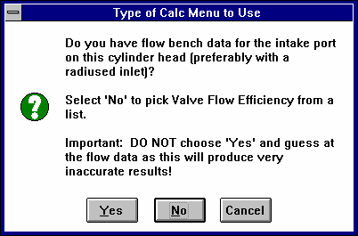
    - Calc Valve Flow Efficiency
Figure 2.29 Valve Flow Efficiency Options
Click on the Clc button by Flow Efficiency in the Head(s) menu and you are first presented with the screen of Figure 2.29. Click on Yes only if you have flow bench data. Then you will be presented with the menu shown in section 2.9.5.2. If you answer No you are presented with the menu below in section 2.9.5.1.
      - Estimated Flow Efficiency

This calculation menu simply presents a list general descriptions of ports and a typical Flow Efficiency.
Pick Intake Port Description Pick Exhaust Port Description
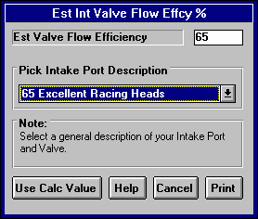
Simply click on the down arrow for the combo box for the list to appear, then click on your choice. There are more choices than can appear at 1 time on the list so be sure to scroll down through all choices. The Flow Efficiency for your choice will appear at the top as the Est Valve Flow Efficiency.
Figure 2.30 Calc Menu to Estimate
Flow Efficiency

      - Calculated Flow Efficiency

This calculation menu calculates Flow Efficiency from flow bench data for either the intake or exhaust port and valve from following specs. Valve Flow Efficiency is defined on pages 18-20 under cylinder Head(s) specs. You would use this menu only if you have flow bench data for your ports. See page 91 for
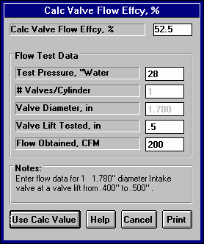
general notes on Calculation Menus and for an example of their use.
Figure 2.31 Calculated Flow Efficiency

Test Pressure, “Water
Is the pressure drop maintained across the port and valve during the flow test, measured in inches of water. From Figure 2.32, you would enter 25. If you have test pressure in inches of Mercury, multiply by 13.6 to obtain "Water.

Test Pressure, " Water = Test Pressure, " Mercury x 13.6
This is initially set to the “Default Test Pressure”. (When you first get your program this is set to 28 because 28” is so common.) However, you can change Test Pressure to most anything you want. Ten (10) and 25” are other common flow bench test pressures.

If you usually get flow data at some pressure other than 28”, you can change the Default Test Pressure by clicking on Preferences at the Main Screen, then Set Default Test Pressure (currently xx”). See Preferences on page 14 of this manual.
Figure 2.32 Typical Flow Curve (valve dia=1.52)
Flow, CFM @ 25”
200
Lift = Diameter
4

Lift = .38”
150
CFM = 192
100

50

0
0.1.2.3.4.5
Valve Lift, inches
# Valves/Cylinder
The number of intake or exhaust valves being flowed during the test. Most cylinder heads have only 1 intake and 1 exhaust valve, so this value would be 1. This number is set to whatever is currently in the Layout spec in the Head(s) menu for this port. If this is not correct for the flow test, you must change this in the Head(s) menu before using this calculation menu. You can not change this number in this menu.
Valve Diameter, in
Identifies the outside (largest) diameter of the head of the valve(s) in inches. From Figure 2.32, you would enter 1.52. This number is set to whatever is currently in the Valve Diameter spec in the Head(s) menu for this port. If this is not correct for the flow test, you must change this in the Head(s) menu before using this calculation menu. You can not change this number in this menu.

Valve Lift Tested, in
Is the valve lift at which the flow data CFM is measured. Use a valve lift (and corresponding CFM flow) as close as practical to one fourth the valve head's diameter. A range of lifts close to 1/4 the valve’s diameter is given in the Notes at the bottom of this menu The program will warn you when Valve Lift is not 1/4 of Valve Diameter in this menu. For example, for a 1.52" diameter valve, use flow (CFM) at .38" valve lift. CFM at .4 lift would also be acceptable. See Figure 2.32.

Note: This is NOT valve lift produced by the cam

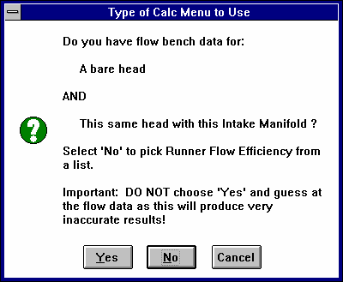
Flow Obtained, CFM
Fig 2.33 Runner Flow Effcy Options
Is the CFM flow obtained at the valve lift given for Valve Lift. Shown in Figure
2.32 is a typical flow curve from a flow bench. For this data you would use the 192 CFM value. For most conditions, it is best to install a radiused inlet on the intake and a short "stub stack" on the exhaust, rather than just flow the head only.

    - Runner Flow Efficiency
Click on the Clc button by Flow Efficiency in the Intake menu or Exhaust menu and you are first presented with the screen of Figure 2.33. Click on Yes only if you have flow bench data. Then you will be presented with the menu shown in section 2.9.6.2. If you answer No you are presented with the menu below in section 2.9.6.1.

      - Estimated Runner Flow Efficiency
This calculation menu simply presents a list general descriptions of ports and a typical Flow Efficiency.

Pick Manifold Description Pick Header Description
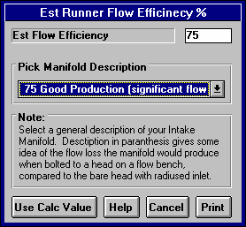
Simply click on the down arrow for the combo box for the list to appear, then click on your choice. There are more choices than can appear at 1 time on the list so be sure to scroll down through all choices. The Flow Efficiency for your choice will appear at the top as the Est Flow Efficiency.
Figure 2.34 Estimated Flow Efficiency

      - Calc Runner Flow Efficiency
Is the intake or exhaust runner Flow Efficiency calculated from the following specs. Runner Flow Efficiency is defined on page 26 under Intake System specs and page 36 under Exhaust System specs. Also see Section 2.9.4 describing Valve Flow Efficiency. See page 91 for general notes on Calculation Menus and for an example of their use.

Flow Data, Head Only Test Pressure, “Water
The pressure drop maintained across the port, valve and runner during both portions of the flow test, measured in inches of water. If you have test pressure in inches of Mercury, multiply by 13.6 to obtain "Water.
Test Pressure, " Water = Test Pressure, " Mercury x 13.6
This is initially set to the Default Test Pressure (usually 28”) when you enter this menu. However, you can change it to most anything you want. Ten (10) and 25” are other common flow bench test pressures. See Test Pressure in Calc Valve Flow Effcy, Section 2.9.5.

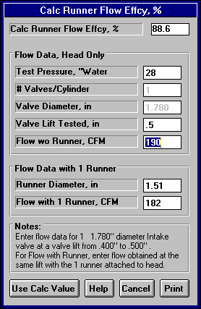
# Valves/Cylinder
Figure 2.35 Calculated Flow Efficiency
The number of intake or exhaust valves being flowed during the test. Most cylinder heads have only 1 intake and 1 exhaust valve, so this value would be 1. This number is set to whatever is currently in the # Valves/Ports spec in the Head(s) menu for this port. If this is not correct for the flow test, you must change this in the Head(s) menu before using this calculation menu. You can not change this number in this menu.

Valve Dia
Identifies the outside (largest) diameter of the head of the valve(s) in inches. This number is set to whatever is currently in the Valve Diameter spec in the Head(s) menu for this port. If this is not correct for the flow test, you must change this in the Head(s) menu before using this calculation menu. You can not change this number in this menu.

Valve Lift Tested, in
Is the valve lift at which the flow data CFM is measured. Use a valve lift (and corresponding CFM flow) as close as practical to one fourth the valve head's diameter. A range of lifts close to 1/4 the valve’s diameter is given in the Notes at the bottom of this menu The program will warn you when Valve Lift is not 1/4 of Valve Diameter in this menu. For example, for a 1.52" diameter valve, use flow (CFM) at .38" valve lift. CFM at .4 lift would also be acceptable. See Figure 2.33.

Note: This is NOT valve lift produced by the cam

Flow w/o Runner, CFM
Is the CFM flow obtained at the valve lift given for Valve Lift with only the cylinder head being flowed. This flow should be the maximum obtainable for the head only.

To obtain maximum flows, the entrance to the intake port should have an "optimum bell mouth" or "radiused" adapter for smooth air entry. The exhaust side may also benefit from installing a short (3-12"), straight section of smooth pipe. You can experiment by simply holding tubes of various lengths and diameters up to the exhaust port, to see the effect on flow. Once you know the approximate dimensions which give maximum exhaust flow, you may want to make a more permanent exhaust adapter for your flow tests.

Flow Data with x Runner
The x in this heading is to indicate you must flow all runners connected to this cylinder for this test. For example, if the engine has 2 intake valves and 2 intake runners for each cylinder, you must first flow both valves with no runner, then add both runners and flow them again.

Runner Diameter, in

Is the Runner Diameter you will use for this runner in either the Intake or Exhaust System menu. This value is initially loaded into this menu, but you can change it if you want. If the runner is primarily oval or rectangular, use the Calc Runner Diameter calculation menu in the Intake or Exhaust System menu first to obtain an effective Runner Diameter.

Flow with Runner
Once you have the maximum flow value for the head only, Flow w/o Runner, install the manifold or header. At exactly the same valve lift and test pressure, repeat the test. Your flow value should drop. If it does not drop, obviously you did not have an optimum entrance or exit adapter, since the manifold you are now flowing is more optimum.

The Engine Analyzer should calculate a value for Calc Flow Efficiency of somewhere between 50 and 100%. The larger the drop in flow between the head only and head plus manifold/header, the worse (smaller) the runner Flow Efficiency. However, like Valve Flow Efficiency, a small runner which reduces flow considerable, may have an excellent Flow Efficiency. This means it is well designed for its size, but its size is the restriction, not its design.

If you enter a Flow with Runner which is greater than or equal to Flow w/o Runner, the Engine Analyzer simply calculates a maximum flow Efficiency of 100%.

Notes:

When flow testing an intake manifold, be sure the other runners are blocked off. Also, do not install the carburetor. The Engine Analyzer treats the carburetor restriction differently from the valve, port and runner restrictions. Occasionally a manifold may flow better with the carb or throttle body than without. In these instances, you should provide an "optimum entrance" at the carb pad, since the carb itself would be a significant restriction. An optimum entrance can be molded out of clay.

It may be more convenient to just flow the cylinder head with the intake and exhaust manifold/header installed, rather than trying to develop "optimum adapters". If this is what you want to do, see Example 4.5. If you did not exactly have an "optimum" adapter for obtaining Flow w/o Runner, then your Valve Flow Efficiency will be too low and your Runner Flow Efficiency will be too high.
Also see Examples 4.5 and 4.6.

Accurate determination of Runner Flow Efficiency has three advantages:
- You can more accurately swap manifold runners onto heads (in the computer) which have not been flowed together.
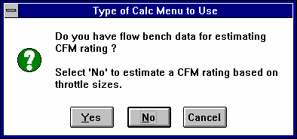
- You gain insight as to manifold and header flow restriction and design. Manifolds and headers with low flow Efficiencies have much potential for flow gains from redesign and porting. Flow restrictions from components with high flow Efficiencies indicate the size of the component is more of a restriction than its design.
Figure 2.36 Calc CFM Flow Rating Options
- Runner Flow Efficiency has a significant effect on tuning, however this effect is not yet clearly understood. See Appendix 3.
    - Calc CFM Flow Rating

Is the CFM Flow Rating calculated from the following specs. CFM Flow Rating is defined on page 35 under Intake System specs. See page 91 for general notes on Calculation Menus and for an example of their use.

You will first be presented with the screen of Figure 2.36. If you answer Yes, you will be presented with the specs outlined in 2.9.7.2. If you answer No, the following specs will be presented, Section 2.9.7.1.

Note: The most accurate way to determine the CFM Flow Rating is to flow the component on a flow bench. The second best way is to use the manufacturer's CFM rating at 1.5" Hg, or rating at 3" Hg and convert it to 1.5" by multiplying by .71. Only if these other methods are not available, should you use the Calculation Menu based on diameter measurements.

      - Calc CFM Flow Rating
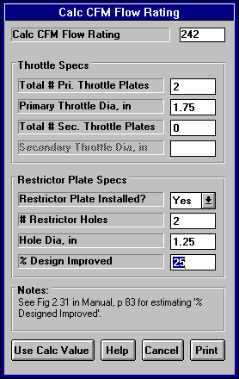
Total # Pri. Throttle Plates
Figure 2.37 Calc CFM Flow Rating from Dimensions
The total # of primary barrels. For a single 4-V carburetor, this would be 2, for three 2 barrel carbs this would be 2.

Primary Throttle Dia, in
The diameter of the throttle opening or throttle butterfly plate for the Throttle Plates, not venturi diameter.

Total # Sec. Throttle Plates
The total # of secondary barrels. For a single 4-V carburetor, this would be 2, for three 2 barrel carbs this would be 4.
Secondary Throttle Dia, in
The diameter of the throttle opening or throttle butterfly plate for the Sec Throttle Plates, not venturi diameter. If Total # Sec. Throttle Plates is set to 0, this value is disabled (dimmed to gray) and ignored.

Note: Primary throttles and secondary throttles are not treated differently in this calculation menu. The only reason they are listed separately here is to easily handle throttle plates which are different sizes. For example, if the primary and secondary throttles were the same size in the three 2 barrel examples above, you could have used 6 Pri Throttles, 0 Sec Throttles and arrived at the same answer.

Restrictor Plate Specs Restrictor Plate Installed
If the carb is used with a restrictor plate, choose Yes. Restrictor plates are special orifice plates mounted below (or after) the carburetor to limit power for special classes of racing. Chances are, if you do not know what a restrictor plate is, you would choose No here.

# Restrictor Holes
The total # holes in the restrictor plate which all engine air must pass through. If Restrictor Plate Installed is set to No, this value is disabled (dimmed to gray) and ignored.

Hole Diameter; in
The diameter of each hole in the restrictor plate in inches. If Restrictor Plate Installed is set to No, this value is disabled (dimmed to gray) and ignored.

% Design Improved
This spec has to do with how the orifice plate is mounted, and what type of transition pieces can be installed on top and below the plate. A plate with no transition pieces and several inches between the carb and the restrictor plate would be called 0 % improved. Where class rules allow, the plate may be "sandwiched" between transition pieces, which can greatly improve flow.
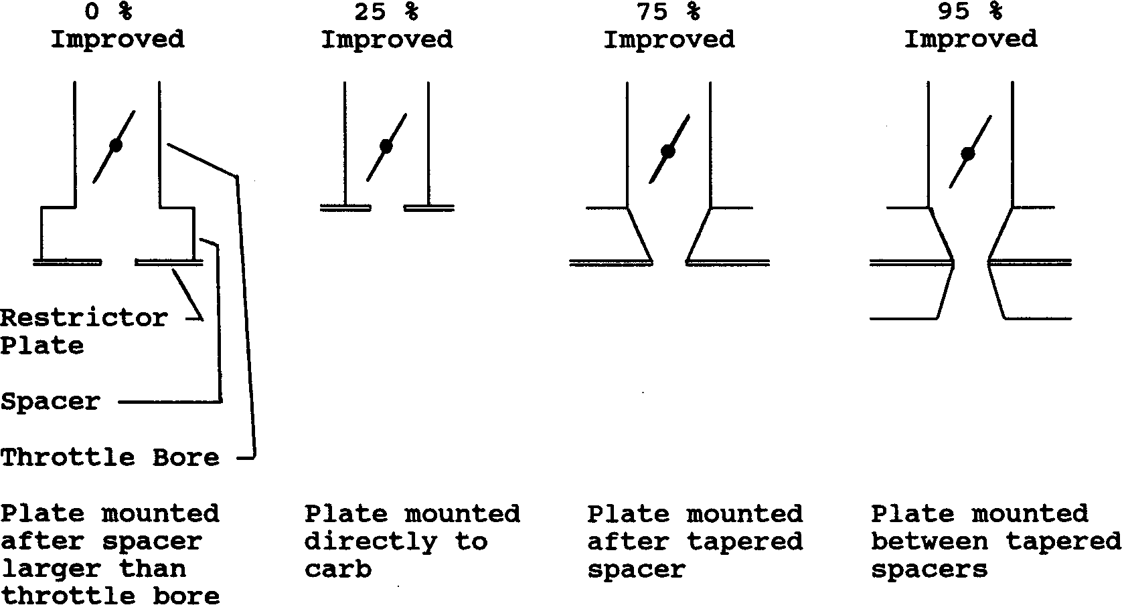
Figure 2.38, Examples of Restrictor Plate Design, % Improved
This could be called 100% improved. See Figure 2.46.

If Restrictor Plate Installed is set to No, this value is disabled (dimmed to gray) and ignored.

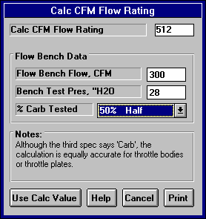
      - Calc CFM Flow Rating
Figure 2.39 Calc CFM Flow Rating from Flow Bench Data
Is the CFM Flow Rating calculated from flow bench data.

Note: Since this calculation is based on flow data for the actual carburetor or throttle body, this is the most accurate method of determining CFM Flow Rating. If the value you obtain here is significantly different than the manufacturer's CFM rating at 1.5" Hg, double check your flow data. The manufacturer's CFM rating should not be more than 15% different, unless you have made modifications to the carb.
Flow Bench Data
Flow Bench Flow, CFM
The CFM recorded when flowing the carb or throttle body on the flow bench.

Bench Test Pres, “ water
The test pressure when flowing the carb or throttle body on the flow bench. This is usually 10, 20, 25 or 28 inches of water. If you flow at 20.4" of water, you are flowing at 1.5" Hg and the CFM you record is the carb's CFM Flow Rating. Since carbs are usually flowed so differently than heads, this menu does not automatically set Test Pres to the Default Test Pressure mentioned in Section
2.9.5 and 2.9.6.

% Carb Flowed
Choices in this combo box let you describes if these flow numbers represent the engine's total carburetor or throttle body flow area. For example:

- If you flowed 1 4BBL carb and the engine is run with this 1 4BBL, you would choose 100%. These flow numbers represent the engine's entire carburetor flow.
- If you flowed 1 4BBL carb, but the engine is run with dual 4BBLs, you would choose 50%, since the test CFM for 1 4BBL only represents half of the engine's carburetors.
- Assume you have a small flow bench and a Quadra-Jet carb. If you flow the entire carb, the test pressure is quite low. However if you block off 1 secondary and 1 primary, the test pressure increases up to 6 ''water. You record 202 CFM for this condition. You would enter 6 for Bench Test Pres, 202 for Flow Bench Flow and choose 50% for % Carb Flowed.

Note: This specs says % Carb flowed but it is equally accurate to estimating the CFM Flow Rating of a throttle body system.

    - Calc Exh Sys CFM Rating
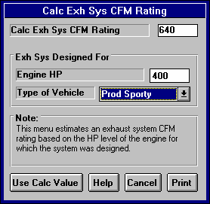
Is the Exhaust/Muffler System CFM Rating calculated from the following specs. Exhaust/Muffler System CFM Ratings s defined on page 40 under Exhaust System specs. See page 91 for general notes on Calculation Menus and for an example of their use.
Figure 2.40 Calc CFM Flow Rating from Flow Bench Data

Note: The CFM Rating calculated in this menu is a very approximate estimate. That is because both inputs are vague and open to interpretation. For that reason, please read Exhaust/Muffler System CFM Rating starting on page 40 for alternate methods to estimate this value.
Engine HP
The rated horsepower output of the engine for which the exhaust system was originally designed. This defines the approximate amount of exhaust flow the system was designed to handle.
Type of Vehicle
Describes the application for which the exhaust system was originally designed. This defines the approximate amount of backpressure the exhaust system was designed to produce.
- Full Race is an exhaust system with extremely low back pressure, designed for classes of racing where rules require mufflers.
- Aftermarket is an exhaust system with very low back pressure, but still quiet enough for the street (as long as you do not go full throttle).
- Prod Sporty is a production exhaust system for performance and sports cars which must pass full power noise standards.
- Prod Quiet is a production exhaust system for a family sedan or luxury sedan where a "throaty" engine roar is undesirable.

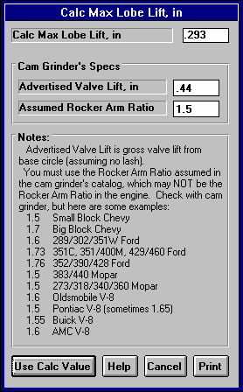
    - Calc Max Lobe Lift
Figure 2.41 Calc Max Lobe Lift
Is the maximum lobe or tappet lift for the cam. Max Lobe Lift is defined on page 47 under Cam/Valve Train specs. See page 91 for general notes on Calculation Menus and for an example of their use.

Advertised Valve Lift, in
The valve lift you see in the cam grinder’s ads, catalog or cam card in inches.

Assumed Rocker Arm Ratio
The Rocker Arm Ratio assumed by the cam grinder for the particular engine. This should be stated somewhere in the catalog or on the card. Note that this assumed rocker arm ratio may be different than what you are actually using on the engine.

    - Calc Belt Ratio
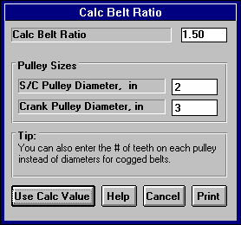
Is the Belt Ratio for either a Roots or Centrifugal supercharger calculated from the following specs. Belt Ratio is defined on page 58 and page 61 under Roots Supercharger and Centrifugal Supercharger specs. See page 91 for general notes on Calculation Menus and for an example of their use.
Figure 2.42 Calc Belt Ratio

S/C Pulley Diameter, in
The diameter of the supercharger pulley measured in inches. This can also be the number of cogs on this pulley if you are using a cogged belt. Then you must also use # cogs for Crank Pulley Diameter, not inches.
Crank Pulley Diameter, in
The diameter of the crankshaft pulley which drives the supercharger measured in inches. This can also be the number of cogs on this pulley if you are using a cogged belt. Then you must also use # cogs for S/C Pulley Diameter, not inches.

    - Notes on Barometric Pressure & Elevation
This menu simply displays the relationship between barometric pressure and elevation specifications, as explained in Section 2.8.1, page 63 and 64. Refer to those pages for further details. Click on OK or press the <space bar> to return to the Running Conditions menu with no change to either Barometric Pressure or Elevation.

    - Calc Dew Point, deg F
Is the Dew Point, Deg F calculated from the following specs. Dew Point, Deg F is defined on page 63 under Running Conditions specs. See page 91 for general notes on Calculation Menus and for an example of their use.

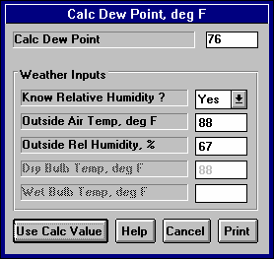
Know Relative Humidity
Figure 2.43 Calc Dew Point
Your choice here will determine which specs are enabled in this menu.

Outside Air Temp, deg F
Is the outside air temperature when the relative humidity measurement was made. For example, if the weather service or weather report gives a relative humidity of 56 % and a temperature of 68 degrees, use 68 for the Outside Air Temp. If you chose No for Know Relative Humidity, this spec is disabled and its value is ignored in the calculation.

Outside Rel Humidity, %
Is the air's relative humidity as reported by a weather service or measured by humidity instruments. If you chose No for Know Relative Humidity, this spec is disabled and its value is ignored in the calculation.

Dry Bulb Temp, deg F
Is the temperature of the dry bulb thermometer on the psychrometer in degrees F. This is also the temperature of any thermometer mounted in the shade when the Wet Bulb Temp reading is taken. The Dry Bulb Temp must not be less than the Wet Bulb Temp. If you chose Yes for Know Relative Humidity, this spec is disabled and its value is ignored in the calculation.

Wet Bulb, deg F
Is the temperature of the wet bulb thermometer on the psychrometer in degrees F. The wet bulb has a "wick" or cloth covering the bulb which is moistened with water. The dryer the air, the greater the difference between the wet and dry bulb readings. Relative humidity or dew point can be manually read off a Psychometric chart from these two readings. This calculation replaces reading the chart. The Wet Bulb Temp must be less than the Dry Bulb Temp. If you chose Yes for Know Relative Humidity, this spec is disabled and its value is ignored in the calculation.

  - Examples
Many of the specs which the Engine Analyzer uses to predict performance are difficult for some users to get. For that reason, the program comes with sets of Example specs which the user can load in automatically and easily.

Check Appendix 5 and 6 for many new features added in std and Plus version of v3.2 and v3.4.

At the top of most component sections of the Engine Analyzer’s menus, you will find a description of the “Type” of component used. In Figure 2.44 the component section is the Manifold Specs in the Intake Specs menu. This combo box can contain several choices:

- Typical Manifold Types
- Use Specs Below
- Pick An Example
- Ex: SB Ford Torquer II (or some other name of a specific example)

Figure 2.44 shows that the current Manifold specs are those picked from the Engine Analyzer’s Example specs for a SB Ford Torquer II manifold. This name can be a handy reminder of the type of Manifold you are simulating, and also where you got these specs.
Figure 2.44 Using Component Examples
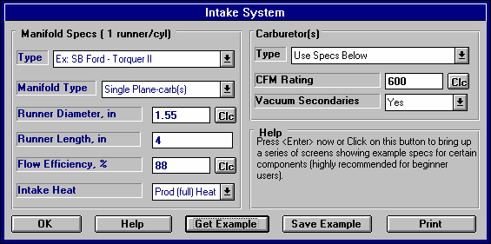
If you are curretly using a set of Example specs, the name of the Example will appear here. You can also click on this combo box to pick a new example or switch the Type to ‘Use Specs Below’. Specs for the Example are displayed in blue (or hidden completely if you are in Beginner mode).
Should you decide to change any of the Example’s specs (from Manifold Type to Intake Heat shown here), the name of the Example will be changed to simply ‘Use Specs Below’.

Click on the Get Example button (or on the Type combo box and select Pick an Example) to bring up a list of example specs.
Click here to save the current specs as an Example with a name of your choosing. (Not available if the current specs are already an Example.)

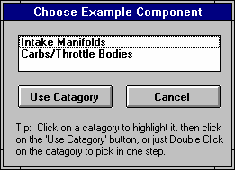
There are 2 general ways to pick an example component. You can either select the Pick An Example from the Type combo box or click on the Get Example button at the bottom of the menu. You may be first presented with a list of general categories of component examples, like shown in Figure 2.45. (This screen would not appear for picking Short Block, Heads or Cams because there are no other component examples available at these menus.)
Figure 2.45 Categories of Example Components (This screen does not appear for all component examples.)

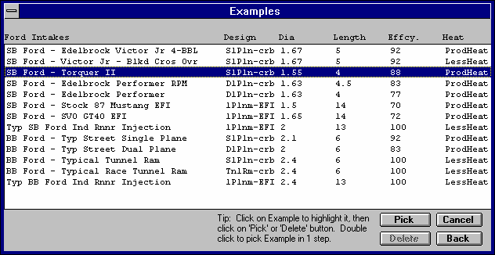
Figure 2.46 List of Ford Manifold Examples

Eventually you will obtain a list of examples, like shown in Figure 2.37. Here you can select your choice by either clicking on it, then clicking on the Pick button, or double clicking on it. (By single clicking on an example you have saved (not one provided by Performance Trends) you can click on Delete to delete it.)
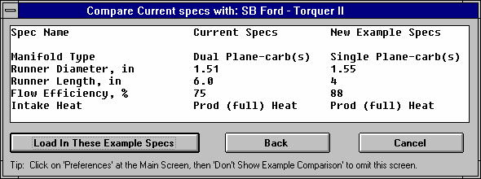
Figure 2.47 Comparing Chosen Example with Current Specs

Next you will be shown a comparison of the example you chose and the current specs, as shown in Figure 2.47. (By clicking on Preferences in the menu bar at the top of the Main Screen, you can omit showing this comparison screen, which you may find annoying. See page 14.) Click on Load In These Example Specs to use these specs. You will then be given a notice about how these specs can not describe all details of the example just chosen, and you should still use your own judgment about the results. See Figure 2.48.

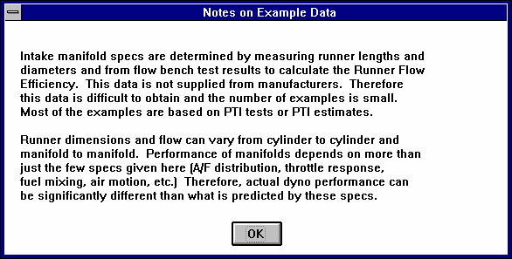
Figure 2.48 Typical Notice about Component Example

You have the option of changing the Example specs. For example, lets say you have blocked the crossover to your Torquer II and eliminated all coolant flow which could heat the intake. You can click on Intake Heat and select No Heat from the choices. The program will warn you that by changing this spec, the name of the example will no longer be for a Torquer II, but will be changed to the general “Use Specs Below”.

Saving Examples
You also have the option of saving your own sets of specs to the list of Component Examples. If the current specs are not an example, click on the Save Example button to be presented with the screen of Figure 2.49. (This button is not shown and saving is not possible in Beginner User mode. See Preferences on page 13.)

This first screen lets you choose a category under which to save the example. For example, you may want a category called VW (as shown in Figure 2.49) where you would save Volkswagen manifolds. Categories lets you easily organize large numbers of examples. To choose a category, simply click on one of the categories on the right side of the screen, under Examples Added by User. (Note that you can not add examples to examples provided by Performance Trends on the left side.) Then click on Use Category to save the
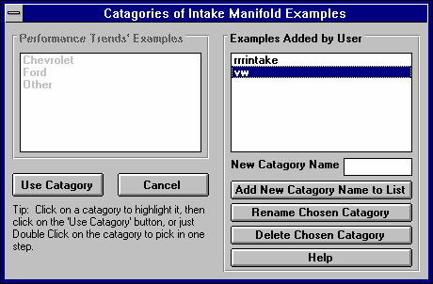
Figure 2.49 Choosing Category for Saving an Example
example to that category. You will then advance to a screen like Figure 2.50.

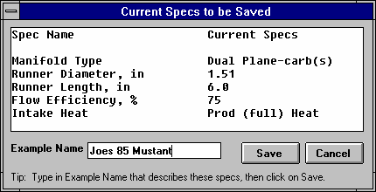
Figure 2.50 Saving an Example

Enter most any name up to the number of letters this box allows (different number of letters for different components).

Saving option not available in Beginner User Mode

If this is the first example you are saving, you will first have to add a new category. Simply type in a category name in the text input box New Category Name, then click on the Add New Category Name to List button. You can also Rename or Delete a category by first clicking on the category you want to change. Then click on the Rename or Delete button.

Notes:
- Not all specs have Examples available and some Example categories have very few examples from which to choose. These features will expand with later updates.
- The specs in these Examples are approximate. Different pieces of hardware and later designs may have different specs, producing very different results. You will be more accurate if you use your own figures from your own tests, or the latest information from the manufacturer.
- No checks are made to see if your combination of Examples is physically possible. You can choose to put small block Ford Torquer II intake on a 5 HP Briggs & Stratton short block with a big block Chevy cylinder head. This may be an interesting "what if", but you must realize this hardware will NOT bolt together.
Chapter 3 Output
The Engine Analyzer provides several ways to view and output the test results, including:
- Tabular, calculated Test Results displayed on the screen. Check Section 2.7 for definitions.
- Analysis Report giving tips, warning of safety issues, etc.
- High resolution graphs
- Printer output of reports or graphs
- Engine Library for recording sets of Engine specs for later use
- History Log
- Send Power Curve to another program

Check Appendix 5 and 6 for new features added in std and Plus versions 3.2 and 3.4.
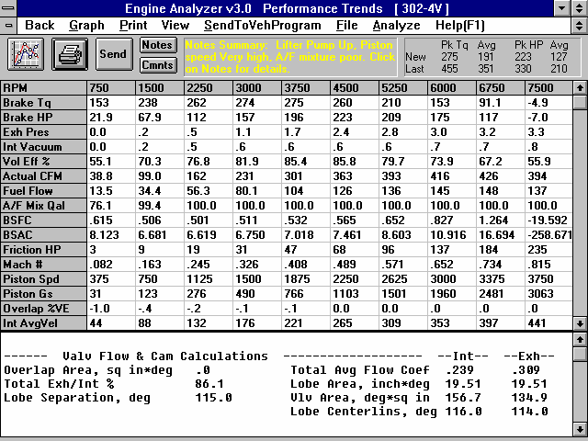
Figure 3.1 Output Options from Test Results Screen
Menu Bar showing names of options
Engine File Name
Click on and slide slide bar button to display all Test Results.
Special Calculations
Click on and slide slide bar button to display all Special Calcula-tions.
Performance Summary
Notes Summary and Notes button giving performance tips Command Option Buttons
RPM Data

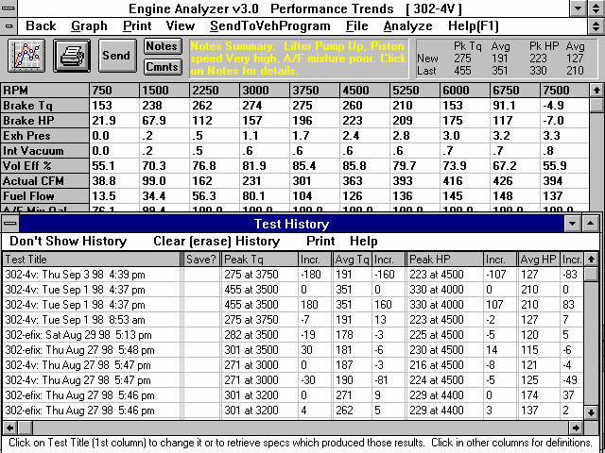
Figure 3.2 Additional Output Options
Click here or here to graph these results Click here or here to print these results
Click here or here to send power curve to vehicle program and run that program
Click here to create Analysis Report (giving tips) as described in Section 3.2
Click here for help

History Log

Click here to write test results to an ASCII disk file
Click here for options to display or not display the Special Calculations section or the History Log
Click here to view and/or edit the Engine Comments Click here to return to the Main Menu
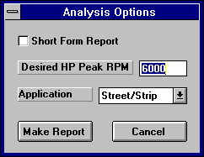
  - Analysis Reports
Fig 3.3 Analysis Options

When calculated performance results are displayed on the screen, you can obtain the Analysis Options menu by clicking on Analyze in the menu bar. See Figure 3.3.

The Analysis report consists of 2-5 pages of suggestions for improving performance, safety warnings, etc. concerning the performance results calculated. See Figure 3.4 for a screen report.

IMPORTANT: The Engine Analyzer can NOT anticipate all UNSAFE and poor performing situations. Do NOT rely only on the Analysis report to point out problems and SAFETY HAZARDS. You must use your own judgment and expert advice by experienced engine builders and the manufacturer of the engine components.

Short Form
Check this Option box if you feel very comfortable with running the Engine Analyzer and understanding its output. If you do not check this option you will obtain the full report which gives additional tips on changing the Engine Analyzer inputs to obtain the desired performance level.

Desired HP Peak RPM
Enter the RPM where you would like this engine's HP to peak. The Analysis report will give suggestions for specifications to produce good performance at this RPM.
Application
Click this combo box for the following choices:

Mild Street | An engine driven primarily on the street. It must idle well, run a low RPM, and have a full exhaust system.
Street/Strip | An engine designed for occasional racing but must be durable and driven on the street.
Full Race | An engine designed for racing only. Since there are several classes of racing, from circle track "claimer" and "restricted" classes to Formula 1, the Analysis report does not get extremely specific.

When calculated test results are displayed on the screen, you can obtain an Analysis Report by clicking on Analyze in the menu bar. The Analysis report consists of 1-3 pages of suggestions for improving performance, safety warnings, etc. concerning the performance results calculated. See Figure 3.3 and 3.4 for examples.
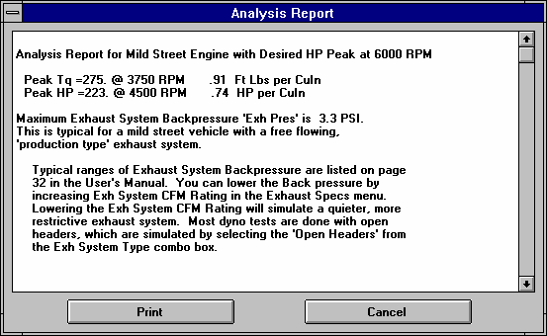
Figure 3.4 Portion of Typical Analysis Report
  - ASCII Data Files
Check Appendix 5 and 6 for new features added in std and Plus versions 3.2 and 3.4.

You may want to use the results from the Engine Analyzer in other software packages. This could be for additional plot capabilities, statistical analysis, data basing, etc. Click on File, then select the Save Current Test Results to ASCII File to write the results to an ASCII file with a name of your choosing. This command is possible any time tabular, calculated results are displayed on the screen.

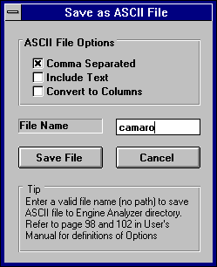
You can only save the RPM data test results for the results currently displayed on the Test Results screen.
Figure 3.5 Ascii File Options
This consists of the RPM, Brk Tq, Brake HP, etc.

Comma Separated
Check this box if you want commas separating the data, leave unchecked and the data is separated by spaces.

Include Text
Check this box if you want the titles of the data included in the file, leave unchecked and no titles are included. Some software packages want only numbers in the files they read. (Lifter Pump Up or Valve Toss is also converted to numbers from 0=None to 3=Severe if you leave Include Text unchecked.)

Convert to Columns
Check this box if you want the data which appears in rows in the Engine Analyzer to appear in columns, like columns of RPM, Brk Tq, etc. Leave it unchecked and the data appears in rows much as in the program and on its printouts.

File Name
Enter the full path and file name to store the file. If you enter no path, the program will store the file in the Engine Analyzer directory (folder).

Appendix 7 shows new option added in v3.4 B to export the data as a Microsoft Excel file

  - Graphs
Check Appendix 5, 6, and 7 for new features added in std and Plus versions 3.2, 3.4 A and 3.4 B.
Graphs are obtained by clicking on the Graph button or the Graph name in the menu bar as shown in Figure 3.1. Figure 3.6 shows a typical graph and a descriptions of some of the basic graph screen items.
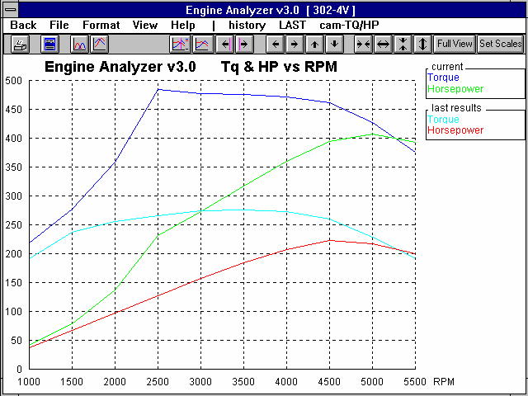
Figure 3.6 Basic Graph Screen Items
Command buttons perform action as pictured with 1 click of mouse.
Menu bar provides for several graph commands and options. Commands to the right of the “|” provide a short cut to commonly used commands.
Graph Title: change by clicking on Format, then Edit Titles/Legend.
‘Short cut’ commands appear to the right of this bar.
Name of current Engine File
Graph Legend, which describes the data graphed. This includes Name of test results, Type of Data. You can also click on Data Type names and the corresponding data line will flash. This is useful to find a particular line when several are graphed.
Names in the Legend can be changed by clicking on Format, then Edit Titles/ Legend.

Horizontal X axis. The scaling of this axis can be easily changed as described in this section.
Grid lines. The style or elimination of grid lines can be changed by clicking on Format, then Grid Style.
Data graph lines. The style and thickness of these lines can be changed by clicking on Format, then Line Style.
Vertical Y axis, the scaling of which can be changed as described in this section.

There are 2 basic types of test data which can be graphed:
    - Brk Torque and Brake HP vs RPM.
    - Valve Lift vs crank degrees.

There are 3 basic types of tests which can be graphed:
    - Current test results. These are the test results whose RPM data is displayed when at the Test Results screen, for the current Engine specs.
    - Last test results. These are the test results from the previous calculation. By comparing the current calculated results to the last results, you can easily watch how each engine modification has effected performance.
    - Test results from the History Log. The History Log is a list of 25 tests, some of which you have specified you want saved long term, some of which are simply some of the last tests you have run.
Tq and HP Data vs Valve Lift Data
You can switch between Tq and HP Data and Valve Lift Data 2 basic ways as shown in Figure 3.7.
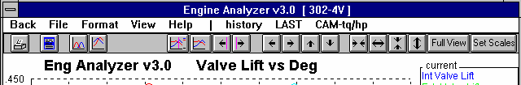
Figure 3.7 Switching between Tq and HP Data and Valve Lift Data
Click on these buttons to switch between Tq and HP Data and Valve Lift Data as pictured.
Click on the “CAM-tq/hp” menu item. Whichever data type “CAM” or “TQ/HP” is given in upper case letters is the data type currently being used. In this case shown, clicking on “CAM-tq/hp” will switch the graph from the current Valve Lift data type to the TQ/HP data type.

Graphing Current, Last and History Log Test Results
The Current and Last Test Results were defined earlier. The History Log is explained in some detail in Section 3.7 starting on page 143. This section will explain how to graph test results for tests in the History Log.
Other Graphing Features
Figure 3.8 History Log (see Section 3.7 for more details)

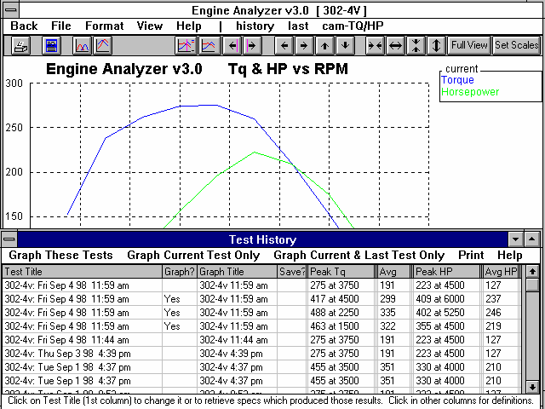
Click on the History Button or the History menu item todisplay the History Log.

The graph screen has several features, including:
    - Printing
    - Cursor to pinpoint the value of a particular point on the graph
    - Changing titles and legend names
    - Changing the scales
    - Miscellaneous Format Options to change the appearance of the graph.

These are discussed in this next section.

Click in this column to show Yes or remove Yes. Tests marked Yes will be graphed.
This column shows name program will display in graph Legend for this test. Click on name to change it.

Choose a ‘Graph’ option from the menu bar to close the Histroy Log and graph the tests identified by the menu option you pick.
Click and drag slide bar to display entire History Log. Some tests marked Yes may be at the bottom of the Log and not be visible now.

Printing

Figure 3.9 shows the options for printing graphs and how to access these options. It also shows the screen for changing the Windows Printer Setup.
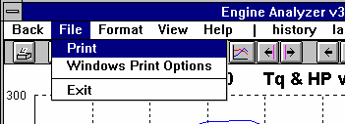
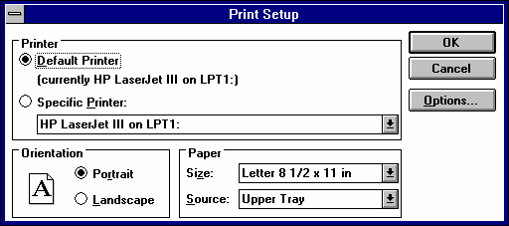
Figure 3.9 Printing Graphs
Clicking on the Printer button is the same as clicking on File and then Print.
Click on File to display the two print menu options

Click here to print the graph.
Click here to change the printer or printer driver, page orientation, etc. as shown below.

Windows standard Printer Setup menu
Cursor
The cursor feature is very useful for determining or comparing the value of the graph lines at various places. See Figure 3.10 for explaining the use of the cursor.
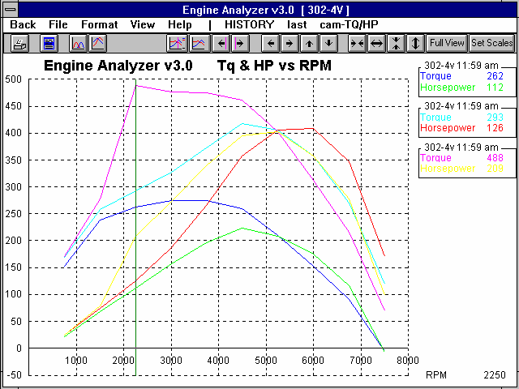
Figure 3.10 Cursor Features and Commands
Click here to turn Cursor On
Cursor line,Click here to turn Cursor Off
usually pink orClick on these buttons to move the cursor left or
green,right. Hold down the <shift key> while clicking
depending onthese buttons and the cursor moves farther.
backgroundYou can also enable the cursor by clicking on View, then Turn Cursor On.
The value of each graph line at the cursor is displayed here.
The X value of the cursor is shown here, in this case the RPM of 2250.
Note for RPM Data: If the RPM where the cursor is at was not run for a particualr test, no value is given here. For example: One test ran 2000,
2500, 3000 RPM
and another ran 2000, 2400, 2800.
When cursor is at 2500 RPM, value is given for first test but not given for 2nd test.
You can also enable the cursor by single clicking on a graph line at a data point. This also provides a quick way to move the cursor from 1 area of the graph to another. (Do not drag the mouse while clicking or you will zoom in on that area.) If you click on a graph line in between data points, the cursor will not appear. A data point is where you see a definite point or bend in a graph line.
Changing titles and legend names
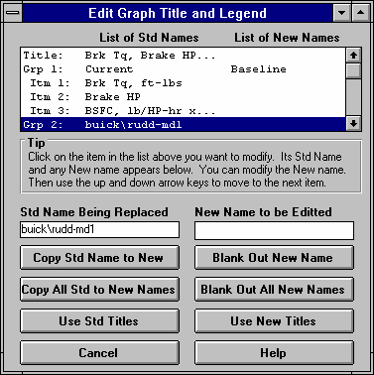
Many times you may want to customize a graph by printing labels of your choice. Click on Format and then Edit Titles/Legend to bring up the menu shown in Figure 3.11 which will allow you to do this.
Figure 3.11 Menu to Edit Title and Legend
This is the list of Standard names the program uses unless you click on the Use New Titles button below. Select (click on) a Standard name you want to change. The Standard Name appears in the edit box, along with the current New name if there is one. Once you have selected a name from this list (that row will be highlighted) it is easier to use the up and down arrow keys to select the next item to edit than clicking the item with the mouse.

This is the list of New names the program will use if you click on Use New Titles. If a title in the List of New Names is blank, the program will use the Standard name.

Standard name from row selected.
New name for you to edit. Other options include clicking on the Copy Std Name to New or Blank Out New Name buttons.
Click here to close this menu and use the New names you have entered. Where New names have been left blank, the Standard name will be used.
Changing the scales
Many times you may want to change the scale of the X or Y axis. This may be to show an area in more detail or to match the scales of a previous graph. The Engine Analyzer has several ways to change the scales as shown in Figures 3.12 and 3.13.

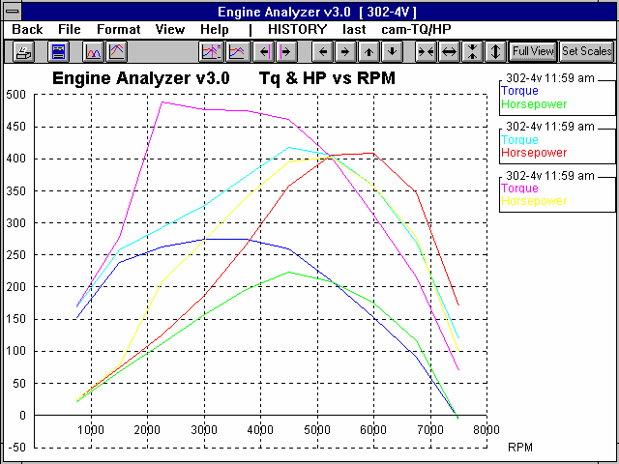
Figure 3.12 Changing Scales for the X or Y Axis
Clicking on these buttons zooms in or zooms out on the graph, either vertically or horizon-tally Hold down the shift key to produce faster action
Clicking on these buttons shifts the graph left, right, up or down. Hold down the shift key while clicking produces faster action.
Click here to restore “auto-scaling”. That is where the computer picks the scale to show all the graph in good detail.
Click on View, then either Zoom or Specify Scales (axes), or the Set Scales button to obtain the menu shown in Figure
3.13 on the next page.
You can use the mouse to outline an area to be zoomed in on. Simply click on the mouse key in the upper left corner of the area, then hold the key down and drag the mouse to the lower right corner of the desired area. A box will be drawn as shown. When you release the mouse key, this area will fill the whole graph. This feature is disabled if the cursor is turned on. Also, start the upper left corner well away from a graph line or the program may turn on the cursor instead.

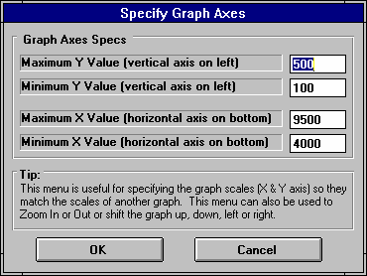
Figure 3.13 Menu to Specify Graph Axes Scales
This menu can be obtained 2 ways. You can click on View in the menu bar then Specify Scales (axes), or click on the Set Scales button, the right most button on the screen. See Figure 3.12.

The current scale limits are loaded when this menu opens. Change any or all these to most any value you want.

Click on OK to have the graph redrawn to these new scale limits .

Format Options
Click on the Format menu item to be presented with several options which will be briefly discussed here.

Line Style
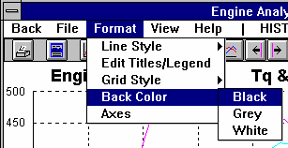
Click on Line Style to change the thickness of the graph lines.
Figure 3.14 Format Options

Grid Style
Click on Grid Style to change or omit the drawing of grid lines on the graph.

Back Color
Click on Back Color to change the background color of the graph from white, black or gray.

Axes
Click on Axes to either add or remove labels like TDC and BDC to the X axis for Valve Lift Graphs.

  - Engine Library
The Engine Analyzer allows you to save a set of Engine specifications to the Engine Library under a name of your choosing. You can then open these Engines out of the Engine Library in the future for comparison or modification. The Open window is shown on the next page with explanations.
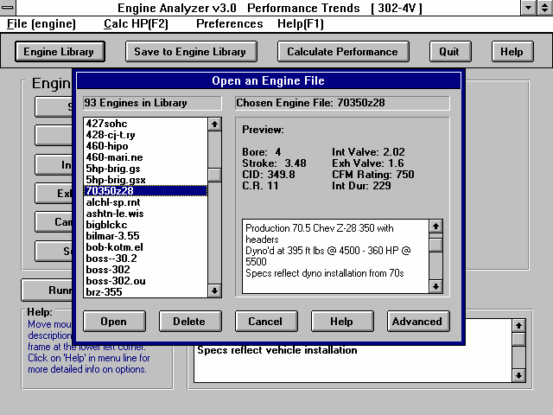
Figure 3.15 Engine Library Options
Click on Open button (or ‘File (engine)’, then ‘Open’) to display Engine Library shown here. (Save option also available after clicking on ‘File (engine)’.)
Click on Save button to save current Engines specs to Library
Total # Engines in Library
Name of chosen Engine (currently highlighted in Engine List)
Preview of Engine chosen

Click and drag slide bar to view all engines in list
Single click on engine to choose it for preview.
Double click to immediately open it.
Click here to open the chosen Engine
Click here to delete chosen Engine.
Click here to close the Engine Library with No changes (without opening an engine)
Click here to bring up standard Windows File Manager window to access any disk drive or directory (folder). Not avaialbe in Beginner User Mode.
Click here to bring up on screen help.

See Appendix 7 to show the latest v3.4B sends files to the Recycle Bin when they are deleted.

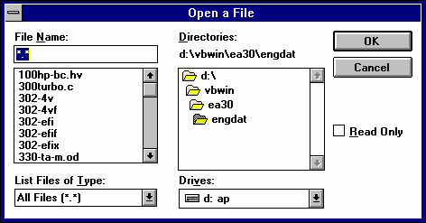
Figure 3.16 Standard Windows File Manager Screen Available by Click on Advanced Button for Either Opening or Saving Engine Files

Open an Engine File
To open an Engine file saved in the Library, either:
    - Click on the Open button
    - Click on the “File (Engine)” menu item and then on the “Open Engine” options from the list.

You will obtain the window shown on the previous page. Single click on one of the Engines in the list, or click and drag the slide button on the right side of the list to display more Engines. Once you single click on an Engine, it is now the Chosen Engine File and a preview of the Engine is given in the Preview section. If the file you chose was not a valid Engine Analyzer file, the program will tell you so and you can not choose it.

Once an Engine has been chosen, you can delete it by clicking on the Delete button, or Open it by clicking on the Open button in this window. You can also click on a different Engine to Preview it or close this window and return to the Main Screen without choosing a new Engine file.

If you are sure of the Engine you want to open, you can simply double click on it from the Engine List. This opens the Engine without a preview and closes this menu.

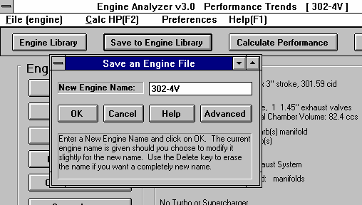
Figure 3.17 Saving Engine File Options
Click on File (engine) menu item, then Save (engine) or click on the Save to Engine Library button to bring up this Save menu.
Click here to save specs to New Engine name shown
New name to save vehicle specs to. Leave unchanged and click OK to save to the current vehicle name. Click on name in box to and start typing to change it, then click OK to save it to the new name.
Name of current vehicle file you are working with

Click here to bring up standard Windows File Manager window to access any disk drive or directory (folder). Not avaialbe in Beginner User Mode.
Save an Engine File
Before we discuss saving an engine file, it is important for you to understand how the program opens and uses Engine files. When you open an Engine from the Engine Library, you are only using a copy of the Engine. The original Engine file is kept in the library.

As you make changes to the Engine, they are only made to this copy. The original file is not changed. If you want to delete your changes, you can simply open a fresh, unchanged copy of the original Engine file from the Library. If you want to keep your changes, you must save them. This can be done by clicking on the Save button. You are also asked if you want to save your changes whenever you open a new Engine, and the program has detected you have made changes to the current file.

To save a Engine File, you will be presented with the Save Window as shown on the previous page. The program suggests a new Engine name which is the same as the current Engine name shown at the top of the Main Screen. If you want to save your changes to the same name, simply click on OK. This will update the current Engine file with your latest changes.

If you want to save the current set of Engine specs with your changes to a new name (and leave the current Engine file in the Library unchanged), then click on the suggested file name and modify it as you want. For example, in the window shown on the previous page, you may want to add -2 to the current name 302-4V to create 302-4V-2 to indicate this is the 2nd revision of 302-4V. This is the safest way to make changes, because you can always return to an earlier version and see what you had done.

Certain engine names are not acceptable, including:

    - Names with more than 50 characters.
    - Names which include certain special characters

If you enter a name which is outside of these limits, the program will warn you and/or make the correction automatically.
Engine files are saved in the ENGDAT subdirectory in the EA30 subdirectory under PERFTRNS.PTI directory. You can copy Windows Engine Analyzer files from programs on other computers to this directory and they will be found by the program.
  - Printer Output
The Engine Analyzer can print the tabular test results for a permanent hardcopy by clicking on Print in the menu bar or the Printer button. The menu of options shown in Figure 3.18 will appear. Check the options you want to use for the printout by clicking on any or all of the top for boxes. All options and buttons are discussed in this section.

Check Appendix 5 and 6 for new features added in std and Plus versions 3.2 and 3.4.

Include Engine Specs

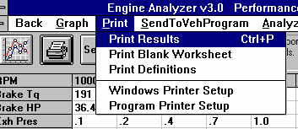
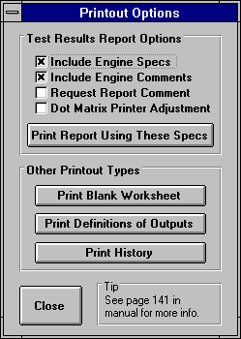
Select this options if you want all the current Engine specs, Transmission specs, etc printed with the results. This will add 1 page to the printed report.
Figure 3.18 Printer Command and Menu of Printer Output Options
The Windows Printer Setup option lets you choose the printer or printer driver being used by Windows and also the page orientation.
Click on Print or the Printer Button for the Printout Options menu shown to the right.

Include Engine Comments
Select this option if you want all the comments for the complete Engine printed with the results.

Request Report Comment
Select this option if you want to be asked for a comment for each particular report you send to the printer. These "report comments" are useful to identify important points for future reference, like modifications, weather conditions, etc.

Dot Matrix Printer Adjustment
Select this option if you are using a dot matrix printer or a printer with fewer fonts and font sizes available. This option usually shrinks the fonts and margins some to correct a problem of the printout going beyond the margin on the right side.

Other Printout Types Print Blank Worksheet
Click on this button to produce a list of engine specs with blank lines next to them. These "worksheets" are handy for gathering engine specs when creating new engines with the Engine Analyzer.

Print Help Definitions
Click on this button to produce a list of output parameters with a 1 line definition. These definitions are the same as when you click on an item in the RPM Data section or Special Calculations section of the Test Results

Print History
Click on this button to print all 25 lines of the History Log. Note that the History Log prints better when the printer is in Landscape mode. Click on the Windows Printer Setup menu item shown in Figure 3.18 for switching to landscape mode.
  - History Log
The Engine Analyzer remembers the results and the Engine specs which produced those results for up to the last 25 runs you have made. This can be a very handy comparison of one run to another and saves you the trouble of making notes on pieces of paper. It is also handy to be able to go back to some condition which gave very good performance, but you don’t remember why or what the specs were. Figure 3.19 shows the History Log and options.
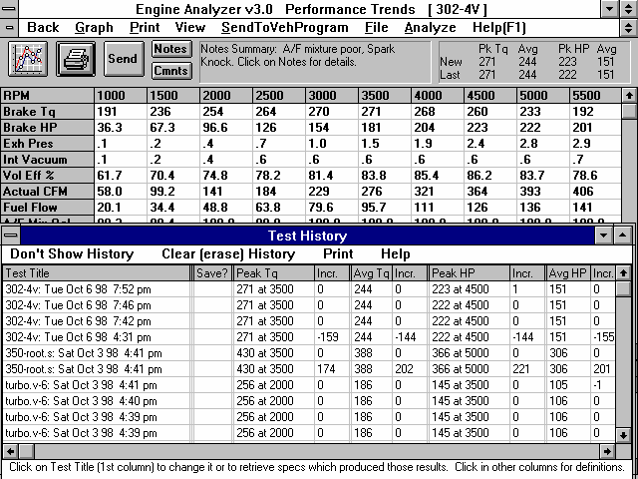
Figure 3.19 History Log and Options
Click on View, then Show History for History Log
Click on Test Title to change the Title or retrieve the specs which produced these results.
History Log is displayed below the columns of test results.
Click and move slide bar to display all 25 tests in the History Log.

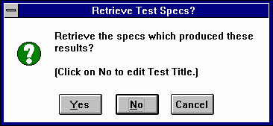
Test Title
Figure 3.20 Clicking On Test Title

Click on Test Title and you are asked if you want to retrieve the specs which produced these results. Answer Yes and the specs are retrieved. Answer No and you can then change the Test Title. This is useful for making notes about this particular run, modifications you made, etc.

Graph?
Click in this column to have a Yes inserted or removed. All test rows with a
Yes will be graphed if you click on Graph These Tests in the menu bar. This column is only visible in the History Log displayed in the Graph screen. See Figure 3.20.
Graph Title
Is the title which will appear in the graph legend for this test. The program creates a simple title based on the Engine File Name and the time the test was run, but you can click on this name and the program will ask you to enter a new name, perhaps something like “34 in Headers”. This column is only visible in the History Log displayed in the Graph screen. See Figure 3.20. The first time you type in a Test Title, the Graph Title will be changed to the first 16 letters of the Test Title.

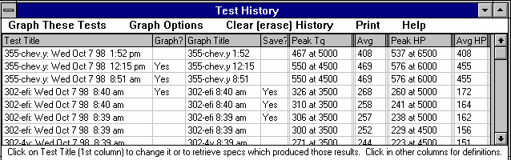
Figure 3.21 History Log from the Graph Screen
Save?
Click in this column to have a Yes inserted or removed. All tests move toward the bottom of the log as new tests are run, and eventually fall off the list. However, tests with a Yes move to the bottom, but do not fall off the list and are saved on the list until you remove the Yes in this column.

Tip: If you want to save a test, but do not necessarily want it on the History Log,, click on it to retrieve it and the engine specs which produced it. At the Main Screen, make notes of what this test and engine are. Then save it to the Engine Library. Although the test results are not available for graphing, you can open this engine file and recalculate the test results at any time in the future.
Peak Tq
Is the peak torque for this particular test, and the RPM at which it occurs.

Incr.
Is the increase in Peak Tq for this test compared to the test below it, usually the previous test run. If Peak Tq dropped, the Incr. will be negative.
Avg Tq
Is the average torque for all RPMs run for this particular test. If the RPM range is different for 2 different tests, comparing averages can be misleading. For example, run the same engine, first from 2000-6000 RPM, then from 3000-7000 RPM. You most likely will get 2 different Avg Tqs, but probably get the same Peak Tq.

Incr.
Is the increase in Avg Tq for this test compared to the test below it, usually the previous test run. If Avg Tq dropped, the Incr. will be negative.

Peak HP Incr.
Avg HP Incr.
These columns are the same as the torque columns, except these track the changes in Peak HP and Avg HP.
  - Send to Vehicle Program
The Engine Analyzer allows you to load engine performance curves into another Windows Performance Trends vehicle program, like Drag Racing Analyzer v3.0. This is accomplished by clicking on the Send button to SendToVehProgram menu item when the Test Results are displayed. You will first be presented with a menu of options as shown in Figure 3.22.

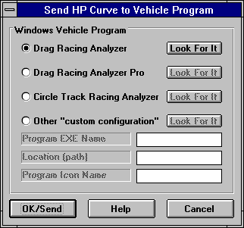
The process of loading Engine Analyzer results into another program are nearly automatic and consists of:
Figure 3.22 Send To Vehicle Program Menu
Click on “dot” to select which program to send curve to.

See Trouble-shooting section for using this “Look for it” button.
- Select the vehicle program you want to send the results to in the Send menu. See Figure 3.22. Then click on OK/Send to leave the Engine Analyzer.
- The vehicle program will be automatically loaded and run. The Engine Analyzer will look where it expects the program to be. If the program is not there, the Engine Analyzer will ask you if it should look for it. See the Troubleshooting section on the next page.
- Follow instructions in the vehicle program like Drag Racing Analyzer to load in the Engine Analyzer power curve, weather conditions which gave this power, etc. This can be done at any time you are in the vehicle program, or not at all. Note that you will have to tell the program to load the power curve. Loading does not happen automatically, to prevent perhaps overwriting some engine information you wanted to save or compare to the new power curve. Usually you go to the Engine Specs menu in the other program to load the power curve.
- When you click on the Return to Engine Analyzer button in the vehicle program or quit the vehicle program, you will be returned to the Engine Analyzer program. Now you can make another modification to the engine, send it again into the vehicle program and see how it effects vehicle performance.
You can jump between the Engine Analyzer and the vehicle program as many times as you want.

If you are using a Performance Trends vehicle program not listed in the Send menu, and the program says it can receive power curves from an Engine Analyzer program, click on the “Other Custom Configuration” button. Fill in the 3 text boxes as instructed in the vehicle program.

Troubleshooting
If in the process of sending the power curve to another program does not work as you expected:
  - Be sure you understand how the process works. Read steps 1-4 on the previous page.
  - You do not have the Windows vehicle program you specified.
  - The Engine Analyzer could not find the vehicle program Click on the Look for It button next to the Vehicle program you want to work with.
  - The Engine Analyzer could not find the correct vehicle program if you have more than 1 copy of the program on your
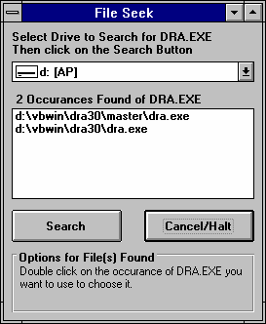
computer. Click on the Look for It button next to the Vehicle program you want to work with.
Figure 3.23 Look For It Menu
Select the Disk Drive to look for the Vehicle program. Then click on Search button to start the search.

Copies of the appropriate program are displayed here. If you click on Cancel/Halt (or the program searches the entire drive), and only 1 copy is found, this copy is automatically assumed to be the one you want to send the power curve to. This menu is then closed.
If more than 1 copy of the program is found (as shown here) you must double click on the program you want to use. This menu then closes.
Chapter 4 Examples

Each of these examples become progressively more complex, assuming you have performed and understand the preceding example. Section 1.5's example is somewhat more basic than Example 4.1, so it may be a better place to start if Example 4.1 looks complicated.

The results shown in these examples may be somewhat different than what you obtain with your particular version of the program That is due to minor upgrades in the calculations in later versions.

Check Appendix 5, 6, and 7 for new features added in std and Plus versions 3.2, 3.4 A and 3.4 B.

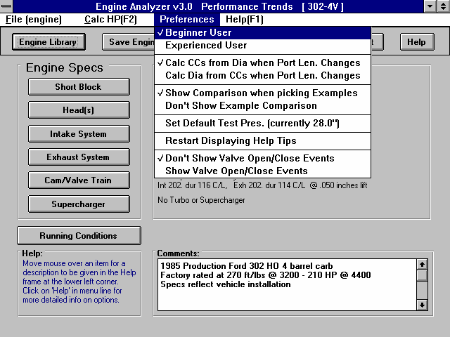
Example 4.1 “I Don’t Know My Engine’s Specs”
Figure 4.1 Main Screen
Click Preferences to see if Beginner User mode has been selected (has check mark by it)
Note here that Beginner is the current mode and is checked
Click here to show Short Block specs.
Features Introduced (and suggested background reading):
- Read the Preliminary "Example To Get You Going" (Section 1.5)
- Moving around in the menus and changing specs (Section 2.0-2.7)
- Calculate Performance (Section 2.8)
- Examples (Section 2.10)
- Graphing Options (Section 3.3)
Example 4.1 will be fairly simple to get you started.
You will answer a fairly
common question “What do I do if I don’t know some particular specs about my engine.” You will go through a process of building an engine knowing hardly more than the cubic inches and number of cylinders.

For this example, you will assume you have a 97 Ford Escort ZX2 4 valve, overhead cam (OHC) 2.0L inline 4 cylinder. Ford rates the engine at 127 ft lbs at 4250 RPM and 130 HP at 5750 RPM.

- Start With an Engine Close to Yours from the Engine Library
First, start the Engine Analyzer program following the procedure in Section 1.4 by either:
  - Clicking on the Engine Analyzer v3.0 icon in the Perf. Trends program group (Windows 3.1)
  - Clicking on Start, Programs, Perf. Trends, then Engine Analyzer v3.0 (Windows 95)
  - Clicking on the EA.EXE (EA) program under the EA30 directory (folder) under the PERFTRNS.PTI directory (folder) using File Manager (Windows Explorer). (Terms in parentheses are for Windows 95.)

You will be shown the Engine Analyzer’s Main Screen as shown in Figure 4.1. Because you are new to the program or new to engines, be sure the program is in Beginner User mode. Click on Preferences at the top of the Main Screen to see if there is a check mark by Beginner User. If there is not, click on Beginner User.

Open up this Engine file by clicking on the Open button as shown in Figure 4.2. Move through the list, clicking on engines which look similar to your Ford 2.0L. You will be shown a preview or summary of the engine. Unfortunately, there are no similar 4 cylinder engines, so you will use whatever engine was loaded in the program when you started it. The name of this engine is shown at the top of the Main Screen as shown in Figure 4.2.

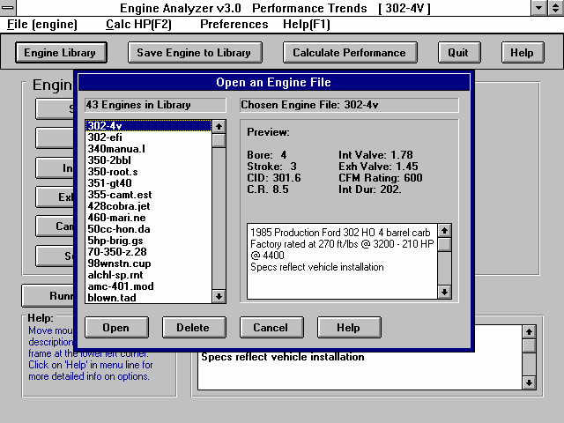
Figure 4.2 Engine Library
Name of Engine the program is currently working with. The current specs may have been changed and be different than the Engine in Library of the same name.
Click on the engine you want to Open to see a Preview.
Double click to Open immediately.
Preview of chosen (highlighted) engine
Click here to show Engine Library
- Pick Typical Example Specs, Starting with Short Block
The Engine Analyzer has “Typical” example specs loaded in for you to pick from. These specs may not exactly match your engine, but are close enough to let you use the program.

Start the engine buildup process by clicking on the Short Block specs button, as shown in Figure 4.1. You will see specs which are for the current engine. Figure 4.3 shows there are usually 2 ways to pick Typical Example specs for your 2.0L:
- Click on the Get Example button at the bottom of the Short Block menu
- Click on the down arrow button on the Type spec at the top of the Short Block menu, then choose the Pick an Example choice.

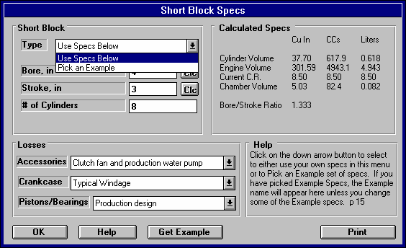
Figure 4.3 To Load an Example Short Block
Click on down arrow button for Type combo box and click on Pick an Example

Or, click on the Get Example button

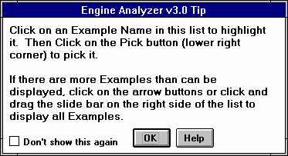
Either way, you will be presented with a list of Short Block Categories as shown in Figure 4.5. You may also be shown one of the several Tips messages in the Engine Analyzer, giving you info helpful if you are not familiar with the program, as shown in Figure 4.4. Simply click on OK to clear the message. Note that this message will be shown again the next time you start the program. However, if you do not want to see this reminder again, click on the Don’t Show This Again box, then on OK and you won’t see this tip again, even if you restart the program.
Figure 4.4 Engine Analyzer Tip
Click here before clicking on OK and you won’t see this message again. Otherwise you will see this message next time you start the program.

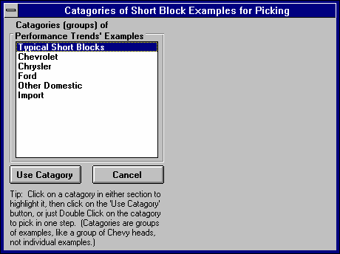
Pick (click on) the Typical Short Blocks to highlight it, then click on the Use Category button. You will get a list of Typical Short Blocks, listed by size in Liters or cubic inches, and number of cylinders. Find the 2.0L 4 cylinder engine, click on it to highlight it, then click on the Pick button to choose it. You will be returned to the Short Block menu with these specs loaded.
Figure 4.5 Picking a Short Block Category
Click on Typical Short Blocks to highlight the category, then click on the Use Category button below.

You can also pick in one step by double clicking on Typical Short Blocks.

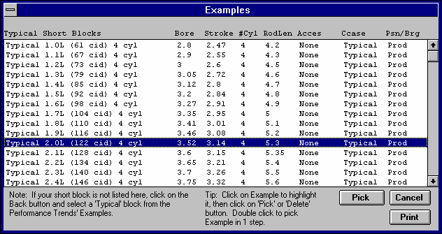
Figure 4.6 Picking the Correct Typical Short Block
Click on your choice to highlight it

Then click on Pick to pick that Short Block

Click on Print to print the entire list of these examples

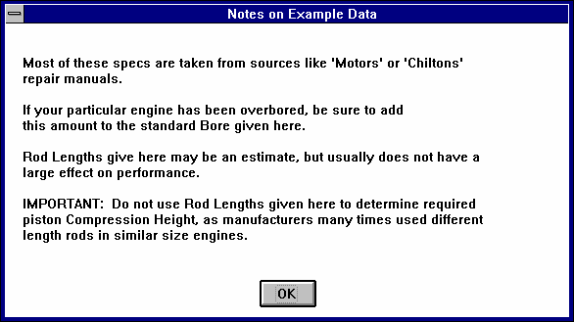
Figure 4.7

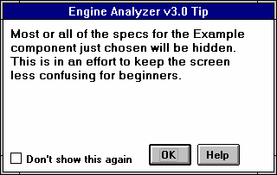
You will probably receive 2 more tips as shown in Figures 4.7 and 4.8. Figure 4.7 explains that these specs are approximate and that there are other things which can effect performance and durability other than what is described by these few specs. Figure 4.8 is letting you know that many of the specs you have picked for this Short Block will be hidden when you are returned to the Short Block specs menu. This is our attempt to avoid confusing or overwhelming the Beginner User with numbers and names they are not familiar with. The Short Block menu will now look like Figure 4.9.
Figure 4.8 Tip Explaining Specs Will be Hidden

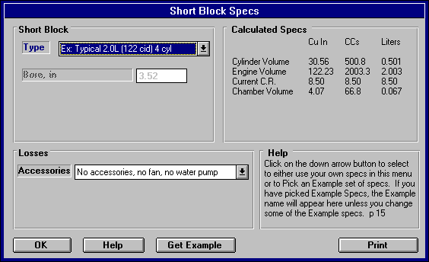
All specs have been hidden except Accessories, which are set to “No accessories, no fan, no water pump”. Click on the down arrow for this combo box, and select the “1990s prod engine in vehicle, all accessories”, which should be typical of your 2.0L as it is installed in your car. On an engine dynamometer, the accessories would be much less, like “No accessories, no fan, no water pump” and performance would improve. That is one reason dynamometer tests usually show higher power than what the engine actually does in the vehicle.
Figure 4.9 Short Block Menu with Typical 2.0L 4 Cyl. Example Specs Loaded
Notice that most specs have been hidden, to avoid confusing the Beginner User. However, Accessories is visible and can be adjusted to match your application, for example full vehicle accessories or minimum dynamometer accessories.

Click on the OK button to close the Short Block menu and return to the Main Screen.

- Continue Picking Typical Example Specs for Other Parts
Head(s)
Click on the Head(s) button to open the Head(s) menu. Click on the Get Example button or select the Pick an Example Type to open the categories of Head Examples. You do know that your ZX2 2.0L is a 4 valve OHC engine, so select the category of Typ Large 4 Valve Heads. The Typical heads are listed for various sizes of cylinder bore, because the larger the bore, the larger the valves which can be fit within the bore. You noticed in the Short Block menu shown in Figure 4.9 that the bore for the Typical 2.0L Short Block was shown as 3.52 inches. Therefore, select the “Typ Stock 4vlv, 3.5” Bore” head.

Notice that this example is contained on 2 lines, because there are so many specs. The second row contains the specs for the exhaust port. When you are returned to the Head(s) menu, you will notice that all specs are now hidden, except Compression Ratio.
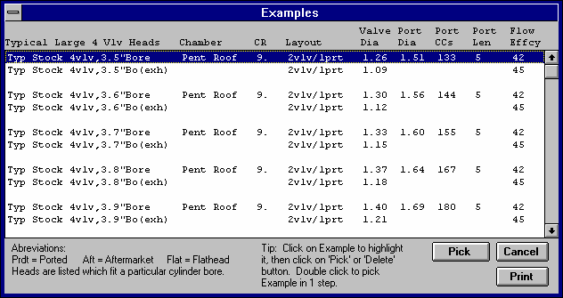
Compression Ratio has been loaded with a 9, but you know from magazine articles that this engine has a 9.6 Compression Ratio. Therefore, click on the
Figure 4.10 Picking a Typical Head for the 2.0L 4 Valve ZX2

Click on either row to pick this example for a 3.5” bore. Note that only 1 row is highlighted, but the specs in both rows will be used.
9 and change it to 9.6. Click on the OK button to close the Heads menu and return to the Main Screen.

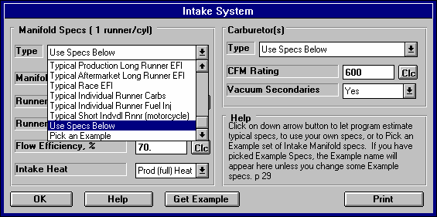
Intake System
Figure 4.11 Picking a Typical EFI Intake Manifold for the 2.0L
Click on the Manifold Type combo box, then select “Typical Production Long Runner EFI”.
There is no need to pick from a list of Examples, as the program calculates runners to match the Head’s ports.
Click on Intake System to open the menu shown in Figure 4.11. The Intake System is divided into 2 parts, the manifold specs on the left side and the carburetor or throttle
body specs on the right side.
Typical Intake Manifolds are not picked as an Example, but simply by picking the appropriate Type from the Type combo box shown in Figure 4.11.
Select the Typical Prod. Long Runner EFI as the Manifold Type and all the Manifold specs are hidden.

Then click on the Throttle Body Type on the right side and select “Fuel Injection Throttle Bodies” for the Category. Then select “Typical Prod 4 Cyl ThrtBody” as the example component from the top of the list. When you are returned to the Intake System menu, all specs have now been hidden except the Manifold Type and Throttle Body Type. Click on the OK button to close the Intake System menu and return to the Main Screen.
Figure 4.12 Picking a Component After Clicking on Get Example

You could have also clicked on the Get Example button to pick the Throttle Body Category, but then you would have gotten the screen of Figure 4.12. If you clicked on Carbs/Throttle Bodies the process would then be the same as described above. Its just that if you click on the Type combo box to Pick an Example, the program already knows what component (manifold or throttle body) you want to pick and you save a step.

Exhaust System
Click on Exhaust System to open the Exhaust System menu. Like the Intake System, the Exhaust System is divided into 2 parts, the manifold/header on the left side and the exhaust system/mufflers on the right side.

Unlike the Intake Manifold, you must pick a Typical Example by clicking on the Type button, then pick the Example Category of Typical Exh Manifolds. You have looked at your exhaust manifold and you see it is made up of several short tubes, similar to a header, so you pick the Example of “Typical Prod ‘Shorty’ Headers”.

Then pick an Example Exhaust System by clicking on the Type button, then pick the Example Category of “Street Exhaust Systems”, then pick the Example of “Typical Prod HiPerf 4 cyl Exh”. Like the Intake System, when you are returned to the Exhaust System menu, all specs have now been hidden except the Manifold Type and Exhaust System Type. Click on the OK button to close the Exhaust System menu and return to the Main Screen.

Cam/Valve Train
Click on Cam/Valve Train to open the Cam/Valve Train menu. Like the other menus, click on Type at the top or the Get Example button to open up the Categories of Cam/Valve Train Examples. Pick the “Typical Cams” Category, and then pick the “Typical Stock OHC” example because you do know that the engine is overhead cam (OHC). Like the other menus, when you are returned to the Cam/Valve Train menu, most all specs have now been hidden. Click on the OK button to close the Cam/Valve Train menu and return to the Main Screen.
Supercharger
The 2.0L is not supercharged, and the Engine Summary at the Main Screen shows that currently there is “No Turbo or Supercharger” installed. If you wanted, you could click on Supercharger button and confirm that the Type is set to “No Turbo or Supercharger”.
Running Conditions
Click on the Running Conditions button and you will now be shown the conditions under which the test will be run. Since you are trying to match Ford’s advertised results, choose “Std SAE Conditions” for the Weather Conditions. You are not sure of the Coolant Temp, so leave it where its at for the current engine file, probably something between 165 to 195 degrees. Be sure no Nitrous Oxide system is on, so choose No Nitrous Injection. Choose Gas for the Fuel and an Octane of 87, the minimum octane which the factories design their cars for (or what ever octane gasoline you typically buy).

For RPMs to Run, use 2500 for the Starting RPM, 10 for the Number of RPMs and 500 for the RPM Increment. The RPM Preview shows “2500, 3000, 3500 ... 7000” which includes the advertised Torque Peak and HP Peak RPMs of 4250 and 5750 with a good RPM range both above and below these RPMs.

You can forget the Starting Point ‘Suggestions’ specs at this time because they are for more advanced work, when you are trying to obtain suggestions for sizing cams or runners for optimum performance. See Example 4.5.

Note: You may say that the Coolant Temp and Fuel Octane inputs suggested here would be complete guesses on your part. In cases like that where you are not sure of specs, calculate performance with a guess at the specs, then calculate performance again with a significantly different guess. If performance does not change much, that particular spec must not be that important for your particular combination, so either guess is adequate. If it does show a big effect, then you will have to read the section of the manual which discusses it to come up with a better estimate of the real value.

- Save Your New Engine
You are probably anxious to run your engine and see its results, but first change the Engine Comments to reflect the changes you’ve made. Click in the Comments box at the Main Screen. Change the comments the same as you would for most any Windows text editing or word processing program. See Figure 4.13. Remember that these comments should help remind you of what this engine is, even several years in the future.

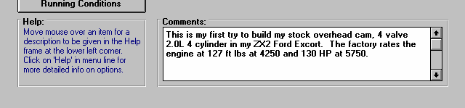
Figure 4.13 Change the Comments at the Main Screen
Click anywhere in this box and use Delete or Backspace keys to delete old comments. Then type in most any new comments.

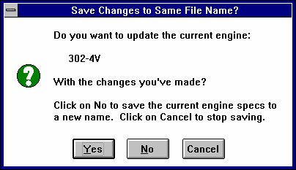
When you are satisfied with your comments, then save this new engine you’ve created to the Engine Library. Click on “Save to Engine Library” at the top of the Main Screen. You are asked the question shown in Figure 4.14 if you want to save these new specs to the same file name, currently at the top of the Main Screen. Since these specs are now completely different than the engine you started with, click on No.
Figure 4.14 Options for Saving Your Engine

The program will present the screen of Figure 4.15. Here you can type in a new name for your engine, then click on OK to save the engine. Remember that a name can not have spaces or certain characters. See Section 3.4. The program may modify your name or warn you if you use a wrong character.

After you have saved the name, you can click on Engine Library and go through the list of engines to find your new engine.

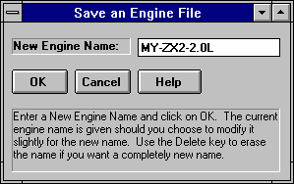
Figure 4.15 Menu for Entering New Engine Name
Type in most any name you want, then click on OK. The program may change the name to be acceptable. See Section 3.4.

- How’d You Do?

Now you can calculate performance and see how you do at matching the factory numbers of 127 ft lbs at 4250 RPM and 130 HP at 5750 RPM. To calculate performance, you can do the following:
  - At the Main Screen you can click on the Calculate Performanc e button at the top
  - At the Main Screen
Figure 4.16 First Test Results for the ZX2 2.0L
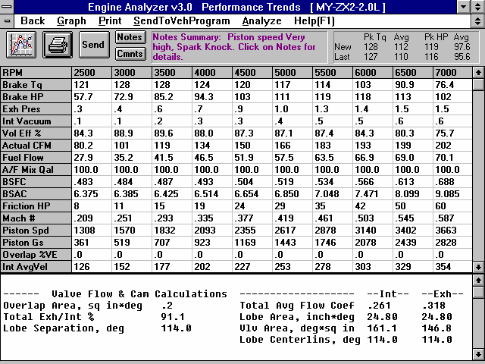
Click on Back (or press <Esc>) to return to the Main Screen

Summary of Peak and Avg Tq and HP showing peaks of 128 ft lbs and 119 HP.

Click and drag ‘slide bar’ buttons to view all results in both the RPM Data section (top) and Special Calculations Section (bottom).

press the <F2> key
  - At the Main Screen click on Running Conditions, then click on Calculate Performance in this menu.

The program first checks your inputs to be sure there are no obvious problems, things like valve sizes being too big to fit into the bore size, etc. If no problems are noticed, calculations will proceed and you will obtain the results screen shown in Figure 4.16. You may initially be given some Engine Analyzer Tips as shown in Figure 4.4, page 153. Read them and then click on OK.

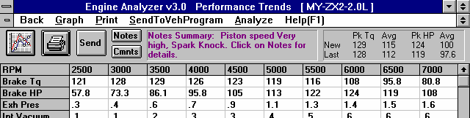
Figure 4.17 Portion of Test Results for ZX2 with Typical Stock HO OHC Cam
Click here for Main ScreenClick here or here to graph the results.
Summary shows peaks of 129 ft lb and 124 HP
Peak HP now at 6000 RPM

The performance summary in the upper right corner of Figure 4.16 shows peaks of 128 ft lbs and 119 HP. These are very close to the factory ratings of 127 ft lbs and 130 HP, especially considering you knew almost nothing about the engine. These results would probably be close enough for you to now make modifications on to see what helps or hurts performance. If some modification showed a 5 HP gain, you could be reasonable sure your engine should show about a 5 HP gain, even though the predicted HP may be about 10 HP low.

- Fine Tuning
The Engine Analyzer’s torque is about right, the HP is low and the RPMs where both peak (3000 and 3500 for torque, and 5500 for HP) are lower than the factory rating. You may not know this now, but most modifications which improve air flow or performance will increase HP more than torque and will shift the peak RPMs to a higher RPM. It looks like some components with “improved breathing” would help the program match the factory ratings.
You may have noticed when you picked several of the Typical example components, there was a higher performance example available. For example, there was a Typical Stock HO OHC cam available instead of just the Typical Stock OHC cam. Try installing the HO cam and see the effect.

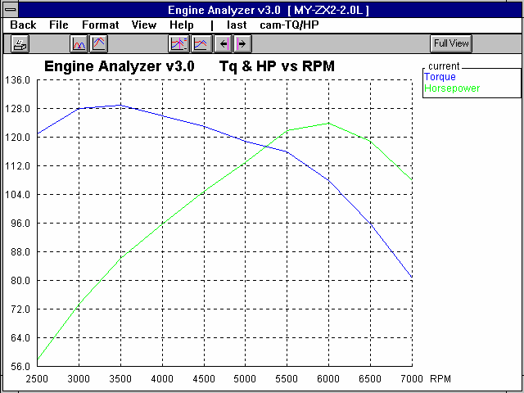
Click on Back in the upper left corner of the test results screen, then click on Cam/Valve Train to open that menu. Just as you did before, click on Type at the top, then “Pick an Example”, then choose the “Typical Cams Category”, then “Typical Stock HO OHC” example.
Figure 4.18 Graph of Test Results from Figure 4.17
Click on Format to change lackground color or to switch to Valve Lift vs Crank Degrees graph.
Click on Last to also show the last perform-ance run (the Typical Stock OHC cam), shown in Figure 4.19
You can also click here or here to produce a graph of Valve Lift vs Crank Degrees, shown in Figure 4.20.
Calculate performance again to obtain results as shown in Figure
4.17. It shows closer agreement to the factory ratings, now being only 6 HP low.

Click on the Graph button or the Graph menu command shown in Figure 4.17 to
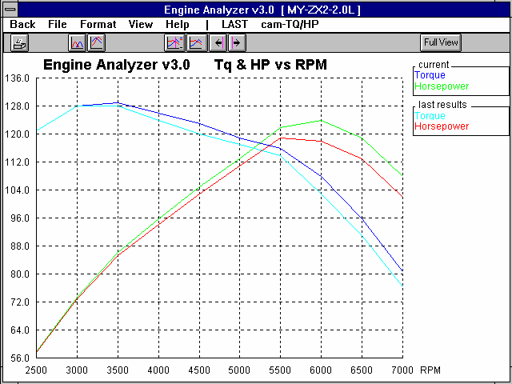
display a graph of the test results, as shown in Figure 4.18. Figure 4.18 also shows how you can change the graph to appear like Figure 4.19 or 4.20. (In “Experienced User”
Figure 4.19 Comparing Last Test (Typ. Stock OHC Cam)
mode, there are even more options. See Preferences on page 13, 14.)

Figure 4.19 shows a comparison of the Typical Stock HO OHC cam to the Typical Stock OHC cam. You can see the HO cam continually shows more torque and HP as RPM increases, and the HP peaks at a higher RPM, just as you though it would.

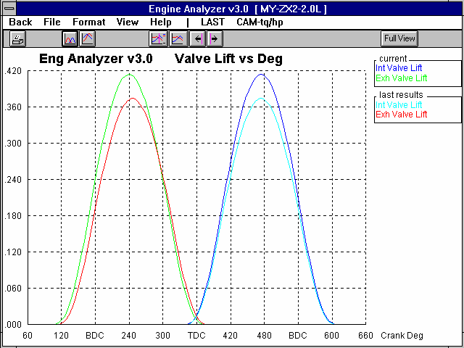
Figure 4.20 compares the valve lift for the 2 cams. As you would think, the Typical HO cam shows more lift, more duration and more “area under the curve”.
Figure 4.20 Valve Lift Graph for Typical & Typical HO Cam

You could try some other higher performance Example components, say “Typical Ported Stock 4 Valve” heads, or a “Typical Aftermarket EFI” intake manifold to get the power closer to 130 HP. However being within 1 ft lb and 6 HP is about as good as you should expect to get, without actual measurements.

Click on Back at the Graph Screen, then Back at the Test Results screen to return to the Main Screen.

- Save Your Changes
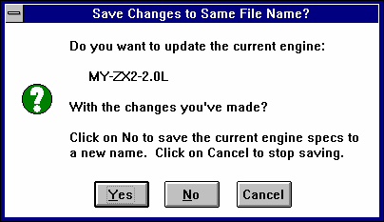
At the Main Screen, you might want to change the comments to mention using the Typical Stock HO cam. Then Save the engine with the HO cam by clicking on the Save to Engine Library button. Answer Yes to the question of Figure 4.21 to update the current engine “MY-ZX2-2.0L” with the HO cam.
Figure 4.21 Saving Changes

Click on Yes to update current Engine File with changes

Conclusions
  - The Engine Analyzer provides even a beginner with enough example parts to build their engine
  - The Engine Analyzer can match the performance of real engines quite well
  - The Engine Analyzer provides ways to analyze and compare results with graphs.
  - You can save your engine to the Engine Library with descriptive comments, for recall in the future.
Example 4.2 Installing Hydraulic And Solid Lifter Camshafts
Features Introduced (and suggested background reading):
  - Using Calculation Menu for cam specs (Section 2.9.9)
  - Graphing Options (Section 3.3)
  - Evaluating Valve Flow & Cam Calculations and General Engine Calculation in the Special Calculations results (Section 2.8.2)
  - History Log (Section 3.6)

More than any other single engine modification, the camshaft determines the engine's "personality", from a low speed "stump puller" to a high revving, Formula 1 winner. Then it's no surprise that a great deal of the Engine Analyzer's calculations center around the cam profile and timing. To investigate these calculations you will simulate installing aftermarket solid and hydraulic camshafts.

Check Appendix 6 for MANY new features to describe the Cam, added in std and Plus version 3.4.

Get Baseline Performance of Stock Cam
Because you will get into more detail in this example, be sure to have selected Experienced User in Preferences at the Main Screen. However, to keep the Cam/Valve Train menu simple, leave “Show Valve Open/Close” unchecked. (See Figure 4.1 in Example 4.1) Then, Open a fresh copy of the 302-4V from the Engine Library by clicking on the Engine Library button at the top of the Main Screen as shown in Example 4.1, Figure 4.2.
Figure 4.22 Response to Clicking on Test Title (all rows except top row)

Calculate Performance so the program’s History Log has a record of how the stock cam performs. At the Test Results screen, click on View (must be in Experienced User mode), then click on Show History Now. You will see the History Log appear at the bottom of the screen as shown in Figure 4.23. You will notice in the left column, a Test Title which the program has given the test consisting of the Engine name and the time and date of the test. If you click on any Test Title other than the first one, the program will ask if you want to change the Test Title, or retrieve the specs which produced those test results (Figure 4.22). If you click on the Test Title in the top row, it assumes you want to change or edit the Test Title. Click on the first Test Title and enter a name like “Stock Cam”.

Click on “Don’t Show History” at the top of the History Log screen to close it. Then, in the lower section of results called the Special Calculations take a look at some results. In particular, note Overlap Area, Total Exh/Int % and Vlv Area in the Valve Flow and Cam Calculations section; Dynamic Comp Ratio, Est Idle Vac and Theo. Crank Comprssn in the General Engine Calculations, and Rec Inertial Len in the ‘Starting Point’ Suggestions section. See Figure 4.24. These have been tabulated in Table 4.2 a couple pages ahead, and will be discussed shortly.

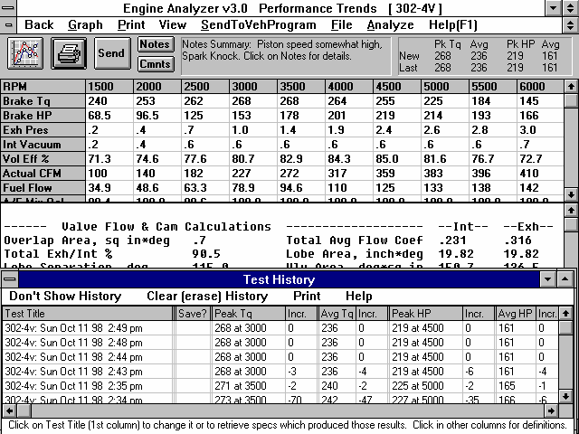
Figure 4.23 Test Results of Stock Cam Showing History Log Click on View,
then Show History Now for History Log
Click here to close the History Log

Click on Test Title and program will ask you to type in a new name for the test, something that describes what this test was of, something like “Stock Cam”.

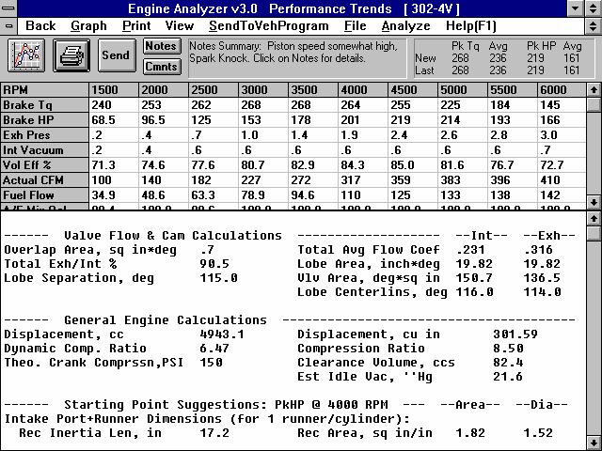
Figure 4.24 Special Calculations Results for Stock Cam
Click on View, then Show Special Calculations (large) for this screen.
Click and drag slide bar to view all results

Certain Special Calculation results to note for this Example.

Run New Hydraulic Cam
Now "install" 2 different camshafts and check performance. Listed in Table 4.1 are the catalog specs for the stock cam and 2 cams you have been considering. You will notice that many cam grinders do not give similar specifications. Fortunately, the program allows you to input specs in many different ways so the program can make comparisons of these cams very easy.

Table 4.1 Cam Specs from Catalog
Catalog Specs | Stock | Hydraulic | Solid
Profile Type | Hyd Roller | Hyd Roller | Solid Roller
Intake Specs:
Recommended Valve Lash | na | na | .026
Lobe (tappet) Lift | .28 | .34
Duration @ .050" Lift | 202 | 220
Advertised Duration |  |  | 264
Lobe Centerline | 116 | 108
Valve Lift (1.6 Rocker Ratio) | .448 |  | .592
Exhaust Specs:
Recommended Valve Lash | na | na | .028
Lobe Lift | .28 | .34
Duration @ .050" Lift | 202 | 226
Advertised Duration |  |  | 264
Lobe Centerline | 114 | 110
Valve Lift (1.6 Rocker Ratio) |  |  | .592
Lobe Separation | 115 |  | 106

Click on Back at the Test Results screen to return to the Main Screen. Click on Cam/Valve Train to open that menu as shown in Figure 4.25. Now you’ll start changing specs to match the Hydraulic Roller cam in Table 4.1.

You can leave most of the General Cam Specs at the top of the Cam/Valve Train menu as they are. The Lift for Rating Events is
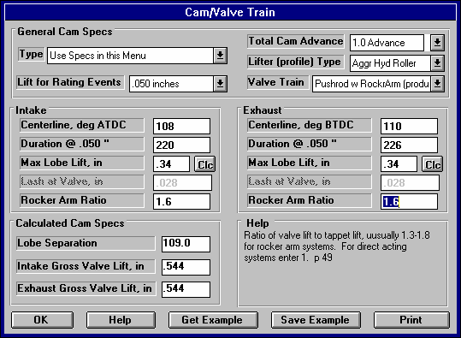
stock cam. The
.050”, just as the
Figure 4.25 Cam/Valve Train Menu with Hydraulic Cam SpecsSwitch to Agr
Hyd Roller
Enter Duration and Centerline for Intake and Exhaust and Cam Advance, Open, Close and Lobe Separation are updated to new numbers
Enter new Lobe (or tappet) lift for Intake and Exhaust, then Intake and Exhaust valve lifts are updated to new
Total Cam Advance
will be determined from the other duration and centerline inputs. Lifter (profile) Type can be switched to Agr Hyd Roller from Mild Hyd Roller because it is usually safe to assume all aftermarket cams are using an Aggressive profile. Since you are not changing valve springs, rocker arms, etc., you should leave Valve Train as Pushrod w RckrArm (prod.). [Note that in reality
you would probably be getting all new roller tappets, pushrods, rocker arms and springs, and you would probably change this setting to Pushrod w Rckr Arm (improved). We’re leaving in the production parts to illustrate some points.]

Next, we’ll start typing in the intake numbers from the catalog (Table 4.1) which you are given. You will notice that as you type in 220 for Intake Duration @
.050” or 108 for Intake Centerline that several other numbers in the menu change.
That’s because the Cam Advance and Lobe Separation are based on the Duration and Centerline. These are being updated to match the new
Figure 4.26 Results for Hydraulic Cam
Note comparison of current results (Hydraulic cam) to last results (Stock cam)
Note Lifter Pump-up with Hydraulic Cam
Name this test “Hydraulic Cam”. Also notice that the History Log shows the Hydraulic cam looses perfor-mance (- Incr) for all conditions except for Pk HP.

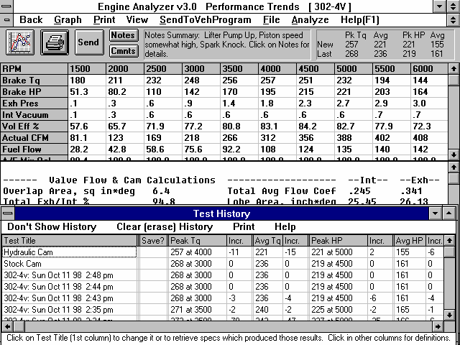
inputs. For that reason, you do now have to know or enter all inputs.

Enter .34 for Max Lobe Lift and notice that Intake Gross Valve Lift changes in the lower left section called Calculated Cam Specs. Leave the Rocker Arm Ratio at 1.6 because you are not changing the rocker arms.

Next enter the Exhaust numbers of 226 for Duration, 110 for Centerline and .34 for Lobe Lift. When finished, the menu should like Figure 4.25. Click on OK to return to the Main Screen, then calculate performance

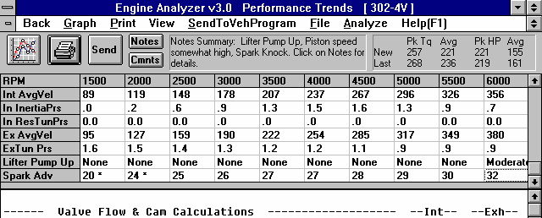
on View, then Show
As done before, click
Figure 4.27 Looking for Lifter Pump-up with Hydraulic Cam
Click on Graph button for Figure 4.28

Click and drag slide bar button down to see all the RPM Data results.
“Moderate” Lifter Pump-up shown at 6000 RPM
History Log Now, then click on the first Test Title and enter a descriptive title, like “Hydraulic Cam”.
See Figure 4.26.

The results for the Hydraulic cam show Lifter Pump up in the notes section at the top. See Figure 4.26.
What this is saying is
the program believes this new cam coupled with the production valve train may produce lifter pump up at some of the RPMs tested. To see which RPMs, click on the slide bar to the right side of the RPM Data results, and slide the button down. The Lifter Pump Up line is second from the bottom. See Figure 4.27 (on previous page).

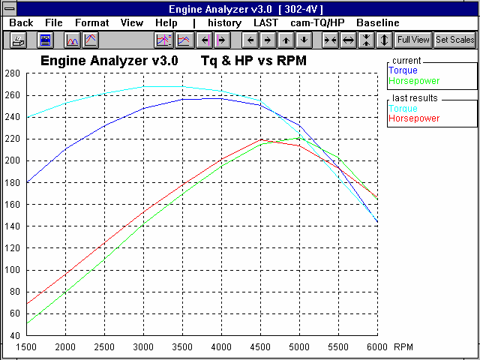
Click on the Graph button to obtain the graph of Figure 4.28. The graph more clearly shows that this aftermarket hydraulic cam looses a lot of low RPM torque, with a very small increase in Peak HP. Click on Back to return to the Test Results screen, then Back again to return to the Main Screen.
Figure 4.28 Graph of Hydraulic Cam with Stock Cam (last results)

Click on Last to show last results (Stock Cam) with current results (Hydraulic Cam)
Small increase in Pk HP and Pk HP occurs at a higher RPM with larger Hydraulic Cam.
Note large loss in low RPM torque

Run New Solid Roller Cam
Return to the Cam/Valve Train menu and start entering specs for the Solid Roller cam in Table 4.1. There are 3 big difference in the specs for this cam compared to the Stock Cam and the Hydraulic Cam:
- There are no Duration at .050” numbers, just Advertised Duration
- There are no Centerline numbers
- There are no Lobe Lift numbers, just Valve Lift

Since there are no .050” Durations, click on Rating Lift in the General Cam Specs at the top of the Cam/Valve Train menu and select Seat Timing. You will notice that the Duration labels are now changed to Advertised Duration, the numbers you have for the Solid Roller. For Lifter (profile) Type, select Agr Solid Roller, since this is an aftermarket (generally aggressive) solid roller camshaft.
Like before, leave Valve Train as Pushrod w Rckr Arm (prod) since you are using the production rocker arms and springs. (Note that in reality you would probably be getting all new roller tappets, pushrods, rocker arms and springs, and you would probably change this setting to Pushrod w RckrArm (improved). We’re leaving the production parts to illustrate some points.)
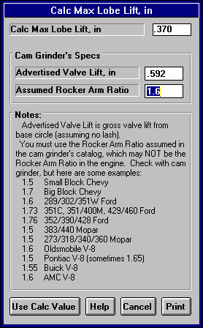
Next we’ll start typing in the intake numbers from the catalog (Table 4.1) which you are given. Because the Durations are now labeled Advertised Durations, you can type in the 264s for both the Intake and Exhaust. For Centerlines, we’ll have to make some assumptions. You may not know this, but if the cam is installed “Straight Up”, the Lobe Separation is the same as the Lobe Centerlines. Therefore make this assumptions, and type in 106 for the Intake and Exhaust Lobe Centerlines. Notice that Total Cam Advance in the General Cam Specs is set to 0 Straight Up, and Lobe Separation in the Calculated Cam Specs is 106 after you type in both centerlines.
Figure 4.29 Lobe Lift Calc Menu
For Tappet Lift, you will have to use the Calculation menu since you only have Valve Lift. Click on the Clc button next to the Intake Max Lobe Lift and you’ll get the menu shown in Figure 4.29. Since this is a Small Block Ford, the cam grinder is probably assuming a 1.6 rocker arm ratio, as shown in the list of Figure 4.29, so type in 1.6 for Assumed Rocker Arm Ratio. (Note that even if you were using ,say, 1.7 rocker arms on the engine, for this calculation you must use the rocker arm ratio the cam grinder used to come up with the advertised valve lift.) Then type in .592 and the Calculation Menu shows a Calc Max Lobe Lift of .37 inches. Click on Use Calc Value to load .37 into Intake Max Lobe Lift at the Cam/Valve Train menu. Since the Valve Lift and Assumed Rocker Arm Ratio would be the same for the exhaust, you can just type in .37 for the Exhaust Max Lobe Lift.
Notice that since this is a solid lifter cam, the Intake and Exhaust Lash at Valve are now printed in black and have become enabled (not printed in gray or disabled). Type in .026 and .028 for the lash numbers. Your menu should now look like Figure 4.30.

Click on OK and then Calculate Performance. Then click on View and Show
History Now to obtain the screen of Figure 4.31. The History Log shows Peak Torque has improved 15 ft lbs over the Hydraulic Cam and 4 ft lbs over the Stock Cam. However, Peak HP for the Solid Roller Cam is down from either the Hydraulic Cam or Stock Cam. Overall, the Stock Cam looks the best, with the highest Avg Tq and Avg HP numbers.

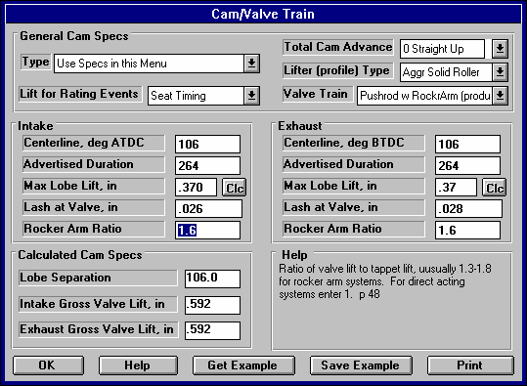
Figure 4.30 Cam/Valve Train Menu for Solid Roller Cam

In the Notes section at the top of Figure 4.31, notice that the Solid Roller Cam also has Valve Toss at some RPMs, probably because you did not improve the Valve Train with this new, more aggressive cam. (For hydraulic cams, valve train problems are shown as Lifter Pump-Up and for solid lifters as Valve Toss.)

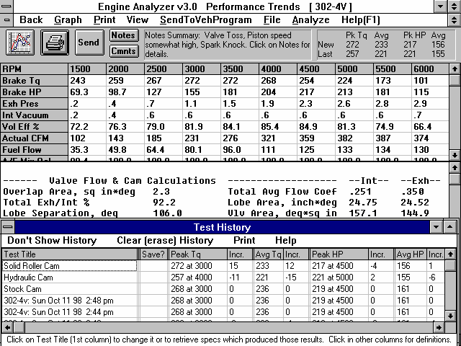
Figure 4.31 Test Results and History Log for Solid Roller Cam

Note Valve Toss in Notes Section.
Test Summary and History Log both show that the Solid Roller Cam is better for Pk Torque but loses Pk HP. History Log shows Stock Cam appears to be the best for most situations (looking at Avg Tq and HP).

Click on Test Title and Type in Solid Roller Cam

Click on the Graph button to obtain a graph like Figure 4.32, showing the Solid Roller Cam with the Hydraulic Cam (the last test results). Figure 4.32 also shows the optional vertical “cursor” bar, which you can move left or right. In the graph legend at the right, the value of each graph line at the cursor bar is displayed. This lets you “pin point” exact values on the graph for more exact comparisons of graph lines.
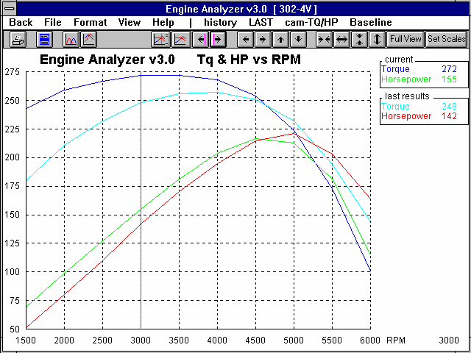
Figure 4.32 Solid Roller Cam vs Hydraulic Cam, shown with Cursor
Click here to
display cursor

Click here or here to move cursor
Click here to turn off cursor

Value of graphs at the cursor appear here.
Cursor “bar”

X axis value at the cursor (RPM in this case) appears here.

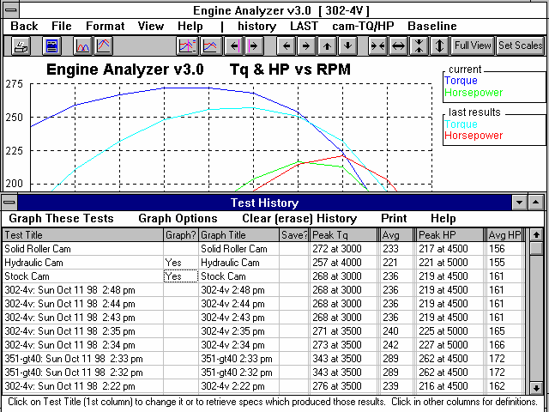
Figure 4.33 Graph History Log
Click on History to display History Log
Click on a blank space in this column to mark Yes for tests to graph. Click on a Yes to remove it. First test (current test) is always graphed.
Name which will appear in graph legend. Click here to change it.

Click here to graph other tests

Click here to graph tests

Graph Options
With the graphs of Figure 4.32 on the screen, click on History in the Menu Bar. You will get the History Log as shown in Figure
4.33. In the “Graph ?” column, click on Stock Cam and Hydraulic Cam. Then click on Graph These Tests to produce the graph of Figure 4.34. This graph shows that the Solid Roller and the Stock Cam show about the same trends, and the Hydraulic cam looses a lot of low RPM torque but does gain some higher RPM HP.

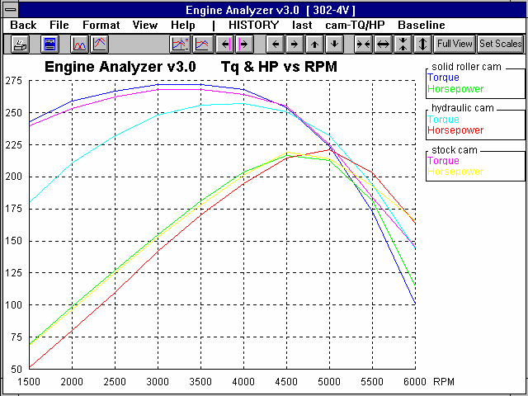
Figures 4.34 through 4.37 show some of the graphing options. Click on the Valve Lift Graph button, or Format and then Valve Lift vs Crank Degrees, or the cam-TqHP menu command to produce the Valve Lift graph shown in Figure 4.35. Here you can compare the actual cam profiles for the 3 cams. Notice that the aftermarket cams have much more lift than the Stock Cam, but not that much more duration. This is why both probably ran into valve train problems at higher RPM. Whenever valve lift increases, but duration remains about the
Figure 4.34 Graph of All 3 Cams Using the History Log
Note the name of the tests appear here in the History Log as you labeled the tests in the History Log
same, the cam has much steeper ramps (is more aggressive or has higher acceleration rates) and usually requires more valve spring. That is one reason cam grinders always recommend you upgrade the rest of the valve train when you go to a new cam.

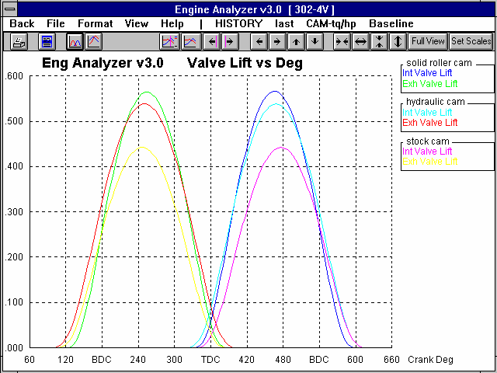
Figure 4.35 also shows that even though the Solid Roller Cam had 264 degrees of Advertised Duration, it actually shows less duration on the graph than the Hydraulic Cam with only 220 degrees of Duration at .050” lift. Advertised duration numbers are always much higher than the duration at .050” numbers for the same cam.
Figure 4.35 Valve Lift Graph for 3 Cams
Click here or on Format or on cam-TqHP to produce Valve Lift graph shown here
Note that both the aftermarket cams have much more lift than the stock cam, but neither produce that much more performance, and on average loose performance. Greater lift for approximately the same duration also explains why the aftermarket cams show valve train problems.
Click and drag mouse to draw box surrounding this area to zoom in on overlap, Figure 4.36

Figure 4.35 also shows that if you Click and Drag the mouse on the graph, you will draw a box. When you release the mouse button, the area enclosed in the box will now fill the entire graph screen. This is a handy “zoom in” method, as shown in Figure 4.36. Figure
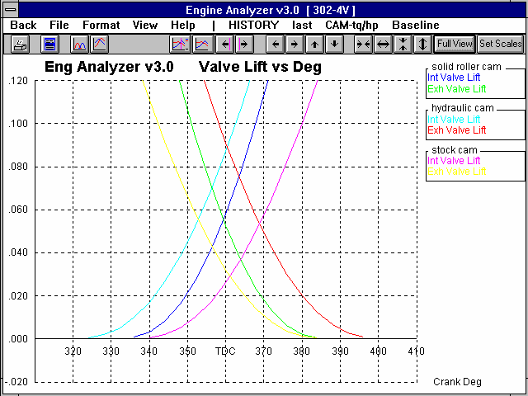
4.36 shows the Overlap Area of the 3 cams. Overlap is very important for engine performance. Too much overlap at low RPM or with stock engines produces performance problems. However, highly tuned engines (good intake manifolds, carbs and exhaust headers) thrive on overlap at high RPM. These aftermarket cams (especially the Hydraulic Cam) probably have too much overlap area for this fairly stock engine.
Figure 4.36 Zooming In on Overlap Area of Valve Lift Graph

Without color it is difficult to see which line is which.
Hydraulic Cam has highest overlap area

Solid Roller has somewhat more overlap area than the Stock Cam

Stock Cam has lowest overlap area

\

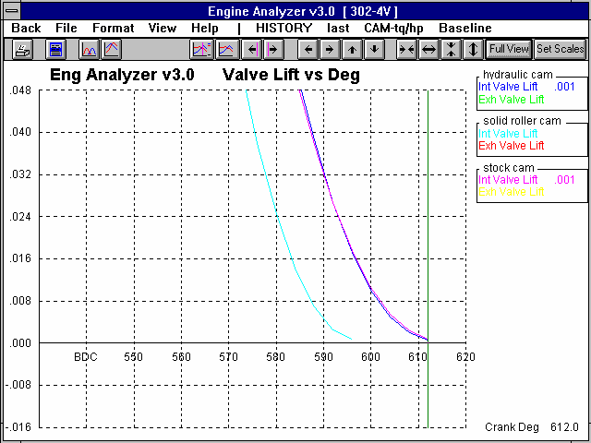
Figure 4.37 Zoomed In Graph on Intake Closing
Cursor showed Solid Roller closes the Intake Valve at 298 degrees, about 16 degrees earlier than the other 2 cams. (That cursor position is not shown here.)
Stock Cam and Hydraulic Roller have very similar Intake Closing events, about 612 degrees shown by cursor
Crank Degrees of cursor position.

Figure 4.37 shows a zoomed in graph on the Intake Closing ramp of the 3 cams Using the cursor function you can see the Hydraulic Cam and Stock Cam close at about 612 degrees or 72 degrees after Bottom Dead Center (after BDC on the graph). The Solid Roller Cam closes at 596 degrees, or 56 degrees after BDC.

More Analysis
Table 4.2 shows a comparison of the 3 cams, looking at several different calculated results. The table highlights some things we’ve already discussed. Overall, the Stock Cam performs very well overall (the best Avg Torque and Avg HP), shows no Valve Train Problems, and produces the highest Est Idle Vacuum.

Other points from Table 4.2 include:
- Cam timing affects nearly every aspect of engine performance
- Typically torque drops and HP increases when duration increases (Stock Cam vs Hydraulic Cam)
- Intake Closing strongly affects lower RPM torque, Cranking Compression Pressure and Dynamic Compression Ratio. (Compare Solid Roller to the other 2 cams.)
- The higher the overlap area, the lower the Est Idle Vacuum.
- Although these cams produce much more lift and are more aggressive, they show a very small amount of improvement, even drops in performance is some areas. However, try these cams again with better heads, intake manifold, and exhaust headers, the story would probably be quite different. This makes the point of how critical the combination of parts can be.
- Note that the Total Exh/Int % is affected by the cam. In the cases shown here, all are over 90% which is much higher than the typically recommended 75%. In this case it is pointing out that the intake cam profile should probably be larger or the intake valve and port (possibly the intake manifold runner) should flow better. The proper selection of cam profile can make up for a poor flowing intake or exhaust port.
- Vlv Area (the flow area through the valves) increases with larger cam profiles, making the point that it is the combination of the valve and port with the cam profile which determines how much air can flow through the engine.

Table 4.2 Comparison or Cam Results
Cam Name | Stock | Hydraulic | Solid Roller
Int Duration | 202 | 220 | 264 Advertised
Intake Closing Event | 72 | 72 | 56
Peak Torque | 268 | 257 | 272
Avg Torque | 236 | 221 | 233
Peak HP | 219 | 221 | 217
Avg HP | 161 | 155 | 156
Valve Train Problems at 6000 RPM | None | Lifter Pump up | Valve Toss
Overlap Area | .7 | 6.4 | 2.3
Total Exh/Int % | 90.5 | 94.8 | 92.2
Int Vlv Area | 150.7 | 168.7 | 157.1
Exh Vlv Area | 136.5 | 159.9 | 144.9
Dynamic Comp Ratio | 6.47 | 6.5 | 7.25
Theo Crank Comprssn | 150 | 151 | 176
Est Idle Vacuum | 21.6 | 14.6 | 18.9
Rec Inertia Len for 4000 RPM | 17.2 | 17.2 | 14.7

Conclusions
- The Engine Analyzer lets you input cam specs in several different ways, making it easy to compare cams from different cam grinders.
- Cam timing affects nearly every aspect of engine performance.
- The Engine Analyzer’s detailed output lets you see several ways engine performance can change, and lets you investigate why performance has changed.
- The History Log provides a convenient way to track your changes, without having to make notes on paper or printing out each performance run.
- The History Log provides a convenient way to pick from (and label) up to 25 past tests to graph.

Example 4.3 Supercharging, Turbocharging And Nitrous Oxide
Features Introduced (and suggested background reading):
  - Changing Supercharger Specs (Section 2.7)
  - Changing Running Conditions (Section 2.8)

Popular street "bolt on" performance modifications include nitrous oxide injection systems, superchargers and turbochargers. The Engine Analyzer lets you simulate all 3 types of systems.

Supercharging and turbocharging are both likely to produce detonation or spark knock. Therefore, the Octane you specify will have an important impact on performance. The stock 302-4V is specified with 87 octane, available at any gas pump. For the first case of Turbocharging, you will examine the effect of running 94 Octane fuel versus the 87. You will then leave Octane at 94 for the other cases.

Again you start with the 302-4V by opening it from the Engine Library by clicking on the Engine Library button. If you don’t have a baseline in the History Log of the performance of the stock 302-4V (like the Stock Cam test from Example 4.2), calculate performance to obtain stock performance.
Turbocharger:
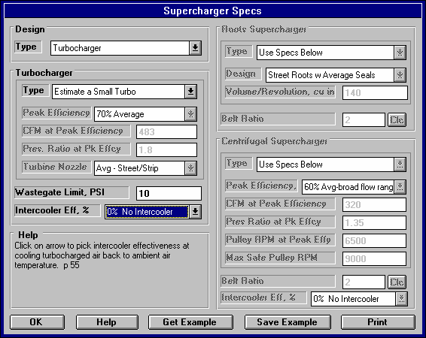
Check the Supercharger menu as shown in Figure 4.38. You first want to check the performance potential of the 302-4V with a turbocharger. First you must switch the Supercharger Type in the upper left corner from None to Turbocharger to indicate a turbocharger is now installed on the engine. Notice the turbocharger specs now become enabled (not dimmed gray) so you can change them. These specs require inputs to specify a turbocharger.
Figure 4.38 Supercharger Menu Simulating a Typical Small Turbo

Assume at this time you are not considering an intercooler, so leave Intercooler Eff % at 0, No Intercooler. Like many performance enthusiasts, you do not know details about different turbochargers, so you will let the program pick turbocharger specs. This is done by clicking on the Type item at the top of the Turbocharger section. Since your 302 is street driven, you should try a small turbocharger. Small turbochargers "come on" quicker, at a lower RPM, which is better suited for the street.
Select Estimate a Small Turbo from the list of Types.

Also, the turbo supplier recommends a waste gate to limit boost to 10 PSI of boost, so enter 10 for Wastegate Limit, PSI. The Turbocharger specs should now look like those in Figure 4.38.

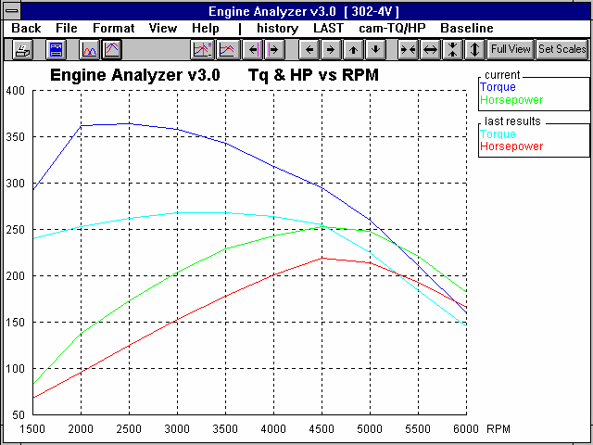
Calculate performance and review the Test Results:
Figure 4.39 Graph of Stock 302-4V vs Small Turbocharger

Note large gain
in low RPM torque, and that perfor-mance with the small turbo increased at all RPMs.
  - This turbocharger provides a huge increase in torque, especially at low RPM.
  - Spark is retarded from optimum spark timing (what the engine wants to run) to as low as 5 degrees at some RPMs to avoid detonation.
This is
indicated by the "*" for various Spark Adv numbers, and by the Spark Knock warning in the Notes section..
  - Boost, PSI jumps up to 10.0 at 2000 RPM and stays there. This is due to the wastegate limiting boost to the Wastegate Limit of 10 PSI you specified. (For non-supercharged engines, this row of data called Boost is called Int Vacuum.)
  - Exh Pres is much higher than stock, increasing from 3.0 to 29.2 PSI. This increased Exh Pres is where the turbo gets its power to compress the fresh air charge.
  - Actual CFM air flow has increased from 410 to 525 CFM at 6000 RPM. The stock 600 CFM carb should still be adequate for flow. It will likely have to be rejetted, especially if this is a "blow through" system.
  - Fuel Flow has increased from 142 lbs/hr to 182 at 6000 RPM. Fuel lines and fuel pump capacity may not be large enough. If this was a fuel injected engine, the injectors may not be capable of handling the extra fuel flow. Click on Analysis to obtain an Analysis Report which discusses fuel injector sizing and other important issues.

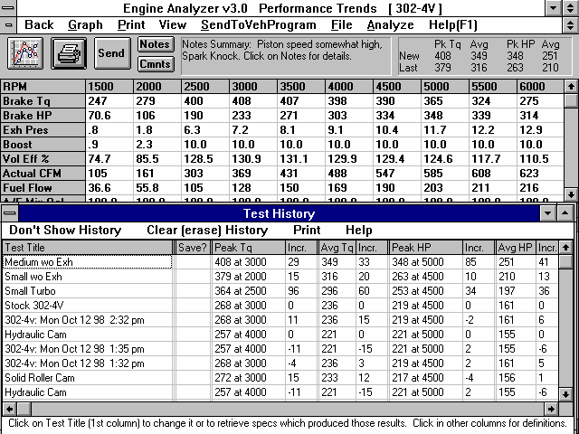
You may have heard that turbocharging thrives on low back pressure, so try completely removing the exhaust system to see the effect on performance.
Figure 4.40, Small and Medium Turbo Performance Without Exhaust System

Note 29 ft lb and 85 HP increase with the Medium Turbocharger.

Tests are
being renamed with meaningful titles as they are being performed and added to the History Log.
Although this is not possible for a street driven vehicle, it will give an idea of the "best possible" gain from installing a lower restriction exhaust system. Calculate performance again with a turbocharger and with Exhaust System
Type set to Open Exhaust
(no mufflers). Then recalculate performance to see this effect.
The History Log shows that removing the exhaust system helped, but only 10 HP, improving Pk HP from 253 to 263. Since a real exhaust system would only show less of a gain than no exhaust system, it may not be a good investment at this time. Also notice that Exh Pres did not drop to 0 "Hg, but stayed up around 24 PSI. That is because Exh Pres is the pressure before the turbo. The pressure after the turbo (which is not reported) would drop to 0 since there was no restriction from an exhaust system.

Since boost is “coming on” so quickly with the Wastegate controlling boost at 2000 RPM, perhaps a "small" turbo is too small. Repeat the calculation with the Turbocharger Type set to Estimate a Medium Turbo. Calculate performance and look at the History Log, as shown in Figure 4.40. The History Log shows performance improved significantly. CFM has increased to 623 and Fuel
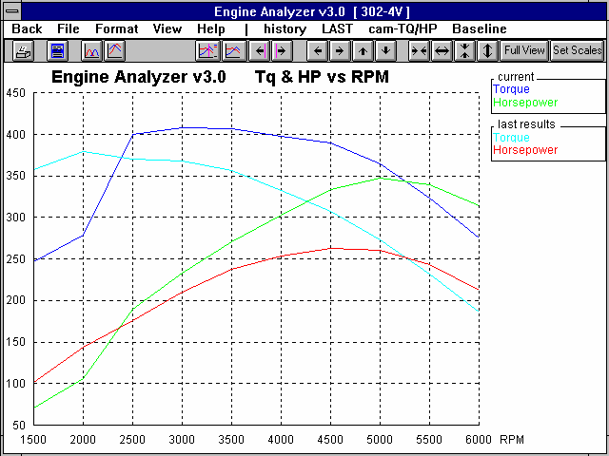
Figure 4.41 Graph of Small vs Medium Turbo Performance

Note that Medium turbo does not “beat” the small turbo until 2500 RPM, but above 2500 RPM the Medium turbo is the clear winner.
Flow to 216 at 6000. Perhaps now a larger carb would help performance, or you may need a larger fuel pump.

For steady running performance, the medium size turbo appears to be a much better choice than the small turbo. However, the Engine Analyzer does not simulate "turbo lag". Smaller turbos are faster responding, which may be better for street performance and throttle response. Figure 4.41 show s a graph of the Medium Turbo vs the Small Turbo.

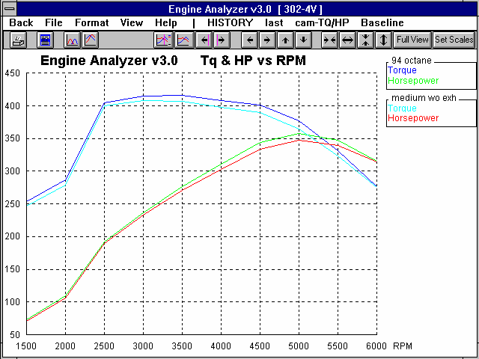
For all turbo cases, Spark Adv has been severely retarded to avoid detonation. See what a higher Octane fuel would do. At the Running Conditions menu, change Octane from 87 to 94, then recalculate performance. You will still see Spark Adv retarded, but not as much. Rename this test in the History Log “94 Octane”. Overplot the 94 Octane results with the previous 87 Octane results as shown in Figure 4.42.
Figure 4.42 Medium Turbo, 87 vs 94 Octane

Octane increase shows fairly small improvement throughout the RPM range.

Now that you know that a “Medium” turbo could perform well, you may want to get actual specs from various turbo suppliers and do more precise simulations. You could also load in Example turbos provided in the program by Performance Trends. To see what Example turbos are available, click on Turbocharger Type and select the Pick an Example option, or click on the Get Example button at the bottom of the menu.
Safety Note: Remember, the turbo manufacturer or supplier has experience with factors not considered by the Engine Analyzer. These factors include high exhaust temperatures, over revving the turbo, turbo lag, etc. The Engine Analyzer should only be used to estimate performance gains and understand the performance tradeoffs. Installing a turbo not properly matched to the engine can be dangerous to you and your engine.

Centrifugal Supercharger:
Return to the Supercharger menu and switch from a turbocharger to a belt driven, Centrifugal supercharger. Choose the Centrifugal Supercharger for the Supercharger Type in the upper left corner of the Supercharger Menu.

You have a friend who has an older used Paxton (tm) supercharger who will sell it cheap. There is a Paxton Example already provided by Performance Trends in the Centrifugal Supercharger Examples. Click on Get Examples, then pick the Centrifugal
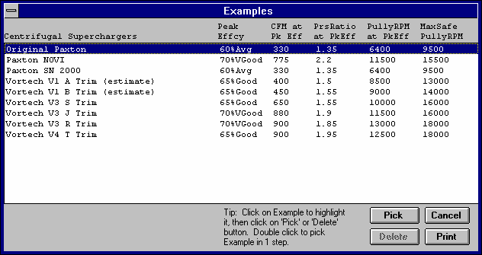
Figure 4.43 List of Performance Trends Centrifugal Supercharger Examples

Click on your choice to highlight, then click on Pick to pick it. (Or double click on choice to pick in 1 step.)
Superchargers as the Category under Performance Trends Examples. You will then obtain the list shown in Figure 4.43.

Choose the Original Paxton from the list, click on it to highlight it, then click on Pick. The program will show some screens comparing the current Centrifugal Supercharger specs with those you picked for the Original Paxton. Then there will probably be a “disclaimer” message, then a note explaining that the specs for the Example Original Paxton will be printed in blue. See Figure 4.44.
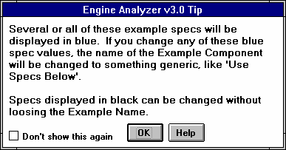
Figure 4.44 Note on Example Specs

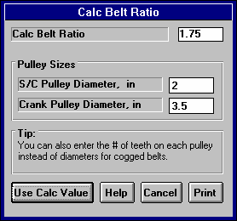
For the other 2 “non-blue” Centrifugal Supercharger specs, you should set them to match your setup. These are not based on the Original Paxton example. For Intercooler Eff % choose 0 No Intercooler. The supercharger Belt Ratio can be calculated by clicking on the Clc button and then entering a crank pulley diameter of 3.5 inches and supercharger pulley diameter of 2.0, pulleys that come with the used Paxton. This works out to a belt ratio of 1.75. See Figure 4.45 For a fair comparison to the turbo engine, leave off the exhaust system Exhaust System Type of Open Exhaust (no mufflers) and the Octane at 94. Calculate Performance with the Original Paxton supercharger with a 1.75 Belt Ratio.
Figure 4.45 Calc Belt Ratio Menu

Figure 4.46 shows the test results for the Original Paxton with the History Log. Notice in the Notes section that “S/C RPM High”, meaning that the Max Safe Pulley RPM entered in the Supercharger menu for the Original Paxton has been exceeded at some RPMs. The performance graph in Figure 4.47 shows a sharp drop in Torque and HP after 5000 RPM, which is due to this Max Safe Pulley RPM being exceeded. (Note that the real supercharger’s performance may not drop at these higher RPMs. The program is forcing performance to drop to make sure you notice that something may be going wrong with the supercharger at these higher RPMs.)
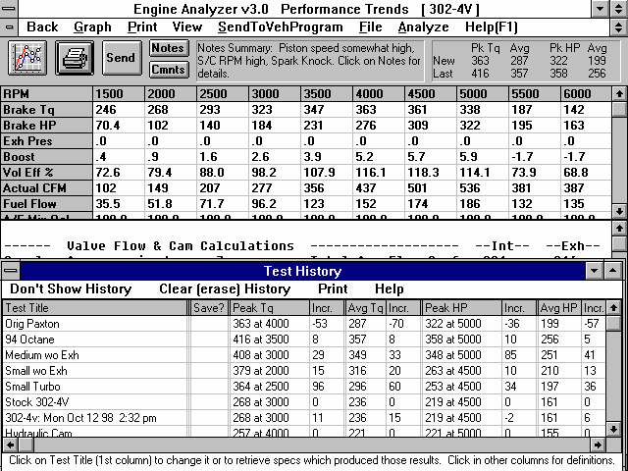
Figure 4.46, Performance Comparison of Turbo and Centrifugal Supercharger
Notes section showing S/C RPM is high at some RPMs (exceeded the Max Safe RPM spec in the Centrifugal specs menu.)
History Log shows Paxton performance is good, but not as good as the Medium Turbo. However, Paxton perfor-mance is still more than 100 Pk HP better than stock.

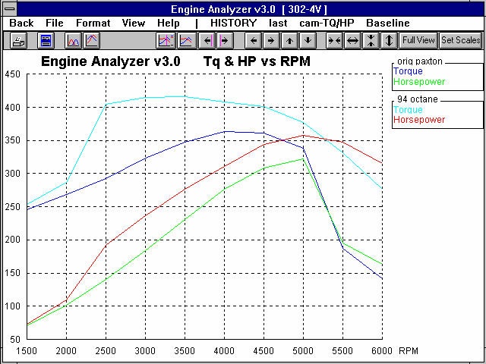
Figure 4.47 Graph Comparison of Medium Turbo and Original Paxton
Performance for Medium Turbo is better than Orig Paxton at all RPMs.

Orig Paxton performance drops at 5500 RPM and higher to point out the Max Safe Pulley RPM has been exceeded.

The results from both Figure 4.46 and 4.47 show performance for the Original Paxton being down significantly compared to the Medium Turbo. However, compared to stock, Peak HP has increased over 100 HP. Another interesting thing in the results is that Friction HP has increased significantly. For example at 5000 RPM it went from 86 HP for the turbo to 110 HP with the supercharger. This extra Friction HP is primarily for the power required to run the supercharger.

Safety Note: Unlike real superchargers, you can over-rev the supercharger in the Engine Analyzer with no problems. Always follow the manufacturer's recommendations for maximum belt ratios and Max Safe Pulley RPM limits.

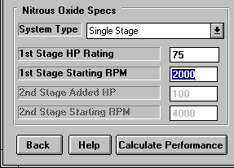
Since the centrifugal supercharger provides pretty good higher RPM power, you are considering installing nitrous oxide injection as well. You have heard that nitrous delivers tremendous low speed torque, which would fill in torque at low RPM where the supercharger builds little boost. At the Running Conditions menu, install a "small" 75 HP, single stage nitrous system, activated at 2000 RPM by setting the Nitrous Oxide System specs as shown
Figure 4.48 Nitrous Oxide Specs in Running Conditions Menu for 75 HP Nitrous Kit
in Figure 4.48.

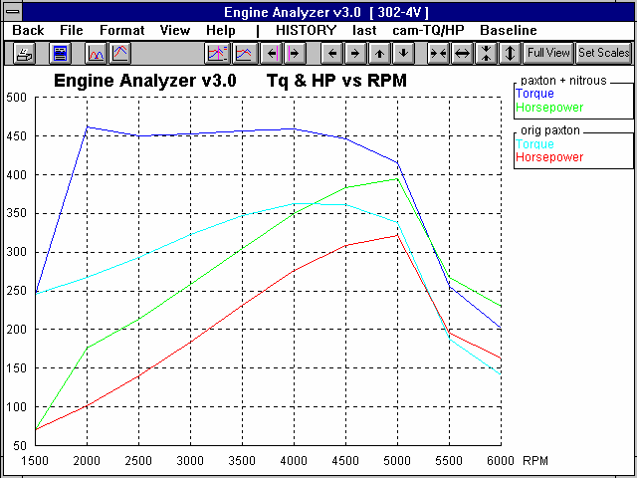
Calculate Performance and then graph the results for this condition of the Original Paxton with a 75 HP Nitrous Oxide kit. See Figure 4.49.
Figure 4.49 Original Paxton with and without Nitrous Oxide Injection

Note the large torque increase at low RPM with the nitrous oxide injection kit.

Figure 4.49 shows the large torque increase at low RPM that you expected. Now graph the Paxton + Nitrous Oxide test with the Medium Turbo test, as shown in Figure 4.50.
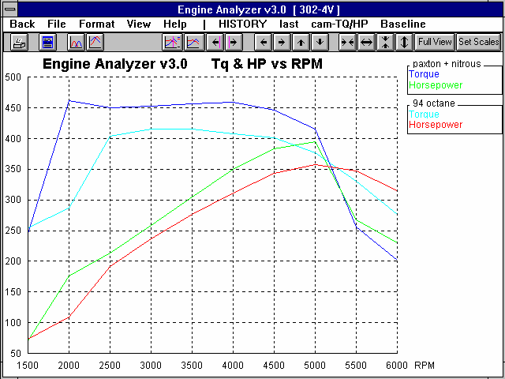
Figure 4.50 Paxton + Nitrous Oxide vs Medium Turbo

Paxton with 75 HP Nitrous Oxide kit outperforms the Medium Turbo at all RPMs until the Max Safe Pulley RPM limit is exceeded at 5500 RPM.

Figure 4.50 shows that even a relatively small nitrous system does provide tremendous torque at low speeds, a 175 ft lb increase at 2000 RPM. Click on Back at the Graph screen of Figure 4.50.
At the Test Results screen, click on Analyze in the menu bar to produce an Analysis Report. Fill in the Analysis Options menu as shown in Figure 4.51, then click on Make Report. The Analysis Report will point out that you are making tremendous amounts of torque, and high cylinder pressures must be dealt with. See Figure 4.52.

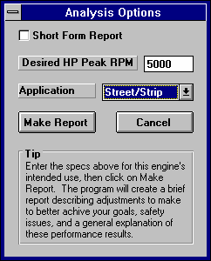
As pointed out with the turbo set-up, Actual CFM air flow and Fuel Flow have increased significantly. The fuel system components may need to be enlarged and the carburetor rejetted.
Figure 4.51 Analysis Report Options

Conclusions:
- Turbocharging, supercharging and injecting nitrous oxide can provide a significant performance increase.
- Turbocharging and supercharging make an engine prone to spark knock. Care must be taken to prevent detonation by retarding spark, running high octane fuel, not increasing (or even reducing) Compression Ratio etc.
- The Engine Analyzer provides a method to estimate performance increases and point out potential problems before the modification is made on the actual engine (excessive spark
knock, insufficient fuel pump capacity, excessive Supercharger RPM etc.)
- As with any modifications, the Engine Analyzer can not consider all details. Therefore, you must follow the manufacturer's recommendations for safe, reliable operation of a particular system.

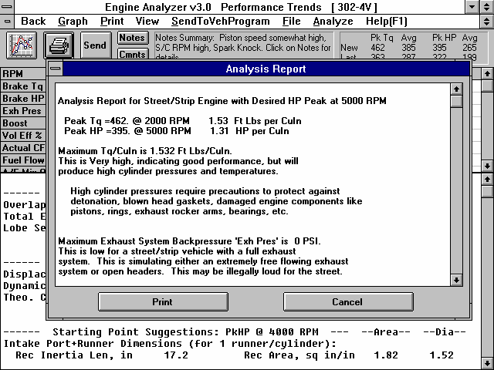
Figure 4.52 Portion of Analysis Report for Paxton + Nitrous Oxide Condition
Click on Analyze to bring up Analysis Options (Figure 4.51) and produce Analysis Report shown here.
Example 4.4 Using Flow Bench Data
Features Introduced (and suggested background reading):
- Calculating Valve Flow Effcy in the Head(s) menu (Section 2.9.5)
- Calculating Runner Flow Effcy in the Intake System menu (Section 2.9.6)
- Appendix 3 Intake and Exhaust Tuning

Check Appendix 5 and 6 for MANY new features added in std and Plus versions 3.2 and 3.4 for describing the head’s flow potential, including using a full flow curve.

The Engine Analyzer allows you to enter flow bench data for your cylinder heads and intake manifold separately. From this information you can determine the flow restriction of the head; and flow restriction and tuning capabilities of the manifold runner or header.

To use the Engine Analyzer's full capabilities, it is necessary to flow the head first with an optimum entrance or exit adapter, and then with the manifold or header. For this example you will use the intake side of the 302-4V's head modified with a 1.94" intake valve diameter. You will also use an aftermarket manifold with rectangular runners 2" high by 1.2" wide. The flow numbers used in the example are arbitrary. Your flow tests will likely show similar but not equivalent trends.

Flow Test:
This flow test will be performed at 28" water test pressure, but it could be any test pressure over 7" water. The Engine Analyzer needs data at an L/D (valve lift to diameter ratio) of 1/4, which is .485" valve lift for the 1.94" valve. To obtain the optimum air flow for the bare head, it is necessary to install a radiused inlet adapter on the bare head's intake port.

Set up the test condition of 28" test pressure and .485" lift with the adapter. The flow reads 201 CFM. Leave all settings "as is" and remove the adapter. You will note the flow falls to 191 CFM when you adjust the test pressure back to 28". (It may be necessary to shut down the flow bench between readings to avoid overheating.)

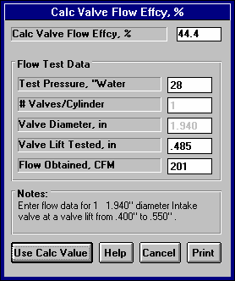
Now install the intake manifold without the carb or throttle body. Be sure all openings in the manifold other than carb/throttle body opening are sealed. This includes all runners not being tested, vacuum ports, EGR openings, etc. Adjust the test pressure back to 28" and you obtain a reading of 194 CFM. Note that the head and intake
Figure 4.53 Calc Menu for Valve Flow Effcy
flow better than just the bare head without the adapter.

Now, start up the Engine Analyzer program. Open a new copy of the 302-4V file by clicking on the Engine Library button. Calculate performance to obtain baseline performance with the production head and intake manifold.

Now we’ll calculate the new head Port Diameter and Valve Flow Effcy, and intake manifold Runner Diameter and Runner Flow Efficiency. Click on Head(s) to bring up the Head(s) menu. Enter the new Valve Diameter of 1.94. If this head has had some port work done when the larger valves were installed, you should CC the ports, which showed an increase from the stock 145 ccs to the new 152 ccs. Type in 152 for Intake Port Volume, and you will notice Avg Port Diameter increases from 1.5 to 1.54. As you would expect, the port length does not change from doing port work.
Now click on the Clc button next to Intake Valve Flow Effcy to produce the menu shown in Figure 4.53. Enter the flow data for the head alone as shown in Figure 4.53. Click on Use Calc Value to
load in the 44.4% Flow Efficiency calculated here. (Note in Figure 4.53 that you could have used any valve lift between .400 and
.550 inches, and that you did not have to use exactly .485 inches.)
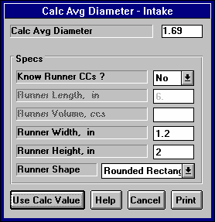
The changes to the Head(s) specs should now be 1.54” Avg Port Diameter, 152 Port ccs and 44.4% Valve Flow Effcy, all for the Intake Port. Click on OK to close the Head(s) menu.
Figure 4.54 Calc Runner Diameter Menu

Click on Intake System to open the Intake System menu. Since this is a different manifold than stock, you may have to change several specs. Click on the Clc button next to the Runner Diameter box to produce the Calc Runner Flow Effcy menu shown in Figure 4.54. Make the entries as shown, using “Rounded Rectangular” as the basic shape of the manifold runner. The program calculates an effective circular diameter of 1.69" for a rectangular runner 2" high by 1.2" wide. Click on Use Calc Value to load 1.69" into Runner Diameter in the Intake System menu.

Last, click on the Clc button for Runner Flow Effcy to obtain the Calc Runner Flow Effcy menu shown in Figure 4.55 (previous). Figure 4.55 shows the test data from Table 4.3 filled in and a calculated Runner Flow Effcy of 86%. Click on Use Calc Value to return to the Intake System menu with 86% entered for Runner Flow Effcy.
Table 4.3 Flow Test Results
Condition | Test Pressure | Valve Lift | L/D | CFM
Bare head, no adapter | 28" | .485" | 1/4 | 191
Bare head, optimum adapter | 28" | .485" | 1/4 | 201
Head and intake | 28" | .485" | 1/4 | 194

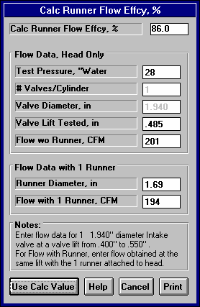
This new manifold is a dual plane design, like the stock manifold so the Design will stay at Dual Plane-Carbs. The average length of the intake runners measure 6 inches like the stock intake, so Runner Length will stay at 6. The same carburetor will be used, so Carb specs will stay the same as stock.
Figure 4.55 Calc Runner Flow Effcy Menu

The Intake System menu should now look like Figure 4.56. These specifications reflect a head with a larger intake valve, manifold with larger runners, and flow coefficients which were determined from actual flow bench testing.

Calculate performance for the 302-4V with the new head and intake manifold. Remember the exhaust side of the head is unchanged.
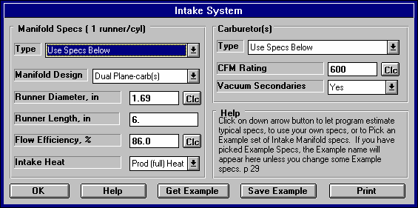
Figure 4.57 is a graph for these results compared to the Stock 302-4V. It shows that below 3000 RPM the stock head and intake manifold perform better, but over 3000 RPM the new Flow Tested intake port and valve, and intake manifold are far superior. Peak HP has increased from 219 at 4500 to 257 at
Figure 4.56, Intake System Menu for Flow Tested Head and Manifold
5500.

Click on Back at the Graph screen to further inspect the
test results. They show:
- Peak torque has increased from 268 at 3000 to 282 at 4000 RPM.
- Peak HP has increased from 219 at 4500 to 258 at 5500.
- Peak In InertiaPrs (intake pressure due to inertia tuning) has increased from 1.3 at 4500 to 2.5 PSI at 5000.
- The Mach # at all RPMs has decreased approximately 27%, which means this engine can rev higher before "running out of breath". This is also evident by the Intake Vlv Area in the Special Calculations section increasing about 35 %, from 150.7 sq-in*deg to 204.4 sq-in*deg.
- The Total Exh/Int % dropped from 90.5% to 66.8%, which is now much less than the "target" 75% with the new intake system. This suggests performance could now be significantly improved with better flowing exhaust ports and runners, or more exhaust cam lift and duration.

It is important to remember that performance for the engine improved because the head and manifold flowed more CFM on a flow bench than the stock parts. Performance did not improve just because the parts were flow tested. The flow testing results simply let the program more accurately predict how much better the engine would perform. Flow testing by itself does not improve performance.

Alternate (but less accurate) Method:
If it is difficult to design optimum exhaust and intake adapters, or this data is not available, it is best to flow the head with the appropriate manifold or header. For the example above, this would give 194 CFM. Some of the restriction is due to the valve and some is due to the manifold runner.

A reasonable assumption is 4% of the total flow restriction is due to the runner. If you multiply the CFM flow for both the port and manifold together by 1.04 you will obtain a reasonable flow value to use for the bare head. In this case 194 CFM x 1.04 = 202 CFM. Using 202 CFM you would calculate a Valve Flow Effcy of 44.7%, and 194 would calculate a Runner Flow Effcy of 83.8%.

Conclusions:
- The Engine Analyzer's calculation menus allow you to easily calculate both Valve Flow Effcy and Runner Flow Effcy from flow bench data to more accurately predict performance improvements.
- An alternative method is suggested if you only have data for flowing the head and manifold as a unit.

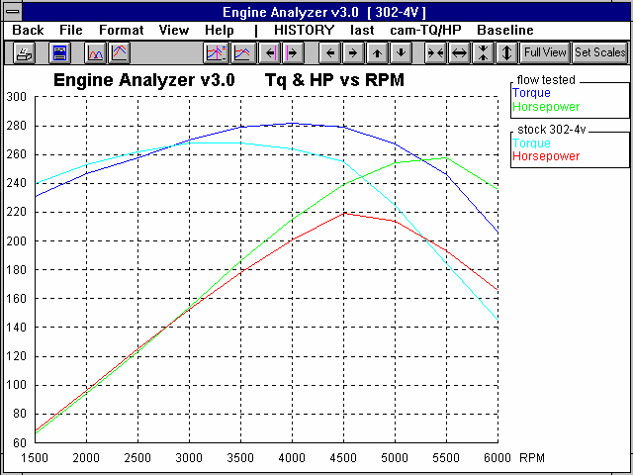
Figure 4.57 Graph of Stock 302-4V vs Flow Tested Head and Manifold

Note increase in HP and RPM where HP peaks with larger, freer flowing intake port and manifold.
Example 4.5 Optimizing Tuning
Features Introduced (and suggested background reading):
- Example 4.4
- Appendix 1 Accuracy and Assumptions
- Appendix 3 Intake and Exhaust Tuning
- Analysis Report (Section 3.1)

The Engine Analyzer simulates the pressure pulsations which are present in the intake and exhaust runners. These pulsations are critical to obtain optimum performance, especially for naturally aspirated, free flowing race engines. With intake and exhaust systems designed to take advantage of these pulses, volumetric efficiencies of well over 100% are possible without supercharging.

Since tuning effects are most noticeable with free flowing heads, individual runner intake systems, and high overlap cams, you will use the HYDRPLN-V6 engine for this example. The goal of this example is to design an intake and exhaust system for optimum tuning at 8000 RPM. Optimum tuning at 8000 should also optimize performance at 8000 RPM.
Intake Tuning
Open a copy of HYDRPLN-V6 from the library. Open the Running Conditions menu and set the Starting RPM to 5000, Number of RPMs to 10 and RPM Increment to 500. The RPM Preview should show “5000, 5500, 6000 ... 9500”. You want to be sure that 8000 RPM is fully contained in the RPM range you are going to run.

Check the ‘Starting Point’ Suggestions specs in the Running Conditions menu. Since you want to optimize tuning and performance at 8000 RPM, set the spec For Peak HP at This RPM to 8000. Also, because the current intake port in the head is 5” and the intake runner in the injection stacks is 13”, enter 18” for the spec For This Intake Runner Len.

Calculate performance "as is" to get a baseline of the current engine. The Engine Analyzer will give suggestions for intake and exhaust runner dimensions and cam specs for good performance at 8000 RPM. The results are shown in Figure 4.59.

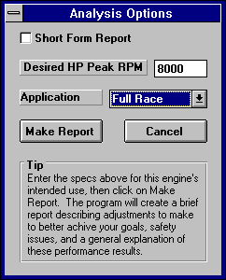
Once performance is calculated as shown in Figure 4.59, the Engine Analyzer can create an Analysis Report. Click on Analyze to bring up the Analysis Options menu as shown in Figure 4.58. Since this is a race engine that you want to produce good HP at 8000 RPM, set Desired HP Peak RPM to 8000 and Application to Full Race. The program will use these guidelines and analyze the calculated performance, for ways to meet your objectives, point out potential safety concerns, etc.
Figure 4.58 Analysis Report Options

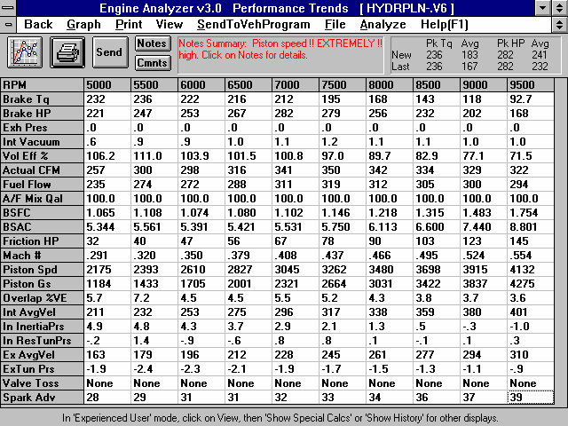
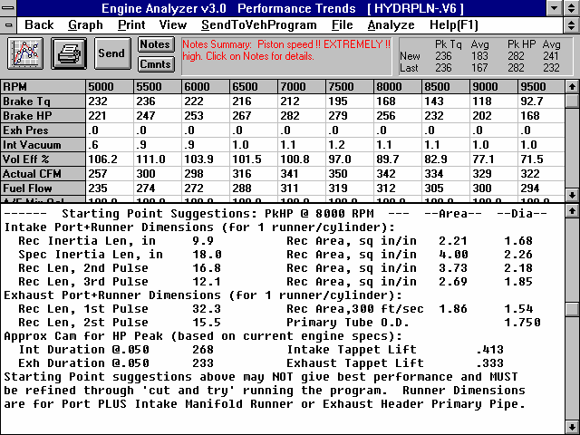
Figure 4.59 Baseline Test Results with ‘Suggestions’ for 8000 RPM
Click on View, the Show Special Calcs (large) for bottom screen
Piston Spd and Piston Gs (indicators of internal stresses on the pistons, rods etc.) increase rapidly with increasing RPM.
Overlap %VE indicates effectivness of resonance tuning
Three intake tuning factors show strength of intake inertia and resonance tuning.
Two exhaust tuning factors show strength of exhaust tuning.

Bottom half of Special Calculations section shows ‘Starting Point’ Suggestions for an RPM you enter at the Running Conditions menu.

Click and drag slide bar to view lower section of results.

Pay close attention to this note describing limitations of these suggestions.

IMPORTANT: The Engine Analyzer can NOT anticipate all UNSAFE and poor performing situations. Do NOT rely only on the Analysis report to point out problems and SAFETY HAZARDS.

As you read through the Analysis Report of Figure 4.60, some important points made by the report include:
- The engine is producing high torque for this engine displacement, indicating good performance but the necessity for good head gaskets, etc.
- Int Vacuum is somewhat high. Performance will likely improve with a higher Throttle Body CFM Rating (larger throttle or better flowing throttle plates). This is a common problem with Individual Runner carburetor or injection intake systems.
- Piston Spd (average piston speed) is in the normal range for a race engines, but this level of Piston Spd requires extremely strong and light reciprocating components, like connecting rods, pistons, etc.
- The engine would likely improve performance at 8000 RPM (while losing some torque at lower RPM) with shorter and larger diameter intake runners.
- Since the spec For Peak HP at This RPM is 8000 (the same as the Analysis Option's Desired HP Peak RPM), you should check the Starting Point ‘Suggestions’ at the end of the calculated performance report. These runner and cam recommendations may give better performance at 8000 RPM than the current specs.

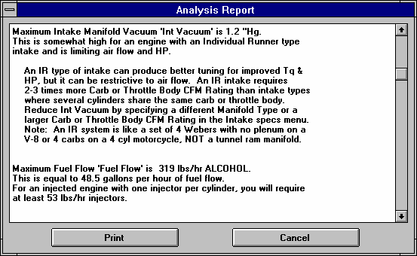
look normal for this
If certain results
Figure 4.60 Portion of Analysis Report
Click and drag slide bar to view entire Analysis Report
Click here to print Analysis Report
type of application (in this case Full Race), they may not be mentioned in the Analysis Report. It is always good to do your own analysis of the calculated performance.
Important points shown on the performance printout in Figure 4.58 and not mentioned in the Analysis Report include:
- Mach # at 8000 RPM
is a relatively
low .466 indicating the intake valve should not be a major restriction at this RPM. (Note that you always want more flow area to produce a lower Mach #. Its just that .466 indicates the intake valve and port and cam profile are not overly restrictive.)
- The Total Exh/Int % of 72.5 is close to the recommended 75%. The exhaust may benefit slightly from more cam or valve flow, but it should not be overly restrictive.
- In the RPM Data section, the peak In InertiaPrs of 4.9 PSI occurs at 5000 RPM. This says the current intake runner dimensions give optimum inertia tuning at 5000 RPM rather than the desired 8000 RPM.
- The contribution to volumetric efficiency during overlap is high, shown by the high values of Overlap %VE of over 7% at 5500 RPM.
- In ResTunPrs pulses are high, showing a maximum of 1.4 PSI at 5500 RPM and a minimum of -.9 PSI at 6000 RPM.
- The Est Idle Vac of 3” indicates this cam has a huge amount of overlap, which is required for a high RPM race engine.
Due to the high RPM, relatively long intake runners, and high overlap camshaft, intake resonance tuning (In ResTunPrs) may be important for this engine. One can see that when In ResTunPrs is high and positive, Overlap %VE is high, Vol Eff % is high and torque and HP are high. Where In ResTunPrs is a high negative number (vacuum pulse during overlap), Overlap %VE, Vol Eff %, torque and HP are low.

At the bottom of Figure 4.58, in the Special Calculations section, there are some Starting Point Suggestions for intake and exhaust runner dimensions. Repeat the performance calculations 3 times with the intake runner combinations from Table 4.4.
Table 4.4 Starting Point Suggestions for Runner Dimensions at 8000 RPM
Case | Int Port & Runner Length * | Int Port & Runner Dia *
Inertia Tuning | 9.9 | 1.68
2nd Pulse | 16.8 | 2.18
3rd Pulse | 12.1 | 1.85
∗ Important: The Starting Point Suggestions are for the entire intake runner, from the valve to the end of the runner. However the runner is broken into 2 parts in the program, the port in the head and the runner in the intake manifold. For these modifications, you will leave the Port Length in the Head(s) Specs menu at 5”, and just change the Runner Length in the Intake System menu to make up the suggested total length. For Port & Runner Dia, you will set the Port Diameter in the Head(s) menu and Runner Diameter in the Intake System menu both to the suggested diameter.

Table 4.5 shows a summary of the test results trying the 3 different intake runner recommendations.

Table 4.5 Comparison of 3 Intake Starting Point Suggestions
Condition | Stock | Inertia | 2nd Pulse | 3rd Pulse
HP @ 8000 | 256 | 310 | 297 | 209
Avg HP from History Log | 241 | 262 | 245 | 255

Overlap %VE @ 8000 | 4.3 | 4.6 | 5.0 | 5.0
In InertiaPrs @ 8000 | 1.3 | 3.2 | 2.4 | 3.0
In ResTunPrs @ 8000 | 0.1 | 0.5 | 1.0 | 1.0

For the combination of the existing head with the “2nd Pulse” intake runner suggestion, you get the warning message shown in Figure
4.61. Because you are just trying things, and you actually do want to try this unusual combo, click on Yes to proceed.

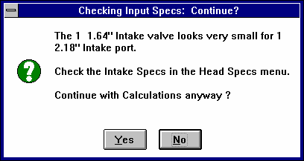
Figure 4.61 Note About Unusual Combo

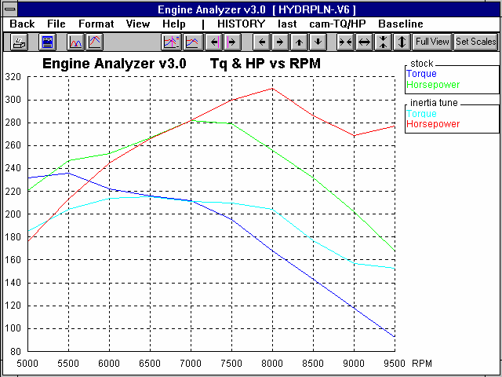
Figures 4.62-4.64 graphically compare some of these results to the Baseline Condition and to each other.
Figure 4.62 Comparison of Baseline with Optimum Inertia Tuning Runners

Large HP improvement over Baseline at 8000 RPM

Figure 4.62 shows a comparison between the stock intake and one designed for optimum inertia tuning (9.9" x 1.68" runners). Both Table 4.5 and Figure 4.62 show a significant increase in higher RPM performance. Table 4.5 shows that inertia tuning is strong at 8000 (In InertiaPrs is 3.2 PSI), but resonance tuning is relatively low (In ResTunPrs is .5 PSI) compared to the other recommended lengths. Figure 4.62 also shows a slight resonance tuning peak occurring at 7500 to 8000 RPM, and another more evident one at 9500 RPM.

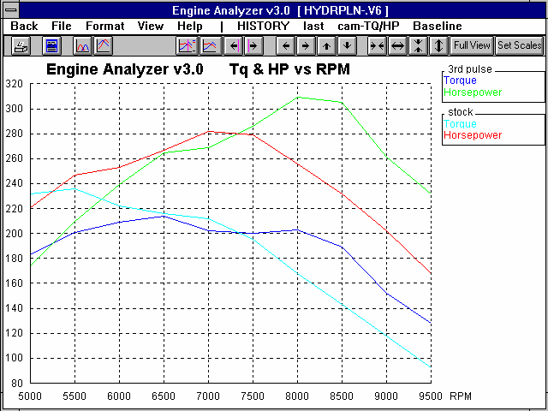
Figure 4.63 shows a comparison of the Baseline with the runners giving optimum tuning from the “3rd reflected pulse” otherwise known as resonance tuning. You can see that these runner dimensions also produce a significant power improvement at 8000 RPM.
Figure 4.63 Comparison of Baseline with “3rd Pulse” Tuning Runners

Large HP improvement over Baseline at 8000 RPM

Figure 4.64 shows that both the Optimum Inertia Tuning runner and Third Pulse runner give good performance through the 7000-9000 RPM range, but overall the Optimum Inertia Tuning runner is best.

Although this example shows resonance tuning to have a significant effect, most engines with shorter runners, less overlap and lower RPM ranges should be designed for optimum inertia tuning.

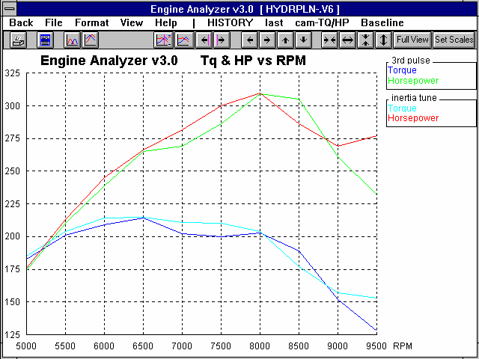
Figure 4.64 Comparison of Optimum Inertia vs “3rd Pulse” Tuning Runners

The intake runner dimensions which give optimum resonance tuning for the 3rd reflected pulse produces more HP only at 8500 RPM. At all other RPMs, runners which produce optimum Inertia tuning perform better.

Safety Note: In Figure 4.58, note the rapid increase in Piston Gs (internal stress) as RPM increases. All 3 tuned systems make more power at higher RPM, therefore it is likely the engine will "see" higher RPM running. If your rotating components are not designed for these high G levels, you may want to tune for a lower RPM. Also, an overspeed set to a safe RPM limit is always a good idea.
This is also pointed out in the Analysis Report when it discusses high Piston Spd (average piston speed). Piston Spd and Piston Gs are related. High levels of either require strong, light reciprocating components.

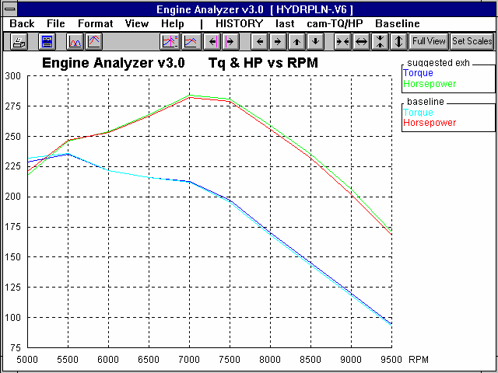
Exhaust Tuning
Figure 4.65 Baseline vs Optimum Suggested Exhaust Header
Suggested exhaust header dimensions provide a slight improvement at high RPM
Now look at the exhaust side of the engine. Go to the Main Screen and open a fresh copy of the HYDRPLN-V6 to
examine exhaust tuning effects. The
Engine Analyzer assumes the best exhaust inertia supercharging occurs at an Ex AvgVel of 300 ft/sec. Figure 4.58 shows that Ex AvgVel does not reach 300 until 9500 RPM. This would indicate the runner (header primary) is too large.
The ExTun Prs pressure (exhaust tuning pressure) is best at 5500 RPM showing -2.4 PSI of suction. The negative sign indicates suction which helps performance on the exhaust side.

Now, try installing the 1st Pulse runner length recommended by the Engine Analyzer in Figure 4.58 of 32.3" and diameter of 1.54". Note that the program assumes 3” of exhaust runner exist in the exhaust port in the head. Therefore, you should use 29.3” (32.3”-3”) for the Header Primary Length and 1.54 for the Header Primary Diameter (inside diameter) in the Exhaust System menu.

Note that peak ExTun Prs of -2.4 now occurs at 6000 and 6500, which is less than 8000 you were expecting, but still is peaking at a higher RPM than it originally did. The recommended length gives slightly better performance throughout a range of RPMs, with 8000 RPM in the middle of this range. Notice that below 6500 RPM Ex TunPrs drops off quickly, but above 6500 RPM it drops quite slowly. If you designed for best exhaust tuning at 8000 RPM, at RPMs below 8000 RPM, exhaust tuning would be quite poor.

Figure 4.65 shows performance of the stock exhaust and the recommended exhaust. Note that the optimum exhaust shows only slight gain through the RPM range.

This example makes some important points:
- Exhaust tuning is not as effective at making performance improvements as intake tuning, especially when intake tuning is already good. Exhaust tuning can only scavenge the clearance volume. However, intake tuning cam both scavenge the clearance volume and provide supercharging at intake closing due to inertia tuning.
- Once the clearance volume has been scavenged clean, additional scavenging only goes to "short circuiting". Short circuiting is when fresh charge goes right through the chamber out the exhaust during overlap. This is probably the case here at 8000 RPM. Overlap %VE was already high at 8000 with the stock engine. Providing additional scavenging vacuum from the exhaust was of little help.
- This example also illustrates that it may be beneficial to tune the intake to the RPM for desired peak HP, Then tune the exhaust to a different RPM, one where intake resonance tuning is reducing power. That would be an RPM where In ResTunPrs was negative. The overall effect would be a broader torque curve.

Conclusions:
- The Engine Analyzer's Analysis Report gives tips for improving performance.
- The Engine Analyzer allows you to simulate simple intake and exhaust tuning principles.
- Intake tuning generally has more impact on performance than exhaust tuning.
- The ‘Starting Point’ Suggestions at the bottom of the Special Calculations section of the results give some ideas of intake and exhaust runner dimensions which may give good performance. Note that you must try them in the program to determine which are best, or if they work well with the rest of your engine combination.
Appendix 1: Accuracy and Assumptions

Background:
The Engine Analyzer was developed as a:
- Learning aid for those who want to better understand internal combustion engines.
- Tool to help predict effects of certain engine modifications for engine builders, racers, and performance enthusiasts.
- "Theoretical Dynamometer" to allow anyone to try things which are too expensive, difficult, or impossible with a real engine.

The Engine Analyzer will provide you an engineering estimate of what should occur when general modifications are made based on internal combustion engine theory and several "rules of thumb". By seeing all the specifications which go into the calculated results, you may have a false sense that the computer knows your engine exactly, what manufacturer's intake manifold and carburetor are installed, who ported the heads, the exact cam profile. Actually the computer does not know if the specifications are for a Model T or a Formula 1 engine.

A good analogy to the Engine Analyzer is a flow bench. A flow bench can not predict exact torque and HP curves, but is still a vital tool for engine development. In the same way, use the Engine Analyzer results as a guide, as a second opinion of how your engine should perform under near optimum conditions.

Iterations:
Before you talk about accuracy, it is important for you to understand the types of calculations going on inside the Engine Analyzer and other sophisticated simulation programs. A simple program could involve calculating torque from volumetric efficiency:

Torque = K x volumetric efficiency

Where: K is a constant which includes engine displacement

You enter a volumetric efficiency and obtain a torque value. The answer you obtain on the left side of the equation has no effect on the inputs on the right side of the equations. (Some rather expensive programs are based on an equation no more complex than this.)

However, lets look at a simplified version of the equation which calculates the temperature rise of intake air as it passes through the intake port.

End Temp = Intake Temp + K * (End Temp + Intake Temp)

In this case the "End Temp" answer you get on the left side has an effect on the inputs to the equation on the right. The only way to solve equations like this is through "iterations".

Iteration is a process where you assume an answer, use that answer in the right side of the equation, calculate the actual answer and see if the actual answer is "close enough" to the answer you assumed. For example:
Iteration Process:

For this example, use above equation with K=.3, Intake Temp = 80 Assume End Temp is 145 degrees
Calculate End Temp: 80 + .3 * ( 145 + 80 ) = 147.5

Are assumed End Temp and Calculated End Temp Close Enough (within 1 degree)
No, so do again using new End Temp answer Calculate End Temp: 80 + .3 * ( 147.5 + 80 ) = 148.25 Are assumed End Temp and Calculated
End Temp Close Enough (within 1 degree) Yes, so an approximate answer is:
End Temp = 148.25 degrees

If "close enough" was 3 degrees, our first answer of 147.5 degrees would have been good enough. If "close enough" was .1 degree, it may require many more calculations to arrive at an answer which is "close enough". If the equation is very complex and the inputs are an unusual combination, no answer may be reached no matter how many times the calculation is performed. This is called "not converging on a solution".

Making the tolerance ("close enough") small will produce more exact answers but will require more calculation time. Performance Trends has selected tolerance bands for iterations which give good accuracy with reasonable calculation times.

Because many of the equations within the Engine Analyzer must be solved by iterations, there is no one exact answer. All calculations are an approximation. Therefore, do not be alarmed if a Total Avg Flow Coef in the Special Calculations section is calculated as .357 for "straight up" cam timing and as .358 with 4 degrees of cam advance. These numbers are close enough that they should be considered equal. Advancing the cam should not and did not change Total Avg Flow Coef.

Correlation with Dynamometer Data:
The Engine Analyzer has been validated using dynamometer data from engines which were generally "streetable", getting between
0.5 to 2.0 HP per cubic inch. With the improved tuning simulations, the Engine Analyzer Version 3, Brk Tq and Brake HP results compared within ±7% of the actual dynamometer data at most RPMs. For example, if the Engine Analyzer predicted 400 ft lbs of peak torque, the actual engine would produce from 372 to 428 ft lbs from dynamometer tests.

One must also remember that dynamometer testing is not an "exact science". How many times have you seen Cam Grinder A's dyno data show their cam better than Cam Grinder B, but Cam Grinder B's dyno data says their cam is better. Significant variability exists from run to run, day to day and especially from dyno facility to dyno facility. Therefore, the dyno data you are comparing to the Engine Analyzer results may be in error more than the program. See Appendix 4.

The weakest area for the Engine Analyzer is the intake and exhaust tuning, and somewhat in the area of cam timing. This is true of most any reasonable sophisticated engine simulation program, including the “million dollar” programs used by Ford and GM. (Simplistic programs don’t even attempt to estimate tuning effects.) Both these areas have an important impact on performance of high output race engines. You are continuing to improve this as you learn more. More accurate calculations are possible with the Engine Analyzer "Pro".

Major Assumptions:
To make the Engine Analyzer and the specifications which describe the engine containable on a personal computer, several simplifying assumptions are made which are listed below. Other approximations and assumptions exist as identified in Section 1.3 A Word of Caution and scattered throughout this manual. See Assumptions in the Index.

- All cylinders in the engine are identical.
- There is a very simplified simulation of the influences from one cylinder on another with regard to intake or exhaust tuning effects. Carb or throttle body restriction level and Exh System CFM Rating are simulated correctly to handle total flow from all cylinders, considering the Intake Manifold Design and an assumed Exhaust System design.
- The fuel remains liquid in the intake manifold and the cylinder until the intake valve closes. Therefore, vaporization of the fuel does not displace any air or reduce volumetric efficiency or performance.
- The program attempts to predict the A/F distribution and A/F mixture quality based on very simple assumptions. The program assumes there are not major A/F distribution problems.
- The Octane number of Gas reduces the vapor pressure of the Gas. This means that the higher the Octane # for the Gas, the more likely A/F Mixture Quality problems.
- Cam timing and profiles are assumed to be typical of "off the shelf" cams. Profiles are assumed symmetric, that means the opening ramp is the same as the closing ramp. Generally this simulates asymmetric cams quite well also.
- For Gas simulations, the energy released during combustion is based on a fuel called octane, with a heating value of approximately 19,000 BTU/lb. For Alcohol, the heating value is 8,600 BTU/LB.
- The frictional drag from the three (3) Losses specs in the Short Block menu increase with increased engine displacement. For example, if you specify a stroke which is 20% longer to the Engine Analyzer, displacement increases 20% and so does the friction from these 3 sources.
- No dynamics of the valve train are simulated until major problems like Valve Toss or Lifter Pump Up are estimated to occur. The Engine Analyzer assumes a near perfect valve train, except that some Rocker Arm Ratio bending is assumed. The higher the Rocker Arm Ratio, the more bending assumed. Rocker Arm Ratio is assumed constant, and Valve Lash does not change with temperature.
- Intake and exhaust tuning are very complex simulations as identified in Appendix 3. Small changes in air temperature, surface temperature within the air tracts and effects from other cylinders make exact tuning simulations impossible. See Appendix 3 for more complete tuning assumptions.
- All combustion chambers are burning the air/fuel mixture well. Although the Chamber Design spec in the Head(s) menu will show some difference for different chamber designs, the program assumes there are no major problems.
- There are no ignition system problems.
Appendix 2: Summary of 4 Cycle, Internal Combustion Engine Theory

Most performance enthusiasts know the 4 processes which occur in the 4 cycle, internal combustion engine, namely:

- Intake
- Compression
- Combustion and Expansion
- Exhaust

However, many do not fully understand the theory of how these processes make HP, or how you change these processes to make more HP.

Let's look more closely at the Combustion and Expansion part of the cycle, the portion of the cycle which actually makes power. Four cycle, IC (internal combustion) engines produce power from the chemical energy stored in the fuel they burn. This stored energy is released when the fuel burns in the cylinder with oxygen in the air. The heat which is released, heats the
air which is trapped in the cylinder, raising its pressure which pushes on the piston and turns the crankshaft. This whole process can be thought of as the "explosion" which occurs when the spark plug fires.

Let's examine the chemical energy in the fuel which is released in the engine. If you look at the engine as just a "black box" (Figure A.1); you do not know what goes on inside, except that fuel goes in and horsepower comes out. You can calculate the amount of horsepower the fuel contains if you know the flow rate of the fuel and the chemical energy of the fuel.

Figure A.1 “Black Box” Engine
Fuel In

HP Out

Example of "Black Box" Engine
Fuel Flow Rate = 40 lbs/hr

Chemical Energy in Fuel = 19,000 BTU/lb Conversion factor: 1 HP = 2544 BTU/hr

HP into "Black Box":

- 40 lbs/hr x 19,000 BTU/lb = 299 HP
2544 BTU/hr

If you knew the efficiency of this "black box" engine at converting chemical energy into mechanical energy (HP), you could calculate its HP output. For this example, let's say the "black box" engine is 25% efficient.

- Efficiency = HP out x 100%
HP in

Filling in the information you know into eq (2):

25% = HP out x 100%
299 HP

Rearranging terms:

HP out = 25% x 299 = 75 HP
100%

Power out of "Black Box" engine:

- F.F.R x C.E.F x Eff = HP out
2544

Where: | F.F.R. | = Fuel Flow Rate, lb/hr
 | C.E.F. | = Chemical Energy of Fuel, BTU/lb
 | Eff | = Total Engine Efficiency

Using this simple logic, if the efficiency stays the same, all you have to do is pump more fuel into the engine to produce more power. For example, remove the carburetor and dump the fuel directly down the intake manifold. You could pump the gas tank dry in a matter of minutes, but you all know that the engine would probably produce no power at all. The energy in the fuel can only be released if there is enough oxygen available to burn it completely and the fuel and air are well mixed in the right proportions.

Under perfect conditions, it takes about 14.6 lbs of air to completely burn 1 lb of fuel (an air/fuel ratio of 14.6:1, or A/F = 14.6)*. Under these conditions, extra fuel over the 14.6 A/F is wasted and can severely reduce power if extremely rich (A/F ratios richer than 11.0). This wasting of fuel decreases efficiency "Eff". Therefore, to get more fuel into the engine to produce more HP, you must also get more air in so the fuel can burn completely. From this information, you can add something to the equation for the "black box" engine, that HP does not depend on fuel flow, but more importantly on air flow. You will replace the "Fuel Flow Rate" with "Air Flow Rate / Air/Fuel Ratio".

HP from "Black Box" Engine:
- A.F.R x C.E.F. x Eff = HP out A/F 2544

Where: A.F.R. = Air Flow Rate, lb/hr
A/F = Air Fuel Ratio

Although it's easy to get extra fuel into the engine, it is difficult to get more air (oxygen) into the engine. The amount of oxygen the engine takes in for a given amount of time depends on:

- The amount of air the engine can take into the cylinder(s) on one Intake Stroke.
- The # of intake strokes in the given amount of time.
- The density of the air that enters the cylinder.
- The amount of oxygen in the air, which is always 21% , unless you are using nitrous oxide or a fuel which contains oxygen like Alcohol.

The amount of air the engine can take in on one Intake Stroke depends on the number and the size of the cylinders. This is the engine's displacement or CID (cubic inch displacement).

The # of intake strokes in a given amount of time is the engine's speed or RPM/2. RPM is divided by 2 because 4 cycle engines ingest air only once for each 2 revolutions.

The density of the air that enters the cylinder depends on many engine design characteristics, for example intake system restrictions, cam timing, etc. A number which describes how dense the air is which enters the cylinder is the Volumetric Efficiency, or Vol Eff % as it is called by the Engine Analyzer. See Vol Eff % in Section 2.8. These 3 items are what determine the Air Flow Rate in equation (4).

* Although 14.6 A/F is the perfect ratio chemically, not every oxygen molecule in the air will "find" a fuel molecule to react (burn) with. Therefore, since air flow is the factor limiting power, extra fuel is added to better ensure every oxygen molecule in the air can find a fuel molecule. For this reason, actual engines run at 11.5-13.5 A/F to obtain maximum power.

- A.F.R. = CID x RPM x 60 x VE % x .0764
1728 2 100%

Where: CID is the cubic inch displacement of the engine RPM is the engine speed
VE % is the volumetric efficiency in % (for the air which actually stays in the cylinder)
1728 converts cubic inches to cubic feet
60 converts RPM to Revs per Hour
.0764 is an approximate density of air (lb/cu ft)
100 is to convert VE % to a simple fraction

Multiplying all the constants together:

- A.F.R. = CID x RPM x VE % x .00001326

Substituting equation (6) into equation (4):

- HP out = CID X RPM x VE % x .00001326 x C.E.F. x Eff
A/F 2544

Now, lets look at the last term in the equation, "Eff". This efficiency term is actually talking about 2 separate efficiencies:

Thermal Efficiency (related to BSFC in the Engine Analyzer’s results): The thermal efficiency is an engineering term that describes how efficiently the combustion and expansion process makes use of the heat energy which pushes on the piston during the expansion stroke. Explaining thermal efficiency can get quite complex for this discussion. However, a simple illustration of thermal inefficiency is the heat left in the exhaust gasses. If the thermal efficiency of the engine were higher, more of the heat of combustion would be used to push on the piston, less heat would be exhausted from the cylinder, and the exhaust would be cooler. The thermal efficiency is quite difficult to improve beyond the range of .40 (40%), with most engines having a thermal efficiency of .25 (25%) to .35 (35%).

Mechanical Efficiency (related to Friction HP in the Engine Analyzer’s results): Up to this point you have talked only about the amount of work the burned gases or "explosion" does on the top of the piston. This work done on the piston is called Indicated Work or Indicated HP. However, not all this Indicated Work or HP gets out of the engine to the crankshaft. Some of the HP is used up in forms which can be grouped under the title of "Friction" which include:

Where HP is lost to Friction:

  - Rubbing, mechanical friction from piston rings rubbing on the bore, bearings rubbing on journals, lifters rubbing on cam lobes, etc.
  - Required accessories like oil pump, water pump, cooling fan, etc. (The cam and valve train could be included under this category.)

Rubbing and accessory friction can be illustrated by removing the spark plugs, putting a torque wrench on the crankshaft bolt and turning the engine by hand. The torque required to turn the engine represents torque which could be used to power the vehicle if the engine had no friction.

The work or power lost to friction is called Friction Work or Friction HP and the work which actually appears at the crankshaft is called Brake Work or Brake HP. See Figure A.2.
Brake HP = Indicated HP - Friction HP
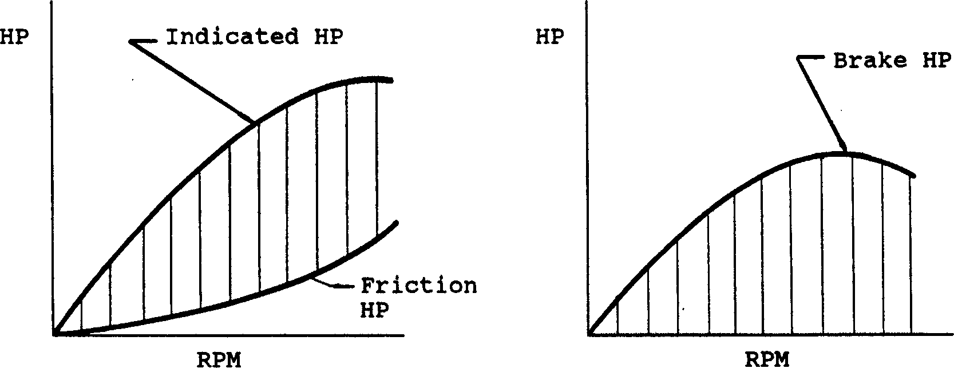
Figure A.2 Indicated HP, Friction HP and Brake HP
The HP lost to friction can also be expressed as an efficiency:

Mechanical Efficiency = Brake HP
Indicated HP

Mechanical Efficiencies can be in the range of .00 (0%) up to .90 (90%) or higher. A good illustration of Mech Eff % = .00 is when an engine is idling, clutch disengaged or transmission in neutral. All the HP being generated by the fuel and the "explosions" in the cylinders are producing no Brake HP at the crankshaft. This fuel is being completely wasted, just to overcome the engine's own friction and keep it running.

Multiplying the Thermal Efficiency and the Mechanical Efficiency together is a better way of describing the "Eff" term in the previous equations:

Eff = Thermal Eff % x Mech Eff %

Substituting this relationship into equation (7) you finally get the formula for HP of an engine:

- HP out = CID x RPM x Vol Eff% x .00001326 x C.E.F. x TEFF % x MEFF %
A/F 2544
Combining all the constants together, (assuming 14.6 A/F and dividing twice by 100 so Thermal Efficiency and Mechanical Efficiency can be in percents) you get:
Detailed Equation for HP of a 4 Cycle, I.C. Engine
HP out = CID x RPM x VOLEFF% x C.E.F. x TEFF % x MEFF % 28 E12

Note: 28 E12 is "scientific notation" for 28,000,000,000,000. Your calculator will probably not let you enter 28,000,000,000,000, so use the "scientific notation" method.

Now, for the important stuff; “What is equation (9) telling us?” It's telling us that to make more HP (to raise the value of the left side of the equation) you must raise the value of something on the right side of the equation. Listed below are these factors from the right side of the equation with some explanation, and a list of some specifications from the Engine Analyzer which effect that particular factor.

CID: The cubic inch displacement of the engine: Bore, inches
Stroke, inches # Of cylinders

RPM: The engine speed:

Stroke (the shorter the stroke, the higher the RPM limit) Rod length (the longer the rod, the lower the piston Gs)
Anything which lightens reciprocating components extends safe RPM limit. Other short block specs which affect strength of rotating components
Valve Train Specs which allow high revving without valve toss VOLEFF%: Volumetric efficiency:
Most cylinder Head(s) Specs Most Intake System Specs All Exhaust System Specs All Cam Specs
Most Supercharger Specs
Weather Conditions and Nitrous Oxide under Running Conditions

C.E.F.: Chemical Energy of the Fuel: Gasoline/Alcohol
Possibly Nitrous Oxide

[Note: This is where alcohol and nitro-methane burning engines make additional power over gas engines. When burned, these fuels release more energy per pound of air than gasoline. Nitrous oxide, on the other hand, is only a way to get more oxygen into the cylinder so more fuel can be burned. Technically, nitrous oxide is improving VE % by supplying "air" with more oxygen (for example 30%) rather than the 21% oxygen typical of normal air.]

TEFF %: Thermal efficiency:

Compression Ratio Spark Advance Specs Piston Coatings
Combustion Chamber Design and Coating Cylinder Head Material

MEFF %: Mechanical efficiency:

Most Short Block Specs
Coolant Temp (effects oil temp and therefore oil viscosity)
Supercharger Specs (for centrifugal or Roots type, belt driven superchargers)

Appendix 3: Intake and Exhaust Tuning

Intake Inertia Tuning
The intake process of a 4-cycle engine is a cyclic process. During the intake stroke, the piston accelerates a column of fresh air from rest to speeds of up to 1000 ft/sec and then back to rest in only a few thousandths of a second. Decelerating the inertia of this column of air at intake valve closing results in high pressures at the intake valve. This high pressure forces additional fresh charge into the cylinder, like a supercharger, resulting in higher volumetric efficiency and torque. This condition is called inertia tuning. See Figure A.3.
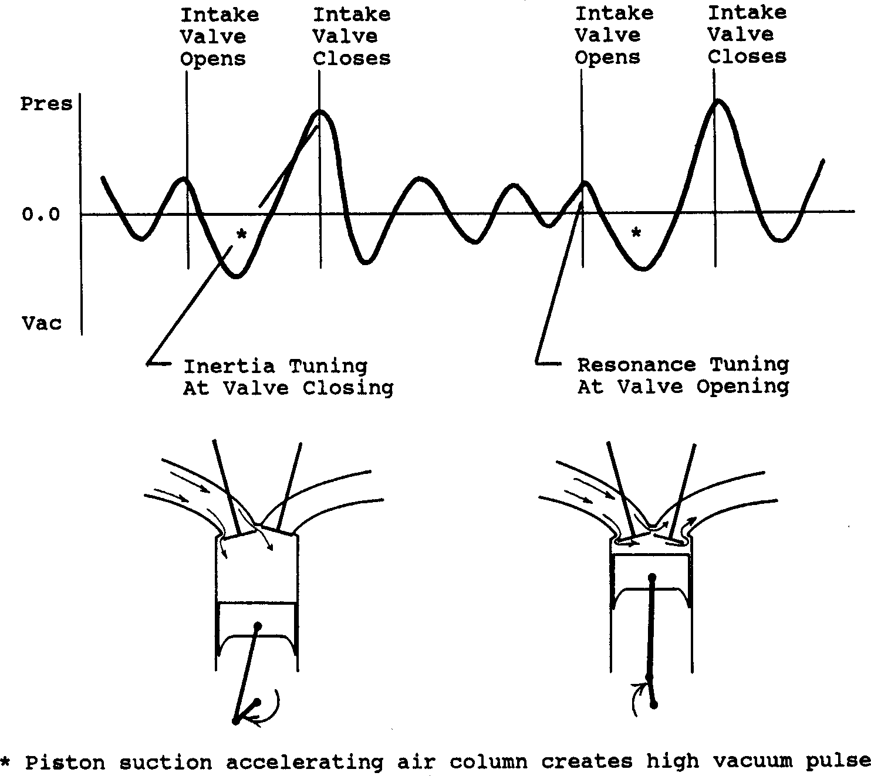
Figure A.3, Typical Intake Runner Pressure Pulsations

A good analogy of inertia tuning is the "water hammer" effect in old plumbing when you quickly close a running faucet. (New plumbing has "trapped air shock absorbers" to reduce this effect.) Decelerating the column of water in the pipes by closing the valve causes a sharp pressure rise that literally "rattle the pipes". This is the same situation as when the intake valve closes.

Inertia tuning is responsible for an increase in volumetric efficiency and torque over a broad RPM range. See Figure A.4. Inertia tuning is optimum when the rise in intake runner pressure is high over a broad range of the valve opening period, especially around intake valve closing. This usually occurs when In Tune Prs is highest in the RPM data test results. See Example 4.5.

Intake Resonance Tuning
Once the intake valve has closed, this pressure pulsation continues to be reflected back and forth in the intake runner until the intake valve opens and the process starts again. If a high pressure peak of this reflected wave is at the intake valve during valve overlap, it can blow the burnt exhaust gasses out of the clearance volume into the exhaust. This results in additional gains in volumetric efficiency.

However, if a vacuum peak arrives at the intake valve during overlap, additional exhaust gasses will be drawn into the intake runner. This process hurts volumetric efficiency since the cylinder must first draw in that "blown back" exhaust from the intake runner before it starts to induct the fresh, power producing air charge. The timing of this reflected wave to aid scavenging is called resonance tuning.

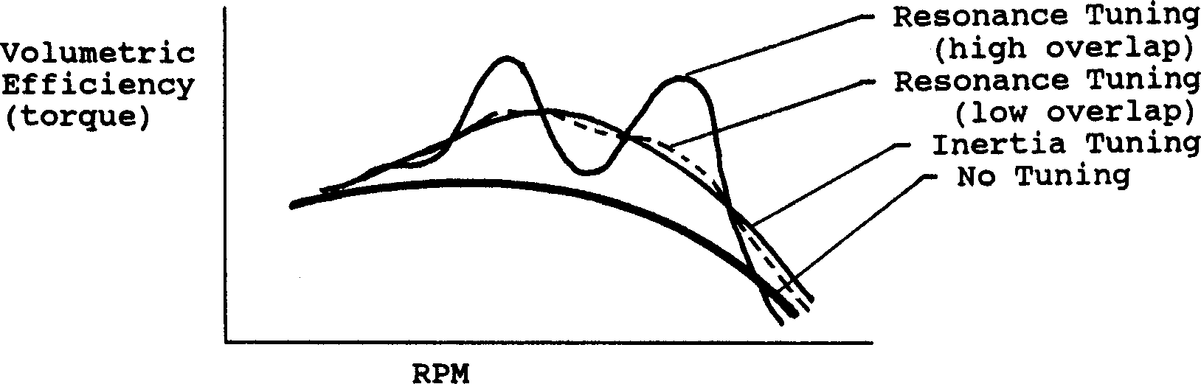
Figure A.4, Effect of Inertia and Resonance Tuning On Volumetric Efficiency and Torque.
For typical runner lengths (6-20 inches) and RPMs (3000-10000 RPM), the resonant pressure wave is reflected several times between intake strokes. Therefore, at some RPMs positive intake tuning occurs and negative tuning occurs at other RPMs. Resonance tuning is responsible for the "wiggle" seen in torque curves for engines with high valve overlap. For engines with low overlap, resonant tuning has much less effect. Also, each time this wave is reflected it looses some strength, so at lower RPMs or for shorter runner lengths resonance tuning is negligible. The Engine Analyzer detailed tuning simulations will show these gains or losses in volumetric efficiency and performance for resonance tuning.

Exhaust Resonance Tuning
Things are much more violent in the exhaust runner due to the sudden rush of high pressure exhaust out the exhaust valve when it first opens. In fact most of the exhaust is expelled during this first rush called "blow down". That leaves relatively little for the piston to push out during the exhaust stroke.

Due to this violent "blow down", exhaust tuning is not significantly affected by the previous cycle as in intake resonance tuning. Exhaust resonance tuning is caused by the reflections of the "blow down" pulse in the exhaust runner while the exhaust valve is open. If one of the negative, vacuum pulses arrives at the exhaust valve during overlap, it benefits performance by:
- Clearing out the cylinder of any residual exhaust to reduce “contamination” of the fresh incoming intake charge.
- Preventing reversion by keeping the exhaust flowing out of the cylinder and the intake charge flowing into the cylinder.
- Letting the intake charge get a “head start” at filling the cylinder, because the exhaust is sucking the intake charge into the cylinder before the piston has moved enough to suck the intake charge into the cylinder.

With high overlap camshafts and good resonance tuning on the intake side, it is possible to completely scavenge the clearance volume of residual exhaust. This provides for very high volumetric efficiencies, and possibly "short circuiting". Short circuiting is when fresh intake charge passes directly through the clearance volume out the exhaust during overlap. Obviously this wastes fuel, but to produce optimum power that may not be important.

As on the intake side, exhaust resonance tuning will produce torque gains when a vacuum pulse arrives at the exhaust valve during overlap. However, a torque loss will be produced when a positive pulse arrives.

As runner velocities increase (smaller pipe diameters), the shape of the exhaust pulses change.
- The primary blowdown pulse gets wider and the arrival of the 1st vacuum pulse gets delayed.
- The amplitude (height) of the blowdown pulse gets higher and generally the suction of the 1st vacuum pulse gets stronger also.

Therefore, the combination of pipe length and diameter are important to determine what pipe should be used for a particular applications. At Performance Trends we are still trying to better understand the details of intake and exhaust tuning. As we improve our understanding and capabilities, we will add these improvements to our software.

Additional Factors Affecting Tuning:
All tuning factors are affected by temperature, since temperature affects the speed of sound. The speed of sound in the runner influences how fast the pulsation’s are reflected. Since temperatures are affected by so many factors not simulated by the Engine Analyzer, tuning effects can only be estimates.

The pulsation’s produced by other cylinders can affect tuning pulsation’s. This is especially true at points where neither the intake or exhaust are at peak tuning, or "off design" points. These influences from other cylinders are simulated only very simply by the Engine Analyzer.

Low restriction runners (high Runner Flow Effcies) provide better tuning effects. However, the exact relationship between Runner Flow Effcy and tuning strength is not completely developed. Therefore, you are advised to try a range of Runner Flow Coefs for your simulation. For example, if you measure a Runner Flow Effcy to be 85%, also try the calculations at 80% and 90%. If performance changes significantly, you know tuning is critical. However, you are not guaranteed that the estimated performance at Runner Flow Effcy = 85% is the best estimate of the engine's actual performance.

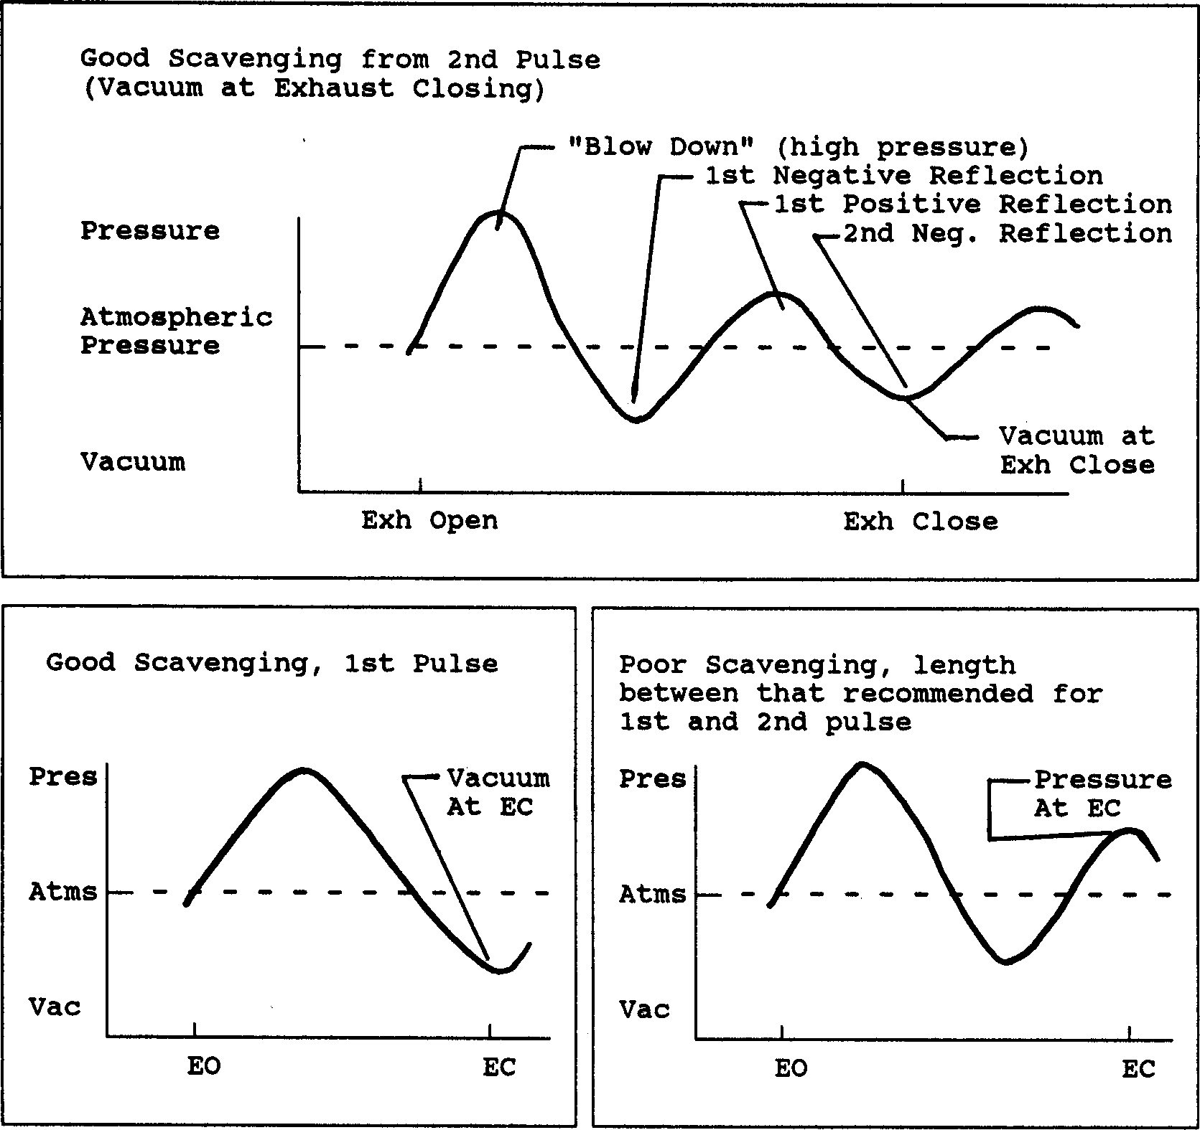
Figure A.5, Exhaust Pressure Diagrams Showing Various Types of Tuning

Appendix 4: "Fine Tuning" Torque & HP Curves

The Engine Analyzer was primarily designed to illustrate basic Internal Combustion Engine Theory and give estimates of the "pay back" of certain engine modifications. See Appendix 1. If you are using the Engine Analyzer program to help you make the right decisions for modifying a particular engine and you have dynamometer performance data for that engine, you should first get the Engine Analyzer calculated results to agree with the dynamometer data. The suggestions which follow will help "dial in" the engine specifications to match your dynamometer data. These suggestions will also help you tune your engine to give a desired torque or HP at a desired RPM.

Also check Example 4.5 and Appendix 3 for how to adjust tuning effects, which can dramatically alter the torque and HP curve.

When creating any engine file for a particular engine, it is best to start with an existing file which most closely resembles that engine. Then modify all the specifications to match that engine for the things which you can measure or you know for certain.

For other specifications like Runner Flow Effcy, Exh System CFM Rating, etc you may not have data to make a calculation. Estimate these values as best you can from the tables or equations provided in Chapter 2. Calculate performance and compare the Engine Analyzer's results with your engine's actual dynamometer results (or desired torque and HP objectives).

First, compare the Engine Analyzer's secondary information (not Brk Tq and Brake HP) to that which has been measured on the dynamometer, i.e. air flow (Actual CFM), fuel flow (Fuel Flow), friction HP (Friction HP), intake vacuum (Int Vacuum), exhaust back pressure (Exh Pres) and Mach #.

Actual CFM:
Actual CFM is the volume of air flowing into the engine. If the dynamometer data has air flow readings, try to match its CFM readings to those of the Engine Analyzer. Most dynamometer equipment reads out directly in Actual CFM.

Actual CFM air flow can be increased by several means, depending on the RPM where the increase is needed. To increase Actual CFM at low RPM (with little effect at higher RPM):
- Change Intake Heat to Less or None to allow less heat to be transferred to the intake charge
- Reduce Coolant Temp to allow less heat to be transferred to the intake charge
- Specify a smaller turbo or higher belt ratio (if boost limited and supercharged)
- Adjust Runner Flow Effcies to alter strength of tuning

To increase Actual CFM at high RPM (with little effect at lower RPM):

- Reduce any intake or exhaust flow restrictions, or increase flow ratings, for example Carb CFM Rating, Runner Flow Effcy, Exh System CFM Rating, etc.
- Adjust Runner Flow Effcies to alter strength of tuning
- Decrease Exhaust Header Diameter bring Ex AvgVel up to 300 ft/sec to exhaust increase exhaust inertia tuning
- Increase Roots Supercharger Volume/Revolution, Belt Ratio, Turbo or Centrifugal CFM at Pk Effcy, and other Supercharger specs if the engine is supercharged.

To increase Actual CFM at low RPM and reduce Actual CFM at high RPM:

- Increase Total Cam Advance or Lash @ Valve
- Decrease most any of the cam specs, especially Intake Duration
- Decrease intake or exhaust Valve Flow Effcy for Valve Diameter
- Specify longer length and smaller diameter intake and exhaust runners
- Adjust Runner Flow Effcies to alter strength of tuning

To increase Actual CFM in the mid range:

- Specify Secondary Throttles as No
- Increase intake Runner Flow Effcy to produce more flow where In InertiaPrs is already high
- Adjust Runner Flow Effcies to alter strength of tuning

Fuel Flow:
Fuel flow will generally follow air flow (Actual CFM) if the A/F is constant. If the dynamometer data includes fuel flow in lbs/hr and an actual A/F measurement based on exhaust gas analysis, calculate dynamometer air flow as follows:

Dyno Actual CFM = Dyno Fuel Flow (lb/hr) x Dyno A/F x .218

Now you can use the Actual CFM rules to make dynamometer and Engine Analyzer air flows match.

If the dynamometer data does not include a measured A/F, then assume your engine is running at 12.5, just as the Engine Analyzer assumes. Use the same rules as listed under Actual CFM to get the Engine Analyzer fuel flow to match the dynamometer fuel flow. For example, if the Engine Analyzer's results need more fuel in the midrange to match the dynamometer results, try specifying Secondary Throttles as No as listed under "To increase Actual CFM in the mid range".

Friction HP:
If the dynamometer your engine is tested on can "motor" the engine (spin the engine over at high speed with spark and fuel off), the dynamometer data should include the measured motoring friction HP. This data should be taken with oil and coolant at operating temperature and WOT (wide open throttle). If this data is available, multiply the Engine Analyzer's Friction HP by 1.3 to account for some pumping work HP. Then compare it to the dynamometer motoring HP.

For example, if the dynamometer results show 45 HP of motoring friction at 4000 RPM, and the Engine Analyzer shows 22 Friction HP:

Example of Engine Analyzer Friction HP vs. Friction Measured on Dynamometer

Estimate of Engine Analyzer motoring friction:

22 F HP x 1.3 = 29 HP estimated motoring friction Actual dynamometer motoring friction: 45 HP Difference = 45 HP - 28 HP = 17 HP
The Engine Analyzer needs 17 HP more friction to match the dynamometer data.

To increase Friction HP, increase any of the Losses specs in the Short Block Specs menu, like Accessories, etc.

Int Vacuum:
To the Engine Analyzer, Int Vacuum is the intake vacuum after the carb or throttle body during the intake stroke. Intake vacuum measurements on a dynamometer are an average over all 4 strokes. Therefore, dynamometer data will (and should) show a lower
vacuum than the Engine Analyzer's results, especially for individual runner intakes or engines with less than 3 cylinders. However, if the dynamometer data shows more vacuum than the Engine Analyzer, you may want to increase the Engine Analyzer's vacuum by reducing Carburetor or Throttle Body CFM Rating in the Intake System menu.

Exh Pres:
Exh Pres is calculated by the Engine Analyzer so as to correlate well with dynamometer exhaust pressure measurements. If the dynamometer data shows more pressure than the Engine Analyzer, you may want to increase the Engine Analyzer's back pressure by reducing Exh System CFM Rating.

Mach #
Although you can not measure Mach # with a dynamometer test, it can be measured on a flow bench. Accurate flow bench data will give accurate flow coefficients, which are key for accurate Mach #s.

Without significant tuning effects, severely restrictive runners, carb or exhaust system, the Mach # primarily dictates torque and HP peaks. The torque peak will occur at a Mach # of approximately .4 and the HP peak at a Mach # of about .55. For example:

Example of Adjusting Torque Peak Using Mach #

The dynamometer data show (or you require) a torque peak at 5500 RPM The Engine Analyzer calculates a Mach # of .48 at 5500 RPM
You should try to lower the Mach # to .4 at 5500 by providing:
  - More intake cam duration or lift
  - Larger intake valve area (increase Valve Diameter or # Valves/Cylinder)
  - Improved intake air flow (increase Intake Valve or Intake Runner Flow Effcy)
  - Decrease Bore or Stroke for the same size head

Brk Tq and Brake HP:
If you match up the secondary information as shown previously, ideally the torque and HP will automatically match. However, it is not an ideal world or perhaps some secondary information is not available from the dynamometer data. Therefore you are left with matching dynamometer brake torque and HP with Brk Tq and Brake HP from the Engine Analyzer.

Since torque and HP are largely a function of air flow, follow the rules outlined under the Actual CFM category. That is, if the Engine Analyzer needs more torque at low RPM, apply the rules under "To increase Actual CFM at low RPM (with little effect at higher RPM):", for example "Set Intake Heat to Less or None".

Another factor which has a large impact on Brk Tq and Brake HP is Friction HP. If the Engine Analyzer results show significantly more HP at higher RPM, try increasing Friction HP as discussed previously.

Look through all 22 rows of the RPM data. Three factors which effect performance, but not necessarily air flow include:
- A/F Mix Qal being less than 100%, especially at low RPM, reduces the engine’s thermal efficiency (ability to burn the fuel efficiently). Reduce runner sizes, valve sizes, Octane (which program assumes affects vapor pressure), carburetor size, or specify Secondary Throttles, etc.
- Valve Toss or Lifter Pump-up indicated as Moderate or Extreme will significantly reduce power at high RPM. Avoid this by specifying less aggressive cam ramps (less Lobe Lift for the same duration), less Rocker Arm Ratio, or a better Valve Train rating.
- Spark Adv can be retarded to avoid spark knock or detonation. Look for asterisk (*) at different Spark Adv readings to see if spark has been retarded from what the engine wants to run. If so, you may need to increase Octane, lower Compression Ratio, lower Coolant Temp, etc.

An excellent tool to understand the Engine Analyzer’s output and find potential problems with a combination is the Analysis Report. See Section 3.1 and Example 4.5.

Differences in Dynamometer Testing Methods:
Variations in dynamometer testing procedures can produce significant differences in measured torque and HP. Some dynamometer tests try to simulate actual vehicle installations, but most go for "maximum possible HP". The table below shows differences between typical vehicle installation and dynamometer installation for various Engine Analyzer specifications.

The Running Conditions for engine files reflecting vehicle installations use the SAE (Society of Automobile Engineers) standard weather conditions for rating engine power, per SAE Procedure J-1349. However, dynamometer tests going for "maximum possible HP" for racing engines use a different set of standard conditions which result in approximately 4% more power. These "Other Std Conditions" are also typical of the dynamometer conditions used in the 60s by the automobile manufacturers, which tended to "overrate" an engine's power.

Then we have Chassis Dynamometers, where the power is measured at the tires. These dynos will measure 10-30 % less than a pure engine dyno because of losses through the drivetrain and the tires as they slip on the rollers. Even though the tires are not “smoking”, they are slipping, from 3-10%. This slippage and any torque converter slippage (at least at higher RPM where the converter has “coupled”) are direct losses in power. A 10% converter slippage is a 10% power loss. Then there are all the additional losses of full vehicle accessories, trans and rear axle friction losses, etc.

However, some chassis dynos do math corrections trying to compensate for these losses. Depending on how they correct, you may actually see more power measured on a chassis dyno than the engine actually puts out. The important thing with chassis dynos is to know what that particular dyno is reporting for power, and any corrections being made.

Table Showing the Difference Between Typical Vehicle and Dynamometer Installations

Engine Analyzer Specs | Vehicle | Dynamometer
Engine Specifications
Accessories | All vehicle accessories installed |  | Minimum accessories, including no water pump and no fan
Intake Heat | Production |  | Probably blocked exhaust crossover, and coolant temp is lowered for better torque
Exh Header/Manifold | Actual Manifold |  | Aftermarket Exhaust Headers
Exh System CFM Rating | Actual Exhaust system or a restriction to simulate the exhaust system restriction |  | No exhaust system, Open headers
Weather Conditions | SAE Conditions |  | Std Dyno Conditions
Intake Air Temp | 77 |  | 60
Dew Point | 49 (approx 36% relative humidity) |  | 0 (completely dry air)
Baro Pres | 29.6 |  | 29.92
Elevation, ft | 0 |  | 0

Appendix 5: New Features in Version 3.2
Here is a brief listing of some of the features new in Version 3.2:
- Program is now a 32 bit version, fully compatible with newer operating systems, starting with Windows, 95, then 98, Me, XP, and 2000. This also allows you to use much longer, more descriptive file names for saving vehicles, suspensions and engines. It is also more compatible with newer printers.
- The program is now designed for 600 x 800 or higher resolution screens. Screen colors are also more compatible with Windows XP.
- The graph screen is now larger, and generally fills the entire screen.
- There is now a separate “Examples” folder for example engine files provided by Performance Trends. New engines which you save will be saved to a separate folder.
- File commands to save a vehicle file to a floppy disk, or open a vehicle file from a floppy disk. This allows easy transfer of files from one computer to another.
- You can now choose to list engine files alphabetically (as normally done) or by saved date, with the most recently saved files listed first. This should make it easier to find recent files more quickly.
- New Example Engines have been added, like Crate Engines.
- The user’s manual is now available from inside the program by clicking on Help at the top of the main screen, then Display User’s Manual. The manual is in a high quality PDF format
- The Performance Trends website is now available from inside the program by clicking on Help at the top of the main screen, then Performance Trends on the Web.
- Several features have been added to make the process of picking example components, calculating performance, making comparison graphs faster. Once an example has been selected on an input specification has been changed, the <F5> key lets you progress toward calculating performance and making a graph. Then the <Esc> key backs you up to the same point as where you started. This is explained in more detail below.
- The program now remembers the point where you picked an example component, so if you choose to pick another, it will default to the last component chosen.
- The ‘Flow Efficiency’ of the ports can now be calculated from up to 3 flow/lift points.
- The calculation accuracy has been “tweaked”. Most evident changes are:
  - Low RPM torque is higher for some engine combos.
  - Spark knock simulation is improved for more realistic trade-offs between knock, octane and power loss from spark retard.
  - The required spark advance for a particular engine has been improved.
  - Revised the BSAC calculation to be more consistent with fuel flow (not change so significantly 'with weather conditions as done in earlier v3.0).
  - Very Rich gas as fuel option to help to reduce detonation.
- On program shut down, the program now asks if you want your changes saved to the “Library Copy” of the file you are working with.
- Several features have been added to the graphs, including:
  - The Graph cursor now interpolates between points. This means that if one power curve has results at 2000, 2400 and 2800 RPM, and another has results at 2000, 2500 and 3000, the cursor will read both curves at all RPM points you ran, 2000, 2400, 2500, 2800 and 3000.
  - TDC and BDC labels are now displayed on the Valve Lift graphs. If you are using a cursor, the cursor value is also given as, say “24 deg ABDC”.
  - You can now print graphs in color or B&W with various styles of dashed lines.
  - A Preference lets you turn off the Graph always AutoScaling a new graph. This means that if you have found a set of scales you like, the program will maintain them.
- The powerful ‘Optimize’ feature at the main screen lets you try thousands of combinations of critical engine specs to find the best combo automatically.
- Hundreds of new example parts have been added, including the entire Crane Cams Catalog, Brodix, AFR, Edelbrock, World Products, Dart and TFS heads, more Import parts, motorcycle parts and kart parts, and more.
- New Printing options for reports, including different Font Sizes and omitting the “Starting Point Suggestions” for cam and runner dimensions (in Preferences). “Starting Point Suggestions” are now done much better through the “Optimize” feature.
- New Printing options for graphs, including “Dot Matrix Printer Adjustment”, Width adjustments and more (in Preferences).
- Comments can be saved with each component, describing it in some detail.
- Version 3.0 let you send a power curve to a vehicle program to be loaded and run in that vehicle. Version 3.2 lets you do that also. However, that process requires several key strokes and time. Version 3.2 lets you “Auto-Link” with a vehicle program of your choosing. Auto-Link runs every power curve you produce through a vehicle program, and produces a summary of the results. Now you can instantly see how a cam change, head swap, more nitrous will affect ET or circle track Lap Times. At the time of printing this manual, Auto-Link was only available for the Drag Racing Analyzer v3.2 and Circle Track Analyzer v3.2.

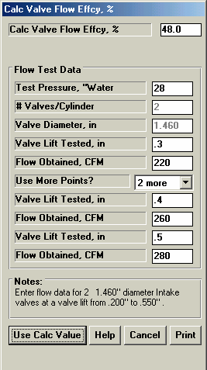
Figure A1 Calculation Menu for Flow Efficiency

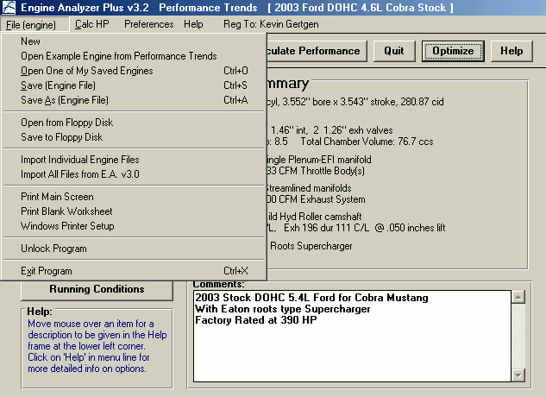
Figure A2 New Options at Main Screen
Powerful Optimize Feature
Demo program can now be easily unlocked from Main Screen.
Windows Printer Setup now available from Main
Commands to Open From and Save To floppy drive makes it easy to transfer vehicle files from one computer to another.
Example Engines are now stored separately from vehicles you create.
Set what Idle Vacuum is required, the more vacuum, the more “streetable” the final
Choose which engine specs you want to Adjust to find the best combo. The more you choose, the better the final combo but the longer it takes.
Choose what you want optimized. Averages are calculated for entire RPM range set in Calculations Conditions on Main Screen.
Figure A3 Optimize Screen to Have Program Try Hundreds of Combinations Automatically to Find the Best One

Click on “Optimize” to open this screen.

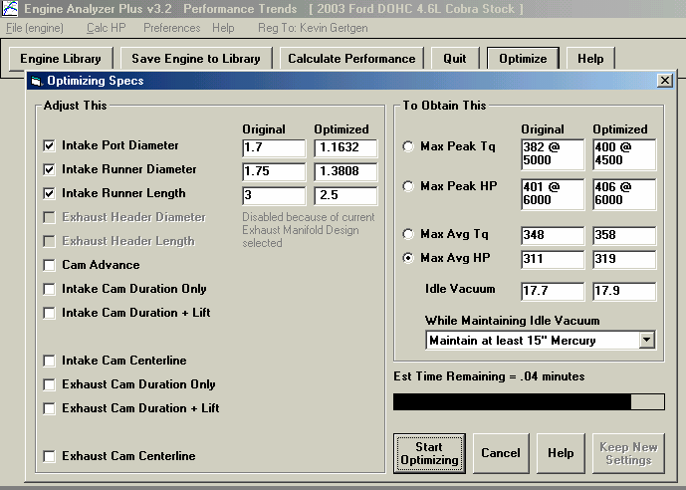
Notes:
If the process is taking too long, click Cancel and “de-select” some of the engine specs to adjust.
When finished you can click here to keep the Adjusted specs. Otherwise, click on Cancel to close out.
Click here to start the process.
- All other specs during the Optimize process are at the current settings in the individual Component menus.
- Average Torque and HP are calculated for the entire RPM range you have set in the Calculate Performance Conditions menu. If you want to optimize the Average Torque or HP from just 5000 to 7000 RPM, set this range in the Calculate Performance Conditions menu before Optimizing.

Figure A4 <F5> and <Esc> Keys for Quicker Calculations and Graphs

Follow steps 1-8

- Pick an example part, then press the <F5> key to return to component menu.
- Press <F5> from component menu to immediately calculate performance.

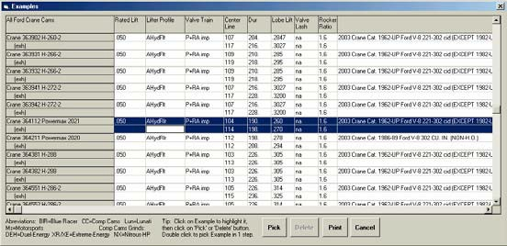
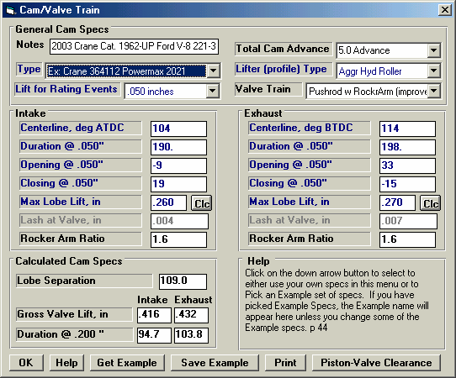
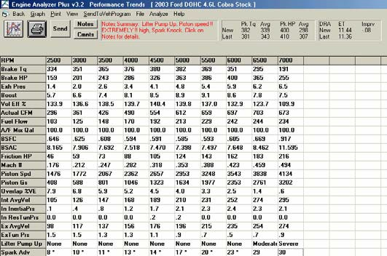
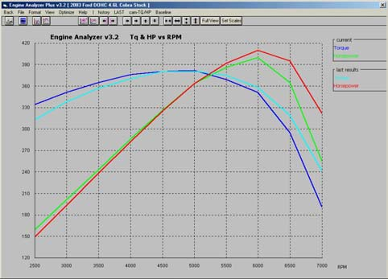
Note Comment for this Component

8) You will see your previously picked Example highlighted, so you can pick the next one in series; if you wish.
7) Press <Esc> to return to the Examples screen
3) Press <F5> from here to make a graph.
4) At the graph screen you can compare the current results with some previous results.

6) Press <Esc> to return to the Component screen
5) Press <Esc> to return to the Test Results screen

Note: You can just start at step 2, change a component spec setting, press <F5> twice to get a graph, then press <Esc> twice to return to the component menu to make another change. You may want to adjust Preference and Graph settings to make this process more streamlined.

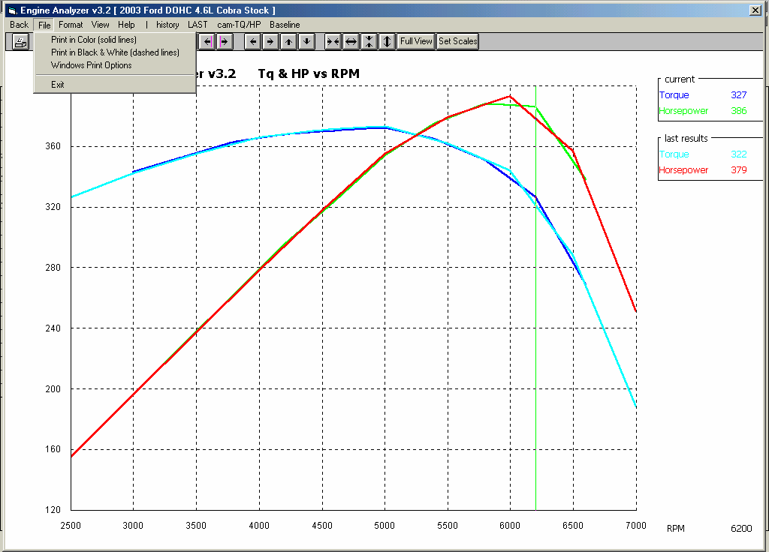
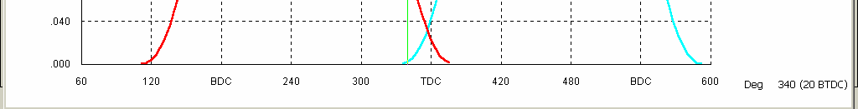
Figure A5 New Graph Features

Printing graphs in Black & White (dashed lines) is now available.
Even though no results were calculated for 6200 for the “last results”, the program interpolates and displays the value

A Preference lets you choose to Not have a new graph always Autoscaled. (must be in Experienced user mode).
Graph now fills your computer screen for most any screen resolution.

For Valve Lift graphs, the cursor location now includes location before or after TDC or BDC.

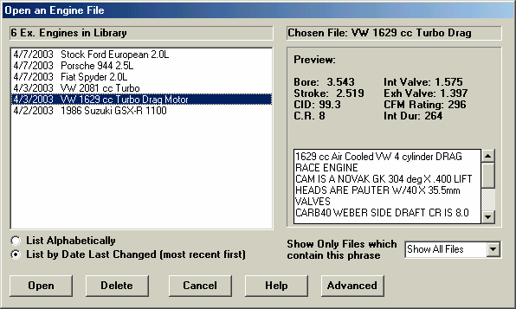
Figure A6 List Vehicle Files by Date Last Changed in Open File Screen
You can display files which only have certain words in the name, like “Chev” or “Import”
New Option to List Files by Date Last Changed, which lists the files you most recently worked with first.
Note longer, more descriptive file names.

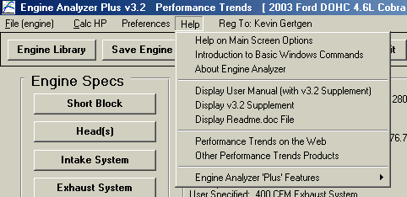
Figure A7 New Help Options
New Help Options available by clicking on Help at top of Main Screen.

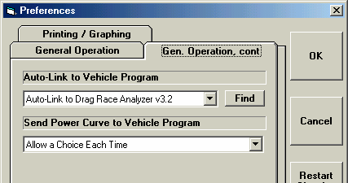
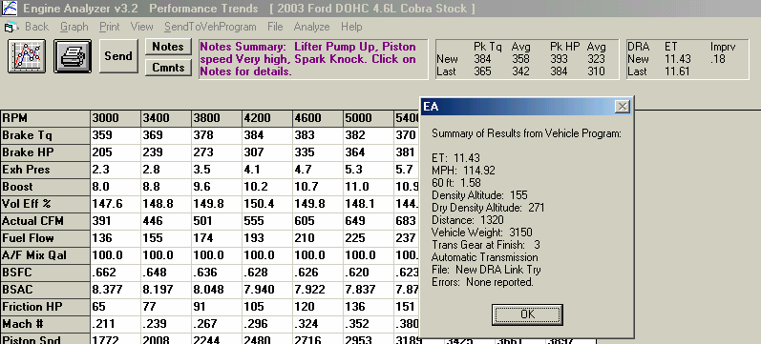
Figure A8 Auto-Linking to a Vehicle Program (Drag Racing Analyzer v3.2 shown here)
In Preferences, choose which Vehicle Program to “Auto-Link” to. At this time, only Drag Racing Analyzer v3.2 and Circle Track Analyzer v3.2 will Auto-Link.
Click here to have system locate the Vehicle Program you have chosen

The results of the New (current) Engine Power Curve coupled with the Vehicle File in the Vehicle Program produces these results. The “Last” results are for the previous Engine Power Curve coupled with the same vehicle.

Click on these results to get a summary of the New vehicle results as shown here.

You do not need to start the vehicle program; the Engine Analyze will do it automatically. The vehicle file being used is the last vehicle you were working with when you shut down the vehicle program (the vehicle that would be opened when you start the vehicle program).

A 2-3 second time delay is built in the Engine Analyzer to ensure reliable communications when doing Auto-Link. You will not be able to click on Back to return to the Main Screen before this delay is over. You may also notice the progress bar from the Vehicle Program momentarily appear on the screen, indicating the vehicle program is running.
Appendix 6: New Features in Version 3.4
Here is a brief listing of some of the features new in Version 3.4:
General Operation:
- The program now requires you to 'Allow' it to run in Vista and Windows 7 (same as right click on desktop icon, then select 'Run As Administrator'). This should make the program more Vista and Windows 7 compatible.
- You can now save a graphics picture file with engine data, which could be a picture of your car or engine. This picture appears on the main screen, and can be printed out with graphs and reports, or just separately from the main screen. Fig A 9, A 23.
- We’ve added a global switch to turn Off or On the Intro Help Tips in Preferences. Fig A 24.
Short Block:
- We’ve added hundreds of combinations of bore, stroke and rod length examples.
- We’ve increased the size of the Comments box for all components, to allow you to better describe your changes. This is common to all Component Screens. Fig A 24.
Heads:
- We’ve added the ability to import flow files from Port Flow Analyzer. Plus version only.
- You can now import head files from some Desktop Dyno (tm) and Dyno Sim (tm) programs and those available from Stan Weiss, .flw and .dfw files. Fig A 14, A 19.
Intake/Exhaust:
- A picture explaining the definition of primary pipe length and collector length is available in the Exhaust System Specs screen.
- The program now shows pictures of intake manifold and exhaust manifold/header types, to more clearly explain the choices. Cam/Valve Train:
- We’ve added a new screen to let you do Variable Cam Timing (VVT). Plus Version Only. Fig A 13.
- Dwell over Nose (Cheater profile) can now be more exactly defined, to the nearest 2 degree increment. Also, now this setting can be different on the intake vs the exhaust. Plus version only. Fig A 14.
- The program now allows for using a Ramp Rating for the cam profile for more exact cam profiles. There is also a ‘Clc’ screen to calculate the ramp rating to match certain duration specs at either .200 lift or seat timing. Plus version only. Fig A 14, A 15.
- We’ve added hundreds of new Example Cam Categories (especially Imports and Motorcycles) and cams themselves. Many are stock engine cam files from John Holm. Many thanks John.
- The screen for opening std Engine Analyzer Example components now let you select to only show components which match up to 3 criteria you have selected at the bottom of the screen. Fig A 16.
- We’ve added option to import Other Format Files for Cam files, like .cam and .scm files from Desktop Dyno (tm) and DynoSim (tm). Fig A 18.
- The screen for opening Example Cams now show the Gross Valve Lift and Lobe Separation for the cam you selected if you right click on the selected cam. Fig A 16.
- We’ve added an “Optimize Using These Cams” button in the Example Cams screen. The program will run each cam you’ve selected in the Example Cams screen and display the 4 cams which best meet your “Optimize” criteria. Fig A 16, A 17.
- When you change Lobe Separation in the Cam Specs screen, now the program adjusts the centerlines correctly.
- We’ve added a “Clc” button for Lobe Lift being calculated from Gross Valve Lift and Rocker Arm Ratio. We’ve also added a “Clc” button for Lobe Separation. Fig A 15.
- Cam Advance can now go from 30 Retard to 30 Advance
- We’ve made some refinements to the Cam Profiles created by the EA Pro to more precisely time them to the nearest 0.1 deg.
- We’ve added .053" lift for rating events (like Harley Davidson cams). Fig A 14. Turbo/Supercharger:
- The Roots Supercharger type now allows for an Intercooler. Fig A 19. Calculation Conditions:
- Program now has Fuel Option of E85. Plus Version Only. Fig A 20.
- Program now displays the Typical Octane for various fuel types. Fig A 20. Calculations:
- We’ve increased the Piston Speed limit above which program says is Impossibly High because materials and technology have made huge strides over recent years.
- Idle vacuum now more precisely estimated for super/turbocharger type and size.
- The program now better checks for blank inputs before doing calculations.
ASCII Data Files:
- We’ve added a Browse button to screen for writing ASCII files of test results. Fig A 21.
- We’ve added an option to include the Special Calculations section for writing ASCII files of test results. Plus Version Only. Fig A 21.
Graphs:
- Program now has an “Edit Printed Graph” command under Format. It opens a screen where you have several options on how to print your graph, include various comments, etc. You can now select to include the torque and HP data in a table when you print out RPM data graphs as long as there are torque and/or HP data on the graph. Plus Version Only. Fig A 22, A 23.
- Program now has larger Legend Text sizes available (under Format) on graph screen. Fig A 23.
- Program now prints cursor and cursor values when you print a graph. Fig A 23.
- We’ve added additional graph scale multiplier for Special Graph types of x 1000. Printouts:
- We’ve refined the printouts to look better and be more compatible with more types of printers. Fig A 23.
- The program now better remembers Printer Changes and Printer Type.
- You can now print a Company Logo graphics files on reports and graphs. This info is loaded in the Preferences screen. You can specify 2 lines of text which can appear at the top of printouts of reports and graphs in the Preferences screen, under Printing/Graphing. Plus version only. Fig A 23, A 24.
- The program is now better at finding more versions of Acrobat and Reader for a printer choice.
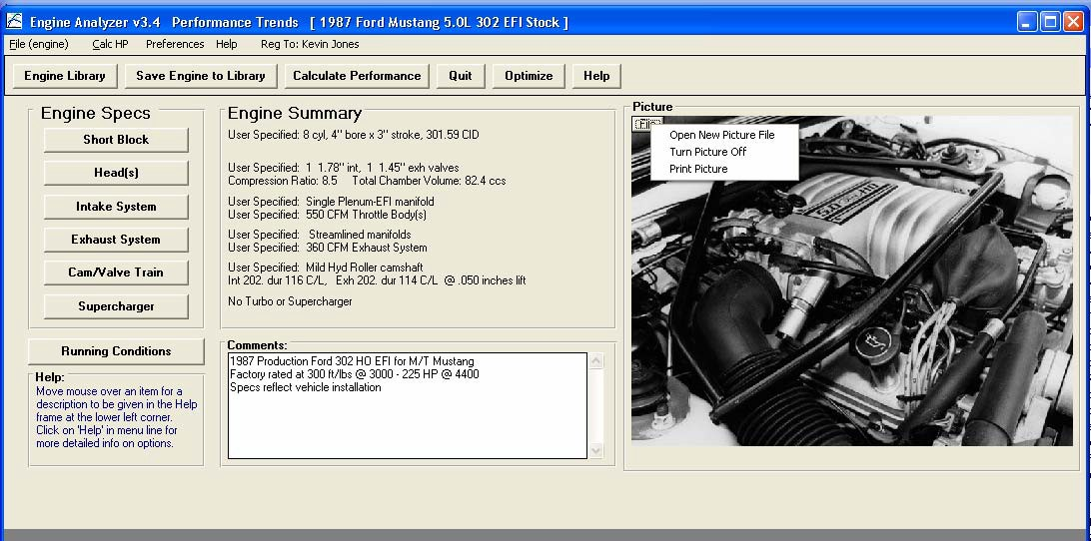
Figure A 9 Main Screen Showing Engine Picture
Click on File for options to pick a graphics file, and other options.

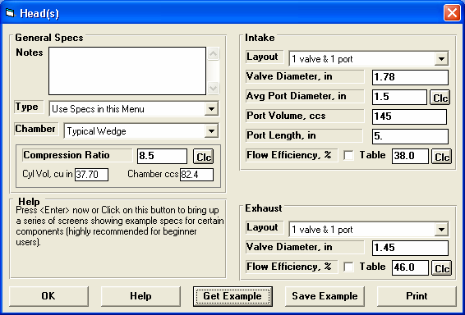
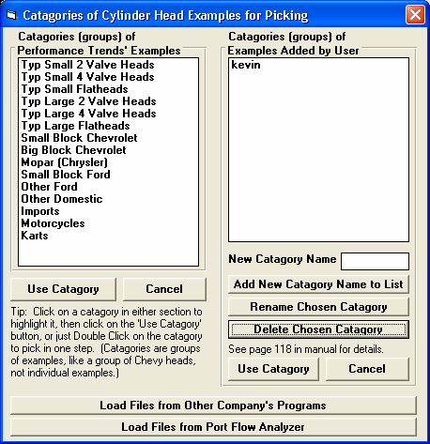
Figure A 10 New Feature for Picking Example Component Files

Click on Get Example button to bring up the screen for picking a Category of component example files.

Pick a Category from either group (side) and click on the Use Category to open the screen for picking a component.
See Figure A 16.
Click on this button for the screens shown in Figure A 11.
Click on this button to bring up the screens shown in Figure A 12.

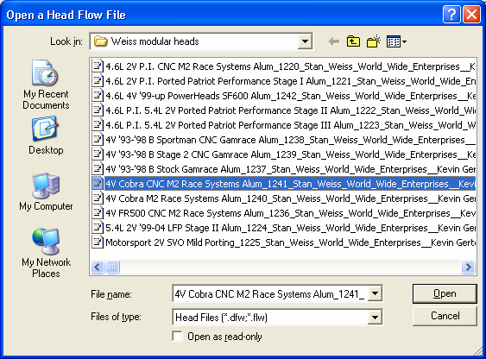
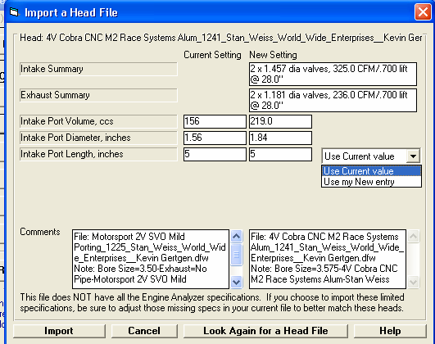
Figure A 11 Importing Head Files from Other Company’s Programs.

Use this standard Browse screen to find the Head Files with “.dfw” or “.flw” extensions.

Click on Open to pick the file you’ve highlighted.

Std Head File extensions to look for.

This screen shows a comparison summary between new file selected and the existing head on your current engine (shown in left column).

Click here to import these specs.

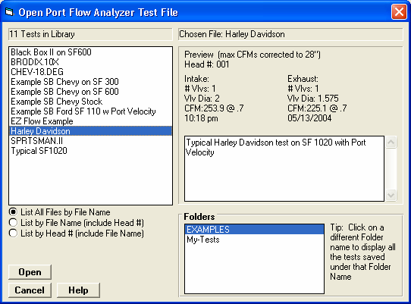
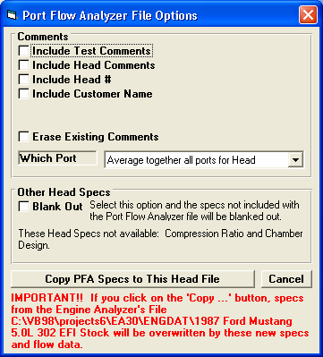
Figure A 12 Importing Head Files from Performance Trends’ Port Flow Analyzer (Plus Version Only)
You get this screen by clicking on the “Load Files from Port Flow Analyzer” button shown in Fig A 10. This screen is very similar to the File Open screen in your Port Flow Analyzer. Use it to choose the file you want to load.

Find the file, then click on the Open button for the screen below.

Check the options you want, choose which Port (or Average all ports Together), and click on the “Copy PFA Specs to This Head File” button.

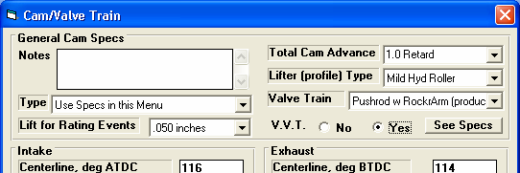
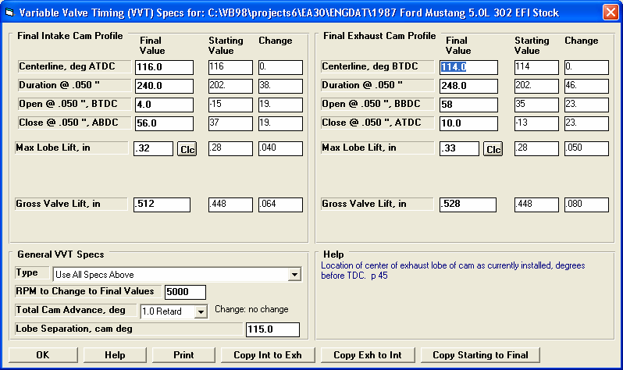
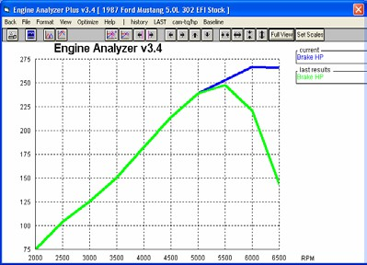
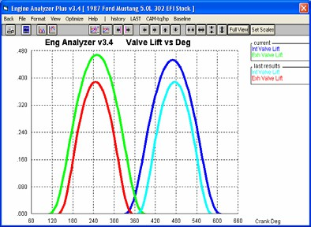
Figure A 13 Variable Valve Timing (V V T) Specs (Plus Version Only)
Choose Yes, and then you can click on the “See Specs” button to see screen below.
Enter the values you want to use at and above the “RPM to Change to Final Values” input in lower left corner.
These are the settings from the original Cam Specs screen, shown for comparison.
This column shows the “Change” (difference) between the Starting Value and the Final Value.

Your choice here determines which specs are enables on this screen.
Enter the RPM at which the program should switch from the specs on the original Cam Specs screen to these VVT settings.
Click here for more details on how this screen works.

Bigger VVT Cam

At 5000 RPM and higher, bigger VVT cam makes more power

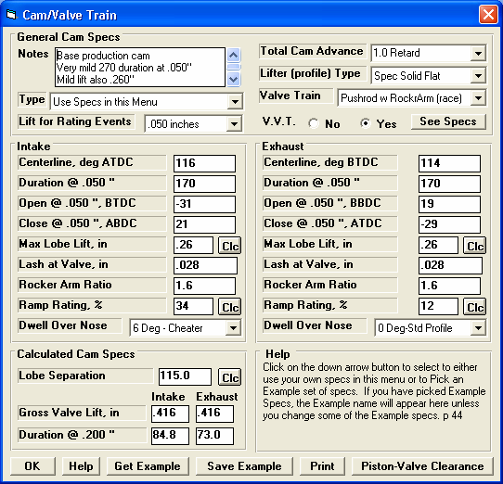
Figure A 14 New Features in Cam/Valve Train Screen
“Cheater” profiles are gone, replaced by Int and Exh “Dwell Over Nose shown below.
New “Spec” (specified) profile option displays Ramp Rating input below for you to “fine tune” the ramp. Plus Version only.
New “Clc” option for Lobe Separation. See Figure A 15.
Std Version lets you pick std (no dwell) or Typical Cheater (lots of dwell). Plus Version lets you fine tune this in 2 degree steps.
New “Clc” option for Max Lobe Lift.
Ramp Rating is displayed if you choose “Spec” (user specified) profile type in upper right corner. Click on the “Clc” button to calculate from 2 duration specifications (Figure A 15).
New VVT specs as shown in Figure A 13.
Larger Notes box to allow for more comments (same in other screens).

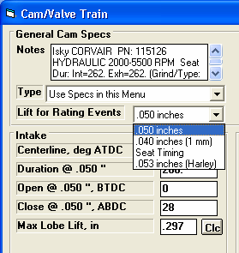
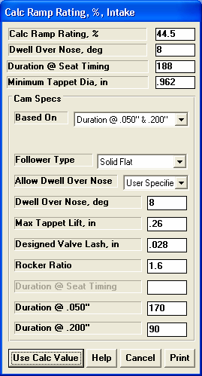
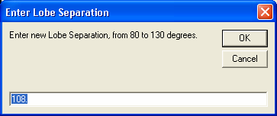
Figure A 15 More Cam/Valve Train Specs Screen Features
You can calculate an exact Ramp Rating for a “General Description” or to match 2 specific duration inputs by your choice of “Follower Type”. Four (4) calculated outputs describing the resulting profile are shown at the top of this screen.
You can now choose the Harley Davidson lift spec for rating events of
.053” tappet lift.

Simple “Clc” screen to let you change lobe separation. Program will change both centerlines the same amount to keep the Total Cam Advance or Retard the same.

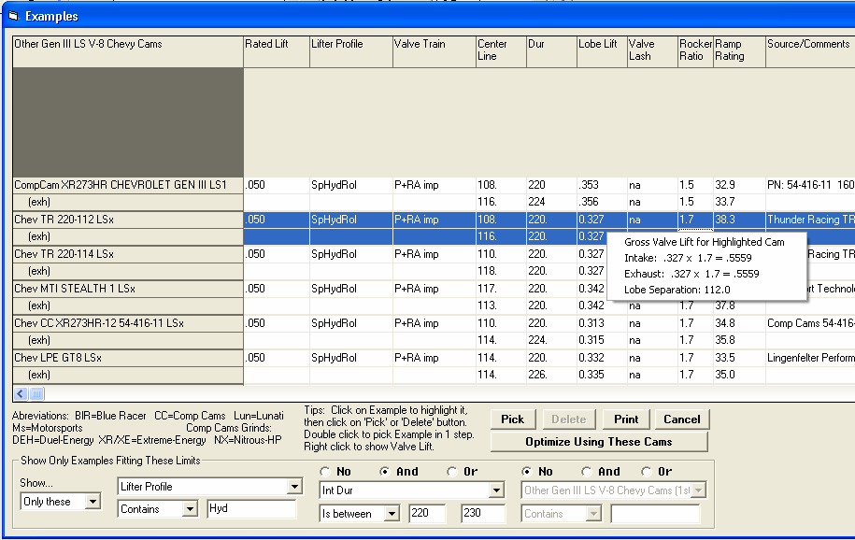
Figure A 16 New Features for Picking Example Components, Many Especially for Cams
In this section, you can choose to Show… ‘All Examples’ or ‘Only These’ as shown. Then you can use the 3 groups of conditions to determine what examples are shown. For example, in this screen, we have picked to only show cams with the phrase “Hyd” in the Lifter Profile description and an Intake Lobe Duration from 220 to 230 degrees. Now this screen will only
Click on this button (only available for example Cams) and the program will optimize trying each example cam shown. See Figure A 17.
Plus Version shows Ramp Ratings for Cams, if available.
Several Examples are NOT shown because they do not meet the criteria you set in the “Show Only Examples Fitting These Limits” section described below.

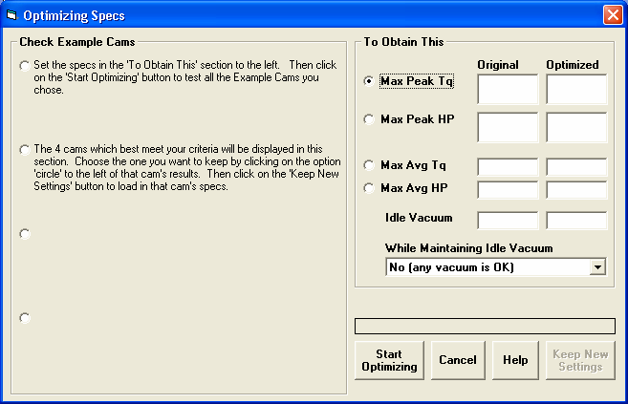
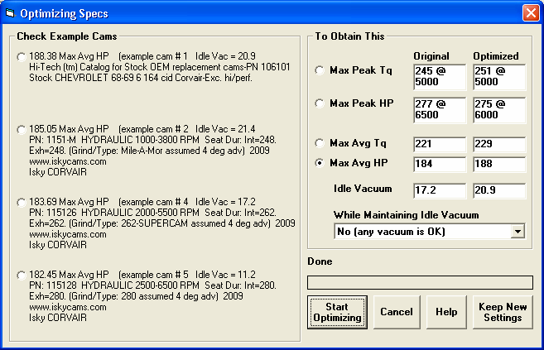
Figure A 17 Optimizing Example Cams, as Described in Figure A 16

If you click on the “Optimize Using These Cams” button as shown in Figure A 16, instructions for using this screen are displayed here. Basically you pick what you want to optimize (Max Peak Tq, etc), pick an Idle Vacuum level, and then click on the Start Optimizing button.

The program will show the 4 best cams which meet your criteria. Pick one of these 4 using the round option button, then click on the “Keep New Settings” button to load in this Example Cam.

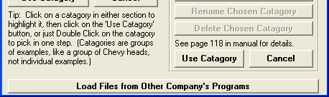
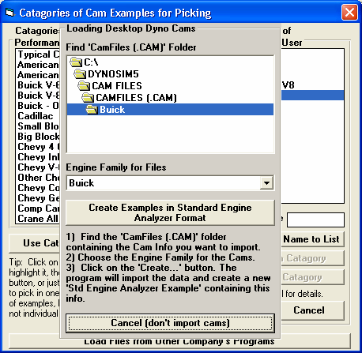
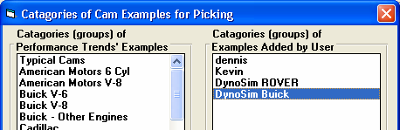
Figure A 18 Loading Cam Files from Other Company’s Programs
If you are picking a Category of Example Cam File (screen shown in Figure A 10), you have this Option button. If you click on it, you get the screen shown below.
Use this section to Browse to the folder containing the Cam Files you want to import.

Choose the Engine Family for the Cam Files you want to import. Note, many times this may be the same exact name as for the folder.
However, if you chose the folder Chevy, you may want to only import for the Engine Family “Small Block Chevy”
Click on this button to start importing All these cams. This process may take several minutes.

When finished, you will have a new Category in the “Examples Added by User” section. Now you can open up this Category to see all the Cams and use all the features as described in Figure A 16.

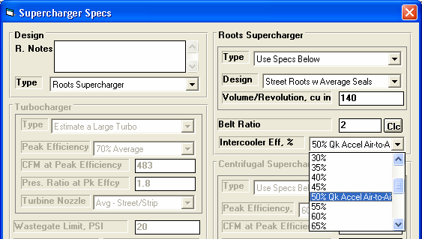
Figure A 19 New Features for Supercharger Specs
Now you can pick an Intercooler for a Roots Supercharger.
Larger section for Notes.
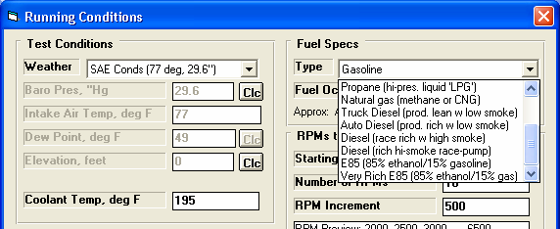
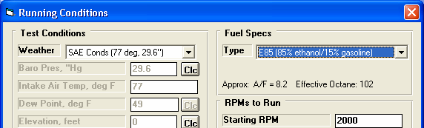
Figure A 20 New Features in Calculate Performance Running Conditions
Std and Plus versions both display the approximate A/F and Effective Octane the program will use. For some fuels, the program picks the Octane, like for E85, Alcohol (methanol), etc.
Plus Version has E85 Fuel Options.
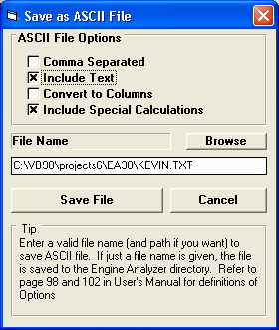
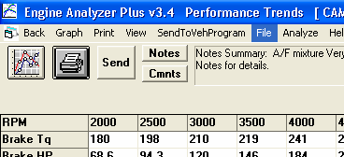
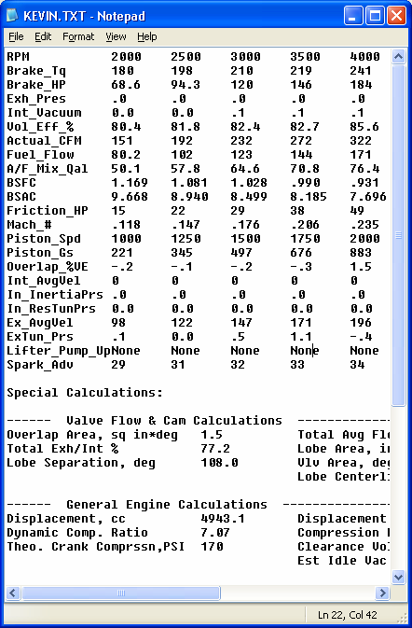

Figure A 21 New Features for Writing ASCII Data Files
Plus Version has “Include Special Calculations” option.
New Browse button lets you more conveniently pick a file name and folder for your ASCII file. The program will also remember this information for the next time you write a file.
Larger box for file name.
At the top of the Calculated Results, click on File for the screen shown in the lower left.

Here’s the file created with the options shown in the screen in the lower left corner opened up in Windows’ Notepad. This file could be easily printed or emailed to a friend to show Engine Analyzer results.

Note that this file includes the Special Calculations.

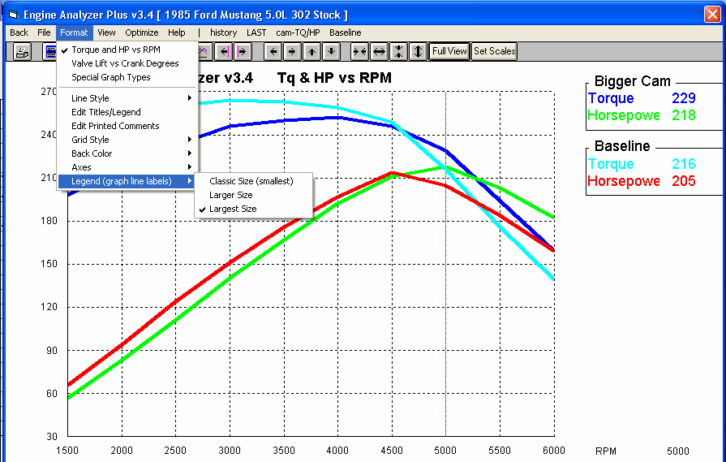
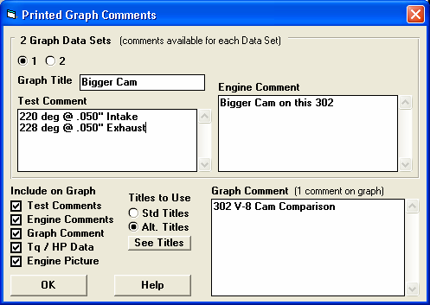
Figure A 22 New Features for Graphs Screen
Options and the Comment in this lower section apply to the whole graph. Figure A 23 shows a printout for the options picked here.
Choose option to display the different options available for each test being graphed.
Click on Edit Printed Comments for the screen of options shown below.
Legend shown in Largest Size font.
You can now pick to show the legend (labels on right side) in 3 different sizes of Fonts.

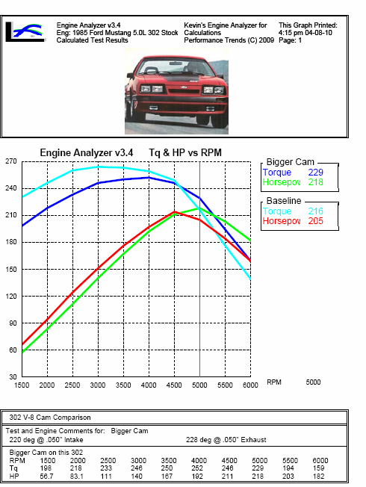
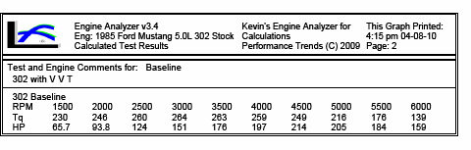
Figure A 23 Printed Graph with New Features

Company Logo graphics file (Plus version only)
2 lines of user entered text (Plus version only)

Graphics file from Main Screen of Program

If you have a cursor line on the graph, the cursor line is now printed also. Values at the cursor are also printed in the legend.

Additional text and data printed at bottom of page, under graph, as selected in screen shown in Figure A 22.

Comments and data may continue onto a 2nd page as shown here.

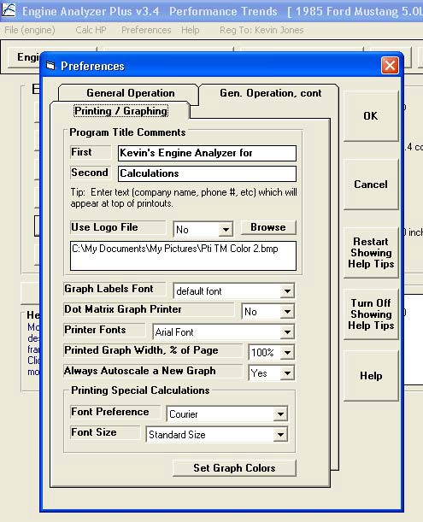
Figure A 24 New Preferences
New buttons to turn Off or turn On all intro help tips.
This section “Program Title Comments” is available only in the Plus version, and lets you specify 2 lines of text and some graphics file (typically a company logo) to appear at the top of your printouts (reports and graphs).
Appendix 7: New Features in Version 3.4B
Here is a brief listing of some of the features new in Version 3.4B:

Accuracy:
Several refinements to the performance calculations have been made. We have also added a Preference “Use v3.4B Performance Calculations” where you can choose to use these new calculations, or revert back to the calculations very similar to used in v3.4A.

The program has added Direct Injection option for Combustion Chamber design The program now more realistically simulates cam profiles for OHC valve trains. The program has about 100 more example Complete Engine files.
The program has hundreds more example components, like Heads and Camshafts. GM LS Cams and Heads are now a separate category.

The program now shows "Peak Int. Sec. Tune RPM" in the Special Calculations section so you can see if the program is simulating Secondary Intake Tuning Effects.

New Roots type superchargers have been added similar to those in Engine Analyzer Pro: Modern Screw Type and Modern 2000+ Screw Type.

When reading Engine Analyzer Pro files, the program now better determines the individual port flow efficiencies when the file has a full flow curve.

The program has updated the Piston Speed recommendations in the Analyze Performance reports. AnalysisReport.txt is now done in Notepad for easier reading, printing, editing, copying, etc for the user. The Analysis Report also has an improved header for printouts.

Operation:
The program will now more reliably open your default internet browser to accessing the internet. Fixed bug where canceling from printing to a PDF printer could cause program to stop.
The Preview when opening a Saved File now includes more info about the engine.

The method for displaying a PDF file (like the User Manual) has been updated to be more compatible with more operating systems. The method for opening a file or page on the internet has been updated to be more compatible with more operating systems.
The program has eliminated repeating error messages, or repetitive questions about printing in landscape vs portrait orientation.

The program now keeps the Case (upper and lower) of the Graph Titles from History Log. This way what you enter will be displayed correctly on graphs.

The Graph menu items of Background Color, Grid Style, and labels for valve lift graphs to include TDC, BDC, are now properly marked with check marks for the current setting.

There is a new Preference “Use Larger Fonts on Output Grid” that lets you increase font size for calculations output data table. The Special Calculations section font has been changed to Courier New to allow for changing font size.

Many Help screens are now shown in Notepad so you can save or print them. Prior to this, they would be displayed on 1 or more separate screens without any options like printing.

Files and folders you delete are now actually sent to the Recycle Bin so they can be recovered later if you want.

Features have been added so input screens can be resized and the size and location is remembered for next time the screen is open. You can now stop displaying the Opening Warning screen when you start the program with a check box for “Don’t show this again”. Several screens have been increased in size to allow for longer file names, and to accommodate higher screen resolutions.
The program can now open newer versions of Engine Analyzer Pro files.

The program will now display all columns in History Log. Prior to this the columns of “Graph?” and “Graph Title” were sometimes hidden.

The program now allows Graph File Names up to 30 characters long.

A bug was fixed where the software would check for reasonable lash settings even if the cam was Hydraulic prior to calculations.

Now the list of Example components is not updated if the criteria box for searching is blank. For example, if you have requested to look for Duration less than some amount, but the text box for the amount is blank, the example list is not updated. This can make the process of searching for examples more efficient and quicker.

The program now explains why you can not open very old files from Engine Analyzer Pro, rather than just not opening them.

The Program now checks the configuration file after it is written and makes a backup copy. If a problem is sensed in the configuration file the next time the program starts, the backup configuration file is used.

The program has a bug fixed which avoids problems opening History Log on VERY high resolution screens.

Changed Preference "Main Screen Enlarged to Fill Screen" to "Main Screen Fonts Increase w Screen Size". Now you can also resize and reposition the main screen and it is remembered the next time you start the program. If you set this Preference to No, then the fonts will stay the original size, but the picture area will be large. If you set this Preference to Yes, then the fonts will grow in size, but the picture area will stay relatively small.

The program has a new Preference "Allow Input Screens to be Resized" to let you resize and reposition the component screens, like Short Block, Heads, etc. The size and position is remembered each time you open a screen, and the next time you start the program. Set this to No (the default) and the screens stay relatively small, stay in their default positions, and can be faster loading.

The default Font Size on the main screen is now larger to show up better on higher resolution screens, even without changing any Preferences.

The program has removed 2 Preferences: “Beginner User” setting and the option to not "Show Open/Close Events in Cam Specs". Most users wanted Experienced User features and the program to show the Cam Events.

There is now a "Make Microsoft Excel File" option for creating ASCII files from the calculated results.

Optimize Feature, Plus Version Only:
Several changes to the Optimize feature have been made, so that more accurate answers can be found for more possible combinations. For example, the program now assumes the optimum cam durations are larger if the RPM range for the calculations is high.
An Optimize option of "Only Check Cam Specs close to the original Specs" has been added. If the program's standard "Optimize" feature can not find optimum Cam Specs, turn on this option and the program may better find them.

When Optimizing, a display of “Valve Toss” or “Lifter Pump Up” for the combinations found has been added. This can help explain why an Optimum combination could not be found.

When Optimizing both Cam Duration and Lift, the lifts have been reduced some to be more realistic for typical cams.

If Optimize can not find better performance than the engine's original settings, the info message gives suggestions for changes to be made for it to work better at optimizing.

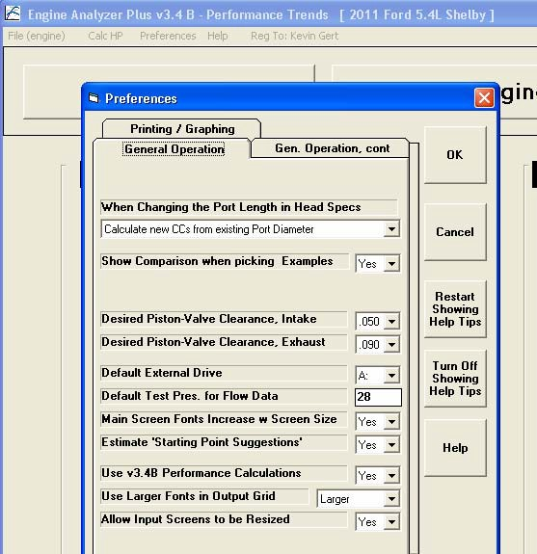
Figure B.01 Four (4) New Preferences in v3.4B
Click on Preferences to obtain screen below.
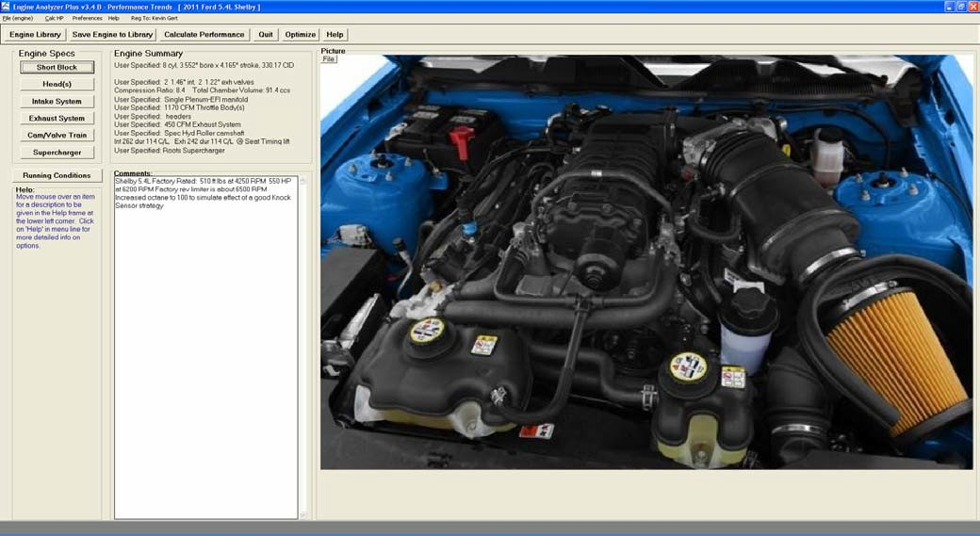
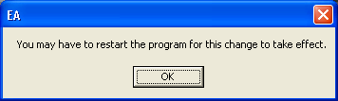
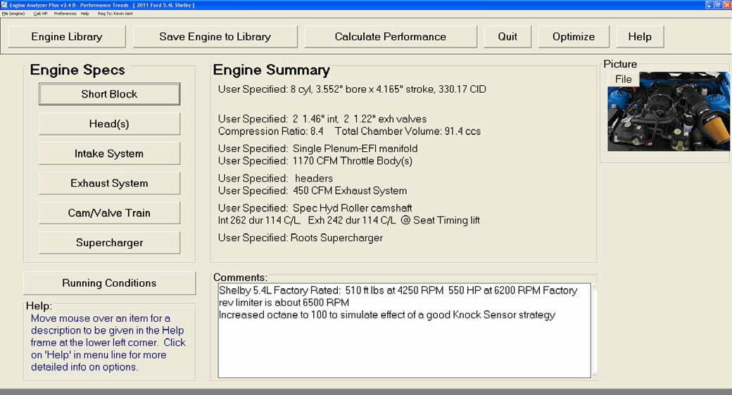

Figure B.02 Main Screen Fonts Increase w Screen Size
Set to No

Even set to No, the fonts are larger than in v3.4A

When you change this Preference, you will get this message. Restart the program to see the true effect.
Set to Yes.

Picture screen remains small

Fonts for most all items are much larger.
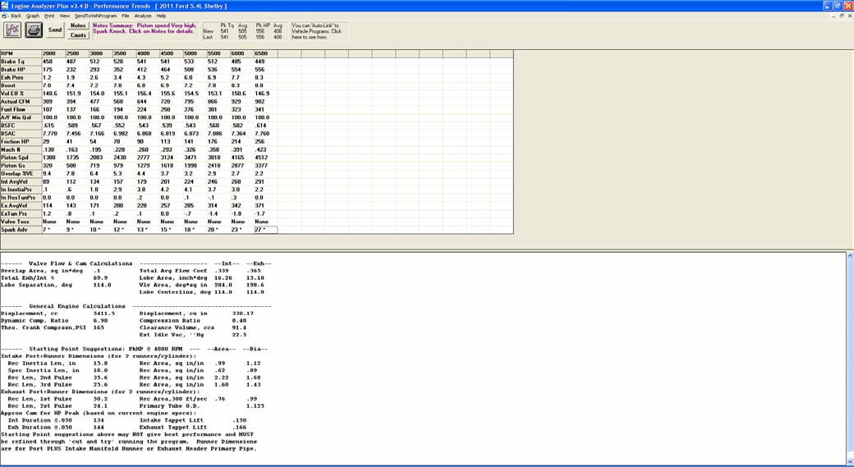
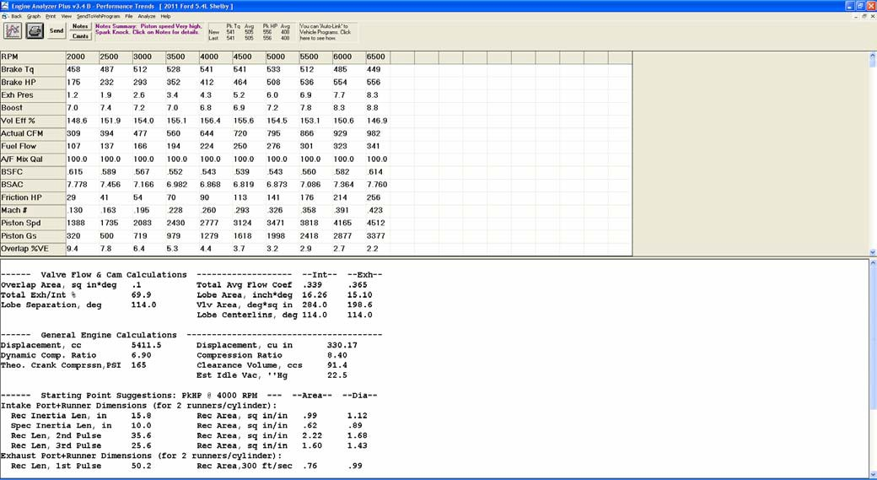

Figure B.03 Use Larger Fonts on Output Grid
Set to No

Set to Largest
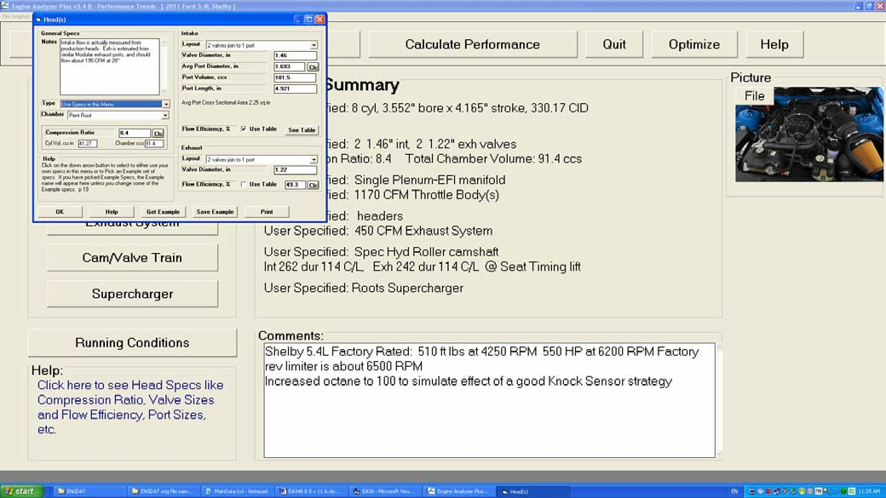
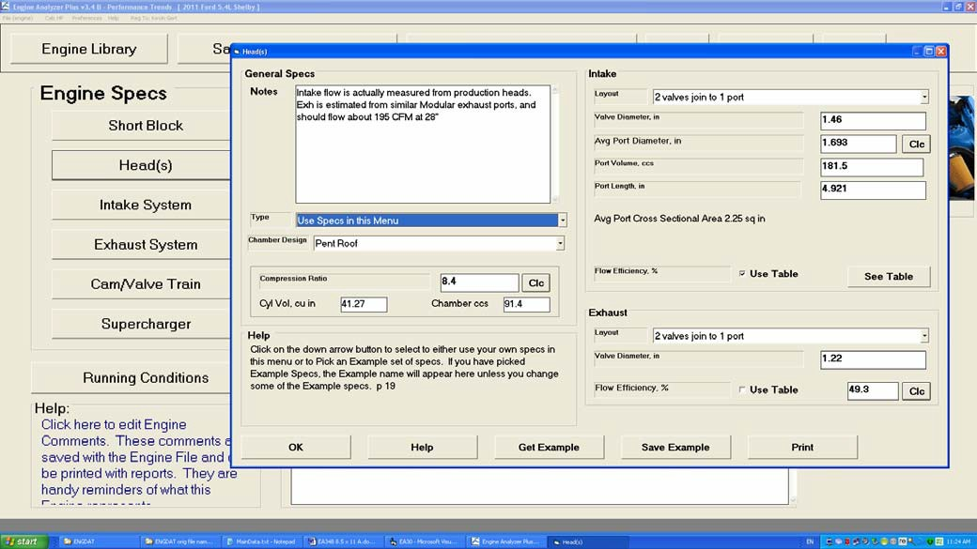

Figure B.04 Allow Input Screens to be Resized
Set to No

Set to Yes.

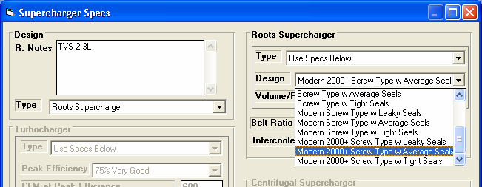
Figure B.05 New “Modern” Supercharger Designs

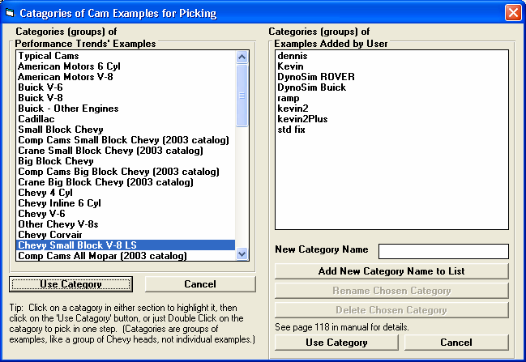
Figure B.06 New Chevy LS Categories for Example Components
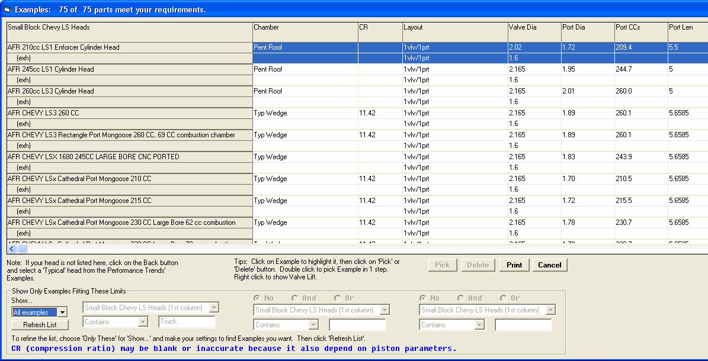
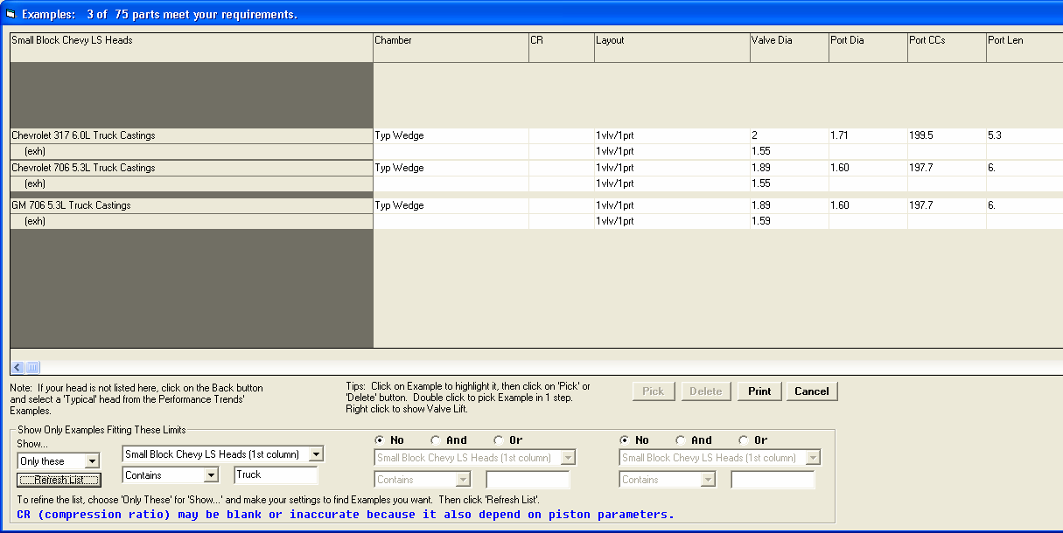

Figure B.07 Chevy LS Example Heads
New label showing how many examples fit the search criteria

Show All Examples

Show only Examples which contain the word Truck in the first column
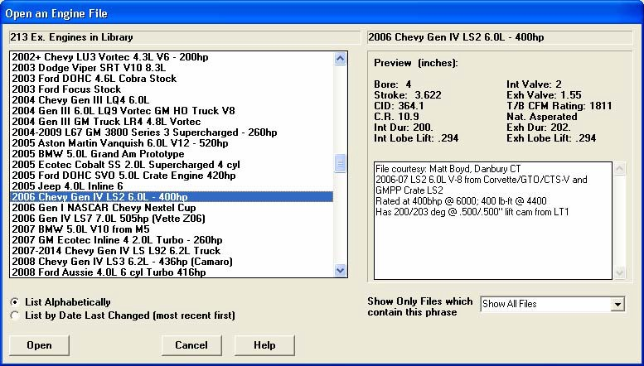
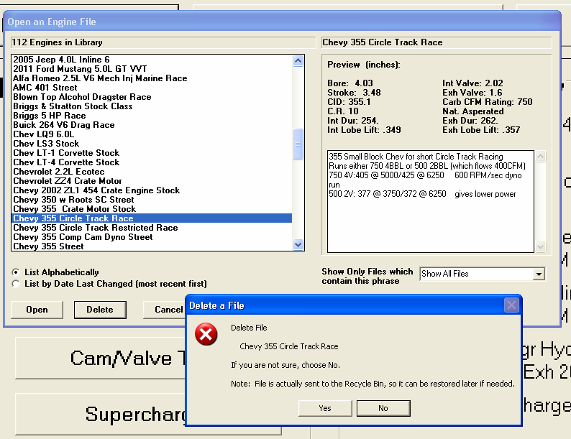

Figure B.08 More Example Complete Engines and Deleting Files
Now 213 Example Engines provided with program (was 112)

Screen is wider to allow for much longer file names

If you choose to Open one of your Saved Engine Files, highlight it by clicking on it, then select to Delete it, the file now goes to your computer’s Recycle bin.
This way you can restore it if you make a mistake. The Delete button is not shown if you choose to open an Example file provided with the program. You can not delete these files.
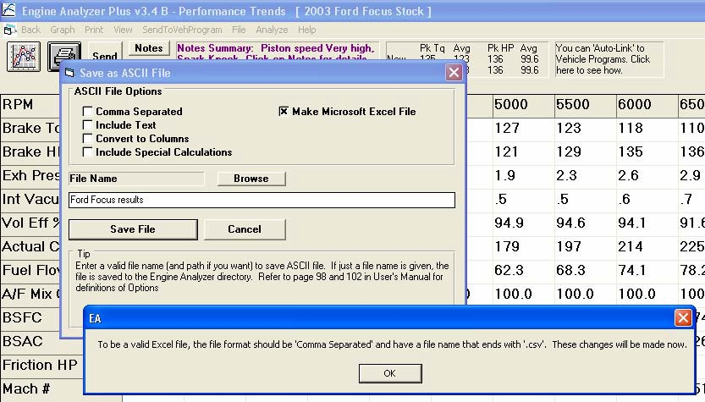
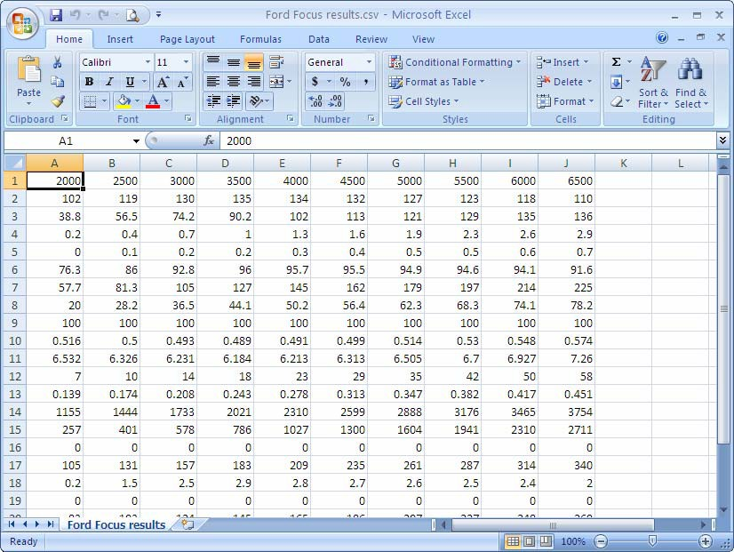

Figure B.09 Exporting Microsoft Excel File of Calculated Results
Click File to bring up screen
Check this box to make a Microsoft Excel file

Program tells you the changes it will make to create a valid Excel file.

File will open directly in Excel
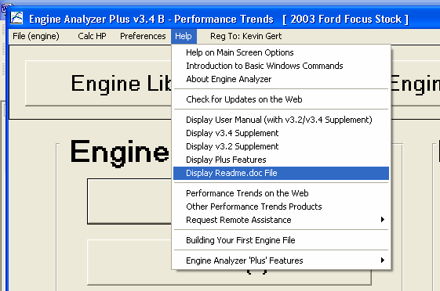
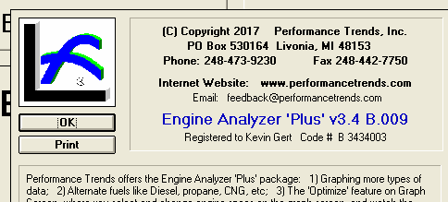
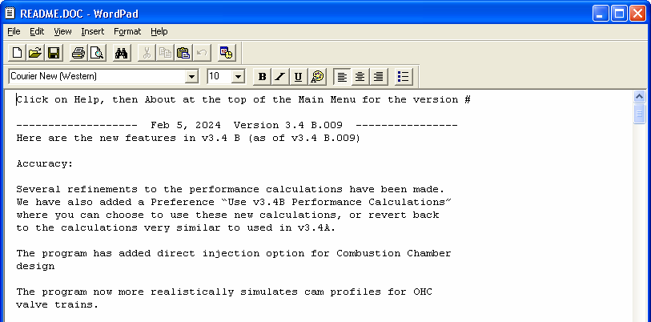

Figure B.10 New Help Options
Click Help to bring up Help Options.
Click About… to see the complete version number for your software, like v3.4 B.012.
Click here to see the Readme.doc file on the web. Then you can see what updates have been published.
Displaying these PDF files should work better on most all computers.

Click on About to see the complete version number for your program.

Check the Readme.doc file on the web to see the latest version which is available, and a list of updates since your program’s version. For example, if the Readme.doc file on the web showed updates up to v3.4 B.019, it should show you updates for the 10 minor version updates you have missed.
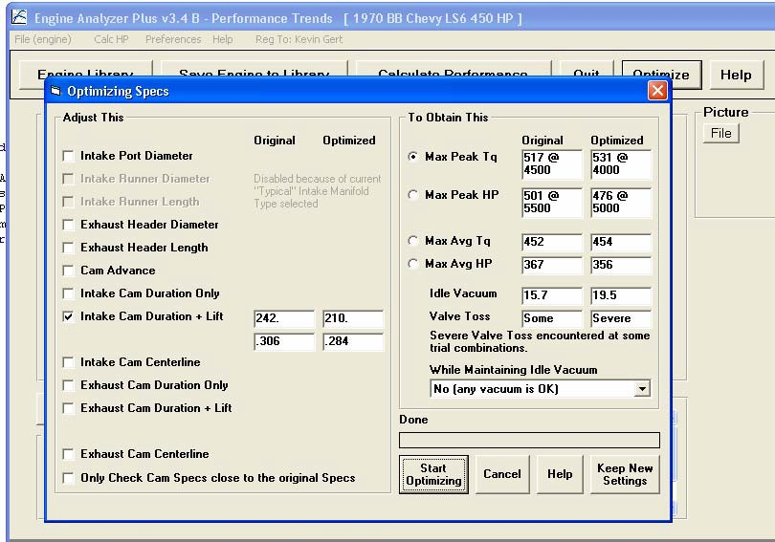

Figure B.11 New Optimize Features, Plus Version Only
Click the Optimize button to bring up this screen.
Some Intake or Exhaust specs may be disabled (grayed out) if the “Type” in their screens is set to a Generic Type, like “Typical Street Dual Plane”.

Valve Toss or Lifter Pump Up is shown here. If either is encountered, power may be significantly limited at some of the RPMs tested.

This message can give info on how to interpret the results. For example, if Severe Valve Toss is encountered, you should maybe improve the valve train design and try again. Or you should realize that power may be limited by Valve Toss in the RPM range tested.
If you think the current cam specs are near optimum, check this box. Then the program will concentrate only on cam specs fairly similar to what your current cam specs are. Otherwise the program could try durations from, say, 160 to 340 degrees, and could miss a combination close to what you have now.

Engine Analyzer ‘Plus’ Features Supplement

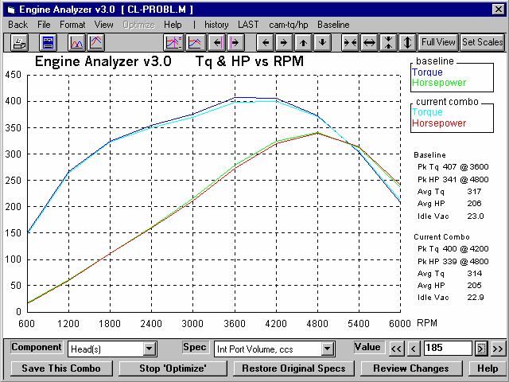

PERFORMANCE TRENDS, INC.
Check DISCLAIMER OF WARRANTIES and LIMITATION OF LIABILITY at the beginning of the manual.
Engine Analyzer ‘Plus’ Features
The Engine Analyzer Plus is a package of features the owners of the standard Engine Analyzer can add to their program. This package can be added either at the time of the original purchase or after they have purchased a standard program. See Figure 1 for obtaining information, activating your ‘Plus’ version, or running a demo of the ‘Plus’ features.
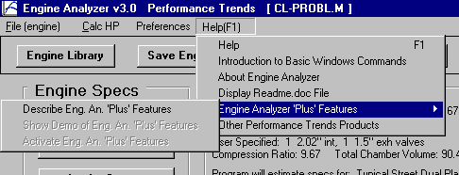
Figure 1 Click on Help, the Engine Analyzer ‘Plus’
Major Features:
- Calculate up to 20 RPMs.
- Calculate performance for alternate fuels like Diesel, propane or CNG (compressed natural gas).
- Estimate Piston-to-Valve Clearance.
- More graphing features.
- The ‘Optimize’ feature which lets you pick and modify most any engine specs and watch the effect on the torque and power curve right on the screen. This is great for quickly finding which specs have the most effect on your engine’s performance.
- Use Full Flow Curve for cylinder head ports (New to Version 3.2)
- Use Millimeters (instead of inches) to enter engine dimensions (New to Version 3.2)
- Hide certain calculated output that you think is not important (New to Version 3.2)
- Choose different colors for graph lines, which can also effect the print quality when printing color graphs. (New to Version 3.2)
- Duration at .200” lift is displayed in the Cam Specs for the particular lobe you have specified. (New to Version 3.2)
Check 11 new features added in v3.4, starting on page 214.

Calculate More RPMs Alternate Fuels
These 2 features are available in the Running Conditions screen. There, you can increase 'Number of RPMs' to calculate up to 20 for more detailed power curves. See Figure 2.

There are also many additional 'Fuel Types':
- Propane (lo-pres. gas) is a typical vapor propane system. If you specify a Carburetor in the Intake System specs, the program assumes you will use a venturi type of 'mixer', which usually has to be fairly small (restrictive with low CFM rating) to work correctly. If you specify an EFI system, the program assumes you are injecting propane vapor, which does not require the restrictive 'mixer'.
- Propane (hi-pres. liquid 'LPG') is a special high pressure, liquid injection EFI system.
- Natural gas (methane or CNG) is a typical vapor methane system. If you specify a Carburetor in the Intake System specs, the program assumes you will use a venturi type of 'mixer', which usually has to be fairly small (restrictive with low CFM rating) to work correctly. If you specify an EFI system, the program assumes you are injecting methane vapor, which does not require the restrictive 'mixer'.
- Truck Diesel (prod w low smoke) is a typical production Diesel Truck, running from about 23:1 to 30:1 A/F (very lean) at full load to avoid smoke. A/F is assumed to lean out at higher RPMs.
- Auto Diesel (prod w low smoke) is a typical production car Diesel, running about 20:1 A/F (very lean) at full load to avoid smoke.
- Diesel (race rich w high smoke) is a rich Diesel run in tractor pulls, and other types of racing. The engine exhausts thick, black smoke running this rich but increases its power.
- Diesel (rich hi-smoke race-pump) is a rich Diesel run in tractor pulls, and other types of racing. The engine exhausts thick, black smoke running this rich but increases its power. It also uses a special, "quick delivery" pump which shortens the injection time, speeding up combustion time. This pump allows the Diesel to run a higher than normal RPMs.

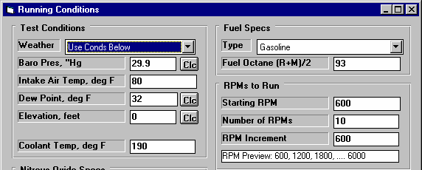
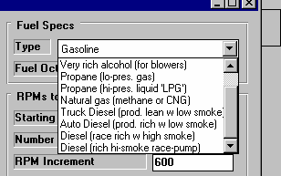
Figure 2 Plus Features in the Running Conditions Screen
You can now enter a number of up to 20 RPMs

Click on Fuel Type for a list of several additional fuel types.

Estimate Piston-to-Valve Clearance
This screen will estimate how close the valves get to the piston. Although this is NO substitute to checking piston clearance with clay, it will let you try different cam profiles, rod lengths, strokes, head designs, etc to see how piston-to-valve clearance is likely to change.
Assumptions:
  - The program assumes a FLAT TOP piston. Clearances for domed pistons will be much tighter than shown here.
  - The program assumes NO rod stretch and NO valve tossing or valve train bending. Therefore, clearances at high RPM are likely to be CLOSER than indicated here.

The clearances calculated are the closest the piston is to the valve, checked every 4 degrees of rotation. If the clearance is less than
.100, the clearance is printed in red.

Negative (-) clearances mean the valve is extending into the piston that amount. For example, if clearance is -.048 and you want .100 clearance, you must notch the piston .148 inches.
Definitions of input dimensions:
Gasket Thickness: Thickness of head gasket torqued to spec.

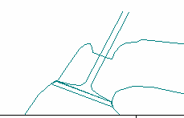
Deck Ht Clearance: Distance from piston top at TDC to block deck. If piston travels above the deck at TDC, enter an negative (-) number.
Figure 3 Illustration of Deck/Valve Clearance (Inches from Valve to Head Surface)
Closest distance from edge of valve to cylinder head deck
Valve angles: Largest angle between valve stem and line perpendicular (90 deg) to the deck surface. For 23 degree Chevy heads, this would be 23.
Deck/Valve Clearance: Closest distance between edge of valve and the head surface. If the valve(s) extend beyond the head surface (ex. valve touches table top when head sits on table), enter a negative (-) number for the amount of distance the valve
edge extends beyond the head surface. See Figure 3.

Click on Save Specs and these dimensions are saved with the engine file.

Examples of dimensions for some typical heads are shown in Table 1.

Table 1 Examples of Typical Head Specs
Head Description | Int Valve Dia | Exh Valve Dia | Int Valve Angle | Int Deck/Valve Clearance | Exh Valve Angle | Exh Deck/Valve Clearance
Stock SB Chevy 186,  492, etc | 2.02 | 1.60 | 23 | .01 | 23 | .08
Brodix -8 SB Chevy | 2.08 | 1.625 | 23 | .10 | 23 | .14
Merlin Cast Iron BB Chevy | 2.19 | 1.88 | 27 | .01 | 7 | .55
Stock SB Ford 351 W | 1.84 | 1.54 | 20 | .08 | 20 | .10
Stock Cleveland Ford 351 C | 2.19 | 1.71 | 11 | .13 | 11 | .27
Stock Pontiac 400, 455,  etc | 2.11 | 1.77 | 14 | .13 | 14 | .20
IMPORTANT: These example specs may NOT exactly match your heads. Use with caution!

Graphing Features
The 'Plus' features add 2 powerful features to the Graph Screen, shown in Figure 4:
- Click on 'Format', then 'Special Graph Types' for a menu to graph most any calculated output vs RPM, like BSFC, Spark Advance, etc.
- Click on 'Optimize' to display several options at the bottom of the graph screen to modify most any engine specs and see the effect immediately on the torque and HP graph.

These options are not visible unless you have the 'Plus' version or a displaying the 'Plus' version demo. Click on Help at the Main Screen, then 'Engine Analyzer 'Plus' Features' to turn on the demo. See Figure 1.
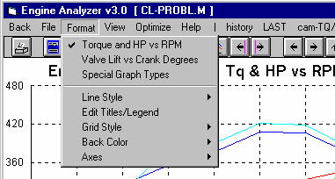
Figure 4 Graphing Features
Click on Format, then Special Graph Types for screen of Figure 5.

Click on Optimize of the Optimize Feature shown in Figure 7.

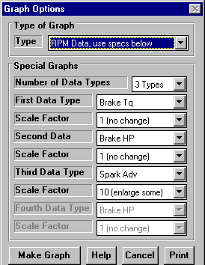
Figure 5 Special Graphs Menu

Special Graphs
This menu lets you graph up to 4 different types of data on the same graph, for example Torque, HP and Spark Advance vs RPM. First, select 'RPM Data, Use Specs Below' as the Graph Type.
Then select the # of Data Types to include in the graph, from 1 to 4. The appropriate # of graph specs will now be enabled. Now you can select from the Data Types available, Torque, HP, BSFC, etc.
Then select the 'Multiplier' for each data type. For example, BSFC only ranges from say .4 to .5 but torque and HP may range from 100 to 500. BSFC would only show as a straight line a 500 HP scale. However, if you multiply BSFC x 1000, BSFC would now range from 400 to 500 and show up clearly. Therefore, select large multipliers for small data values.

Optimize
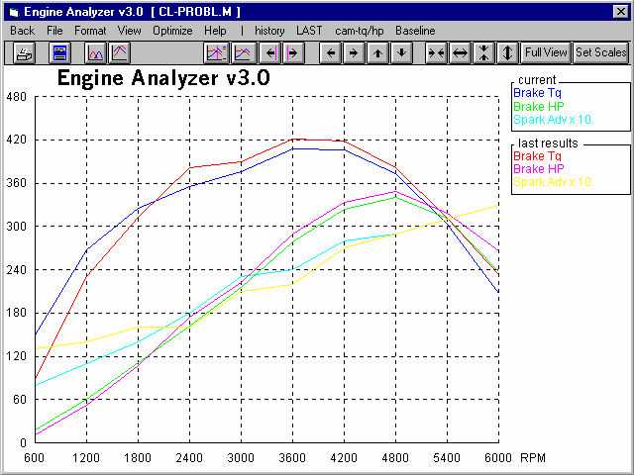
The Optimize feature lets you modify most any engine specs and immediately see the effect on performance. See Figure 7.
Figure 6 Special Graph Created from Specs of Figure 5
Legend shows Spark Advance is multiplied by 10 so it will show up on this scale also graphing torque and HP.
Spark Advance curves added to graph

First, select the 'Component' you want to modify. Then, select the 'Spec' for that Component.

Depending on the type of Spec you selected, you will have a list of settings, or a text box where you can type in a new setting. Each time you make a change to the setting, a new Torque and HP curve will be drawn so you can see the effect of this change.
The Optimize feature lets you modify just 1 spec or many specs for various components.
For example, say you
start by modifying Intake Cam Centerline from the original 110 deg to 104 degrees. Then you select to modify Intake Port Volume on the Head from the original 186 to 220 ccs.
Click on 'Save This Combo' to save any changes you have made to the Engine File you are working with. Note that you are not asked if you want to save to a New Name, meaning these changes overwrite the current specs for the current Engine File. Therefore, you may want to save your Engine to a New Name BEFORE you use the Optimize feature.

Figure 7 Graphing Optimize Screen
Pick Component, then Spec to Optimize
Summary of Original (baseline) and New (current) combination

These buttons let you save, quit, review or restore settings.
Type in a new setting, or click on one of the buttons to adjust up or down a little or a lot.

Click on 'Stop Optimize' to return to the normal graph screen and abandon any changes you have made. Click on 'Restore Original Specs' to return all modified specs back to their original settings.

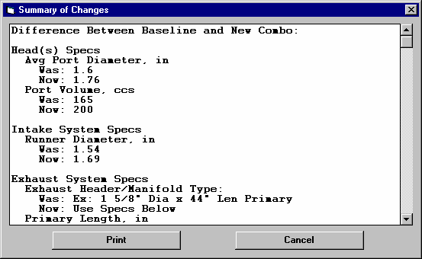
Figure 8 Screen to Review Changes
Click on 'Review Changes' and you will see a history of all changes you have made. Printing these changes is a convenient way to remember these changes. Then you can return to the Main Screen and make these changes and see the effects on other calculated output, like Spark Advance, or Exhaust Pressure, etc. See Figure 8.

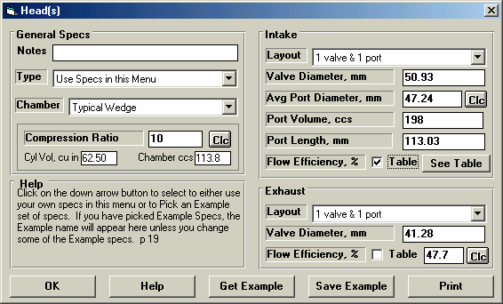
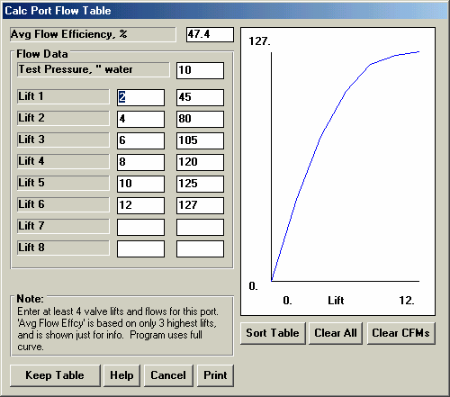
New Plus Features in Version 3.2
Use Full Flow Curve or Flow Table
In the Head Specs menu, there is a check box to let you use the Avg Flow Efficiency for the port, or a Flow Table if you check the check box.

Figure 9 Flow Table Feature in Head Specs

Click here to produce the “See Table” button.
Click on “See Table” to display the table shown below.

The Avg Flow Efficiency is calculated from the 3 highest lift points you’ve entered, and is displayed for your information, so you have a sense of how good a port this is. You must enter at least 4 points before this is displayed. The program uses all points entered

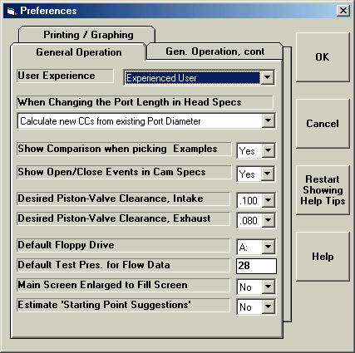
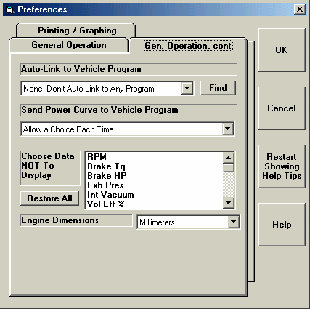
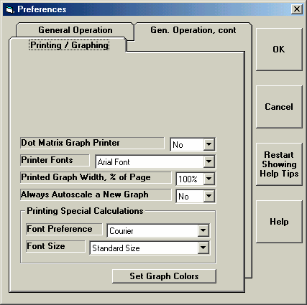
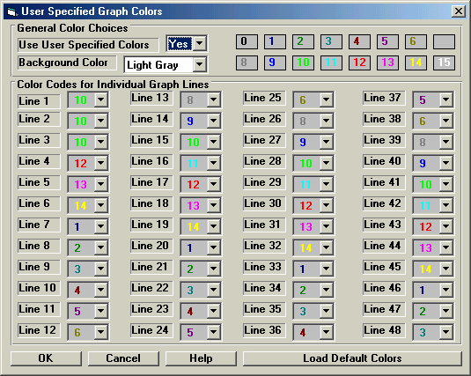
Figure 10 Preferences for Plus Features

Choose what calculated data you do NOT want displayed or printed.

Set desired Clearance for Piston-to-Valve calculation.
Choose if you want to use Millimeters for entering Engine Dimensions.

Set this to ‘Yes’ to have this screen define the graph colors.

Click here to get screen to right to pick which colors you want used for making graph lines.

Use Millimeters
Figure 10 shows where you can select to use Millimeters to enter engine dimensions like Bore, Cam Lift, etc. Note that these dimensions are changed if a file was saved in inches and the Preference is now set to MM. If you switch back and forth between inches and MM, the actual measurements may change slightly due to this conversion and rounding errors.

Desired Piston-to-Valve Clearance
Figure 10 shows where you can select a Desired Piston-to-Valve Clearance from the drop-down list. Most engine builders use .100” clearance for the intake and exhaust, but you can select anything you want here. Because you can now select a clearance, the calculation menu for Piston-to-Valve Clearance is now different than in the earlier v3.0.

Hide Output
Some users have requested that certain output be eliminated, that it can add to confusion to customers reading the output. Figure 10 shows where you can now select which outputs are not displayed or printed.

Choose Different Graph Colors
Figure 10 also shows how you can select each color for each graph line. For example, if Yellow does not show up well on your printer, you can change each occurrence of yellow to, say pink. This screen also lets you change the background color.
New Plus Features in Version 3.4
The Plus version now has over 20 added features compared to the Standard Engine Analyzer. Here’s what we’ve added in v3.4 to the 10 Plus features in v3.2.

- We’ve added the ability to import flow files from Port Flow Analyzer. Fig 11 and Fig 12.
- We’ve added a new screen to let you do Variable Cam Timing (VVT). Fig 13.
- Dwell over Nose (Cheater profile) can now be more exactly defined, to the nearest 2 degree increment. Fig 14.
- Also, now this setting (Dwell over Nose) can be different on the intake vs the exhaust. Fig 14.
- The program now allows for using a Ramp Rating for the cam profile for more exact cam profiles. Fig 14 and 15.
- There is also a ‘Clc’ screen to calculate the ramp rating to match certain duration specs at either .200 lift or seat timing. Fig 14 and 15.
- Program now has Fuel Option of E85. Fig 16.
- We’ve added an option to include the Special Calculations section for writing ASCII files of test results. Fig 17.
- Program now has an “Edit Printed Graph” command under Format. It opens a screen where you have several options on how to print your graph, include various comments, etc. You can now select to include the torque and HP data in a table when you print out RPM data graphs as long as there are torque and/or HP data on the graph. Fig 18 and 19.
- You can now print a Company Logo graphics files on reports and graphs. This info is loaded in the Preferences screen. Fig 19 and 20.
- You can specify 2 lines of text which can appear at the top of printouts of reports and graphs in the Preferences screen, under Printing/Graphing. Fig 19 and 20.
Figure 11 New Feature for Picking Example Component Files
Click on this button to bring up the screens shown in Figure 12.
Click on Get Example button in the Head Specs screen to bring up the screen below for importing a Head Flow File from out Port Flow Analyzer.

Figure 12 Importing Head Files from Performance Trends’ Port Flow Analyzer
Check the options you want, choose which Port (or Average all ports Together), and click on the “Copy PFA Specs to This Head File” button.
Find the file, then click on the Open button for the screen below.
You get this screen by clicking on the “Load Files from Port Flow Analyzer” button shown in Fig 11. This screen is very similar to the File Open screen in your Port Flow Analyzer. Use it to choose the file you want to load.

Figure 13 Variable Valve Timing (V V T) Specs

Choose Yes, and then you can click on the “See Specs” button to see screen below.
Enter the values you want to use at and above the “RPM to Change to Final Values” input in the lower left corner.
These are the settings from the original Cam Specs screen, shown for comparison.
This column shows the “Change” (difference) between the Starting Value and the Final Value.

Your choice here determines which specs are enables on this screen.
Click here for more details on how this screen works.
Enter the RPM at which the program should switch from the specs on the original Cam Specs screen to these VVT settings.
Bigger VVT Cam

Figure 14 New Features in Cam/Valve Train Screen
“Cheater” profiles are gone, replaced by Int and Exh “Dwell Over Nose shown below.
New “Spec” (specified) profile option displays Ramp Rating input below for you to “fine tune” the ramp.

Ramp Rating is displayed if you choose “Spec” (user specified) profile type in upper right corner. Click on the “Clc” button to calculate from 2 duration specifications (Figure A 15).
New VVT specs as shown in Figure 13.

You pick std (no dwell) or Typical Cheater (lots of dwell), or the Plus Version lets you fine tune this in 2 degree steps.

Figure 15 Calc Ramp Rating Screen
You can calculate an exact Ramp Rating for a “General Description” or to match 2 specific duration inputs by your choice of “Follower Type”. Four
(4) calculated outputs describing the resulting profile are shown at the top of this screen.

Figure 16 New Features in Calculate Performance Running Conditions
Plus Version has E85 Fuel Options.

Figure 17 New Features for Writing ASCII Data Files
At the top of the Calculated Results, click on File for the screen shown in the lower left.

Note that this file includes the Special Calculations.
Plus Version has “Include Special Calcu-lations” option.

Figure 18 New Features for Graphs Screen

Choose option to display the different options available for each test being graphed.
Click on Edit Printed Comments for the screen of options shown below.

Options and the Comment in this lower section apply to the whole graph. Figure A 23 shows a printout for the options picked here.

Figure 19 Printed Graph with New Features

Company Logo graphics file (Plus version only)
2 lines of user entered text (Plus version only)

Additional text and data printed at bottom of page, under graph, as selected in screen shown in Figure A 22.

Comments and data may continue onto a 2nd page as shown here.

Figure 20 New Preferences
New buttons to turn Off or turn On all intro help tips.
This section “Program Title Comments” is available only in the Plus version, and lets you specify 2 lines of text and some graphics file (typically a company logo) to appear at the top of your printouts (reports and graphs).

New Plus Features in Version 3.4 B
Version 3.4B has added new features in the Optimize screen. Check the text on pages 204 and 205, and Fig B.11 on page 214.

Index

1st Stage HP Rating, 56 1st Stage Starting RPM, 56

2nd Stage Added HP, 56 2nd Stage Starting RPM, 56

A/F, 32, 55, 56, 57, 61, 62, 65, 162, 165, 166, 168, 176, 177,
218, 219
A/F Mix Qal, 57, 62, 177
A/F Mixture Quality, 32, 62, 162
Accessories, 8, 20, 122, 176, 178
Accuracy, 5, 7, 8, 9, 23, 32, 36, 58, 65, 71, 72, 73, 76, 82, 84,
85, 92, 151, 152, 153, 160, 161, 162, 177, 179, 203, 204
Actual CFM, 61, 142, 148, 175, 176, 177
Adobe Acrobat, 179, 188, 203
Alcohol, 47, 56, 57, 61, 62, 162, 166, 169
Analysis Report, 4, 93, 95, 96, 142, 148, 153, 155, 158, 160,
178, 203
Approx Camxe "Cam" Specs, 71 Area, 66, 70
ASCII, 4, 97, 188, 199, 204, 228, 234
Assumed Rocker Arm Ratio, 86, 134
Assumptions, 9, 23, 28, 29, 39, 40, 41, 46, 48, 55, 56, 57, 62,
67, 68, 69, 70, 71, 119, 129, 131, 134, 159, 161, 162, 163,
176, 177, 204, 218, 219
Auto-Link, 180, 186
Avg HP, 13, 114, 134, 139, 156
Avg Port Diameter, 23, 73, 76, 149, 150
Avg Tq, 13, 114, 134
Axis, 104, 105

Back Color, 105, 227
Barometric Pressure, 54, 55, 60, 69, 87
Baseline, 13, 129, 154, 157, 159
BDC, 20, 63, 74, 105, 138, 179, 203
Beginner, 17, 19, 20, 21, 27, 31, 33, 35, 38, 43, 45, 48, 50, 91,
119, 122, 204
Belt Ratio, 49, 51, 86, 145, 175
Bench Test Pres, 85
Boost, 22, 44, 46, 47, 48, 49, 51, 60, 64, 141, 142, 143, 146,
175
Bore, 19, 20, 69, 74, 75, 123, 168, 177, 227
Brake HP, 13, 60, 97, 99, 162, 167, 175, 177
Brk Tq, 13, 60, 97, 162, 175, 177
Browse, 10, 188
BSAC, 62, 179
BSFC, 62, 167, 221, 222

Calculation Button, 14, 19, 20, 22, 23, 24, 25, 29, 30, 32, 35,
40, 49, 51, 54, 55, 73, 78, 80, 134, 145, 149, 150
Calculation Menus, 4, 14, 40, 73, 74, 75, 76, 78, 80, 82, 85,
86, 87, 129, 134, 149
Cam, 4, 7, 14, 18, 22, 37, 38, 39, 40, 41, 58, 63, 64, 65, 66,
67, 68, 69, 70, 71, 72, 80, 81, 86, 119, 124, 126, 127, 128,
129, 130, 131, 132, 133, 134, 135, 136, 137, 138, 139, 141,
151, 153, 155, 156, 160, 162, 166, 167, 168, 175, 177, 180,
187, 193, 194, 197, 203, 204, 205, 218, 219, 222, 227, 228,
231
Cam Advance, 39, 132, 187
Cam File, 197
Camxe "Cam"/Valve Train, 4, 18, 37, 38, 72, 86, 124, 127,
129, 131, 133, 134, 187, 193, 194, 231
Carb/T-B CFM Rating, 85, 150, 162, 175
Carburetor(s), 31
CD, 10
Centerline, 18, 40, 41, 131, 132, 133, 222
Centrifugal Supercharger, 43, 48, 49, 50, 51, 86, 144, 145,
146
CFM, 24, 28, 32, 35, 36, 45, 50, 61, 79, 80, 81, 82, 83, 84, 85,
142, 143, 149, 150, 151, 155, 162, 175, 176, 177, 178, 218
CFMxe "CFM" at Peak Efficiency, 45, 50
CFM Rating, 28, 32, 35, 36, 85, 155, 162, 175, 177, 178
Chamber, 22, 23, 75, 163
Chamber ccs, 23 Chamber CCs in Head, 75 Chamber Design, 22, 163
Cheater Cam Profile, 187, 228
Clc button, 14, 19, 20, 22, 23, 24, 25, 29, 30, 32, 35, 40, 49,
51, 54, 55, 73, 78, 80, 134, 145, 149, 150, 187, 228
Clearance Volume, 22, 68, 69, 75
Closing @, 40
Collector Length, 34
Combustion Chamber, 169, 203
Comma Separated, 97
Comments, 11, 13, 30, 111, 125, 128, 180, 187, 188, 228
Company Logo, 188, 228
Component Examples, 89, 91
Component Files, 189, 228
Compression Ratio, 19, 22, 23, 68, 69, 73, 75, 123, 139, 148,
169, 177
compressor map, 44, 45, 50
Compressor Map, 44, 45, 50 Convert to Columns, 97
Coolant Temp, 55, 124, 125, 169, 175, 177
Copy, 8, 109, 110, 116, 129, 149, 153, 159, 179, 204
Crank Pulley Diameter, 49, 51, 86
crankcase, 20
Crankcase, 20
Cursor, 100, 102, 135, 138, 179, 188
Cycle Data, 59
Cyl Vol, 22, 68

Deck Height, 75, 76
Deck Height Clearance, 75, 76
Design, 33, 34, 43, 44, 48, 49, 84, 150, 162, 169
Desired Cubic Inches, 74 Desktop Dyno, 187
Dew Point, 14, 55, 87, 178
Diameter, 17, 23, 26, 33, 34, 48, 58, 71, 73, 76, 82, 149, 150,
156, 175
Direct Injection, 203

Directory, 7, 8, 97, 110, 119
Displacement, 68
Display User’s Manual, 179
Dot Matrix Printer Adjustment, 111, 180 Dry Bulb Temp, 87
Dual Plane, 28, 150
Dual Plug, 22
Duration, 18, 39, 40, 41, 131, 132, 133, 137, 139, 204, 205,
218
Duration @ .050, 131
Dwell over Nose, 187, 228
Dynamic Comp. Ratio, 68, 69
Dynamometer, 9, 13, 54, 55, 60, 61, 62, 69, 122, 160, 162,
175, 176, 177, 178, 187
Dyno Sim, 187

E85, 187, 228
Edit Printed Graph, 188, 228
Elevation, 54, 55, 60, 87, 178
Email, 10
Engine Analyzer Pro, 203, 204
Engine File, 108, 109, 113, 223
Engine HP, 26, 85
Engine Library, 4, 12, 14, 93, 107, 109, 114, 119, 120, 125,
128, 129, 141, 149
Engine RPM, 60
Esc Key, 179, 183
Est Idle Vac, 69, 129, 139, 155
Ex AvgVel, 64, 159, 175
Example Components, 4, 5, 17, 24, 25, 45, 50, 82, 84, 89, 90,
91, 92, 117, 119, 120, 122, 123, 124, 144, 179, 220
Exh Pres, 36, 60, 142, 143, 175, 177
Exh System, 4, 33, 35, 76, 80, 82, 85, 124, 142, 145, 159,
162, 168, 175, 177, 178, 187
Exhaust Back Pressures, 36
Exhaust System, 4, 33, 35, 76, 80, 82, 85, 124, 142, 145, 159,
162, 168, 187
Experienced, 17, 127, 129, 204
ExTun Prs, 64, 159

F5 Key, 179, 183
File, Engine, 7, 8, 10, 11, 12, 15, 97, 108, 109, 114, 119, 124,
125, 149, 175, 179, 186, 203, 204, 220, 227
Flat Head, 22
Flow Bench, 5, 18, 24, 25, 26, 30, 34, 78, 79, 80, 81, 82, 84,
85, 149, 151, 152, 160, 177
Flow Bench Flow, 84, 85
Flow Effcy, 8, 22, 24, 25, 26, 29, 30, 34, 64, 66, 78, 80, 81,
82, 149, 150, 151, 152, 173, 175, 176, 177, 179, 225
Flow Efficiency, 8, 22, 24, 25, 26, 29, 30, 34, 64, 66, 78, 80,
81, 82, 149, 179, 225
Flow Obtained, 80
Flow w/o Runner, 81, 82
Flow with, 82
For Peak HPxe "HP" at This RPM, 58, 69, 153, 155 For This Intake Runnerxe "Runner" Len, 58, 153 Friction HP, 62, 146, 167, 175, 176, 177
Fuel Flow, 61, 142, 143, 148, 165, 175, 176
Fuel Injected, 32
Fuel Injection, 124
Fuel Octane (R+M)/2, 57 Fuel Type, 56, 218

Gasket Bore Dia, 75 Gasket Bore Diameter, 75
Gasket Thickness, 73, 75, 220
GMC, 48
Graphxe "Graphs" Title, 113, 203, 204
Graphxe "Graphs"?, 113, 204
Graphics File, 187, 188, 228
Graphs, 4, 7, 12, 13, 97, 99, 100, 101, 102, 103, 104, 105,
113, 114, 127, 128, 133, 135, 136, 137, 138, 139, 142, 143,
145, 146, 147, 151, 152, 179, 180, 183, 184, 188, 200, 201,
203, 204, 218, 221, 222, 223, 227, 228, 235, 236
Grid Style, 105, 203
Gross Exhaust Valve Lift, 41 Gross Intake Valve Lift, 41 Gross Valve Lift, 132, 187

Harley Davidson, 187
Head(s), 4, 15, 19, 21, 25, 27, 29, 33, 58, 66, 70, 71, 73, 75,
76, 78, 79, 81, 123, 149, 150, 156, 163, 168
Headers, 34, 35, 36, 113, 124, 178
Height, 70, 75, 77
Help, 7, 8, 9, 11, 12, 14, 18, 69, 73, 125, 127, 143, 160, 175,
179, 185, 187, 204, 205, 218, 221
Hemi, 22, 25
History Log, 4, 93, 99, 100, 112, 113, 114, 129, 130, 132,
134, 135, 136, 139, 141, 143, 145, 156, 203, 204
Hole Dia, 83
HP, 5, 13, 20, 25, 36, 39, 53, 55, 56, 58, 59, 60, 61, 62, 65,
69, 71, 72, 85, 92, 95, 100, 119, 124, 126, 127, 128, 136,
139, 143, 145, 146, 147, 153, 155, 156, 160, 162, 164, 165,
166, 167, 168, 175, 176, 177, 178, 182, 188, 221, 222, 228
HPxe "HP" Pk Int Dur, 72 HPxe "HP" Pk, Exh Dur, 72
Hydraulic, 5, 7, 39, 40, 64, 69, 129, 131, 132, 133, 134, 135,
136, 137, 138, 139, 204

Idle Vacuum, 66, 69, 129, 139, 155
In InertiaPrs, 64, 151, 155, 156, 157, 176
In ResTunPrs, 64, 70, 71, 155, 156, 157, 160
Include Engine Comments, 111 Include Engine Specs, 111 Include Text, 97
Incr., 114
individual runner, 28, 29, 34, 76, 153, 177
Inertia, 70, 71, 139, 156, 157, 158, 171, 172
Install, 10
Installation, 4, 10, 14, 34, 80, 82, 131, 146, 149, 178
Installing, 5, 129, 144
Int AvgVel, 63
Int Vac, 60, 142, 155, 175, 176
Intake Air Temp, 54, 55, 60, 178
Intake Duration, 39, 63, 65, 66, 67, 68, 69, 71, 72, 128, 131,
132, 136, 137, 139, 151, 175, 177, 187, 228
Intake Heat, 31, 91, 175, 177, 178
Intake Manifold, 23, 58, 64, 69, 73, 123, 124, 162
Intake System, 4, 27, 31, 34, 35, 70, 76, 80, 82, 123, 124, 149,
150, 151, 156, 168, 177, 218

Intercooler Eff, 46, 47, 51, 141, 145
Island CFM, 44, 45

Jet, 55, 85

Knock Index, 57
Know, 5, 73, 76, 87, 119

Lash, 38, 40, 41, 64, 131, 134, 163, 175
Layout, 23, 26, 27, 29, 33, 70, 71, 79
Legend, 100, 103, 113, 135, 188
Length, 17, 23, 70, 73
Library, 12, 45, 49, 107, 108, 109, 129, 141, 153, 179
Liftxe "Valve Lift" for Rating Events, 39, 40, 131
Lifter, 5, 31, 39, 40, 41, 64, 65, 67, 72, 86, 97, 129, 131, 132,
133, 134, 135, 139, 163, 177, 205
Lifter (profile) Type, 39, 40, 131, 133
Lifterxe "Lifter" Pump Up, 39, 64, 65, 97, 132, 163, 205
Line Style, 105
Lobe Centerlns, 68
Lobe Area, 67
Lobe Separation, 41, 67, 131, 132, 134, 187
log, 7, 114
Log, 33, 99, 100, 112, 129, 143
Log Manifold, 33 Look For It, 116

Mach #, 8, 62, 63, 71, 151, 155, 175, 177
Manifold Type, 28, 31, 32, 64, 89, 123, 124
Max Lobe Lift, 39, 40, 41, 86, 132, 134
Max Safe Pulley RPM, 51, 145, 146
Mech Eff, 167, 168
Motoring HP, 62
Mufflers, 36, 85, 124, 142, 145

Nitrous, 5, 55, 61, 62, 124, 141, 146, 147, 148, 168, 169
Notepad, 8, 203, 204 Number of RPM Steps, 57

Octane, 56, 57, 61, 62, 124, 125, 141, 143, 145, 148, 162,
177, 179
Open File, 7, 8, 11, 18, 25, 32, 35, 36, 40, 107, 108, 119, 129,
142, 145, 149, 153, 178, 185, 204
Opening @, 40
Optimize, 180, 182, 187, 204, 205, 218, 221, 222, 223, 238
Optimize Using These Cams, 187 Outside Air Temp, 87
Outside Rel Humidity, 87
Overlap, 63, 65, 66, 67, 129, 137, 139, 155, 156, 160
Overlap Area, 63, 65, 66, 67, 129, 137, 139

PDF, 179, 203
Peak Efficiency, 45, 50
Peak HP, 114, 133, 134, 139, 146, 151
Peak Tq, 114
Pent Roof, 22
Piston, 20, 22, 23, 63, 68, 69, 74, 75, 76, 155, 158, 164, 167,
168, 171, 172, 219, 220
Piston Dome, 73, 75
Piston Dome CCs, 73, 75
Piston Gs @ TDC, 63 Piston Spd, 63, 155, 158
Pistons/Bearings, 20
Plus version, 21, 26, 37, 53, 89, 93, 97, 111, 117, 129, 149,
187, 188, 228
Plus Version, 187, 188, 191, 192, 204
Port Flow Analyzer, 187, 191, 228, 229
Port Length, 17, 23, 58, 70, 71, 73, 76, 156
Port Volume, 17, 23, 58, 71, 73, 76, 149, 222
Port/Runner Volume, 77
Preferences, 4, 11, 17, 40, 79, 90, 91, 119, 127, 129, 180, 183,
187, 188, 202, 203, 204, 226, 227, 228, 237
Pres Ratio at Pk Effcy, 45, 50 Primary Diameter, 34, 159
Primary Length, 34, 159 Primary Throttle Dia, 83 Primary Tube O.D., 71
Print, 4, 7, 8, 13, 73, 76, 93, 101, 111, 112, 179, 188, 204,
218, 228
Print Blank Worksheet, 111 Print Help Definitions, 112 Print History, 112
Printers, 179, 188
Pulley RPMxe "RPM" at Pk Effy, 50 Pump Up, 65, 132
Pushrod, 131, 133

Ramp Rating (cam), 187, 228, 232
Readme.doc, 8
Rec Area, 70, 71
Rec Len, 70, 71
Registered Code, 10
Registered Name, 10
Request Report Comment, 111 Resonance, 171, 172
Restrictor Plate, 83, 84
Rocker Arm Ratio, 38, 39, 41, 86, 132, 134, 163, 177, 187
Rod Length, 20
Roots Supercharger, 43, 48, 49, 86, 175, 187
RPM, 13, 20, 22, 28, 32, 36, 44, 46, 48, 49, 50, 51, 56, 57, 58,
59, 60, 62, 63, 64, 65, 66, 69, 70, 71, 72, 95, 96, 97, 99,
112, 114, 119, 124, 126, 127, 132, 133, 136, 137, 139, 141,
142, 143, 145, 146, 147, 148, 151, 153, 154, 155, 156, 157,
158, 159, 160, 166, 168, 171, 172, 175, 176, 177, 178, 179,
182, 188, 203, 204, 219, 221, 222, 228
RPM Data, 59, 60, 97, 99, 112, 132, 155, 171, 177, 188, 222,
228
RPM Step Size, 57
Runner, 23, 27, 28, 29, 30, 33, 34, 58, 63, 64, 65, 66, 69, 70,
71, 73, 76, 77, 80, 81, 82, 123, 139, 149, 150, 151, 152,
153, 155, 156, 157, 158, 159, 160, 171, 172, 173, 175, 176,
177, 180
Runner Diameter, 27, 29, 30, 73, 76, 81, 82, 149, 150, 156
Runner Flow Coef, 173
Runner Length, 23, 29, 70, 73, 150, 156
runnerxe "Runner"/cyl, 27, 33
Running Conditions, 4, 12, 13, 14, 46, 51, 53, 69, 70, 87, 124,
126, 141, 143, 146, 153, 168, 178, 198, 218, 219, 233

S/C Pulley Diameter, 49, 51, 86

Safety, 3, 9, 13, 20, 46, 49, 51, 64, 65, 93, 95, 96, 131, 144,
146, 148, 153, 158, 168
Save, 7, 11, 91, 97, 109, 114, 125, 128, 220, 223
Save to Engine Library, 125, 128
Savexe "Save"?, 114
Saving Examples, 91
Scales, 36, 45, 50, 100, 104, 105, 180, 188, 222
Screen, Larger Fonts, 203 Screen, Resize, 204
Seat Timing, 7, 187, 228
Secondary Throttle Dia, 32, 83, 176, 177
Secondary Throttlexe "Secondary Throttle Dia"s, 32, 176, 177
Seek, 116
Send to Vehicle Program, 4, 115
Setup, 10
Shape, 77
Short Block, 4, 19, 22, 28, 74, 75, 89, 120, 121, 122, 123,
162, 169, 176, 187, 204
Single Plane, 28
Spark, 22, 49, 55, 56, 65, 141, 142, 143, 148, 164, 167, 169,
176, 177, 179, 221, 222, 224
Sparkxe "Spark" Adv, 65, 142, 143, 169, 177, 221, 222, 224
Spark Knock, 49, 65, 141, 142, 148, 177
Special Calculations, 58, 59, 65, 112, 129, 130, 151, 156, 160,
162, 188, 203, 228
Special Graph, 188, 221, 222
Stan Weiss, 187
Starting Point Suggestions, 58, 69, 125, 129, 153, 155, 156,
160, 180
Starting RPM, 57, 124, 153
Streamlined Manifold, 33
Stroke, 19, 20, 62, 63, 69, 74, 75, 166, 168, 177
Supercharger, Screw Type, 203
Supercharging, 4, 5, 14, 22, 43, 48, 49, 50, 51, 60, 61, 62, 63,
64, 67, 72, 86, 124, 141, 142, 144, 145, 146, 148, 153, 159,
160, 168, 169, 171, 175, 187, 198
System Type, 55, 124

TDC, 20, 63, 65, 68, 74, 76, 105, 179, 203, 220
Tech Help, 2, 9, 10
Test Conditions, 54
Test Pressure, 18, 79, 80, 81, 82, 85, 149, 150
Test Title, 113, 129, 132
Theo. Crank Comprssn, 69, 129
Thermal Eff, 167, 168
Throttle Body(s), 31
Torque, 5, 20, 28, 39, 58, 59, 60, 62, 64, 65, 69, 99, 100, 114,
124, 127, 133, 134, 136, 139, 142, 145, 146, 147, 148, 151,
155, 156, 160, 161, 162, 167, 171, 172, 173, 175, 177, 178,
179, 182, 188, 218, 221, 222, 228
Total # Pri. Throttle Plates, 83 Total # Sec. Throttle Plates, 83 Total Avg Flow Coef, 66, 162
Total Cam Advance, 38, 39, 131, 134, 175
Total CFM Rating, 28, 32, 35
Total Exh/Int %, 66, 129, 139, 151, 155
Total Length, 33
Tuning, 5, 9, 23, 27, 28, 29, 30, 33, 34, 55, 58, 63, 64, 65, 69,
70, 71, 82, 127, 137, 149, 151, 153, 155, 156, 157, 158,
159, 160, 162, 163, 171, 172, 173, 174, 175, 176, 177, 203
Turbine Nozzle, 44, 46
Turbocharging, 5, 43, 44, 45, 46, 49, 51, 60, 66, 141, 142,
143, 144, 148, 187
Type, 19, 21, 22, 27, 31, 33, 35, 38, 43, 44, 45, 48, 49, 50, 85,
89, 120, 123, 124, 127, 131, 134, 141, 142, 143, 144, 145,
149, 188, 203, 222
Type of Vehicle, 85
Typical, 16, 20, 22, 27, 38, 44, 45, 50, 73, 89, 91, 96, 120,
121, 122, 123, 124, 126, 127, 128, 141, 171, 178, 187, 220
Typical Examples, 16, 20, 22, 27, 38, 44, 45, 50, 73, 89, 91,
96, 120, 121, 122, 123, 124, 126, 127, 128, 141, 171, 178,
187, 220
Typical Octane, 187

Valve Dia, 23, 26, 79, 81, 149, 175, 177, 220
Valve Diameter, 23, 26, 79, 81, 149, 175, 177
Valve Lift, 24, 39, 40, 41, 59, 66, 67, 71, 72, 79, 80, 81, 82,
86, 99, 100, 105, 128, 131, 132, 133, 134, 136, 137, 139,
149, 150, 151, 177, 179, 187, 203, 205, 218, 227, 228
Valve Lift Tested, 79, 81
Valve Toss, 39, 64, 65, 97, 135, 139, 163, 177, 205
Valve Train, 38, 39, 41, 65, 124, 131, 133, 135, 139, 168, 177
vapor pressure, 57, 62, 162, 177
Variable Cam Timing (VVT), 187, 228
Vista, 8, 187
Vlv Area, 66, 67, 68, 129, 139, 151
Vol Eff, 60, 61, 156, 166, 168
Volume, 17, 22, 23, 48, 58, 71, 73, 75, 175
Volumexe "Volume"/Revolution, 48, 175
Volumetric Efficiency, 60, 61, 62, 63, 64, 67, 155, 161, 162,
166, 171, 172

Wastegate Limit, 46, 141, 142
Weather, 46, 51, 53, 54, 124, 168, 178
Wedge, 22
Weiss, Stan, 187 Wet Bulb Temp, 87 Width, 70, 77, 180
windage, 20
Windows, 1, 7, 8, 101, 108, 110, 112, 115, 116, 119, 125,
179, 187
Windows 7, 187
Working Code, 10
WOT, 32, 176

Zoom, 7, 137
Zoomies, 33

